**ORIGINAL INSTRUCTIONS**



**Portable sanders SURFACER4**

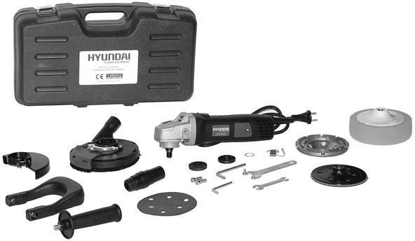

**Instruction manual**

**Warning: Please read the manual carefully before using the unit!**

**FEIDER FRANCE**

**32, rue Aristide Bergès - ZI 31270 Cugnaux - France MADE IN PRC 2019**

**CONTENTS**

1. SAFETY INSTRUCTIONS 3
2. YOUR PRODUCT 7
3. ASSEMBLY 8
4. OPERATION 12
5. MAINTENANCE AND STORAGE 13
6. CE DECLARATION OF CONFORMITY 14

# SAFETY INSTRUCTIONS

 **WARNING Read all safety warnings and all instructions.** *Failure to follow the warnings and instructions may result in electric shock, fire and/or serious injury*.

**Save all warnings and instructions for future reference.** *The term "power tool" in the warnings refers to your mains-operated (corded) power tool or battery-operated (cordless) power tool.*

1. **Work area safety**
   1. **Keep work area clean and well lit**. *Cluttered or dark areas invite accidents.*
   2. **Do not operate power tools in explosive atmospheres, such as in the presence of flammable liquids, gases or dust.** *Power tools create sparks which may ignite the dust or fumes.*
   3. **Keep children and bystanders away while operating a power tool.** *Distractions can cause you to lose control.*
2. **Electrical safety**
   1. **Power tool plugs must match the outlet. Never modify the plug in any way. Do not use any adapter plugs with earthed (grounded) power tools.** *Unmodified plugs and matching outlets will reduce risk of electric shock.*
   2. **Avoid body contact with earthed or grounded surfaces, such as pipes, radiators, ranges and refrigerators.** *There is an increased risk of electric shock if your body is earthed or grounded.*
   3. **Do not expose power tools to rain or wet conditions.** *Water entering a power tool will increase the risk of electric shock.*
   4. **Do not abuse the cord. Never use the cord for carrying, pulling or unplugging the power tool. Keep cord away from heat, oil, sharp edges or moving parts.** *Damaged or entangled cords increase the risk of electric shock.*
   5. **When operating a power tool outdoors, use an extension cord suitable for outdoor use.** *Use of a cord suitable for outdoor use reduces the risk of electric shock.*
   6. **If operating a power tool in a damp location is unavoidable, use a residual current device (RCD) protected supply.** *Use of an RCD reduces the risk of electric shock.*
3. **Personal safety**
   1. **Stay alert, watch what you are doing and use common sense when operating a power tool. Do not use a power tool while you are tired or under the influence of drugs, alcohol or medication.** *A moment of inattention while operating power tools may result in serious personal injury.*
   2. **Use personal protective equipment. Always wear eye protection.** *Protective equipment such as dust mask, non-skid safety shoes, hard hat, or hearing protection used for appropriate conditions will reduce personal injuries.*
   3. **Prevent unintentional starting. Ensure the switch is in the off-position connecting to power source and/or battery pack, picking up or carrying the tool.** *Carrying power tools with your finger on the switch or energizing power tools that have the switch on invites accidents.*
   4. **Remove any adjusting key or wrench before turning the power tool on.** *A wrench or a key left attached to a rotating part of the power tool may result in personal injury.*
   5. **Do not overreach. Keep proper footing and balance at all times.** *This enables better control of the power tool in unexpected situations.*
   6. **Dress properly. Do not wear loose clothing or jewelry. Keep your hair, clothing and gloves away from moving parts.** *Loose clothes, jewelry or long hair can be caught in moving parts.*
   7. **If devices are provided for the connection of dust extraction and collection facilities, ensure these are connected and properly used.** *Use of dust collection can reduce dust-related hazards*.
4. **Power tool use and care**
   1. **Do not force the power tool. Use the correct power tool for your application.** *The correct power tool will do the job better and safer at the rate for which it was designed.*
   2. **Do not use the power tool if the switch does not turn it on and off.** *Any power tool that cannot be controlled with the switch is dangerous and must be repaired.*
   3. **Disconnect the plug from the power source and/or the battery pack from the power tool before making any adjustments, changing accessories, or storing power tools.** *Such preventive safety measures reduce the risk of starting the power tool accidentally.*
   4. **Store idle power tools out of the reach of children and do not allow persons unfamiliar with the power tool or these instructions to operate the power tool.** *Power tools are dangerous in the hands of untrained users.*
   5. **Maintain power tools. Check for misalignment or binding of moving parts, breakage of parts and any other condition that may affect the power tool’s operation. If damaged, have the power tool repaired before use.** *Many accidents are caused by poorly maintained power tools.*
   6. **Keep cutting tools sharp and clean.** *Properly maintained cutting tools with sharp cutting edges are less likely to bind and are easier to control.*
   7. **Use the power tool, accessories and tool bits etc. in accordance with these instructions, taking into account the working conditions and the work to be performed.** *Use of the power tool for operations different from those intended could result in a hazardous situation.*
5. **Service**
   1. **Have your power tool serviced by a qualified repair person using only identical replacement parts*.***

*This will ensure that the safety of the power tool is maintained.*

**Safety instructions for all operations**

**Safety Warnings Common for Grinding, Sanding, Wire Brushing, Polishing or Abrasive Cutting-Off Operations:**

a) **This power tool is intended to function as a grinder, sander or polisher Read all safety warnings, instructions, illustrations and specifications provided with this power tool.** *Failure to follow all instructions listed below may result in**electric shock, fire and/or serious injury.*

b) **Operations such as wire brushing or cutting-off are not recommended to be performed with this power tool.** *Operations for which the power**tool was not designed may create a hazard and cause personal injury.*

c) **Do not use accessories which are not specifically designed and recommended by the tool manufacturer.** *Just because the accessory can be attached to your power tool, it**does not assure safe operation.*

d) **The rated speed of the accessory must be at least equal to the maximum speed marked on the power tool.** A*ccessories running faster than their rated speed can break**and fly apart.*

e) **The outside diameter and the thickness of your accessory must be within the capacity rating of your power tool.** *Incorrectly sized accessories cannot be adequately**guarded or controlled.*

f) **Threaded mounting of accessories must match the grinder spindle thread. For accessories mounted by flanges, the arbour hole of the accessory must fit the locating diameter of the flange.** *Accessories that do not match the mounting hardware**of the power tool will run out of balance, vibrate excessively and may cause loss of**control.*

g) **Do not use a damaged accessory. Before each use inspect the accessory such as abrasive wheels for chips and cracks, backing pad for cracks, tear or excess wear, wire brush for loose or cracked wires. If power tool or accessory is dropped, inspect for damage or install an undamaged accessory. After inspecting and installing an accessory, position yourself and bystanders away from the plane of the rotating accessory and run the power tool at maximum no-load speed for one minute.** *Damaged accessories will normally break apart during this test time.*

h) **Wear personal protective equipment. Depending on application, use face shield, safety goggles or safety glasses. As appropriate, wear dust mask, hearing protectors, gloves and workshop apron capable of stopping small abrasive or workpiece fragments.** *The eye protection must be capable of stopping flying debris**generated by various operations. The dust mask or respirator must be capable of filtrating**particles generated by your operation. Prolonged exposure to high intensity noise may**cause hearing loss.*

i) **Keep bystanders a safe distance away from work area. Anyone entering the work area must wear personal protective equipment.** *Fragments of workpiece or of a broken**accessory may fly away and cause injury beyond immediate area of operation.*

j) **Hold the power tool by insulated gripping surfaces only, when performing an operation where the cutting accessory may contact hidden wiring or its own cord.** *Cutting accessory contacting a "live" wire may make exposed metal parts of the power**tool "live" and could give the operator an electric shock*

k) **Position the cord clear of the spinning accessory.** *If you lose control, the cord may be cut or snagged and your hand or arm may be pulled into the spinning accessory.*

l) **Never lay the power tool down until the accessory has come to a complete stop.** *The spinning accessory may grab the surface and pull the power tool out of your control.*

m) **Do not run the power tool while carrying it at your side.** *Accidental contact with the spinning accessory could snag your clothing, pulling the accessory into your body.*

n) **Regularly clean the power tool’s air vents.** *The motor’s fan will draw the dust inside the housing and excessive accumulation of powdered metal may cause electrical hazards.*

o) **Do not operate the power tool near flammable materials.** *Sparks could ignite these materials.*

p) **Do not use accessories that require liquid coolants.** *Using water or other liquid coolants may result in electrocution or shock.*

**Further safety instructions for all operations**

**Kickback and Related Warnings**

Kickback is a sudden reaction to a pinched or snagged rotating wheel, backing pad, brush or any other accessory. Pinching or snagging causes rapid stalling of the rotating accessory which in turn causes the uncontrolled power tool to be forced in the direction opposite of the accessory’s rotation at the point of the binding.

For example, if an abrasive wheel is snagged or pinched by the workpiece, the edge of the wheel that is entering into the pinch point can dig into the surface of the material causing the wheel to climb out or kick out. The wheel may either jump toward or away from the operator, depending on direction of the wheel’s movement at the point of pinching. Abrasive wheels may also break under these conditions.

Kickback is the result of power tool misuse and/or incorrect operating procedures or conditions and can be avoided by taking proper precautions as given below.

a) **Maintain a firm grip on the power tool and position your body and arm to allow you to resist kickback forces. Always use auxiliary handle, if provided, for maximum control over kickback or torque reaction during start-up.** *The operator can control**torque reactions or kickback forces, if proper precautions are taken.*

b) **Never place your hand near the rotating accessory.** *Accessory may kickback over your hand.*

c) **Do not position your body in the area where power tool will move if kickback occurs.** *Kickback will propel the tool in direction opposite to the wheel’s movement at the**point of snagging.*

d) **Use special care when working corners, sharp edges etc. Avoid bouncing and snagging the accessory.** *Corners, sharp edges or bouncing have a tendency to snag the**rotating accessory and cause loss of control or kickback.*

e) **Do not attach a saw chain woodcarving blade or toothed saw blade.** *Such blades create frequent kickback and loss of control.*

**Additional safety instructions for grinding and cutting-off operations**

**Safety Warnings Specific for Grinding and Abrasive Cutting-Off Operations:**

a) **Use only wheel types that are recommended for your power tool and the specific guard designed for the selected wheel.** *Wheels for which the power tool was not**designed cannot be adequately guarded and are unsafe.*

b) **The grinding surface of centre depressed wheels must be mounted below the plane of the guard lip.** *An improperly mounted wheel that projects through the plane of the**guard lip cannot be adequately protected.*

c) **The guard must be securely attached to the power tool and positioned for maximum safety, so the least amount of wheel is exposed towards the operator.** *The guard**helps to protect the operator from broken wheel fragments, accidental contact with wheel**and sparks that could ignite clothing.*

d) **Wheels must be used only for recommended applications. For example: do not grind with the side of cut-off wheel.** *Abrasive cut-off wheels are intended for peripheral**grinding, side forces applied to these wheels may cause them to shatter.*

e) **Always use undamaged wheel flanges that are of correct size and shape for your selected wheel.** *Proper wheel flanges support the wheel thus reducing the possibility of**wheel breakage. Flanges for cut-off wheels may be different from grinding wheel flanges.*

f) **Do not use worn down wheels from larger power tools.** *Wheel intended for larger power tool is not suitable for the higher speed of a smaller tool and may burst.*

**Additional safety instructions for sanding operations**

**Safety Warnings Specific for Sanding Operations:**

a) **Do not use excessively oversized sanding disc paper. Follow manufacturers recommendations, when selecting sanding paper.** *Larger sanding paper extending**beyond the sanding pad presents a laceration hazard and may cause snagging, tearing of**the disc or kickback.*

**Additional safety instructions for polishing operations**

**Safety Warnings Specific for Polishing Operations:**

a) **Do not allow any loose portion of the polishing bonnet or its attachment strings to spin freely. Tuck away or trim any loose attachment strings.** *Loose and spinning attachment strings can entangle your fingers or snag on the workpiece*

If the supply cord is damaged, it must be replaced by a special cord or assembly available from the manufacturer or its service agent.

**Residual risks**

Even if you use this product in accordance with all safety requirements, the risk of injury and damage remains:

* Adverse health effects resulting from vibration if the product is used for long periods or if it is not handled properly and properly maintained
* Risk of injury to persons and property caused by projectiles.
* Prolonged use of this product which may expose the operator to vibration and may produce a so-called "white finger" disease. To reduce risk, wear gloves and keep hands warm.
* If any of the symptoms of "white finger syndrome" occur, consult a doctor immediately. Symptoms of "white finger" include numbness, loss of sensitivity, tingling, tingling, and pain, loss of strength, color changes or skin condition. These symptoms usually appear on the fingers, hands or wrists. The risk increases at low temperature.
* Inhalation of particles of blown / aspirated material.
* Involuntary projections.
* Contact with foreign objects.
* Contact with tool during operation

**Intended Use**

This tool is designed for sanding materials and surfaces such as concrete or metal. With the accessories supplied with this tool, the tool can also be used for corner grinding, grinding of concrete and polishing.

* This product is intended for private domestic use only. It should only be used indoors.
* This product is not intended for use in a closed room or in areas where gas and flames may be present.
* Do not use this machine as described in this manual and only for the intended use as described above.
* Any other use may result in damage to the appliance, property damage or body injuries.
* No liability will be accepted for damage resulting from improper use or non-compliance with this manual.

**Symbols**

Class II protection product (double insulation)

 Read instructions manual

 Wear eyes protection

Wear hearing protection

Wear dust mask

# YOUR PRODUCT

* 1. **Description**

1- Storage and transporting box 2- ON/OFF switch

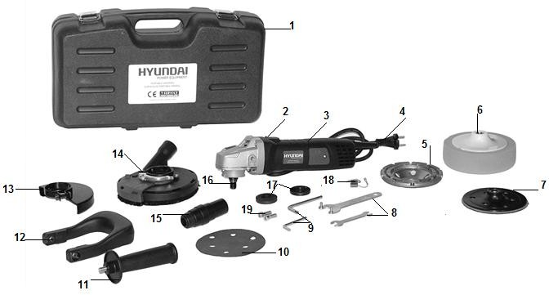

3- Body of the tool 4- Power cable

1. Grinding disc
2. Polisher
3. Sanding disc
4. Wrenches for assembly 9- Hex wrenches
5. Abrasive discs
6. Side handle

12. Second handle

1. Protection housing
2. Crankcase for collecting dust
3. Dust Collector Connection 16 - Installation head
4. Flanges
5. Carbon brushes
6. Screws
   1. **Technical data**

|  |  |
| --- | --- |
| Voltage | 230-240V~ 50Hz |
| Rated power | 1400W |
| No load speed | 2800-10000/min |
| Grinding disc diameter | Ø125mm |
| Spindle thread | M14 |
| Weight | 2.30 kg |
| Protection class | / **II** |
| Sound pressure level | LpA =89 dB(A) K=3dB(A) |
| Sound power level | LWA =97 dB(A) K=3dB(A) |
| Vibration | ah, AG=2.5 m/s2 |
| Uncertainty | K=1.5 m/s2 |

The declared vibration total value has been measured in accordance with a standard test method and may be used for comparing one tool with another;

The declared vibration total value may also be used in a preliminary assessment of exposure. Warning:

that the vibration emission during actual use of the power tool can differ from the declared total value depending on the ways in which the tool is used; and of the need to identify safety measures to protect the operator that are based on an estimation of exposure in the actual conditions of use (taking account of all parts of the operating cycle such as the times when the tool is switched off and when it is running idle in addition to the trigger time). Wear hearing protection.

1. **ASSEMBLY**

**Remove the plug from the socket before carrying out any work on the machine! Consider the operating instructions and safety instructions!**

1. **Mounting the handles on the tool**

the tool is delivered with two handles. You can install one of them, depending the work to do:

* + 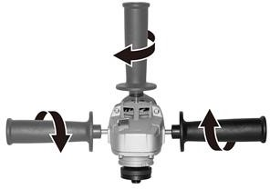Side handle: you can install it in the one of the three holes (on top, left or right). Screw it in the desired hole to fix it.
  + Second handle: install the second handle on the tool and align its hole with the hole on the both side of the tool. Screw the handle with the two provided screws. This handle can be adjusted to 30º.

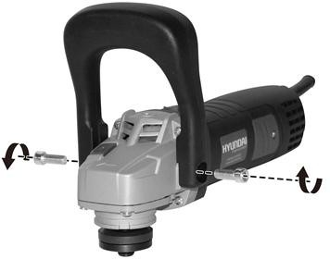

1. **Mounting the carter for the dust collector (for sanding)**

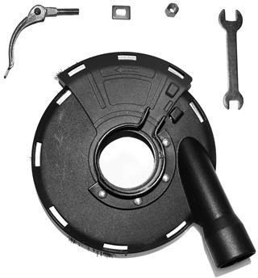

Assemble the square washer into the release handle. Assemble the handle into the holes and tighten with the nut.

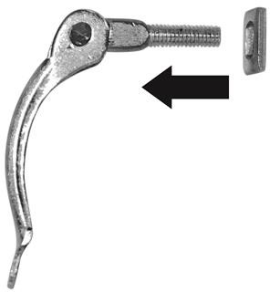Insert the suction nozzle into the tool. Connect your dust connector to the guard.

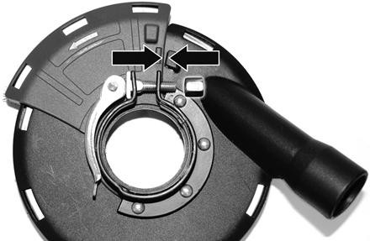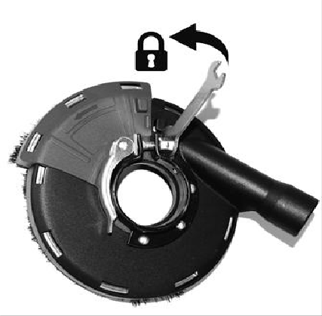

1. **Mounting the carter of protection (for grinding)**

Install the carter of protection on the machine head. Tighten the screw with the supplied wrench.

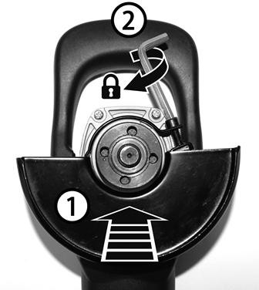

1. **Mounting the grinding disc**

Install the carter of protection as explained above.

Push and hold firmly the spindle lock button. Remove the second flange. Install the grinding disc. Add and screw the flange until it is locked.

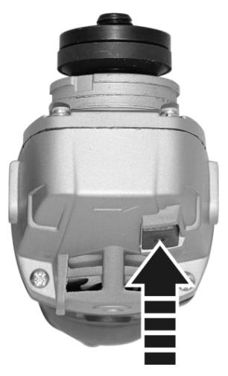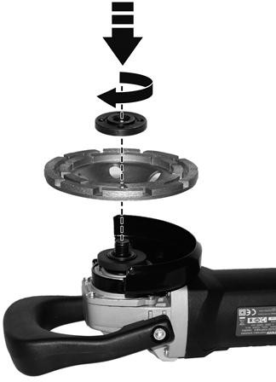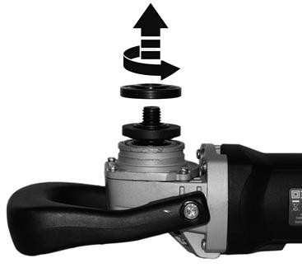

10

The second flange can be installed on the two sides (for thin grinding and thick grinding):

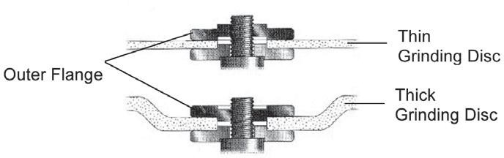

1. **Mounting of the sanding disc.**

* Install the carter of protection with the collecting dust.

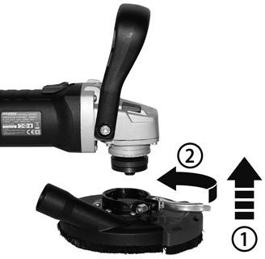

* 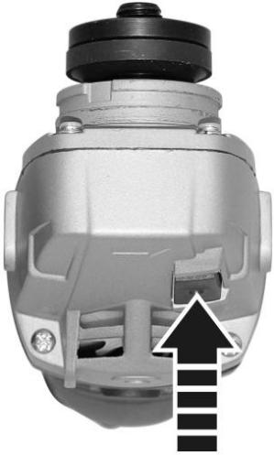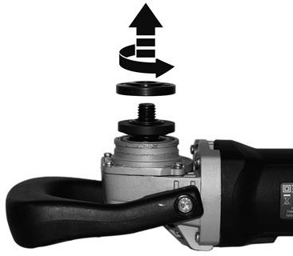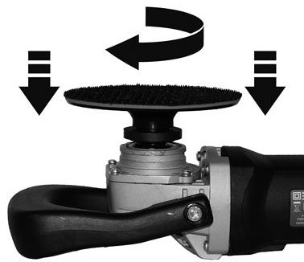Push and hold firmly the spindle lock button. Remove the second flange; Install and tighten the grinding disc until it is locked.

11

* 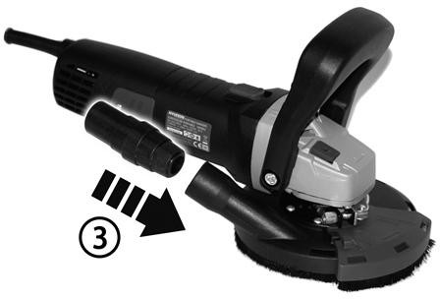Install the dust collector connection on the tool. You will able to connect the tool to a dust collector device.

1. **Mounting an abrasive disc**

after mounting the sanding disc, attach an abrasive disc to it while aligning the holes.

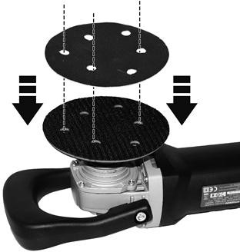

1. **Install the polisher**

Push and hold firmly the spindle lock button. Remove the second flange. Add the polisher and turn it to screw it on the tool.

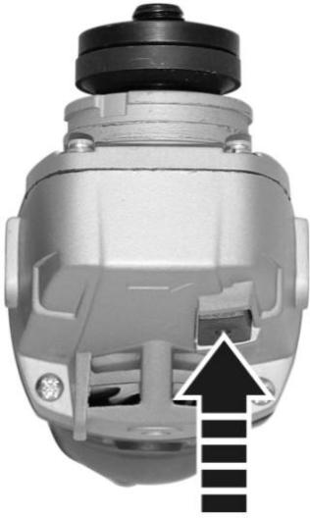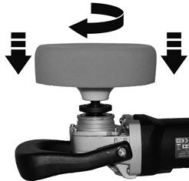

1. **Removing the accessories (polisher, sanding disc and grinding disc)**

* Stop the tool and unplug it from the electrical supply.
* Push and hold the spindle lock button
* For sanding disc and polisher, turn it anticlockwise to remove the accessory.
* For the grinding disc, Push and hold the spindle lock button then use the hex spanner to unscrew the flange.

Remove after this the flange and the grinding disc.

# OPERATION

* 1. **Starting and stopping the tool**
* Push forward and hold the ON/OFF switch to start the tool.
* Release the switch to stop the tool.

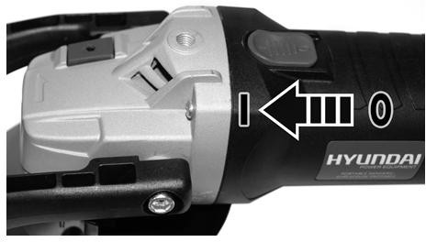

* To run the machine continuously, push the switch and then press it firmly to lock it. Press the back of the switch to release the switch and stop the tool.

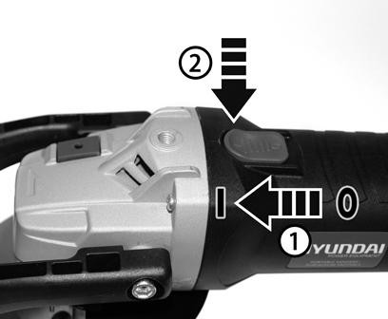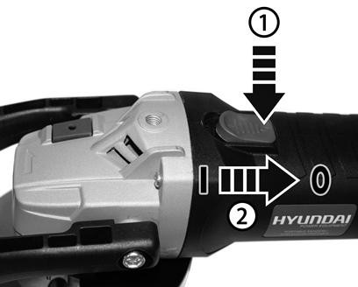

**Note: Before turning the machine off, be sure to keep the attachment away from the workpiece.**

* 1. **Works**

Before use, check that the tool is fully installed. When starting the tool, rotate it idle for 60 seconds to see if the tool is working without worry. If there is a problem, stop the tool immediately and inspect it.

In case of excessive vibrations, stop the tool immediately and change the disc to be sanded. If the tool continues to vibrate abnormally, stop using it, inspect it and / or have it repaired by an authorized repair service.

Do not press the tool excessively. Pressing the tool will damage the quality of the work, the workpiece and the machine itself. The speed must be at its maximum.

In case of blockage, stop the machine immediately and unplug it from the socket. Check and eliminate the cause of the blockage. If the blocking problem cannot be resolved, do not use the tool again and return it to an authorized service for inspection and repair.

# MAINTENANCE AND STORAGE

Keep your tool on a regular basis. This will keep your tool in good working order and extend its lifespan. Do not use abrasive or corrosive agents to clean the tool. These types of products damage your tool.

Do not make any repairs by yourself. Repairs and inspections should be carried out by a competent person or an authorized service center (please contact your dealer).

## After each use

Check the condition of the accessories and the tool body (cleanliness, wear, damage, etc.). If you notice any damage, wear or malfunction, do not use the tool and take it to a qualified service for inspection and repair.

* 1. **Servicing**

No specific maintenance is required by the user. After each season, please bring the tool to an authorized service center for general machine maintenance.

* 1. **Spare parts**

You can order spare parts directly from our service center. Please place your order according to the type of machine and the part number indicated in the explosion drawing.



* 1. **Storage**
     + After use and cleaning, please keep your tool.
     + Store the tool in a clean, dry place, preferably in its box.
     + When transporting and storing, always put the protective cover on the blade.
     + The tool should be stored away from children and pets.
     + Avoid exposing the tool to direct sunlight.

1. **DISPOSAL**

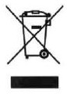Electrical products should not be discarded with household products. According to the European Directive 2012/19/EU on waste electrical and electronic equipment and its implementation into national law, electrical products used must be collected separately and disposed of at collection points provided for this purpose. Talk with your local authorities or dealer for advice on recycling.

1. **CE DECLARATION**



CE Declaration of conformity FEIDER FRANCE

32 rue Aristide Berges -Z1 31270 Cugnaux - France Tel: +33 (0) 5.34.508.508 Fax: +33 (0) 5.34.508.509

**Declares that the machine indicated below:**

Portable sander SURFACER4

Serial number:

**Complies with the provisions of the Directive "machinery" 2006/42/EC and national laws transposing it;**

**Also complies with the following European directives:**

EMC Directive 2014/30/EU RoHS Directive: 2011/65/EU

**Is also in line with European standards, with national standards and the following technical provisions:**

EN 60745-1:2009+A11:2010

EN 60745-2-3:2011+A2:2013+A11:2014+A12:2014+A13:2015

EN 55014-1:2006+A1:2009+A2:2011

EN55014-2:2015

EN 61000-3-2:2014; EN 61000-3 3:2013

Cugnaux, the 11/03/2019

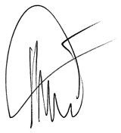

Philippe MARIE / CEO

Responsible of technical file: Mr. Olivier Patriarca