ORIGINAL INSTRUCTIONS

GASOLINE MULTI TOOL KIT (Brushcutter, grass trimmer, pole pruner and hedge trimmer)

RAC54KIT

INSTRUCTIONS MANUAL
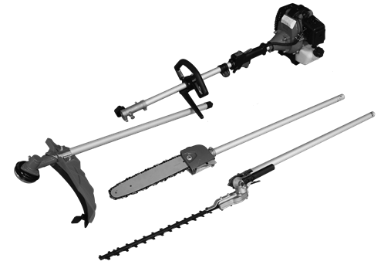

WARNING: To reduce the risk of injury, the user must read and understand this manual before operating the tool.
BUILDER
ZI, 32 RUE ARISTIDE BERGES 31270 CUGNAUX, FRANCE

CONTENTS

- GENERAL SAFETY INSTRUCTIONS 4

- THE TOOL 11

- ASSEMBLY 14

- FUEL TANK 19

- UTILISATION 21

- CARE AND MAINTENANCE 26

- TRANSPORT AND STORAGE 28

- TROUBLESHOOTING 31

- EC DECLARATION OF CONFORMITY 32

- SAFETY INSTRUCTIONS

Safety instructions for brushcutter and grass trimmer
Proper safety precautions must be observed. This unit must be handled carefully. DO NOT EXPOSE YOURSELF OR OTHERS TO DANGER.
Follow these general rules. Do not permit others to use this machine unless they are thoroughly responsible and have read, and understand the machine manual and are trained in its operation.
- Always wear safety goggles for eye protection. Dress properly; do not wear loose clothing or jewellery that could become caught in moving parts of the unit. Safe, sturdy, non-skid footwear should always be worn. Long hair should be tied back. It is recommended that legs and feet be covered to protect from flying debris during operation.
- Protective equipment must always be wear during the operation of the tool, including at least hearing protection, eyes protection, helmet, gloves, and mask of protection, slip-resistant foot protection, and protective clothes.
- Inspect the entire machine for loose parts (nuts, bolts, screws, etc.) and any damage. Repair or replace as necessary before using the machine. DO NOT USE any attachment other than the ones recommended by our company. Serious injury to the operator or bystanders could result as well as damage to the machine. Ask advice to you dealer of manufacturer. Do not use cutting attachment such as metal multi-piece pivoting chains and flail blades.
- Secure the machine during transport to prevent loss of fuel, damage or injury; always install the protection device on the blade, check the cap of the fuel tank, and do not transport the tool upside down.
- Keep the handles free from oil and fuel.
- Always use proper handles and shoulder strap when cutting.
- Do not smoke while mixing fuel or filling tank.
- Do not mix fuel in an enclosed room or near open flames. Assure adequate ventilation.
- Always mix and store the fuel in a properly marked container that is approved by local codes and ordinances for such usage.
- Never remove the fuel tank cap while the engine is running.
- Never start or run the engage inside a closed room or building. Fumes from the exhaust contain dangerous carbon monoxide.
- Never attempt to make engine adjustments while the unit is running and strapped to the operator. Always make engine adjustments with the unit resting on a flat, clear surface.
- Do not use the unit if it is damaged or poorly adjusted. Never remove the machine’s guard. Serious injury to the operator or bystanders could result as well as damage to the machine.
- Inspect the area to be cut and remove all debris that could become entangled in the nylon cutting head. Also remove any objects that the unit may throw during cutting.
- Keep children away. Onlookers should be kept at a safe distance from the work area, at least 15 meters.
- Never leave the machine unattended.
- Do not use this unit for any job other than those for which it is intended as described in this manual.
- Do not overreach. Keep proper footing and balance at all times. Do not run the unit while standing on a ladder or on any other unstable footing location.
- Keep hands and feet clear of the nylon cutting head or blade while unit is in use.
- Do not use this type of machine for sweeping away debris.
- Do not use the unit when you are tired, ill or under the influence of medication, drugs or alcohol.
- Use nylon cutting head which is free of damage. If a stone or any other obstacle is hit, stop the engine and check the nylon cutting head. A broken or unbalanced nylon cutting head must never be used.
- Do not store in a closed area where fuel vapours can reach an open flame from hot water heaters, furnaces, etc. Store in a locked, well-ventilated area only.
- Ensure safe and proper performance of your product. These parts are available from your dealer. The use of any other accessories or attachments may cause a potential hazard or injury to the user, damage to the machine and void this warranty.
- Clean the machine completely, especially, the fuel tank, its surroundings, and the air cleaner.
- When refuelling, be sure to stop the engine and confirm that it is cooled down. Never refuel when the engine is running or hot. When gasoline spills, be sure to wipe it up completely dispose of those materials before starting the engine.
- Stay clear of other workers or bystanders by at least 15 meters.
- Whenever approaching an operator of the machine, carefully call his attention and confirm that the operator stop the engine. Be careful not to startle or distract the operator which can cause an unsafe situation.
- Never touch the nylon cutting head or blade whenever the engine is running. If it is necessary to replace the protector or cutting attachment, be sure to stop the engine and confirm that the cutting device has stopped running.
- The engine should be turned off when the machine is moved between work areas.
- Be careful not to hit the nylon cutting head against stones, or the ground.
- Unreasonable rough operation will shorten the life of the machine as well as create an unsafe environment for yourself and those around you.
- Pay attention to loosening and overheating of parts. If there is any abnormality of the machine, stop operation immediately and check the machine carefully. If necessary, have the machine serviced by an authorized dealer. Never continue to operate a machine which may be malfunctioning.
- In start-up or during operation of the engine, never touch hot parts such as the muffler, the high voltage wire or the spark plug.
- After the engine has stopped, the muffler is still hot. Never place the machine in any places where there are flammable materials (dry grass, etc.), combustible gasses or combustible liquids.
- Pay special attention to operation in the rain or just after the rain as the ground may be slippery.
- If you slip or fall to the ground or into a hole, release the throttle lever immediately.
- Be careful not to drop the machine or hit it against obstacles.
- Before proceeding to adjust or repair the machine, be sure to stop the engine and detach the spark plug.
- When the machine is placed in storage for a long time, drain fuel from the fuel tank and carburettor, clean the parts, move the machine to a safe place and confirm that the engine is cooled down.
- Make periodic inspections to assure safe and efficient operation. For a thorough inspection of your machine, please contact a dealer.
- Keep the machine away from fire or sparks.
- It is believed that a condition called Raynaud’s phenomenon, which affects the fingers of certain individuals, may be brought about by exposure to vibration and cold. Loss of colour and numbness in the fingers. The following precautions are strongly recommended because the minimum exposure which might trigger the ailment is unknown.
- Keep your body warm, especially the head, neck, feet, ankles, hands and wrists.
- Maintain good blood circulation by performing vigorous arm exercises during frequent work breaks and also by not smoking.
- Limit the hours of operation. Try to fill each day with jobs where operating the brush cutter or other hand-held power equipment is not required.
- If you experience discomfort, redness and swelling of the fingers followed by whitening and loss of feeling, consult your physician before further exposing yourself to cold and vibration.
- Always wear ear protection, loud noise for long time can make hearing debase even lost hearing.
- Total face and head protection must be wearing to prevent damage from plummet or branch.
- Wear no-slip heavy duty work gloves to improve your grip on the brush cutter handle. Gloves also reduce the transmission of machine vibration to your hands.
- WARNING: The cutter area is still dangerous while the machine is coasting to a stop.
- When transport, this unit must be handled carefully. Do not expose yourself or others to danger.
- Envelop the blade before storage. Keep children away from it.
- Never remove the machine’s guard.
- Clean and maintain the tool before storage (see the chapters on this manual). Bring maintenance after each use according the instructions of this manual. Improper maintenance can reduce the lie of the tool, bring bad results and wear the tool and its accessories.
- Check the tool before and after use. Check for loose fasteners, fuel leaks and damaged parts, such as cracks in the cutting attachment. If the tool is damaged, if parts are missed or meet some dysfunctions, do not use the tool and bring it to a service agent for inspection and reparation.
- Check the tool after dropping or other impacts to identify any significant defects; if any defects are observed, stop to use the tool and bring it to a service agent for inspection and reparation.
- Do not store in a closed area where fuel vapours can reach an open flame from hot water heaters, furnaces, etc. Store in a locked, well-ventilated area only.
- Never place the machine in any places where there are flammable materials (dry grass, etc.), combustible gasses or combustible liquids.
- When the machine is placed in storage for a long time, drain fuel from the fuel tank and carburettor, clean the parts, move the machine to a safe place and confirm that the engine is cooled down.
- Emission of exhaust gases
- National regulation can restrict the use of the machine.
- Never modify a trimmer or cutter in any way.
- Improper use of the machine can cause SERIOUS OR FATAL PERSONAL INJURY.
- The engine exhaust form this product contains chemicals to cause cancer, birth defects, of other reproductive harm.
- Check regularly that the cutting attachment stops turning when the engine idles.

Kickback and Related Warnings
- Kickback is a sudden reaction to a pinched or snagged rotating wheel, backing pad, brush or any other accessory. Pinching or snagging causes rapid stalling of the rotating accessory which in turn causes the uncontrolled power tool to be forced in the direction opposite of the accessory’s rotation at the point of the binding.
- For example, if an abrasive wheel is snagged or pinched by the workpiece, the edge of the wheel that is entering into the pinch point can dig into the surface of the material causing the wheel to climb out or kick out. The wheel may either jump toward or away from the operator, depending on direction of the wheel’s movement at the point of pinching. Abrasive wheels may also break under these conditions.
- Kickback is the result of power tool misuse and/or incorrect operating procedures or conditions and can be avoided by taking proper precautions as given below:
  - Never place your hand near the rotating accessory. Accessory may kickback over your hand.
  - Do not position your body in the area where power tool will move if kickback occurs. Kickback will propel the tool in direction opposite to the wheel’s movement at the point of snagging.
  - Use special care when working corners, sharp edges etc. Avoid bouncing and snagging the accessory. Corners, sharp edges or bouncing have a tendency to snag the rotating accessory and cause loss of control or kickback.

Residual risks
Even if you use this tool correctly, there are always residual risks. The following hazards may arise in connection with the structure and manufacture of this power tool:
- Hearing impairment if no suitable hearing protection is worn.
- Cuts if no suitable protective clothing is worn.
- Health damage resulting from vibration in the hands and arms if the device is used for a long period of time or is not handled and maintained properly.
- Inhalation of particles
- Inhalation of exhaust gases
- Skin contact with oil / gasoline
- Inhalation of gasoline / oil vapours
- Contact with projected objects
- Burns when touching with hot surfaces
- Prolonged use of this product exposes the operator to vibration and can produce so-called "white finger" disease. To reduce the risk, wear gloves and keep your hands warm.
- If any of the symptoms of "white finger syndrome" occur, seek immediate medical attention. Symptoms of the "white finger" include numbness, loss of sensitivity, tingling, pain, loss of strength, colour changes or skin condition. These symptoms usually appear on the fingers, hands or wrists. Risk increases at low temperatures.

Safety instructions for the hedge trimmer

WARNING! Before using this tool, please read these instructions of safety and use. It will help you to use safely the machine and reduce the risk of electrical shocks and accidents. If you give this tool to another person, also give this manual.

Use this tool as described in this manual. Any mishandling and any use contrary to instructions will not in any way engage the liability of the manufacturer.

Non-compliance with safety instructions and use can cause a risk of electric shock, fire and / or injury to persons.

IMPORTANT
Read carefully before use
Keep for future reference

Safe operating practices

Training
Become familiar with the owner’s manual before attempting to operate the equipment.

Preparation
- THIS HEDGE TRIMMER CAN CAUSE SERIOUS INJURIES. Read the instructions carefully for the correct handling, preparation, maintenance, starting and stopping of the hedge trimmer. Become familiar with all controls and the proper use of the hedge trimmer.
- Never allow children to use the hedge trimmer.
- Beware of overhead power lines.
- Avoid operating while people, especially children, are nearby.
- Dress properly! Do not wear loose clothing or jewellery, which can be caught in moving parts. Use of sturdy gloves, non-skid footwear and safety glasses is recommended.
- Use extra care when handling fuels. They are flammable and the vapours are explosive. The following points should be observed:
  - Use only an approved container.
  - Never remove the fuel cap or add fuel with the power source running. Allow engine and exhaust components to cool down before refuelling.
  - Do not smoke.
  - Never refuel indoors.
  - Never store the hedge trimmer or fuel container inside where there is an open flame, such as near a water heater.
  - If fuel is spilled, do not attempt to start the power source, but move the hedge trimmer away from the spillage before starting.
  - Always replace and securely tighten the fuel cap after refuelling.
  - If the fuel tank is drained, this should be done outdoors.
- If the cutting mechanism strikes any foreign object or the hedge trimmer starts making any unusual noise or vibration, shut off the power source and allow the hedge trimmer to stop. Disconnect the spark plug and take the following steps:
  - inspect for damage;
  - check for, and tighten, any loose parts;
  - have any damaged parts replaced or repaired with parts having equivalent specifications
- Wear ear protection.
- Wear eye protection.
- In case of emergency, stop the hedge trimmer; release the trigger, switch off the tool with the ON/OFF button. Let it completely stop and be cool before any intervention.

Operation
Use the tool for the intended purpose and follow these provided instructions for use and maintenance
- Stop the engine before:
  - cleaning or when clearing a blockage,
  - checking, carrying out maintenance or working on the hedge trimmer,
  - adjusting the working position of the cutting device,
  - Leaving the hedge trimmer unattended.
- Ensure that the hedge trimmer is correctly located in a designated working position before starting the engine.
- While operating the hedge trimmer, always ensure that the operating position is safe and secure, especially when using steps or a ladder.
- Do not operate the hedge trimmer with a damaged or excessively worn cutting device.
- To reduce fire hazards, keep the engine and silencer free of debris, leaves and excessive lubricant.
- Always ensure that all handles and guards are fitted when using the hedge trimmer. Never attempt to use an incomplete hedge trimmer or one fitted with an unauthorized modification.
- Always use two hands to operate a hedge trimmer fitted with two handles.

Maintenance and storage
- When the hedge trimmer is stopped for servicing, inspection or storage, shut off the power source, disconnect the spark plug wire from the spark plug and make sure all moving parts have come to a stop. Allow the hedge trimmer to cool before making any inspections, adjustments, etc.
- Store the hedge trimmer where the fuel vapour will not reach an open flame or spark. Always allow the hedge trimmer to cool down before storing.
- When transporting or storing the hedge trimmer, always fit the cutting device transport guard.

Additional instructions
- Never allow children to use the hedge trimmer.
- Work only during in the day or with a sufficient artificial light.
- Before starting to work, check the condition of the tool.
- Ensure that all the parts of the machine are well fixed and tightened.
- Control regularly that the blade of cut is in good state.
- Always hold firmly the hedge trimmer with the two hands.
- Never take or hold the hedge trimmer by the blade.
- Maintain clothing out of reach blade as well with the stop as under operation.
- Keep the device distant from all shapes of sparks, flames and flammable materials.
- Control that the working areas are free from all shapes of obstacles.
- Work with precaution, be not distracted.
- Do not use the tool when you are under the influence of alcohol, meds or drugs, and where you are sick.
- Dry all possible gasoline traces by using a dry rag.
- In case of accident, immediately stop using the machine. Check the problem. Do not use the machine while the machine is damaged.
- Operate the machine only at reasonable hours – not early in the morning or late at night when people might be disturbed;
- When blockage occurs, immediately turn off the engine with the ON/OFF button. Let the tool cool down. Check and correct the blockage before starting again to work. Use gloves when clearing a blockage. Restart the machine securely when the machine is totally unblocked.
- When a danger or a non-intended situation arise, stop to work immediately and switch off the tool. Restart to work when there is no danger and you are able to work safely.
- Cut before the large branches with a hand shears to avoid the blocking of the blade.
- Pay attention not to cut iron wire or others.
- Do not use non recommended accessories with this tool. To replace any piece of this tool, please contact the retailer, service agent or manufacturer.
- Use only the mixture recommended by the manufacturer.
- Store the mixture in a specific container for the gasoline.
- Keep the device in a quite dry place and out of reach of children.
- Store the mixture only on free air or in a well-ventilated place. Handle the fuel with precaution, it is highly flammable.
- Do not smoke or use telephone when you handle gasoline.
- Use a funnel and fill the tank only when the engine is cold.
- Do not open the tank if the engine is hot or under operation.
- Keep [people and yourself far away from the exhaust to avoid the risks of burns.
- Maintain the people and the animals far away from the working area.
- Always remind that this machine can cause very serious incidents.
- Do not work under the rain and/or in places wet and/or slipping.
- Do not expose to the rain.
- Do not use the tool during bad weather conditions and where a risk of lighting is possible.
- Use complete personal protective equipment during the use of the tool: gloves, antiskid footwear, helmet, eyes protection, protection clothes, and mask of protection.
- Do not use the machine when you are tired, under the influence of alcohol or drugs or sick.
- The machinery must not be used in a way where experience has shown that danger and/or risks might occur.
- Never use hedge trimmer inside a building. Your hedge trimmer produces toxic exhaust fumes as soon as the engine is started. The use of this product can generate dust, vapours and smoke containing chemicals known for their harmful effects on health. So be careful during the use of your machine and protect yourself correctly. Also avoid voluntarily breathing exhaust fumes; always hold the machine correctly when you use it.

Residual risks
Even if you use this product in compliance with all safety requirements, the potential risks of injury and damage remain. The following hazards may arise in the structure and design of this product. Always be vigilant when using this product, so you can recognize and manage the risks rather. Rapid intervention can prevent serious injury and property damage.
- There are harmful health consequences resulting from the emission of vibrations if the product is used for long periods of time or not properly managed and properly maintained.
- There is risk of injury and property damage due to attachments or broken the sudden impact of hidden objects.
- Risk of injury to persons and property caused by flying objects.
- Prolonged use of this product exposes the operator to vibration and can produce so-called “white finger” disease. To reduce the risk, wear gloves and keep your hands warm. If any of the symptoms of “white finger syndrome” occur, seek immediate medical attention. Symptoms of the “white finger” include numbness, loss of sensitivity, tingling, tingling, and pain, loss of strength, color changes or skin condition. These symptoms usually appear on the fingers, hands or wrists. Risk increases at low temperatures
- Inhalation of particles
- Inhalation of exhaust gases
- Unattended projections
- Contact with foreign objects
- Contact with the tool in operation
- Hearing loss in the absence of correct hearing protection

Safety warnings for the mounted pole pruner
- Respect the capacity of the tool. Use the tool as described in this manual and for its intended use, safely and safely.
- Do not use the tool if the switch is defective. In the event of a malfunction, do not use the tool and take it to a qualified service for repairs.
- Stop the tool before making adjustments, changing the accessories or storing the tool.
- Keep the tool out of the reach of children. People who are not familiar with the tool or who have not read these instructions should not use it. Tools are dangerous when used by untrained people.
- The tool must be regularly maintained. Regular tool maintenance reduces malfunctions and improves work efficiency.
- Check that the moving parts are working properly and that they are not jammed. Check that there are no broken or damaged parts that could impair the functioning of the tool. If the tool is damaged or faulty, do not use the tool anymore and bring it to a qualified service for repairs.
- Keep cutting tools sharp and clean. Carefully maintained tools with sharp, sharp edges are wedged less frequently and can be guided more easily.
- Never touch any part of the body of the cutting chain when the tool is operating. Before starting the tool, make sure that the cutting chain is not in contact with anything. A moment of inattention while using the tool may cause your garment or part of the body to stick to the cutting chain.
- Wear safety glasses and hearing protection. Additional protective equipment is recommended such as helmets, protective gloves and safety shoes.
- Do not place yourself on the path of falling branches.
- Before felling, check where the trees or branches are going to fall. Make sure that there are no obstacles to prevent or hinder travel.
- Do not work in areas where the grass is wet and where the soil is slippery.
- Do not use this tool in a tree, on an unstable ladder or surface.
- Adopt a stable position and keep your balance constantly.
- Hold the tool firmly with both hands when the engine is running.
- When the chain is moving, it must not touch objects, materials or persons.
- Start cutting only with a chain at full speed.
- Do not attempt to insert the saw into a pre-existing notch. Always make a new notch.
- Pay attention to moving branches or other forces that could close a notch and pinch or hinder the chain.
- Do not attempt to cut a branch with a diameter greater than the cutting length of the chain saw.
- Always switch off the tool, let the chain completely stop before making any adjustments, maintenance, cleaning or repairs.
- When transport and storage, always stop the tool first and put the protection on the tool.
- The chain must remain sharp and taut. Regularly check the tension of the chain.
- Only use replacement parts and original accessories.
- Use only the manufacturers specified replacement guides and chains. Incorrect replacement guides and chains may cause chain breakage and / or rebound.
- Check that there are no obstacles or electrical wires hidden in the work area.
- Check the general condition of the appliance before each use. Do not use a device with a damaged battery or other parts. Do not touch a damaged cable. In case of any damage, have the appliance repaired by an authorized repairer.
- Immediately stop the device if an abnormal level of vibration has been detected. In case of damage to the blade, it is necessary to change the complete set of blades.
- Use the device only if all protective devices are mounted. Do not use the device with faulty protective equipment. Do not modify the unit.
- Keep the cable away from the work area.
- Do not work with the tool when it rains, in bad weather or in a damp environment. Do not use the machine when there is a risk of thunderstorms and storms.
- Only work outdoors, under daylight or under artificial lighting.
- Always carry the appliance by its handle
- Tie long hair in a way to prevent them from coming into contact with the blades. Do not wear jewelry and loose clothing when operating the machine.
- The appliance should never be used near people, especially children and pets. Stop the operation immediately if this condition is not met. In all cases, ensure a safe area of ​​at least 15 meters around the work area.
- The operator is responsible for accidents caused to others.
- Always take a stable working position. Make sure you step on the slopes. Take extreme caution when working on slopes.
- Do not use the tool when you are tired, sick or under the influence of alcohol or drugs.
- Take regular breaks to reduce the risk of fatigue.
- Never leave the machine unattended. Switch off and remove the battery and put it out of the reach of people if you are away from work.
- Remove the battery when transporting it. Put the guard on the blade when it is being transported.
- This device is not intended for use by persons (including children) whose physical, sensory or mental capacities are reduced, or by persons without experience or knowledge, unless they have been able to benefit, By means of a person responsible for their safety, supervision or prior instructions concerning the use of the appliance. Children should be supervised to ensure that they do not play with the appliance
- Always keep this manual at hand.
- The device must always be used fully assembled and secured.
- Store the tool with its blade guard and out of the reach of children
- Never use an incomplete or unauthorized tool.
- Local laws may restrict the use of this tool.
- Check the tool regularly and before each use to observe any impact or damage.
- Always use the tool with the supplied harness.

Residual risks
Even if you use this product in compliance with all safety requirements, the potential risks of injury and damage remain. The following hazards may arise in the structure and design of this product:
- There are harmful health consequences resulting from the emission of vibrations if the product is used for long periods of time or not properly managed and properly maintained.
- There is risk of injury and property damage due to attachments or broken the sudden impact of hidden objects when using cutting.
- Risk of injury to persons and property caused by flying objects.
- Prolonged use of this product exposes the operator to vibration and can produce so-called "white finger" disease. To reduce the risk, wear gloves and keep your hands warm.
- If any of the symptoms of "white finger syndrome" occur, seek immediate medical attention. Symptoms of the "white finger" include numbness, loss of sensitivity, tingling, tingling, and pain, loss of strength, color changes or skin condition. These symptoms usually appear on the fingers, hands or wrists. Risk increases at low temperatures.

Intended use
- Brushcutter and grass trimmer
Intended use
This machine can be used as a trimmer with the cutting edge, and as a brushcutter with the cutting blade.
The grass trimmer must be strictly and only to cut grass or weeds that are not too dense. The brush cutter must be used to cut hard grass, more dense weeds and small branches with a maximum diameter of 10mm.

Improper use
This machine is not intended to cut bushes or others similar plants requiring the tool to get off the ground. Do not use this tool to work other materials such as stones, clay soils, etc.
.

- Mounted pole pruner
Intended use / improper use
The pole pruner is exclusively intended for pruning trees and/or cutting small wood from the ground. Any other use is considered improper and will damage the tool.
The correct use also includes reading and observing the instructions for use at each use as well as observing the warnings fixed on the machine. Before and during use, it is imperative to check the blade to ensure that there is no mechanical damage. In case of necessary repairs, please contact your specialist dealer.
Only the use of spare parts approved by the manufacturer or original spare parts is permitted. If unauthorized or non-original spare parts are used, the user is liable for consequential injury to persons or property resulting in the manufacturer being deprived of all liability.

- Hedge trimmer
Intended Use
Your hedge trimmer is a device used by a person to trim hedges and shrubs by working with one or more blades arranged linearly and back and forth. A potential hazard exists if the device is used for other purposes. Improper handling of the hedge trimmer increases the risk of injury from blades. Only the use of spare parts and accessories approved by the manufacturer is permitted.

Symbols on the machine
Wear an equipment of protection including an helmet, protective glasses, hearing protection

Wear protective gloves
Wear protective and non-skid shoes
Read the instruction manual

Danger of kickback

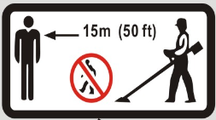 Keep bystanders away from the working area, at least 15m

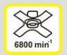 Brushcutter speed

Cutting attachment for grass trimmer speed

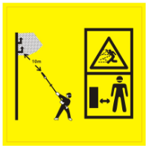 Maximum height of use: 10 meters. Risk of projections! Keep bystanders away

Warning symbol

Do not use the tool when raining and in damp locations

Wear protective gloves

wear protective clothes

Wear a mask of protection

Read the instructions handbook

Wear helmet, hearing protection and protection glasses.

Wear anti-skid shoes

Guarantee noise level

Warning! Cutting elements

Exhausting gas is dangerous. Do not inhale them

Do not smoke

Caution: the accessible surface maybe hot when using the tool

- The tool

Main unit
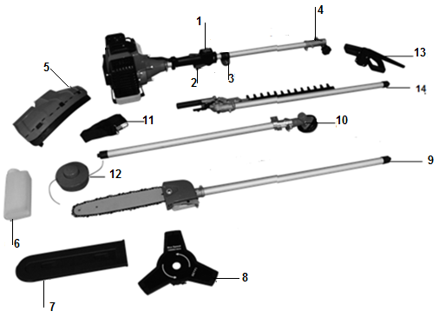
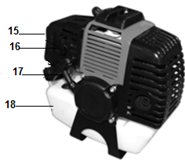

        - ON/OFF switch
        - Throttle lever
        - Hanger
        - Mounting tube
        - Carter of protection (brushcutter and trimmer)
        - Bottle for the oil mixture
        - Cover protection of the blade (pruner)
        - 3 teeth blade (brush cutter)
        - Pole mounted pruner
        - Tube(brushcutter and trimmer)
        - Shoulder strap
        - Cutting head for grass trimmer
        - Handle
        - Hedge trimmer
        - Air filter
        - Choke lever
        - Starter
        - Fuel tank
        - Tool set

Pole mounted pruner
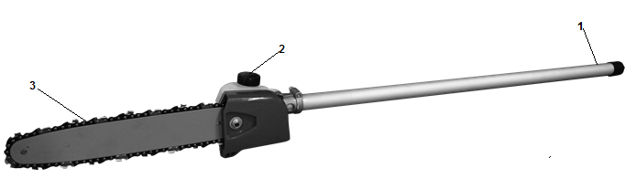
- Tube
- Oil tank for lubrication
- Saw chain

Hedge trimmer
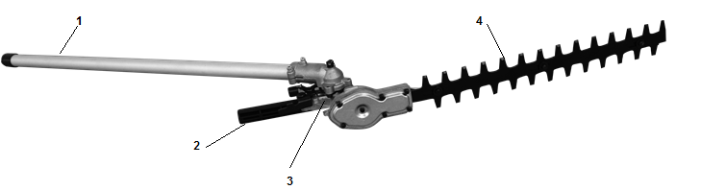

- Tube
- Adjustment lever
- Notching of adjustment 135° from cutting unit
- Blade

Brushcutter
- Carter of protection
- 3-teeth blade
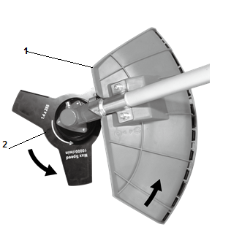

Grass trimmer

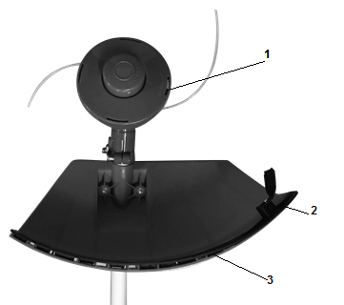

- Nylon wire
- Device of cutting the nylon wire
- Carter of protection

- ASSEMBLY

  - Main unit
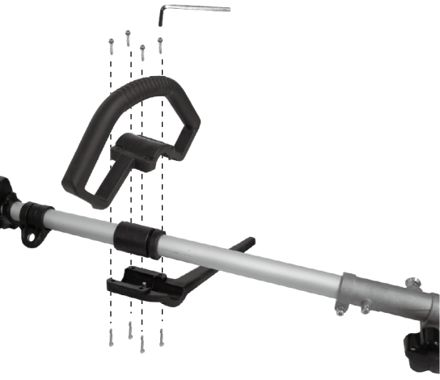

  - Install the front handle as shown in the picture below. Be sure to orient the stem toward the hole. Do not fasten the screws until you have set the most comfortable working position with the straps. The front handle must be oriented as shown in the picture for "the motor and drive unit".
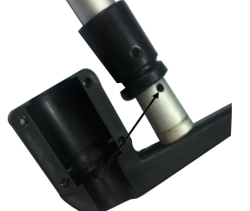

  - Install the desired tube on the bar of the main unit. Be sure that the locking pin is inserted in the hole of the bar
  - Fix the bar by turning the nut anticlockwise.

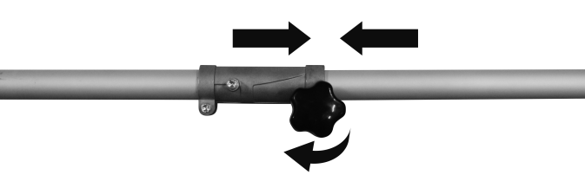

  - Carter of protection (Brush cutter and grass trimmer)
  - Remove the two screws from the carter of protection.
  - On the tube of the brushcutter/grass trimmer, place the carter of protection on its support.
  - Screw the carter of protection with the two screws.
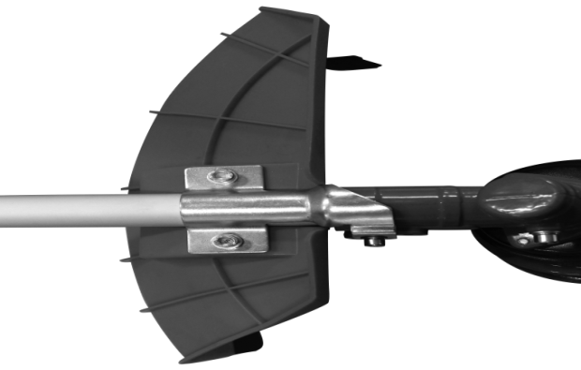

  - 3-theethes blade for brushcutter
- On the tube of the brushcutter/grass trimmer, insert a metal locking tool into the hole on the side of the drive gear and on the tool drive.
- Remove cover bell and the holding nut from the shaft.
- Install, in the following order, on the shaft: the blade, the cover bell and then the holding nut.
- Remove the metal locking tool.
- To remove the metal blade, put a metal locking tool into the hole on the side of the drive gear and on the tool drive. Unscrew the holding nut and then remove the cover bell and the blade.
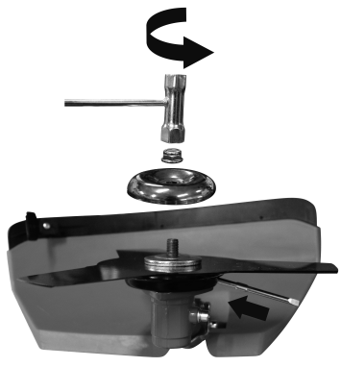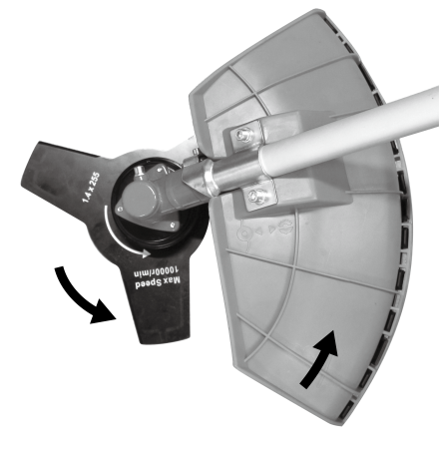

  - Cutting head for grass trimmer
- On the tube of the brushcutter/grass trimmer, insert a metal locking tool into the hole on the side of the drive gear and on the tool drive.
- Remove cover bell and the holding nut from the shaft.
- Install and screw the nylon cutting head. Make that it is well installed.
- Remove then the metal locking tool.
- To remove the nylon cutting head, put a metal locking tool into the tool and then unscrew the nylon cutting head.

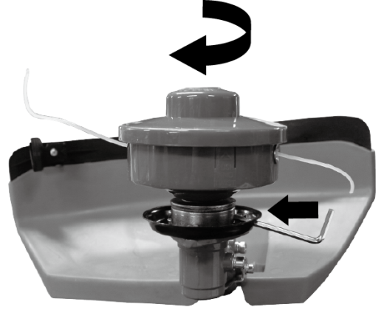

  - Hedge trimmer
- Install the bar of the main unit. Be sure that the locking pin is inserted in the hole of the bar
- Fix the bar by turning the nut anticlockwise.

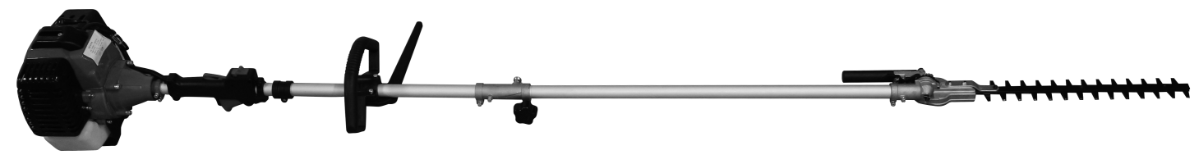
- Press the release / safety plate to loosen and turn the unit to the desired position according to the type of work to be performed.
- Loosen the release / safety plate, making sure that the sharp accessories are secure.

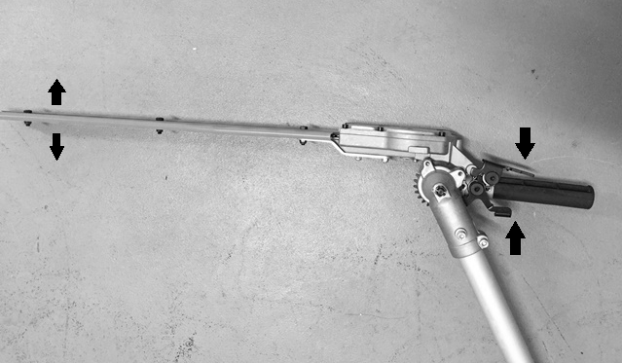

  - Pole pruner
- Install the bar of the main unit. Be sure that the locking pin is inserted in the hole of the bar
- Fix the bar by turning the nut anticlockwise.

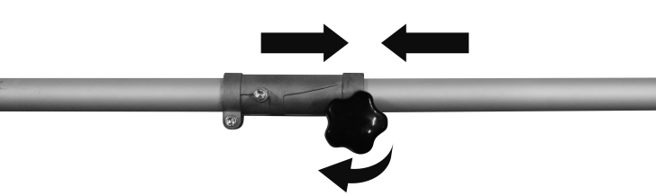
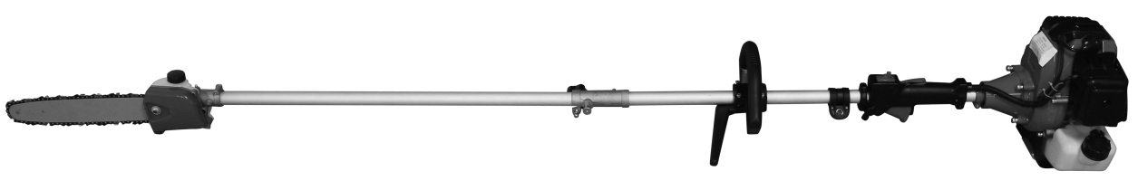

  - Assembly of the chain guide and the cutting chain:
Remove the safety screw and remove the guard.
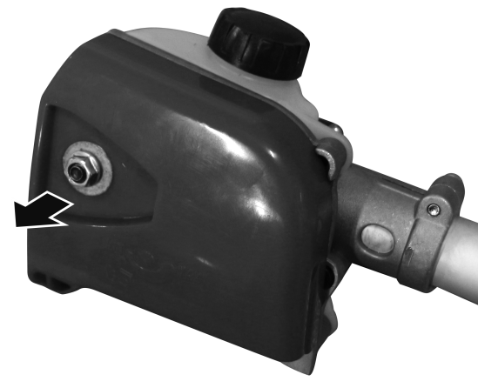
Place the chain guide so that the safety pin on the chain engages in the chain's teeth. Make sure that the direction of movement of the cutting chain is correct. Install the chain guard and tighten the fastening screw.
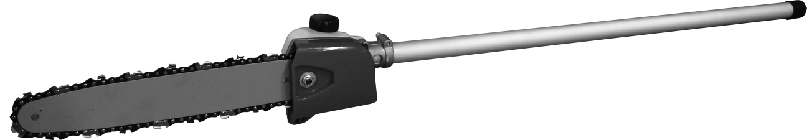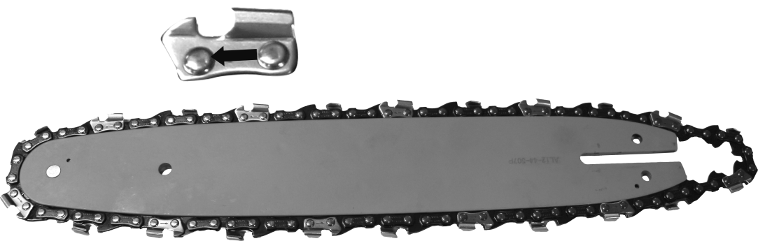

  - Adjusting the chain tension
The chain must not have too much clearance, but it must be possible to lift the chain a few millimeters from the guide rail.
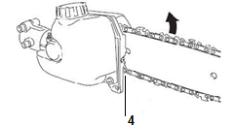
- Loosen the fixing screw.
- Slightly lift the end of the chain guide
- Check the cutting chain for ease of operation by turning it manually.
- Adjust the tension of the chain by means of the screw for adjusting the tension of the chain (4) so that the chain can be lifted a few millimeters from the center of the guide rail.
- Secure the safety screw.

  - Installation of the harness
Hang the harness in its dedicated location on the tube. Adjust the size of the harness properly to have a correct working position.

The shoulder strap is equipped with an emergency release mechanism. To detach the machine from the shoulder strap in emergency situations, pull the rope to move away from the machine.
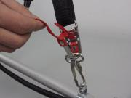

WARNING
Check the emergency release mechanism BEFORE operating the machine.
Be sure to hold the machine when operating the emergency release mechanism.
When holding the machine firmly with your right hand, press both sides of the belt buckle.

- FILLING TANK
Warning: Gasoline is highly flammable. Keep the fuel in specially designed cans.
- Only fill the tank outside and do not smoke during the operation.
- Fill the tank before starting the engine. Never remove the fuel tank cap, add fuel while the engine is still running, or while the engine is still warm.
- Avoid overfilling the tank: When excess fuel has escaped, do not attempt to start the engine, but move the machine away and avoid any sources of ignition in the vicinity until the fuel vapors Have dissipated.
- Fully tighten all fuel filler caps and cans.
- Fill the tank on the floor.
- The engine must be started at a distance of at least 3 meters from where the fuel tank has been filled.
- Switch off the engine before adding fuel. Shake the mixture thoroughly before filling the tank.
- Store gasoline in tanks specially designed for this purpose.
- Fill the fuel tank of your appliance outdoors and avoid smoking during work.
- Fill the tank before starting the engine. Never open the fuel tank cap or fill fuel tank while the engine is running or the engine is still hot.
- Avoid spilling gasoline: When gasoline is spilled, do not start the machine and move it away from where the gasoline has spilled to avoid possible sources of fire.
- Screw all caps and tank cover carefully

Gasoline is highly flammable. Do not smoke and avoid sparks or open flames near the fuel. Turn the engine off and allow it to cool before filling the fuel tank. Filling must be done externally, ideally on the bare ground. Leave at least 3 meters from where you filled the tank to start the engine.
The engine requires oil specially adapted for two-stroke engines with an air cooling system. Use quality oil enriched with corrosion-inhibiting products explicitly provided for two-stroke engines with an air cooling system (JASO FC or ISOEGC).
Do not use BIA or TCW OIL (suitable for 2-stroke engines equipped with a water cooling system).

SUGGESTED PROPORTIONS: GASOLINE 40: OIL1

Exhaust emissions are regulated by the basic technical characteristics of the engine and its components (carburation, adjustment of spark plugs, control of exhaust opening and closing times) in the absence of accessories or a catalyst during combustion.
- These motors are designed for use with unleaded gasoline.
- Always use gasoline with a minimum octane rating of 90RON.
- Using gasoline with a lower octane rating may cause an increase in engine temperature, causing problems with the engine, including seizure.
- Using unleaded gasoline prevents unnecessary pollution in the interests of your health and the protection of the environment.
- Using gasoline or oil of lesser quality can damage seal rings, ducts or fuel tank.

  - Prepare the mixture

IMPORTANT
MIX THE MIXTURE CAREFULLY.

  - Measure the fuel and oil needed for the fuel mixture.
  - Pour a little gasoline into a clean container provided for this purpose.
  - Add all the oil before stirring the can.
  - Add remaining gasoline and shake the can for at least 1 minute. Certain oils mix with difficulty because of the substances they contain. Sufficient agitation of the mixture is essential to ensure proper operation over the life and power of the engine. If your fuel mixture is not stirred sufficiently, the poor and inadequate mixture may increase the risk of seizure.
  - Identify the can by locating it with a distinctive emblem in order to always know what is there.
  - Indicate the substances contained and the proportions of the mixture.

- Filling the tank
  - Unscrew the tank cap. Place the tank cap in a clean, dust-free place.
  - Fill the tank to 80% of its capacity.
  - Screw the fuel cap back on. Clean the fuel tank cap and the area around after filling the fuel tank. Eliminate overfill of fuel mixture by rubbing.

NOTE
When filling, avoid:
- OIL-FREE FUEL (PURE FUEL) - This can quickly cause serious damage to the interior of the engine components.
- GASOHOL - may cause deformation of rubber or plastic parts and cause engine lubrication to stop.
- OIL FOR 4-TIME ENGINES - causes clogging of the spark plug, clogs the exhaust channel or leads to seizure.

Fuel mixtures stored for more than one month may, if used, clog the carburetor and cause the engine to malfunction.
If the unit is to be stored for an extended period of time, the tank must be cleaned after being emptied. Leave the engine running to remove the remaining fuel from the carburetor.
Observe local regulations when disposing of used containers.

- UTILISATION

    - Starting the 4-in-1 multifunction tool
Do not start the appropriate module of the machine until all components have been connected correctly! Attach the cutting blade of the brush cutter with a torque of 20 Nm and the cutting head of the mower with a tightening torque of 15Nm.

WARNING Fill the fuel tank before tightening the fuel tank cover.

- Put the machine on a level, solid floor. Keep the cutting head away from the ground and away from surrounding objects (Fig.5).

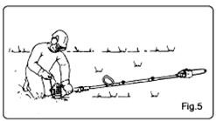
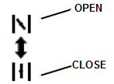
- Press the priming bulb 5 to 8 times until fuel flows through the clear hose.
- Position the choke in the closed position.
- Set the ON/OFF switch to position "I". Make sure the cutting head is clear.
- Keep the machine on the ground safely and then pull the starter until the engine starts.

WARNING
The machine is equipped with a centrifugal clutch system.
When starting the engine, place the machine on a level, clean floor and hold it firmly to prevent the sharp components or the throttle lever from coming into contact with any objects when the engine is started.

IMPORTANT
Avoid pulling the starter to the end or return the cable by suddenly releasing its handle. This can cause the engine to fail.
Position the choke in the "open" position and restart the engine.
Let the engine warm up a few minutes before starting work.

NOTE
- When restarting the engine directly after stopping it, keep the choke switch in the "open" position.
- Overheating complicates engine starting due to overfilling of fuel. If the engine does not start after several attempts, open the starter and press the starter several times, or remove and dry the spark plug.

- Stop the engine
- Release the throttle lever and let the engine run for about 30 seconds.
- Set the ON/OFF switch to the 0 position.

IMPORTANT
Except in case of emergency, do not switch off the engine by pulling on the choke lever.
If the engine does not stop by pressing the stop switch, move the choke to the closed position.

- Using the grass trimmer
Be sure that you have installed the correct accessory.

- Trimming
Tilt the head slowly to direct debris away from you. If cutting up to a barrier such as fence, wall or tree, approach from an angle where any debris ricocheting off the barrier will fly away from you, Move the line head slowly until the grass is cut right up the barrier, but do not jam (overfeed) the line into the barrier. If trimming up to a wire mesh or chain linked fence be careful to feed only up to wire. If you go too far the line will snap off around the wire. Trimming can be done to cut through weed stems one at a time. Place the trimmer line head near the bottom of the weed-never high up which could cause the weed to chatter and catch the line. Rather than cut the weed right through, just use the very end of the line to wear through the stem slowly.

- Scalping and edging
Both of these are done with the line head tilted at a steep angle Scalping is removing top growth leaving the earth bear.
Edging is trimming the grass back where it has spread over a sidewalk or drive way. During both edging and scalping, hold the unit a steep angle and in a position where the debris, and any dislodging dirt and stones, will not come back towards you even if it ricochets off the hard surface. Although the picture shows how to edge and scalp every operator must find for himself the angles which suits his body size and cutting situation.

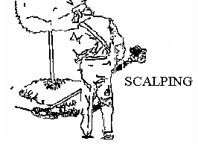
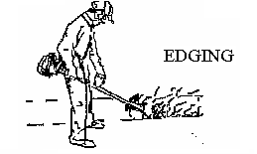

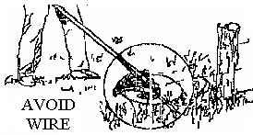

- Using the brushcutter
Be sure that you have installed the correct accessory.
- Do not use the brushcutter for cutting trees.
- Do not cut with dull, cracked or damaged meal blade.
- Before cutting growth, inspect for obstructions such as boulders, metal stakes or strands of wire from broken fences. If an obstruction cannot be removed, mark its location so that you can avoid it with the blade. Rocks and metal will dull or damage a blade. Wire can catch on the blade head and flap around or be thrown into the air.
- Use the shoulder harness at all times adjust both harness and harness clamp on the unit so that the unit hangs a few inches above ground level .The cutting head and the debris shield should be level in all directions. Harness the unit on the right side of your body.
- Cut only with the side of the blade that the debris is moving away from you.
- If kickback occurs, the blade may be dull, or the material so thick and hard that you should use other tool instead of this machine.
- Do not force the blade to cut. Do not change the angle of cut after into the wood. Avoid using any pressure or leverage which could cause the blade to bind or crack.

Scything weeds
This is cutting by swinging the blade in a level arc. It can quickly clear areas of field grass and weeds. Scything should not be used to cut large, tough weeds or woody growths.
Scything can be done in both directions, or just in one way which results in the debris being thrown away from you.
That is using the side of the blade that it is rotating away from you. Tilt down the blade slightly on this same side. You will be hit by some debris if you scythe in both directions.

- Using the hedge trimmer
When using the machine on lawns, hold the scythe at an angle of 30 ° and perform semicircular movements by sweeping the ground from left to right.
The best results are obtained when the grass is 15 cm high. When the grass is higher, we recommend repeating the mowing several times.
Warning! Never place the cutting head on the ground while the machine is running.
- It is recommended to cut the trapezoidal hedges to prevent the lower branches from being stripped. This corresponds to the natural growth of plants and hedges can be potentially prosperous. The cut makes the new annual shoots reduced, so a dense branching and a good protection of the sight must be considered.
- First cut the edges of a hedge. Move the hedge trimmer to cut the part that grows greatly from bottom to top. If you cut from top to bottom, the thinner branches move outward; Narrow places or holes may form.
- Cut the top of the hedge, just like a roof or a round shape.
- Cut the seedlings into the desired shape. The main stem must be intact and remain until the hedge reaches the proposed elevation. All other shoots should be cut to half.

- Using the pole pruner
Never use the tool at an angle of more than 60 °. The correct operation of the pruner is not impaired at angles greater than 60 °, but the risk of injury increases due to sudden drops of branches. Pay attention to the floor in front of you when using the appliance. This allows you to avoid tripping over branches on the ground. Never use the saw without oil. Use a biodegradable chain oil. The pruning machine uses a low rebound chain. In addition, special attention has been paid to the construction of the device to prevent the smallest possible rebounds given the technical conditions given. Nevertheless, a slight rebound can not be ruled out by using the upper cutting blade. Expect a rebound when using this side of the blade or when the top of the blade comes into contact with another branch. The device should always be used with both hands. The thin branches can be cut at once. To prevent a branch from splitting or bending, it is advisable to slice it end to end. When slitting longer branches, the branch should be cut from the bottom. First cut the branch from below at a point away from where you want to saw the branch. The notch must have a depth between one third and 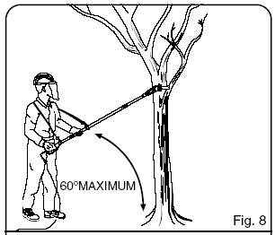one half the thickness of the branch. This prevents the branch from breaking when you cut it from the top a little further away from the trunk. To finish, saw the stump by making a straight cut. If you wish, you can seal the cut using a suitable product.
60°max.

CARE AND MAINTENANCE
Regularly maintain your tool. This will keep your tool running smoothly and extend its life. The tool must always be kept in good working order.
Do not use abrasive, caustic products to clean the tool. These types of products will damage your tool.
Regular maintenance is important; Failure to maintain the tool will result in rapid wear of parts that can cause malfunction and accidents. In addition, a poorly maintained tool will cause poor work results and rapid aging
Wear protective gloves when servicing the tool.
The tool must be completely extinguished and cooled before any maintenance and intervention.
Perform the machine maintenance as described in this manual. Use accessories and replacement parts only recommended by us. Do not remove or modify system components or modify the speed of the tool (serious accidents may result). Repairs or modifications must be made only by a qualified service. No repairs or modifications must be done by the user.
After work, it is essential to always check the entire machine and clean it.

Regular checks and maintenance:
  - Check the air filter (to be cleaned if necessary)
  - Check spark plug (replace if necessary)
  - The correct operation and quantity of the cutting wire.

Always switch the drive unit off when performing any maintenance or repair work.

Repairs should only be carried out by authorized specialists with the necessary technical knowledge. Interventions by non-specialists may damage the machine or be hazardous to safety.

Follow the instructions below:
  - Ensure that all nuts, bolts and screws are tightened to ensure that the machine meets all safety conditions
  - Never store the machine with fuel remaining in the tank in a building where gasoline vapors may come in contact with flames or sparks.
  - Allow the engine to cool before storing it in an enclosed area.
  - To reduce the risk of fire, remove grease, grease and grease from the engine, muffler, battery and gasoline storage area.
  - Replace worn or damaged components.
  - When the fuel tank is to be emptied, do so outdoors.
  - Do not attempt to repair the machine unless authorized to do so.
  - Use only spare parts and accessories recommended by the manufacturer.

Maintenance plan
To carry out the regular maintenance operations, please refer to the following table
Stop the engine systematically before performing any maintenance on the machine. When all parts have stopped rotating, remove the cable from the spark plug so that maintenance can begin.
Never repair the cutting attachments by welding, grinding or modifying their shape. This can cause serious injury.
Never attempt to perform maintenance operations not listed in this manual. All repairs must be carried out by an authorized specialist.

functions | requirements | Before operation | After operation | Filing | Once a year | Once a year | If damaged | If required
Machine | Visual inspection (leak) | ● |  | ●
Throttle lever | Check of the correct operation | ●
Fixation of the throttle lever |  | ●
Stop switch | Checking | ●
Fuel tank | Cleaning of the exterior of the tank |  | ●
Cutting accessories Checking (wearing) |  |  |  |  |  |  |  | ●
Transmission case | Grease |  |  |  |  | ● |  | ●
Air filter | Checking/cleaning | ● |  |  | ●
 | Replacement if too dirty of used |  |  |  | ● |  |  | ●
 |  |  |  |  |  |  | ● | ●
Housing | Cleaning |  | ●
Cylinder | Cleaning |  |  |  |  |  |  | ●
Spark plug | Cleaning, adjustment and replacement if necessary |  |  |  |  | ● |  | ●
Nylon cutting | Replacement |  |  |  |  | ● |  | ●
Head of the hedge trimmer | Cleaning/replacement | ●
 |  |  |  |  |  |  | ● | ●
All fixation | Tighten | ● |  |  |  |  |  | ●
Exhaust pot | Checking, cleaning, replacement | ● |  |  | ●
 |  |  |  |  |  |  | ● | ●

Replacement of the spark plug
Remove the cover of the spark plug, unscrew the spark plug and then replace it.

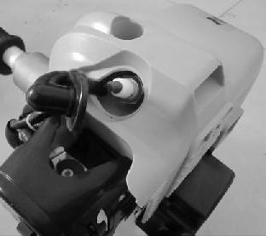
2
1
- Air filter
- Accumulated dust in the air filter will reduce engine efficiency. Increase fuel consumption and allow abrasive particles to pass into the engine. Remove the air filter as often as necessary to maintain in a clean condition. Light surface dust can readily be removed by tapping the filter. Heavy deposits should be washed out in suitable solvent.
- Remove filter cover by loosening air filter cover knob.

- Adjusting the carburettor
Do not adjust carburettor unless necessary. If you have trouble with the carburetor, see your dealer. Improper adjustment may cause engine damage and void warranty.

- Fuel filter
When the inside of the fuel tank is dirty, it can be cleaned by rinsing the tank out with gasoline.

TRANSPORT AND STORAGE
When the 4-in-1 multifunction machine is not used for an extended period of time (1 month), the following measures should be taken:
  - Empty the oil and fuel tank.
  - Disassemble and clean the thread spool and cutting blade.
  - Dry the spool of wire and the cutting blade using a cloth.
  - Rub the outside of the machine using a soft, damp cloth.
  - Store the machine in an enclosed and well ventilated place. Keep the machine so that it is not accessible to children.
  - Store the machine in a dry place.
  - The cutting blade, pruning machine and hedge trimmer must be properly packaged to prevent cuts.
  - Use the baffles on cutting accessories with a metal knife.

TECHNICAL INFORMATION

Engine information
Type of engine | 1E44F-5, 2-stroke engine
Volume of the fuel tank | 1200 cm³
Max engine speed | Max. 9000 min-¹
Engine idling speed | 3100±400 min-¹
Clutch engagement speed | 4600 min-¹
Engine displacement | 52 cm³
Maximal power | 1,75 kW
Carburettor
Spark plug
Brushcutter
Unit without cutting attachment, empty tank | 7,3 kg
Cutting diameter | 255 mm
Cutting thickness | 1.4 mm
Number of cutting teeth | Single piece (three teeth metal blade)
Blade hole centre diameter | 25.4
Maximum rotational frequency of the spindle | 7500 min-1
Gear ratio | 4:3
Engine speed with cutting attachment | 10000 min-¹
Cutting blade | JINLIFU 10000/min
Hedge trimmer
Unit without cutting attachment, empty tank | 7.9 kg
Cutting length | 390 mm
Type of the hedge trimmer blade | PN410/ HUZHOU JINLIFU YK-58/YINKE
Engine speed with hedge trimmer attachment | 10000 min-1
Gear ratio | 28:7
Grass trimmer
Unit without cutting attachment, empty tank | 7.3 kg
Cutting diameter | 420 mm
Cutting thickness | Ø2,5 mm
Number of cutting teeth | 2 lines (non-metallic flexible line)
Maximum rotational frequency of the spindle | 6600
Gear ratio | 4:3
Cutting string head | ROYAL, 10000/min
Engine speed with cutting attachment | 8800 min-¹
Pole pruner
Unit without cutting attachment, empty tank | 7.5 kg
Volume of oil tank | 140 cm³
Cutting length | 300 mm
Chain pitch | 9,525 mm
Chain gauge | 1,27 mm
Sprocket | 7 dents * 9,525 mm
Chain type | Kangxin 3/8 LP-44
Type of the chain guide bar | Kangxin AL12-44-507P
Gear ratio | 1:1
Engine speed with cutting attachment | 9300

- TROUBLESHOOTING

Problems | Causes | Resolutions
The tool cannot be started | The starting process is not followed | Follow the instructions of use of this manual
 | Spark plug dirty or moist | Clean the spark plug or replace it by a new one
 | Incorrect carburettor adjustment | Contact your dealer or contact SWAP
The tool starts but no in a full power | Non correct setting of the starter | Open the starter
 | Air filter is dirty | Clean the air filter
 | Incorrect carburettor adjustment | Contact your dealer or contact SWAP
The engine cannot reach its maximal power | Non correct gap between the electrode and the spark plug | Clean the spark plug and adjust the gap between the electrodes or replace them with a new one
 | Incorrect carburettor adjustment | Contact your dealer or contact SWAP
The engine generate of lot of smoke | Incorrect mix of the tank | Do a correct mix of the fuel (see the corresponding chapter)
 | Incorrect carburettor adjustment | Contact your dealer or contact SWAP

DECLARATION OF CONFORMITY UE

RACING
ZI, 32 rue Aristide Bergès – 31270 Cugnaux - France

Declare that the tool:
Gasoline multi tool kit
Ref：RAC54KIT

Serial number:
Is in conformity with the Directive Machine 2006/42/EC and the national regulation transposing it

Also in conformity with the following European regulation:
Machine Directive 2006/42/EC
EMC Directive 2014/30/EU
Emission Directive 2010/26/EU

Noise Directive 2000/14/EC and 2005/88/EC Annex V
Guarantee sound power level: 113 dB (A)

Is also in conformity with the following standards:
EN ISO 11806-1:2011;
EN ISO 15017:2009+A1:2013;
EN ISO 11680-1:2011
EN ISO 14982:2009

Responsible of the technical file: Mr Olivier Patriarca

Cugnaux, 26/03/2018

Philippe MARIE
