BUILDER
ZI, 32 RUE ARISTIDE BERGES 31270 CUGNAUX, FRANCE
Tel : +33 (0)534.502.502
Fax : +33 (0)534.502.503
______________________________________________________________________________________



HEDGE TRIMMER

RAC26PHT-2



Translation of Original Instructions

Read this handbook before any use because it contains advice and very important recommendations concerning the safety of the user, the people and the surrounding goods.

IMPORTANT
Read carefully before use
Keep for future reference

INDEX

SAFETY page 3

NOMENCLATURE page 5

TECHNICAL CHARACTERISTICS page 5

ASSEMBLY - MIXTURE STARTED page 6

USE page 7

MAINTENANCE page8

REPAIR pages 10

USEFUL COUNCILS pages 10

GUARANTEE page 11

CE DECLARATION page 12

1) SAFETY
Before the starting
Before any use of the hedge trimmer, ensure that it is in perfect state.

- Do not start it before you familiarized yourselves well with all the functions of this material.
- Locate well the stop key of STOP of the engine in order to be able to stop cuts immediately in case of need or danger.
- The safety specifications form part of the material completly. Preserve those with caution and do not forget to transmit them, in the event of loan to the person concerned
- Never allow children to use the hedge trimmer.

The good use

This product is only intended to hedge trimmer.
- The use of accessories other than those provided by the manufacturer can appear dangerous.
- Any use different from that recommended or any modification of the device increases the accident risks considerably. The manufacturer declines any responsibility in the event of incidents resulting from a use different from that recommended or in the event of modification of the device.
- This device was not designed for a professional use.


Security standards


Read the instruction manual before use



Do not expose to rain.


This CE sticker attests conformity with the European standards of safety.

- Wear adapted protective clothing, because remains can be projected by the machine. Use a working clothes adjusted well with the body and without floating parts as well a protection for the head for the people having long hair which could be caught in the moving parts of the device.

-  Use anti skidding shoes of work and be maintained quite assured on its two legs. Wear protective gloves for any intervention on the blade.
-  Wear ear protection
-  Wear head protection.
-  Wear eyes protection.
- Work only during the day or with a sufficient artificial light.
- Before starting to work, check the good state of the material.
- Ensure that all the parts of the machine are well fixed and tightened.
- Control regularly that the blade of cut is in good state.
- Always hold firmly the hedge trimmer with the two hands.
- Never take or hold the hedge trimmer by the blade.
 Do not approach the hands of the blades during operation.

- Maintain clothing out of reach blade as well with the stop as under operation.
- Keep the device distant from all shapes of sparks, flames and flammable materials.
- Control that the places of work are free from all shapes of obstacles.
- Work with precaution, be not distracted, do not be under the influence of alcohol or drugs being able to disturb your reflexes and your reactions. If such were the case, you could run and make even run of serious accidents to you and the others.
- Dry using a dry rag all possible gasoline traces.
- In the event of unspecified risks, immediately turn off the engine with the STOP button and correct the anomaly before starting again to work.
- Cut before the large branches with a hand shears to avoid the blocking of the blade.
- Pay attention not to cut iron wire or others.
- Use only the accessories provided by the manufacturer.
- Use only the mixture recommended by the manufacturer.
- Store the mixture in a specific container for the gasoline.
- Keep the device in a quite dry place and out of reach of children.
- Store the mixture only on free air or in a well ventilated place. Handle the fuel with precaution, it is highly flammable.
- Do not smoke or use telephone when you handle gasoline.
- Use a funnel and fill the tank only when the engine is cold.
- Do not open the tank if the engine is hot, as under operation.
- Take care to hold you far away from the exhaust to avoid the risks of burns.
- Prohibit with whoever and especially with the children to approach or use this material.
- Maintain the people and the animals far of the working area.
- Always recall that this machine can cause very serious incidents.
- Do not work under the rain and/or in places wet and/or slipping.
- Do not expose to the rain.
- Always carry an anti noise helmet.
- Set up the sleeve of protection on the blade when the material is not used in order to avoid the accidental cuts.
- 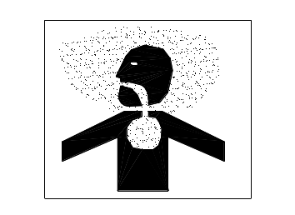Never use hedge trimmer inside a building. Your hedge trimmer produces toxic exhaust fumes as soon as the engine is started. The use of this product can generate dust, vapors and smoke containing chemicals known for their harmful effects on health. So be careful during the use of your machine and protect yourself correctly. Also avoid voluntarily breathing exhaust fumes, always hold the machine correctly when you use it.
-  Caution: do not touch the muffler. He is very hot.
- The prolonged use of the hedge trimmer exposes the user to vibrations which can produce in the long term the symptom of the white fingers. In order to reduce the risk of not feeling correctly the handles of the machine in the hands, please always wear protective gloves and keep the hands in the warmth. If the symptom of the white fingers appears, consult a doctor immediately.
- Absolutely avoid any contact of the blade of cut moving with the hands, the arms, the legs or with all other parts of the body.
Before starting to work, familiarize yourself with the operation of the accelerator handle with double safety.

2) NOMENCLATURE: Hedge trimmer MOD: RAC26PHT-2

- Stop button
- Choke lever
- Primer starting
- Safety lever
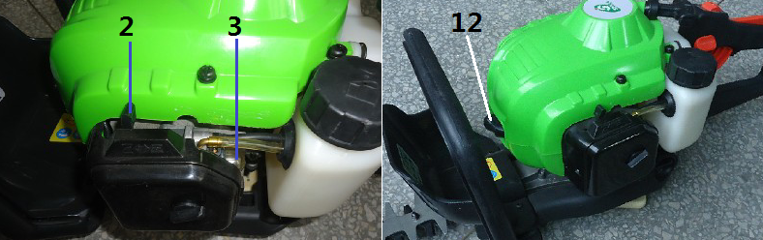
- Accelerator lever
- Recoil starter
- Rear handle
- Front handle
- Air filter
- Fuel tank
- Front guard
- Spark plug
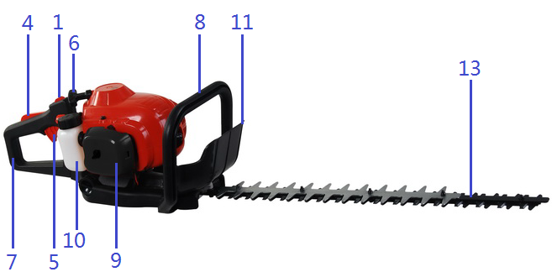
- Double blade

Technical characteristics
Engine model : SPK1E34F
Engine type : 2 stroke
Displacement : 26 cc
Maxi speed : 7,500 min⁻¹
Power : 0,75 kW.
Mixture oil / gasoline. : 3.3% (1:30)
Type of gasoline for mixture : Unleaded 95 RON.
Fuel tank gasoline capacity : 0,6 liter.
Length/Cutting width : 700/560 mm
Width teeth : 28 mm
Ignition : Electronic CDI
Net Weight : 5,8 kg.
Gross Weight : 7 kg
Acoustic pressure level at the station of
control according to NF EN 774/A3 : LpA : 86.5 dB(A) (K = 3 dB(A))
Level of sound power measured according
to directive 2000/14/EC: 2000,
standards EN ISO 3744: 1995 and
ISO 11094: 1991: : LwA : 106.5 dB(A) (K = 3 dB(A))
Level of sound power guaranteed
according to 2000/14/EC : 109 dB
Handlebar level of vibration : Rear handle 4.956 m/s² (K = 1,5 m/s²)
Front handle 4.764 m/s² (K = 1,5 m/s²)

3) PREPARATION OF THE MATERIAL BEFORE STARTING

WHICH MIXTURE TO USE?
Mixture
Carry out the mixture with unleaded 95 RON added with special 2 strokes synthetic oil in the proportion of 3.3% (an oil share for 30 gasoline shares).

Example: For 1 liter gasoline to add 3.3 oil cl
2 liters gasoline to add 6.6 oil cl
3 liters gasoline to add 9.9 oil cl… etc
 Caution: Do not use a percentage different from that recommended by the manufacturer and never use pure gasoline.

- Never use a mixture oldest than 30 days.
- Always agitate vigorously the material with its gasoline inside the tank before starting the engine.
- Unscrew the fuel cap of the fuel tank and put the mixture using a funnel (take care not to wear synthetic clothing at the time of this operation in order not to risk an electric arc being able to cause a dangerous explosion.)
- Wipe the tank and the engine of any possible gasoline traces.

4) STARTING OF THE MACHINE

- Cold start of the engine

- Put the stop switch on the position: “ON” or “RUN”.

- Put the choke lever on the position
- Press 8 to 10 times on the primer of the carburettor until the gasoline arrives and sets out again well of this one.
- Put the hedge trimmer on a flat ground in order to be able to easily pull on the recoil starter handle all while firmly maintaining the device with ground with your left feet.
- Vigorously pull 4 or 5 times on the handle of the recoil until obtaining the starting of the engine.
- If engine starting is not obtained, give the lever of choke on the position and draw again on the recoil handle 4 or 5 times and until driving starting.
- In all the cases, after starting, give the lever of the choke on

- Warm start of the engine

- Put the stop switch on the position: “ON” or “RUN”.
- Put the lever of the choke on the position
- Pull on the recoil handle to obtain starting.

- Shutdown

- Put the switch on STOP.

5) HOW TO USE THE HEDGE TRIMMER

    - How to use the hedge trimmer?

- Use this device only when you are absolutely sure to control all the functions of it well. In case of doubts, read again this handbook or inform yourself near a qualified person and/or your retailer. Ensure to be able to easily turn off the engine with the STOP button of the handle.
- Position a hand on the rear handle so as to press on the lever of safety and the other hand on the front handle. Accelerate the engine while pressing on the accelerator lever of the handle.
- Maintain an engine speed in order to profit of the best power of cut available.
- Immediately stop the engine with the STOP button if you run up against either a stone or a too large branch. Control the state of the blade after any similar incident. Do not put back on the way in case of doubt.

2. How to use the revolving handle

- Press downwards on the red button of locking located on the left side of the handle and turn this one in the desired direction and of a quarter of turn before slackening the red button.
This rotation of handle must be carried out with the engine on stop.
ATTENTION always be vigilant and well ensured on your two legs when you are using the hedge trimmer and more especially on difficult grounds, sloping or are positioned on a scale.
Always carry safety goggles, protective gloves, anti noise helmet, safety shoes and adequate working clothes.

      - Capacity of cut of the hedge trimmer

Between tooth of the guide blade being of 28 mm, it will be necessary to cut all the branches of large diameter to the assistance of a pair of hand shears or of a wood saw.

6) MAINTENANCE

Before any maintenance operation on the material turn off the engine with the STOP button and withdraw the spark plug cap.

- Current maintenance

- For the cleaning of the plastic parts use a wet rag. Do not use detergents, solvents or objects being able to stripe.
- Regularly clean using a brush all the air intake and the parts moving.
- The hedge trimmer can be stored vertically against a wall.
- Regularly oil the guide as well as the blade.
- Use only biodegradable oils.
- Lubricate regularly the eccentric with its mechanism with a good quality grease throw the lubricator.

- Maintenance of the air filter

- Wash the foams filter element regularly with soapy water.
- Well dry foam in a dry rag.
- Oil the foam of the air filter with engine oil, mass to distribute oil in the pores of foam and well dry the oil surplus before positioning it back in the plastic air filter.

- Replacement of the gasoline filter

Leave the gasoline filter to the tank with a hook and systematically replace it by a new one at the beginning of each season of use, or after one long period of non-utilization because this one can be filled because of deposits of brushwood or gum resulting from ageing from old mixture.

- Control spark plug

- Control and clean periodically the electrodes of the spark plug, especially after long periods of non-utilization.
- The correct adjustment between the two electrodes is of 0.6/0.7 mm.
- During the reassembly tighten the spark plug with the torque of 12/15 Nm.
- Put back in place the spark plug cap and control that it does not present some tears.
- Reference of the spark plug: NGK BPMR7A.

- Adjustment of the carburettor

The carburettor of the engine was adjusted in factory. When it’s necessary, address yourself to a repairer approved by the manufacturer or his representative.

- Storage/wintering

In order to guarantee a good performance of the material, please conform to the recommendations below:
- Empty the tank completely as soon as the mixture is oldest than thirty days or make function the engine until exhaustion of the fuel. In this second case empty the gasoline residues located at the bottom of the tank.
- Let cool the engine and dismount the spark plug.
- Introduce a spoonful with engine two times oil by the hole of the spark plug and slowly draw two or three times on the cord from the recoil starter in order to well lubricate the piston and the cylinder.
- Control the spark plug and replace it if necessary.
- Put back the spark plug.
- Store the hedge trimmer in a dry place.

- The Councils for the cutting of the hedges

- The persistent hedges must be cut if possible in April and/or in August.
- The hedges with always green sheets must be cut in June and in October
- Conifers as well as the shrubs with rapid growth must be cut every six weeks as from May.
- A hedge must always be crossed so that the base of this one is increasingly broader than the top (approximately of 10 cm per meter). This size of form very slightly pointed supports the sunning and improves the stability of the hedge. The top perhaps either right or round.

7) REPAIR

Any maintenance or important repair will have to be carried out only by very qualified personnel or preferably by a station approved by the sailor or his representative, especially during the guaranty.

8) USEFUL COUNCILS
- Excessive smoke exhaust:
Use synthetic engine oil 100% of high-quality with low level of smoke and to respect the percentage of 4% recommended by the manufacturer.
- Bad starting of the engine
  - Control that the bottom of the air filter body is not broken following a fall of the material for example because in this case the shutter of choke could not close correctly and the engine cannot start.
  - Drain all the mixture of the tank and remake the full one with a 4% mixture and new gasoline which you will seek in a service station gasoline.
  - Dismount the spark plug, to wipe it and/or brush it, regulate the spacing between the electrodes and go back up it by tightening it with the torque of 12/15 Nm.
  - Leave the foam filter element, wash it with soapy water, rinse it, oil with a coffee spoon of engine oil and go back up it in the air filter plastic body.
  - Clean or replace the gasoline filter of the tank (use an original part).
- All other various incidents or adjustments
Consult the list of the network after sale and entrust your material to an approved agent which knows your material well. You can contact your sailor for the after sales list.

GUARANTEE.

The manufacturer guaranteed his machine for 12 months as from the date of purchase. The machines intended for the hiring are not covered by the present guarantee.
The manufacturer ensures the replacement of all the parts found defective by a defect or a vice of manufacture. In any cases, the guarantee cannot give place to a refunding of the material or direct or indirect damages.
This guarantee does not cover:
- An abnormal use
- A use at professional ends
- The postage and packing of the material.
- In all the cases those remain with the load of the customer. Any sending at a repairer import of will be refused. It is heard that the guarantee will be automatically cancelled in the event of modifications made to the machine without the authorization of the manufacturer. The manufacturer declines any responsibility as regards civil responsibility rising from an abusive employment or not in conformity with the standards of employment and maintenance from the machine.
- The assistance under guarantee will be accepted only if the request is addressed to the service after sale approved accompanied by a proof of purchase. At once after the purchase we advise you to check the condition of the product and attentively reading the note before its use.
- The interventions under guarantee must be made by a service stations, approved by the manufacturer or his representative.
- A guarantee made by a not approved service station will be cancelled.
- Before asking any intervention under guarantee, ensure that the recommendations described in this handbook were respected strictly.
- The incidents resulting from the negligence, a bad maintenance, the use of spare parts not original or with a fair wear and tear are not covered by the guarantee.

The list of the approved service stations is available near your sailor.

GB / DECLARATION OF CONFORMITY


BUILDER
ZI, 32 rue aristide Bergès – 31270 Cugnaux - France
Tel : +33 (0)5.34.502.502 Fax : +33 (0)5.34.502.503
www.tck-garden.com

declares that the machines:
GASOLINE HEDGE TRIMMER 26CM³
Model: RAC26PHT-2

Serial No.: from XXXXXX to XXXXXX
the people name holding the technical file：Mr.Olivier Patriarca

have been designed in compliance with the following standards:
EN ISO 10517/A1:2013
EN ISO 14982:2009
EN ISO 3744:1995 & ISO 11094:1991

And in accordance with the following directives:
Machine Directive 2006/42/EC
EMC Directive 2004/108/EC
EMISSION Directive 97/68/EC & 2010/26/EU
Noise Directive 2000/14/EC & 2005/88/EC

Notify Body for Noise Certificate:
TÜV SÜD Product Service GmbH,
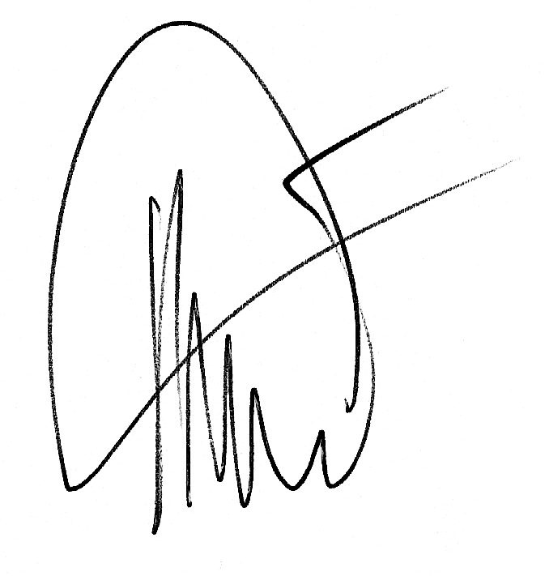
Zertifizierstelle - Ridlerstraße 65
80339 MÜNCHEN (Germany)

Philippe MARIE / PDG
08-9-2015



