

Thermal High-Pressure Cleaner
Model: HNHPT206B-A2
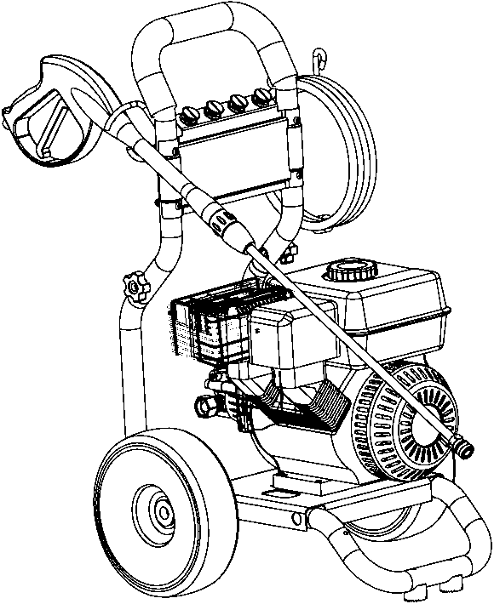

R210_B_J


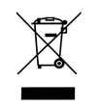


Warning: Please read the instructions before using this device.

HYUNDAI
32, rue Aristide Bergès - ZI 31270 Cugnaux - France
Licensed by Hyundai Corporation, Korea

Table of contents

- Product description ………………………………….......………………… 3
- Description of Safety …………………………………….....………………3-11
- Description of Installation process ………………………………..…......12-13
- Method of operation ………………………………............………………14-16
- Switch off ………………………………....………………………………17-18
- Storage ……………..………….……………….......………………………19
- Cleaning guide ………………………….…….........………………………19-20
- Removal of danger …………………………………….....…………………21
- Maintenance …………………………………………………………………22-23
- Technical characteristics …………………………………………………….24-26

Intended use
This device is a high thermal pressure cleaner gasoline, designed for external maintenance works. It has four pipes which have 0 °, 15 °, 40 °, high pressure angles respectively. The other pipe is to be used for the detergent.
Use SP98 petrol; otherwise the unit may be damaged.
- Use this unit as described in this manual. Any mishandling and any use contrary to instructions for use shall in no case be the responsibility of the manufacturer.
- Failure to observe the safety and operating instructions may result in a risk of electric shock, fire and / or personal injury.
- If you are giving this unit to another person, please also provide this manual.
- Do not use attachments other than those recommended by the manufacturer; they can damage the unit and / or cause injury.
- This machine should not be used by children.Children should be supervised to ensure that they do not play ith the appliance.
- This machine can be used by people with reduced physical, sensory or mental capabilities or lack of experience and knowledge if they have been given supervision or instruction concerning use of the machine in a safe way and understand the hazards involved.
- Children shall not play with the appliance.
- Do not disassemble the device yourself. Any disassembly, repair or inspection should be carried out exclusively by a qualified person.

- WARNING: This machine is intended for use with a cleaning agent supplied or recommended by the manufacturer. Use of other cleaning or chemical agents may affect the safety of the machine.
- WARNING: High pressure jets can be dangerous if misused. The jets should not be directed to people, electrical equipment or the machine itself.
- WARNING: Do not use the machine near people unless they wear protective clothing.
- Do not direct the jet against yourself or others to clean clothes or footwear.
- WARNING: Risk of explosion. Do not spray flammable liquids.
- WARNING: High pressure cleaners should not be used by children or untrained persons.
- WARNING: Pipes, fittings and connectors are important for the safety of the machine. Only use hoses, fittings and connectors recommended by the manufacturer.
- WARNING: To ensure the safety of the machine, use only the original manufacturer's parts or approved by the manufacturer.
- WARNING: Water that has flowed through the flow shutters is considered to be unsafe.
- WARNING: The machine must be switched off and ignition key removed during cleaning or maintenance and when replacing parts or converting the machine to other functions by removing the power source plug.
- WARNING: Do not operate the machine if any important parts are damaged, such as safety devices, high pressure hoses or the trigger gun.
- WARNING Do not use combustion engine powered machines indoors unless adequate ventilation is assessed by national labour authorities.
- WARNING: Make sure there are no exhaust emissions near the air intakes.
- Children, animals and persons not participating in the use of the machine must remain at a minimum distance of 10 meters from the sprayer.
- The high pressure hose must remain connected to the compressor as long as the system is under pressure.
- Do not use corrosive or flammable liquids in the machine.
- The appliance must be connected to a water supply using a new set of hoses; the old pipe set must not be reused.
- Make sure that there are no exhaust emissions near the air inlets.
- When using the machine, wear protective equipment including safety goggles, safety shoes, safety gloves, safety helmet with visor and double-insulated hearing protection.
- In order to move the unit easily, bend the lance.Make sure the unit is turned off and ignition key removed before transporting the unit.
- Before assembling, dismantling, repairing, transporting, servicing and storing, please check if the machine switched-off. •
- Handle the unit with care, do not drop it.
- Do not use the machine in extreme weather conditions, when it is very cold. Do not use the machine with ice water.
- Use the tool in a stable and plane location.
- The inlet hose can be connected to the water mains with a maximum pressure of 10 bars.
- The appliance must not be connected to potable water supply.
- When transporting the machine, take note of its weight. Do not overestimate your efforts and get help if necessary.
- The machine must be transported from one point to another and switched off and ignition key removed. Always use the handle to push the machine.
- Use the handle to lift the machine.
- Improper transport of the machine may result accidents and injuries.
- During use, transportation, assembly, dismantling when out of service, testing or foreseeable breakdowns, the tool must keep always stand up.
- Do not use the tool where dangerous situations or accidents may occur. Do not use it indoor, in places where are exhausted gases, etc.
- In case of accidents or breakdowns, stop to use the tool, switch off it and unplug it. Check the conditions of the tool and bring it to a service agent for inspection and reparation if necessary.
- When opening the trigger gun, pay attention to the kickback force. The power of the gun can cause a kickback and can produce a loss of control of the gun and create accidents and injuries. Hold the gun firmly, and with both hands if possible. The kickback forces exceed 20N.
- WARNING Always switch off the mains disconnecting switch when leaving the machine unattended.
- To avoid dangerous situations in the event of an accident (e.g. contact with or spill of detergents, fuel or oil) or equipment failure (such as a puncture or component failure), please stop to use the machine immediately. Check the problem. Have the machine inspected by a qualified technician. In the event of a spill, move the machine away and clean up spills.

• Strictly forbidden to use on people or animals. This device is not intended for use by people (including children) whose physical, sensory or mental abilities, are reduced, or people who lack experience or knowledge, unless they have been given by the intermediary of a person responsible for their safety, of supervision or instruction concerning the use of the device.
• While using the device, avoid being under the influence of alcohol and drugs. Children should be monitored to ensure they do not play with the device.
• Never spray electrical cables, sockets
• It is strictly forbidden to add fuel when using the device
• It is strictly forbidden to fill fuel when the power is on.
• Do not touch hot surfaces or place the pipe in contact with hot surfaces of the engine.
• Do not use the device in a confined space, in order to prevent poisoning by carbon monoxide
• Do not use the unit near fire
• Never turn the device towards the gasoline.
• Never use hot water.
• Never operate the device without water supply.

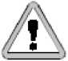
Carefully follow the instructions when using this machine.
• Read all instructions before using the machine.
• Be warned against the risk of fire! Do not add gasoline while the engine is running. Do not exceed the amount of fuel provided for the operations
Do not operate the machine if fuel has been spilled, if there was gasoline spill, change location, and wait until the device is dry before restarting it.
• Use in open space and avoid contact with devices creating heat, such as, boiler, water heater, etc.
• If the device is not properly used, the high pressure spray will be dangerous. The device must not be in direct contact with the human body, animals, and electrical devices.
- This machine is designed to use only cleaning agents supplied or recommended by the manufacturer. Using other detergents or chemicals can impair the safety of the machine. Only use products with a neutral pH.
- The high-pressure cleaner accessories, such as pipe fittings and joints, are of significant importance for the machine’s safety. So use accessories recommended by the manufacturer of the machine.
- For more safety, use only original spare parts or equivalent parts approved by the manufacturer.
- Do not use the cleaner when the fuel pipe or a strategic part of the machine is damaged, for example a safety device, the spear, the high pressure hose or gun.
- Do not operate a gasoline engine machine inside a room.
- Exhaust gases are toxic, does not run inside a home or garage, keep the cleaner running at a minimum distance of 1 meter of a building or any equipment.
- Place the device on a firm, flat surface.
- Do not run the machine at excessive speed, which could lead to an accident or body injury.
- Do not touch the settings that increase or decrease the engine speed.
- Systems of exhaust gas can heat up to the point of exploding flammable materials. Keep the machine far from these materials. Do not use the machine next to combustible material.
- Do not refuel the device inside a room or while the machine is running.
- Do not cover the machine while the engine is running.
- The exhaust system becomes burning and remains very hot shortly after stopping the engine. Be careful not to touch the exhaust, let the engine cool off after it has been shutdown.
- Do not use mobile phones or smoke when filling the fuel.
- Check the condition of the cleaner and its parts before use , including the gun, hose, clamps parts of the reservoir. Any defects must be eliminated before starting.
- Keep children and people away from the workplace.
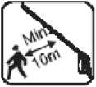
- The high-pressure cleaner must be used by a trained person and must be serviced by a qualified staff.
- Before transporting the cleaner, empty the fuel tank to rule out the possibility of leakage.
- Avoid using flammable cleaning products such as acid, alkali, sea water and hot water (50 ° C)
- Store the cleaner in a dry, airy place, with the empty tank.
- Wear protective equipment to protect against projections and noises such as anti-dust mask, safety glasses, hearing protection, a hard hat and anti-slip shoes.

NOTE: gun safety lock prevents the trigger from accidentally operating, yet this device does not lock the trigger in the opposite direction.
• Do not touch hot surfaces of the machine as it may cause burning.
• Do not put into contact the hose and the protective mesh on the muffler exhaust.
• Use the device in a suitable environment out of the reach of children.
• The user should not move away from the machine during operation.
• The user shall know how to stop the machine and release pressure quickly. Familiarize yourself with
control buttons.
• Stay focused while using your device
• Do not use the device when you are tired or under the influence of alcohol or drugs.
• Do not place the device on an uneven surface, keep balance while working.
• Do not overturn the device.
• Do not use fuel not recommended as it can cause a dangerous situation.

Warning!
When the device is turned on, even if it has not pulled the trigger, the internal pump switches on. Leaving the machine running for more than 3 minutes without pulling the trigger can damage the engine and pumps.

Water Supply
Warning! NOT TO BE CONNECTED WITH HOT WATER.
■ the water pipe should be a minimum diameter of 19mm
■ the water supply speed must be greater than 6.2 minute litters.
■ Flow rate can be determined by filling a container in a minute.
■ the water temperature should not exceed 60 ° C
■ do not use water that contains solvent, such as thinner for paint, gasoline, oil, etc.
■ always use clean water to avoid putting dirt in the cleaner.

We strongly recommend that this cleaner should not be left running without the gun trigger being engaged for a period of more than 5 minutes or more, it is necessary to have circulating water in the pump to cool it off.

Refer to the maintenance instructions in the user manual

The location of the safety labels
These labels warn of potential risks that could lead to injury.
Read these warning labels and instructions guides given in this manual attentively.
Explanation of symbols:

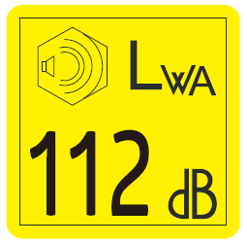 | Guarantee noise level
 | WARNING. HOT SURFACE. DO NOT TOUCH.
 | Put on a hearing protector.
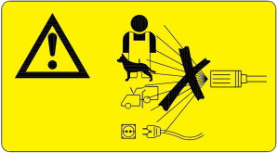 | Do not turn the gun towards people, animals or the supply means
This machine is not suitable for connection to potable water supply.
Names of different constituents
- Ducts
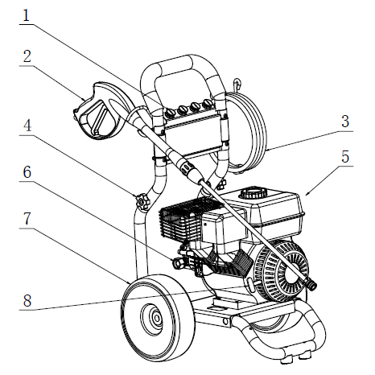

- Gun
- flexible
- Binding of handlebar
- Engine
- Water inlet fitting
7. Wheel
8. Launcher
Assembling instructions:
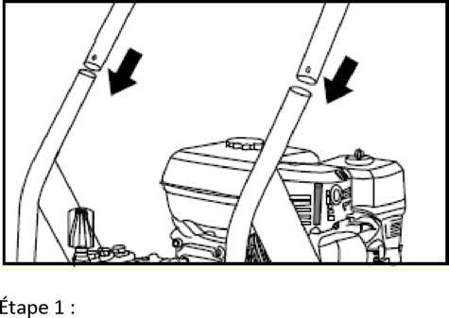
Step 1: Insert the handlebar into the frame tubes of the high pressure cleaner by aligning the holes, put the bolts and tighten.

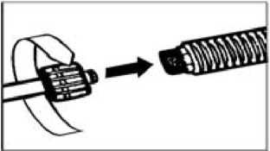
Step 2: Attach the nozzle to the spray gun

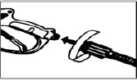
Step 3: Set the nozzle on the gun
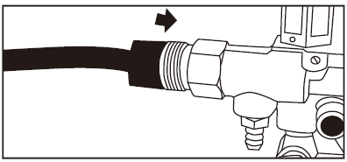
Step 4: Connect the hose to the water connecting outlet of the high- pressure cleaner.

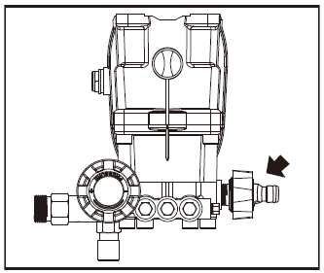
Step 5: Connect the water supply hose to the cleaner water inlet connection.
.
Operating instructions
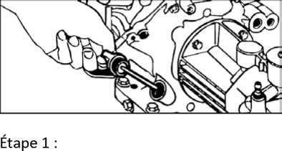
1. Check the engine oil level. The oil must reach the max mark engraved on the lower edge of the neck of the oil filler, or use the mark maximum on the gauge.
Refer to the engine user manual
After 5 hours of use, drain the machine, change the oil, then drain every 50 hours

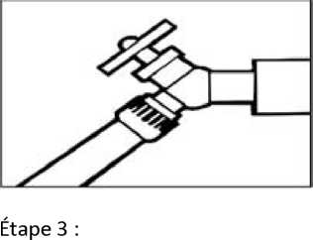
2. Add unleaded gasoline in the fuel tank.
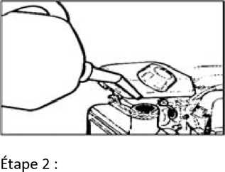

3. Connect the pipes to a water tap and completely open the valve.
4. Press the gun trigger to expel the air from the cleaner and pipe, wait until the water coming out of the nozzle is stable.
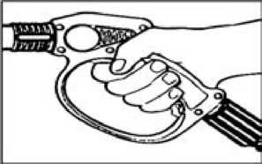

Starting the engine.

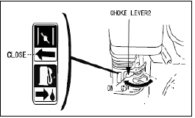
Close
Lever register 2

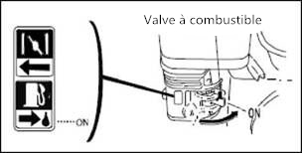
5. Move the choke lever to the "ON" position

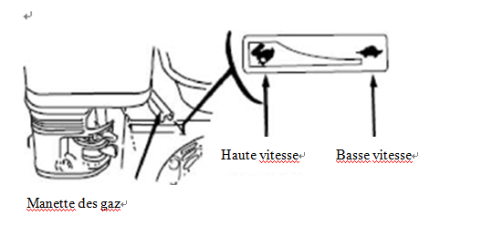
6. Open the fuel tap

7. Push the throttle lever towards the left
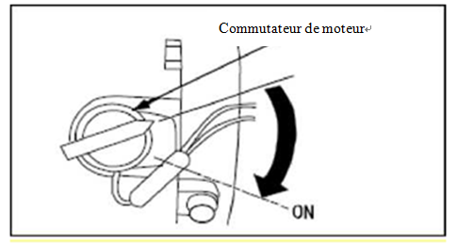
8. Turn the switch on the device to "ON"

Information: Do not use the choke if the engine is hot or if the atmospheric temperature is high.
NOTE: Do not turn the engine when the oil level is too high or too low; this may damage the engine.

9. First of all gently pull the starter handle up to the stop, then pull off sharply to start the engine.
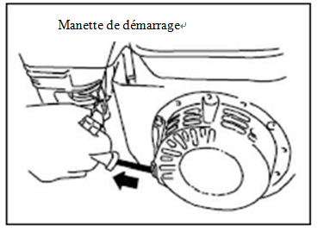
Note: to avoid the sudden return of the launcher, support the launcher up to its original position.

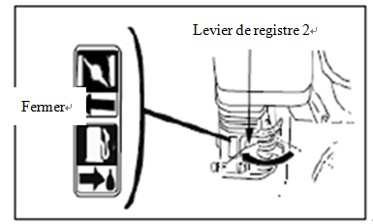

10. Place the choke lever to the position "OFF"

Stopping the engine
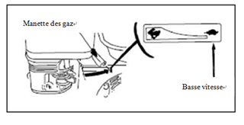
1. Push the throttle lever to the far right
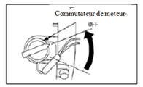

2. Turn the engine switch on the "OFF"
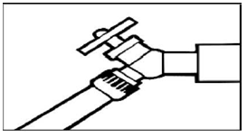
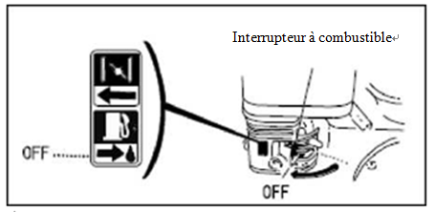

3. Close the fuel tap
4. Close the water supply tap

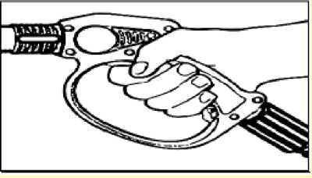
5. Pull the trigger to release water pressure.

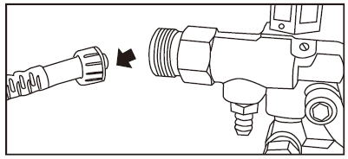
6. Disconnect the water hose from the water cleaner inlet connection entry.

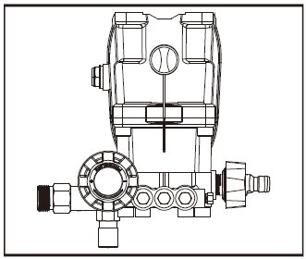
7. Disconnect the high pressure hose from the water outlet fitting of the water cleaner.
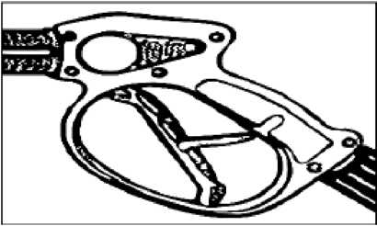
8. Engage the trigger lock tab.

Do not turn the pump without water for more that 5 minutes
Extended storage:

- Remove all water connections
- Allow the cleaner to function for a few seconds in order to remove the remaining water.
- Drain the fuel from the cleaner.
- Be careful not to bend the flexible high pressure.
- Keep the cleaner and accessories in a place where the temperature does not drop to -0 °.
- To avoid any risk of fire or burn, let the engine cool before transporting the cleaner or keep it inside a house.
When transporting the machine, it is necessary to close the fuel valve, keep the cleaner on a flat surface and make sure the tank cap is closed and is in good condition. This is because of spilled gasoline and gasoline vapours which can cause fire.

WARNING: If these instructions are not followed, it could damage the pumps, equipment and accessories.

How to use the high-pressure cleaner
WARNING!
Firmly hold the gun while pulling the trigger. Warning! The force of the recoil can make you lose your balance. Use both hands to hold the gun.
Cleaning the deck of a boat
(With or without detergents)
Clean the deck with fresh water as well as its surrounding platform. If using detergent, place detergent suction tube directly into cleaning solution and apply detergent on the surface with the low pressure nozzle. For best results, limit the cleaning area to smaller sections; allow the detergent to react for 1 to 3 minutes. Be careful not to let the surface dry with the detergent. Then rinse with high pressure in a long sweeping motion keeping the spray nozzle at about 40 cm from the surface to be cleaned. Always clean from bottom to top and from left to right. When moving from one section to another, ensure to overlap the previous section to eliminate stop marks and ensure satisfactory cleaning results.
Cleaning house facades
(With or without detergent)
Clean the surface with fresh water. If using detergent, place detergent suction tube directly into cleaning solution and apply detergent on the surface with the low pressure nozzle. For best results, limit the cleaning area to smaller sections, and always apply detergent from bottom to top, allow the detergent to react for 1-3 minutes. Do not allow detergent to dry on the surface. If the detergent has become more or less dry, simply wet facades with fresh water. If necessary, use a special brush to remove sticky dirt. Then rinse high downward pressure in a long sweeping motion keeping the spray nozzle at about 40 cm from the surface being cleaned.

Cleaning of concrete, brick and stone
(With or without detergent)
Clean the surface with fresh water. If using detergent, place detergent suction tube directly into cleaning solution and apply detergent on the surface with the low pressure nozzle. For best results, limit the cleaning area to smaller sections, and always apply detergent from bottom to top, allow the detergent to react for 1-3 minutes. Ensure not to let the detergent dry on the surface. Then rinse high downward pressure in a long sweeping motion keeping the spray nozzle at 40 cm from the surface being cleaned. To remove stubborn stains, use the high pressure nozzle.

Cleaning of car, boat or motorcycle
(With or without detergent)
Use fresh water to clean the car. If using detergent, place detergent suction tube directly into cleaning solution and apply detergent on the surface with the low pressure nozzle. For best results, wash the car from one side to the other. Do not allow detergent to dry on the surface. Then rinse with high pressure from top to bottom and from left to right in a long sweeping motion keeping the spray nozzle approximately 40 cm from the surface to be cleaned the distance should increase when cleaning delicate surfaces). For better effect, wipe surfaces with a chamois or soft dry cloth after washing.
Clean grill and garden tools
(With or without detergent)
Clean the surface with fresh water. If using detergent, place detergent suction tube directly into cleaning solution and apply detergent on the surface with the low pressure nozzle. For best results, limit the cleaning area to smaller sections, and always apply detergent from bottom to top, leave the detergent to react for1-3 minutes. Ensure not to let the detergent dry on the surface. Then rinse high downward pressure in a long sweeping motion keeping the spray nozzle at 40 cm from the surface being cleaned. To remove stubborn dirt, it is necessary to bring closer the spray nozzle from the surface to obtain a higher projection. To remove dried sludge on garbage containers, mower blades, wheelbarrows or other non-sensitive metal surfaces, you can use the high pressure nozzle.

Cleaning of garden furniture
(With or without detergent)

Use fresh water to clean the furniture. If using detergent, place detergent suction tube directly into cleaning solution and apply detergent on the surface with the low pressure nozzle. Allow the detergent to react for 1-3 minutes. Ensure not to let the detergent dry on the surface. Then rinse with high pressure while maintaining the spray nozzle at 40 cm from the surface being cleaned. For best results, clean from bottom to top and from left to right.

Warning:

Before cleaning the surface, do a spray test on a less visible area. This is to choose the shape of the jet, as well as the best distance. For painted surfaces that begin to flake, you should work with a lot of care, as the cleaner could take paint peeling from the surface.
Problem resolution:
Before each maintenance and repair, disconnect the power supply before doing any maintenance or repair.
Breakdowns | Possible reasons | Solution
During start up, the engine does not start | No fuel | Fill the fuel tank
During start up, the engine does not start | Oil level is very low | Add oil
During start up, the engine does not start | The choke is not in the right position | Move the starter to "ON"
During start up, the engine does not start | The gas command is not in the right position | Move lever gas control to the left
During start up, the engine does not start | The pressure remains in the cleaner | Press the trigger to remove the remaining air in the pipes
The high pressure cleaner cannot be reached | The diameter of the inlet hose is too small | Use a bigger pipe
The high pressure cleaner cannot be reached | The water supply is insufficient | Check if the hose is twisted, folded or stuck
The high pressure cleaner cannot be reached | The water inlet is small | Open valve completely
The high pressure cleaner cannot be reached | Filter clogged water | Remove filter, clean with warm water
The high pressure cleaner cannot be reached | The black nozzle detergent suction mounted | Use high pressure nozzle
The output pressure undergoes fluctuations | Pump inhales air | Stop the machine; hold the trigger, to completely remove the air in cleaner.
The output pressure undergoes fluctuations | The water inlet filter is clogged | Remove the filter, clean with warm water
The output pressure undergoes fluctuations | The nozzle is clogged | Blow air or use a needle to remove the clog
The output pressure undergoes fluctuations | spray gun, hose or the lance is calcified | Fill the detergent inlet tube with white vinegar
No detergent | The detergent suction tube is not connected properly | Check the connection
No detergent | Detergent too thick | Dilute detergent
No detergent | Detergent filter valve is set to a very small passage | Adjust the valve to a bigger passage
No detergent | Filter detergent suction tube is clogged | Pour warm water in the filter in order to remove particles
No detergent | Detergent suction hose is damaged or obstructed | Remove the obstruction or replace the pipe
The connection of the hose or spray lance leaks | The nozzle is clogged | Clear tip
The connection of the hose or spray lance leaks | Fixing parts are loose | Tighten the fixing parts
The connection of the hose or spray lance leaks | Damage or wear of the pipe or spear | Replace damaged parts
The water pump is noisy | Pump inhaling air | Put off the machine, press the trigger to purify the water circuit cleaner
Leakage of water pump | Damage or wear of the seal | Ask customer service, to be replaced with new seals
Oil leakage | Damage or wear of seals | Ask customer service, to be replaced with new seals
If you encounter other problems, do not hesitate to call the customer service for assistance
Maintenance
- Normal maintenance
• The connection hose, spray gun and hose must be inspected and cleaned regularly to avoid blockage or leakage.
• To clean the nozzle, separate the launchers of the spray gun, clean the nozzle with a piece of stiff wire or paper clip to remove dirt, then let water pass through the nozzle and then, back to the spear gun.
• If the nozzle cleaning method seems inefficient, change the nozzle.
• Check the condition of the water pipe; replace it if there are fissures, cracks.
• Control the filtering element of the air filter. Dusting, removing dirt and keeping it clean.
• Check the fasteners to ensure proper tightening.
• Check the oil level
2. Clean the air filter after every 25 hours of use. The specific cleaning method is as follows:
• Remove the air filter cover;
• Remove foam filter, replace it with a new oiled filter or clean with lukewarm water and mild soap;
• Replace the filter element foam by evenly pressing to ensure that the foam is well seated in the right position
• Replace the air filter cover such that it is well placed and is fixed by the locking tabs.
3. To ensure the good condition of the spark plug, proceed according to the following method:
• 1. Check the spark plug at the beginning of each season.
• 2. Disconnect the cap of the spark plug and remove debris and dust around the plug area.
• 3. Remove the spark plug and replace it if it detects the following faults:
The electrode was burned out of porcelain or high carbon deposit on the spark plug.
• 4. The gap between the electrodes should be 0.6-0.7 mm (0.024-0.028in)
Tighten spark plug correctly
• Replace the spark plug cap.
4. It is necessary to ensure the cleanliness of the engine oil. To change the oil, proceed as follows:
• Place the cleaner on a flat surface, first heat the engine for a few minutes and then stop the engine. Close the fuel cock;
• Loosen the drain screw;
• Place a pan under the engine, tilt the cleaner to completely drain the engine oil.
• Place again the cleaner on a flat surface;
• Do not tilt the cleaner when filling the engine oil to prevent an oil spill that would be harmful to the engine.
• Check the condition of the seal and tighten the drain screw
• Add engine oil up to the maximum limit.
5. Clean fuel tank and filter it every 100 hours of use;
• Open the cap of the fuel tank, remove the fuel filter and use a brush to clean.
• Clean the tank; remove dirt and stagnant water.
• Replace the fuel filter.
• Fill the fuel tank to the red line representing the maximum fuel level.
6. After two years of use, check for wear and flexible hoses. If the hose or hoses are cracked , replace them with new parts.
7. Before storing the cleaner for a more or less extended period, take a number of preventive measures against degradation:
• Drain the tank, fuel hose and carburettor,
• Pour a glass of oil in the tank engine, shake the machine to distribute the oil to all internal walls of the tank, and then remove excess oil.
• Remove the spark plug, put a spoonful of SAE 10W30 engine oil 20W40 or in housing of the spark plug, and then put the candle.
• Pull the starter grip to gently rotate the engine (with the switch to OFF position) stop pulling the starter cord when resistance is felt in the hand.
• Put the cleaner in a place where the temperature does not drop below 0 °. Put antifreeze in the water circuit.

NOTE:
Treating used lubricating oil in a manner compatible with the environment.
We strongly advise you to put it in a sealed container and bring it to a local recycling service. Never discard with household waste or pour onto the ground.

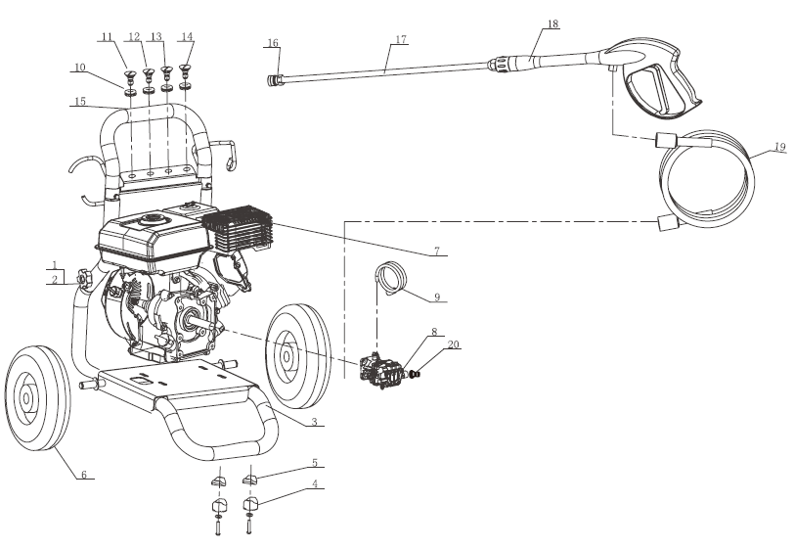

1 | NUT | 2
2 | LOCK | 2
F | FRAME | 1
4 | FOOT RUBBER | 2
5 | PLUG | 2
6 | WHEEL | 2
7 | ENGINE | 1
8 | AXIAL PUMP | 1
9 | ASPIRATION DETERGENT | 1
10 | SUPPORT NOZZLE | 4
11 | NOZZLE, 0 ° | 1
12 | NOZZLE, 15° | 1
13 | NOZZLE, 40° | 1
14 | DETERGENT NOZZLE | 1
15 | FOAM HANDLE | 1
16 | CONNECTION | 1
17 | LANCE | 1
18 | GUN | 1
19 | HIGH PRESSURE HOSE | 1
20 | BRASS CONNECTOR | 1

Technical characteristics
Model | HNHPT206B-A2
Pump model | Axial pump
Nominal pressure | 18,6 MPa
Maximum pressure | 20,7 MPa
Normal speed | 8,2 l/min
Maximum speed | 9,1 l/min
Min/Max water level | 0,5 / 1,0 MPa
Maximum nominal temperature | 60°C
Quick installation of nozzles | 0°, 15°, 40° and DETERGENT NOZZLE
Start system | Launcher
Recommendation fuel | SP98 gasoline
Fuel tank capacity | 3,6 L
Engine model | LF170F
Engine type | four-stroke, air-cooled gasoline engine
Capacity | 212 cc
Nominal strength | 4.2kW / 3600/min
Quantity of engine oil | 0,6 L
Rotation speed(slow down) | 3400±50/min
weight(kg) | 29 kg
Product volume | 543 x 520 x 930 mm
Packing volume | 550 x 550 x 550 mm
Sound pressure level | 94,7 dB(A) K=3dB(A)
Measured sound power level | 109 B(A) K=3dB(A)
Guarantee sound power level | 112 dB(A)
Vibration | 4,6 m/s² K=1,5 m/s²

Electric pattern
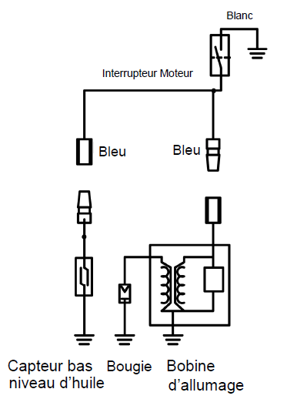
DECLARATION OF CONFORMITY

Declaration of conformity
BUILDER SAS
ZI, 32 rue Aristides Bergès – 31270 Cugnaux - France
Declares that the machine designated below:
Thermal High-Pressure Cleaner
Model: HNHPT206B-A2
Serial number: 20190403368-20190403525
Head of technical file: Mr Michel Krebs
Complies with the provisions of the directives ‘‘machine’’ 2006/42/CE and national regulations transposing it;
Also complies with the following European directives:
At the CEM Directive 2014/30/UE
Emission Directive 97/68/CE, modified 2012/46/UE
Noise- Directive 2000/14/CE Annexe V and 2005/88/CE
Guarantee sound power level: 112 dB(A); measured sound power level: 109 dB(A) K= 3 dB(A)
It is also in accordance with European and national standards and the following technical provisions:
EN 60335-1:2012+A11:2014, EN 60335-2-79:2012, EN ISO 14982:2009
Notified body

Cugnaux, le 25/06/2018
Philippe MARIE / PDG

