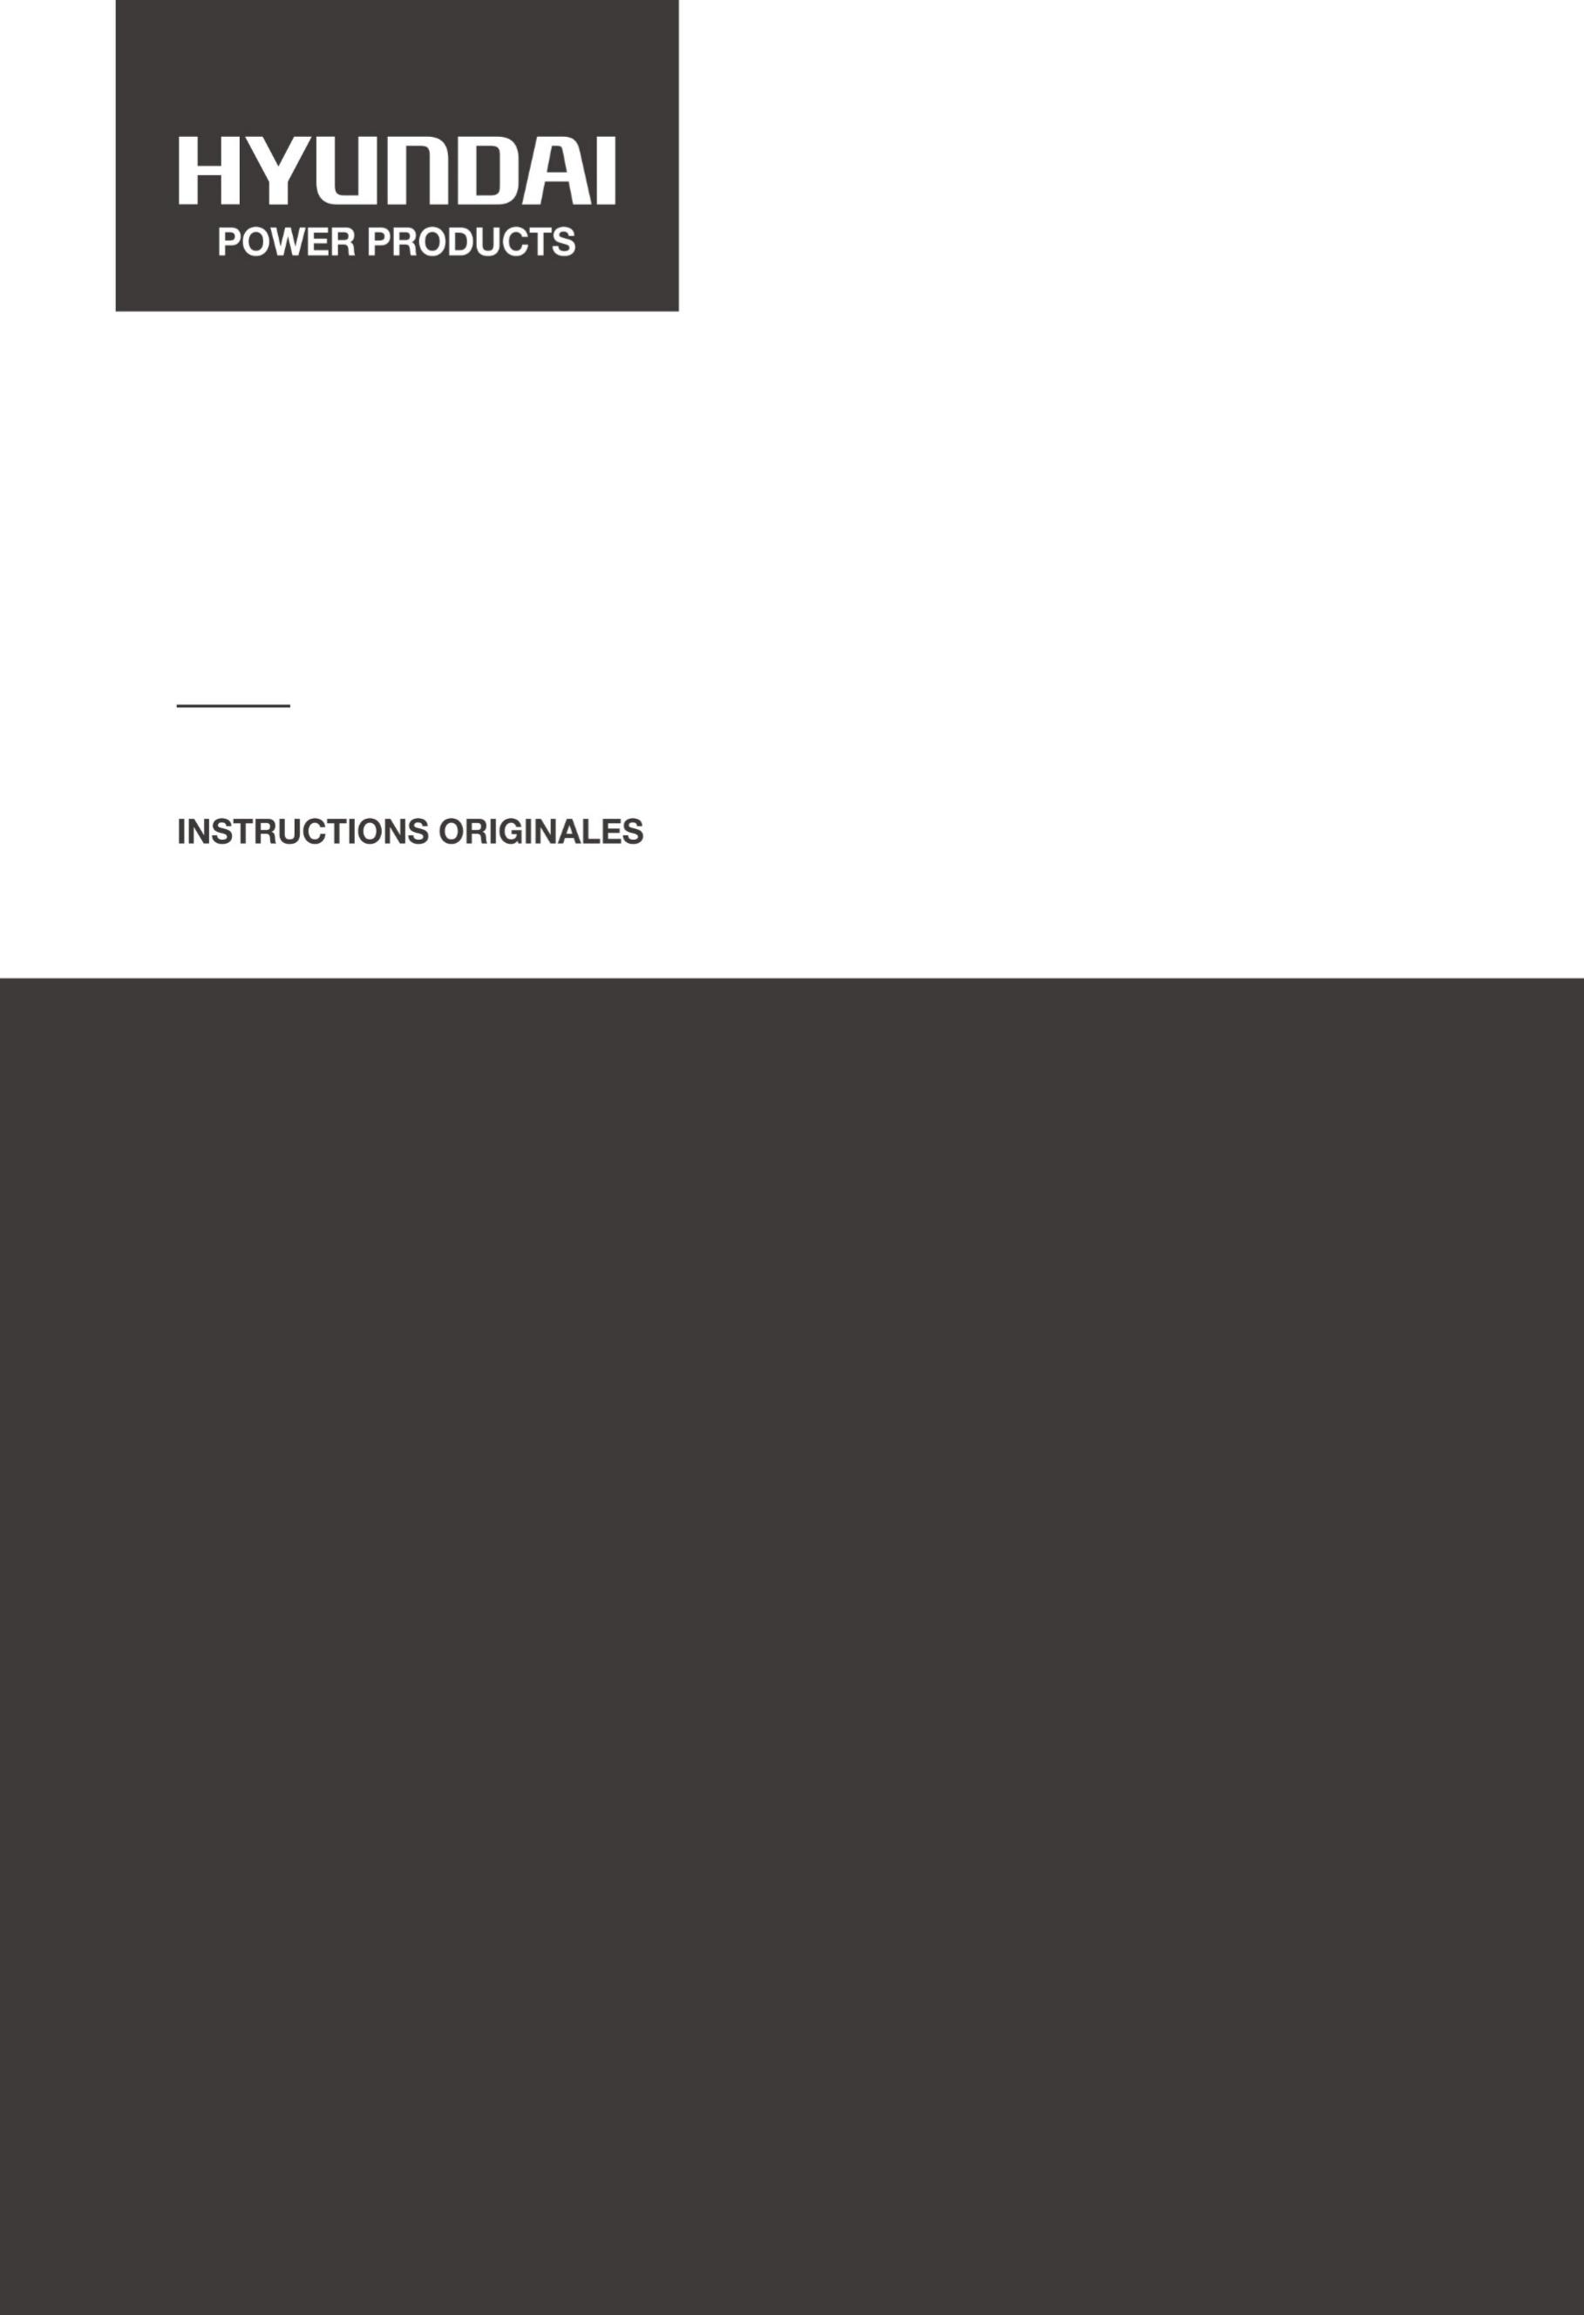

HIGH-PRESSURE CLEANER
HNHP1600-115AC

_________

ORIGINAL INSTRUCTIONS

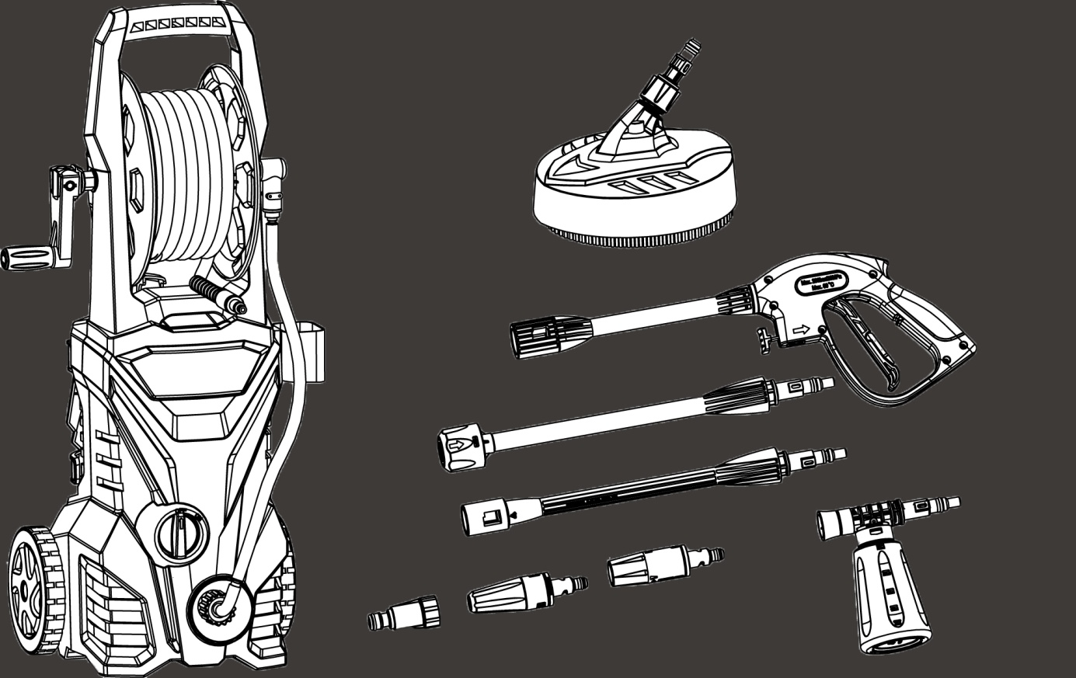

Intended use

The high-pressure washer is used to clean objects and outdoors surfaces (tools, vehicles, boats, terraces, facades, garden furniture etc.) with a high-pressure water jet. It's not intended for commercial use.
Ensure that vehicles and their engines are clean and located in equipped places with an oil separator.

The following safety instructions should be read and followed before using the pressure washer!

Safety instructions for high-pressure cleaners:

- The device may only be connected to an electrical connection made by an electrician in accordance with IEC 60364.

- The device should be used in an upright position.

- The device should be used outdoors.

- This tool is not designed to be used by people (including children) whose physical, mental or sensory abilities are impaired, or who lack experience and knowledge.
- The high-pressure washer should not be used by children or persons who are not familiar with its operation.

- The device should not be used in an environment subject to explosion hazards.

- The device should not be left unattended while the operating switch (5) is turned on.

- The jet (23+24) of the high-pressure cleaner should not be directed at persons, animals, electrical components or the device itself. Keep people away from your working area.

- Never direct the jet (23+24) at yourself or others to clean clothing or shoes.

- Spraying products that may contain harmful substances (e.g. asbestos) are prohibited.

- Check the power supply cable (8) and high-pressure hose (3) for damage before starting work.

- A damaged spray gun (10) should be replaced by an authorized workshop.

- A damaged high-pressure hose (3) should be replaced before starting up against an original hose.

- If the power supply cable (8) is damaged, it should be replaced by a specific junction available from the service centre or the manufacturer.

- Do not touch the power plug and power cable (8) with wet hands.

- If necessary, use splash-protected extension cords and make sure that the power plug and extension cord connection are watertight. Non-suitable extension cords can be dangerous.

- Make sure that the drain pipe is sealed and connected to the hose coupling (4).

- The drain pipe and the high-pressure hose (3) should not be bent.

- Tires and car valves should be cleaned at least 30 cm away from the vehicle, using only the round jet.

- When using detergents, the detergent manufacturer's instructions for use, disposal and precautions should be observed.

- This device has been designed for use with cleaning detergent supplied or recommended by the manufacturer. The use of other detergents or chemicals may interfere with the safety of the device.

- The jet of water causes the spray gun (10) to reverse backward force. Be sure to maintain proper balance and hold the spray gun (10) and spray tube (11) firmly.

- Protect yourself from the elements that can be sprayed by wearing suitable work clothing and protective goggles.

- Wearing a noise protection is recommended

- The machine is transportable, use the handle. Do not use the cord to carry the cleaner. Do not pull on the cord to disconnect the plug.
- NEVER transport the device by pulling on the high-pressure hose. Use the handle located on the upper part of the device.
- Only install the machine on stable surfaces for operation, assembly and disassembly. Hold the machine firmly during transport

- Attention: Use only original spare parts and accessories from the manufacturer, in order to ensure the safety of the device. High-pressure hoses, controls and fittings are important for the safety of the device.

- Never operate the device if the power cable or important parts of the device, e. g. safety device, high-pressure hose or spray gun are damaged.

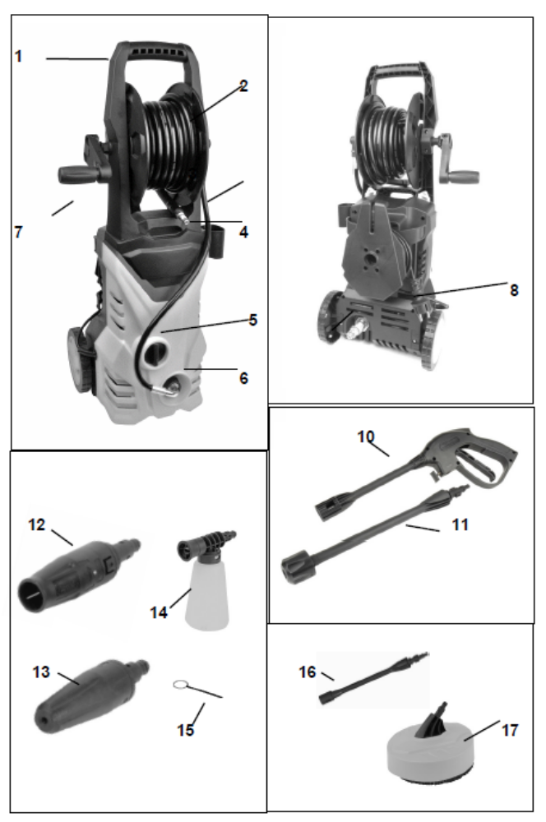
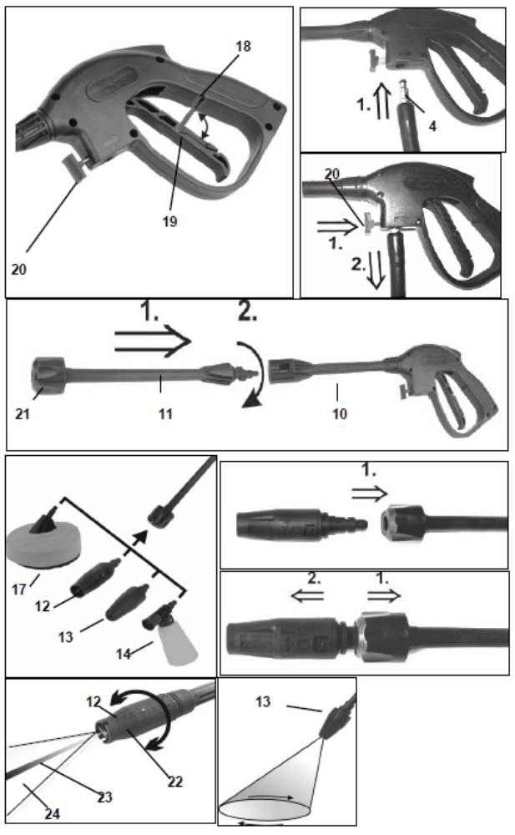
Delivery contents | Description of the device (photo 1)
1 high-pressure cleaner  1 high-pressure hose  1 spray gun  1 spray tube  1 dirt milling machine  1 wide jet nozzle  1 foam nozzle  1 surfaces cleaner  1 hose connection  1 nozzle cleaning needle | - Carrying handle  - Hose drum  - High-pressure hose  - Hose connection  - Operation switch  - High-pressure outlet  - Hand cam  - Power cable  - Water supply  - Spray gun  - Spray tube  - Wide jet nozzle  - Dirt milling machine  - Foam nozzle  - Nozzle cleaning needle  - Extension  - Surfaces cleaner  - Locking system  - Trigger  - Unlocking  - Locking cover  - Tip nozzle  - Linear jet  - Round jet

Symbols:

Read the instructions manual.
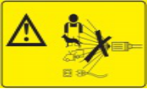 WARNING! The jet should not be directed at persons, animals, live equipment or the equipment itself.
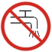This machine is not suitable for connection to the drinking water supply.
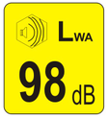Guaranteed sound power level.

Technical data

Nominal voltage | 230 V~
Frequency | 50 Hz
Nominal power | 1600 W
Water flow temperature, max. | 40 °C
Water production, min. | 5.0 l/min
Water production pressure, max. | 0.3 MPa (3 bars)
Operating pressure, nominal. | 7.7 MPa (77 bars)
Operating pressure, max. | 11.5 MPa (115 bars)
Sound pressure level  (Uncertainty K = 3 dB) | 88 dB(A)
Sound power level max.  (Uncertainty K = 3 dB) | 98 dB(A)
Vibration of the spray gun | ≤ 2.5 m/s²
  Protection class | II /
Degree of protection | IPX5
Weight | 7.4 kg
 Wear hearing protection when using the power tool.
Note:
- The declared vibration total value was measured in accordance to a standard test method and may be used for comparing one tool with another.
- The declared total vibration value can even be used in a preliminary exposure estimate.
Warning:
- Vibration emission during actual use of the power tool may differ from the total declared value depending on how the tool is used;
- Avoid the risk of vibration
Suggestion: 1) wear gloves during the operation.
2) limit the operating time and shorten the tripping time.

Protection class IPX5

The product is protected against a small jet of water e. g. by spraying garden water on the device.

Automatic stop of the engine

This high-pressure washer is equipped with an automatic engine stop. If the trigger (8) of the spray gun is activated during operation, the motor stops automatically. By pressing the trigger (19) again, the motor restarts. During short work breaks, the trigger (19) of the spray gun (10) should be locked by the locking system (18) to prevent unintentional starting of the engine. In case of longer interruptions, the operation switch (5) should also be set to "OFF".

Use of detergents

This high-pressure washer is suitable for the use of universal cleaning products, for cars, boats, home and garden, recommended by the manufacturer and approved for use with high-pressure cleaners (e.g. Kärcher, Mellerud).
The use of other cleaning products or chemicals may interfere with the safety and functionality of the appliance.
- When using cleaning products, the dosing and application instructions of the manufacturer of cleaning products should be observed.
- Do not use aggressive cleaning products.
- Consult your specialist dealer for advice on suitable cleaning products.

Before start-up

- It is recommended that a specialist install a current protection switch at the electrical connection of the device, to interrupt the power supply when the fault current exceeds 30 mA for 30 ms.
- According to the applicable regulations, the device should never be operated without a system separator on the drinking water system. Use a separator system according to EN 12729 type BA. Always connect the system separator to the water supply and never directly to the device!
- Slide the hose reel (2) into the holder provided at the front and secure it with two screws.
- The high-pressure hose (3) should be screwed firmly to the high-pressure outlet (6).
- Plug the free end of the high-pressure hose (4) into the corresponding opening of the gun until you hear a click. To remove the high-pressure hose from the gun, press the unlock button (20) and pull the hose out.
- Screw the water hose onto the water connection sleeve (9) or push it into the pre-assembled hose connector. At the same time, make sure that the dirt filter is in the suitable position.
- Screw the spray hose (3) firmly into the spray gun (10).
- If necessary, insert one of the nozzles into the steel pipe until you hear a click. To replace the nozzle, pull the locking cap (21) backwards towards the gun and pull the nozzle out from the front.
- Connect the power plug into a properly grounded outlet.
- Turn the water supply on. If you are using the high-pressure washer and the water supply is interrupted, this causes damages to the pump.

Turning on

Fully unwind the high-pressure hose from the hose reel. At the same time hold it with the transport handle (1).
- Turn the operating switch (5) to the "ON" position
- Point the spray gun (10) downwards.
- Unlock the locking device (18) of the spray gun (10) and press the trigger (19) fully.

Turning off

- Release the trigger (19) and lock it with the locking system (18).
- In case of longer interruptions, the high-pressure cleaner should be switched off with the operation switch (5). ("OFF")

Foam nozzle
The foam nozzle (14) allows adding automatically the detergent to the washing water if needed.
- Before mounting the foam nozzle (14) remove the power plug (8) from the socket.
- Install the foam nozzle (14) in the steel tube as described below. For this operation the tank must be directed downwards.
- Unscrew the detergent tank and fill it with product according to the manufacturer's instructions.
- Screw the tank onto the foam nozzle and activate the gun trigger.
- Spray the detergent on the dry surface and let it act for a moment (do not let it dry!).
- Remove the foam nozzle (14) from the gun, reassemble the wide jet nozzle (12) and remove the diluted dirt from the product by watering it with the high-pressure jet.

Cleaning operation
- Start possibly by cleaning the object in high-pressure operation mode to remove most of the dirt.
- Spray the detergent on the dry surface to be cleaned and let it act for a few moments (do not let it dry!).
- Rinse with a high-pressure jet to remove the dissolved dirt.

Round jet nozzle

By turning the nozzle tip (22) you can choose between linear jet (23) and round jet (24) for the spray nozzle.

Dirt milling machine

The dirt milling machine (13) produces a rotary linear jet. This makes cleaning large wall and floor surfaces faster.
- Proceed first, as described above in the section ("Before starting up").
- Mount the nozzle to the rotor (13) into the spray tube (11) as described below.
- By pressing the trigger (19) a rotating linear jet is produced.
- For instance, by moving the spray gun here and there, you can effectively remove algae or foam from outdoor surfaces.

Surfaces cleaner

The surface cleaner (17) allows efficient cleaning of terraces, paths and similar large surfaces. This function provides the user with optimum splash protection. The high-pressure nozzles in the cleaning housing are rotated by water pressure. The housing and tight brushes close to the edge prevent splashing.
- Connect the junction of the surface cleaner (17) to the spray tube (11) until you hear a click. If needed, mount the extension (16) between the gun and the spray tube.
- Push the bayonet connector of the surface cleaner (7) into the extension (3) until it stops and secure it by turning.
- First, place the surface cleaner on the surface to be cleaned and turn on the high-pressure cleaner, as described above. Without too much pressure, guide the surface cleaner onto the surface to be cleaned.
- ATTENTION: Never operate the spray gun trigger until the surface cleaner is placed on the surface to be cleaned.
- Thanks to the rotating nozzles and cleaning brushes, you can remove algae, moss and other dirt of the same type from terraces, paths and similar surfaces without splashing.

The extension (16) should only be used with the surface cleaner (17).
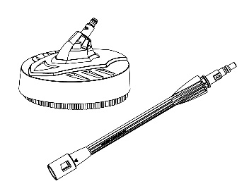

Warning: The extension (16) must only be used with the surface cleaner (17). The surface cleaner can not be used without the extension as shown below:
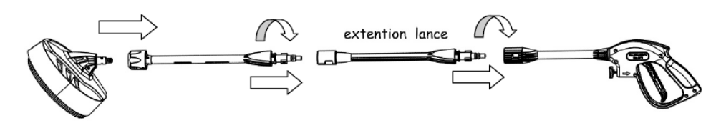
When using the surface cleaner, the extender must be attached to the spray gun as shown below:
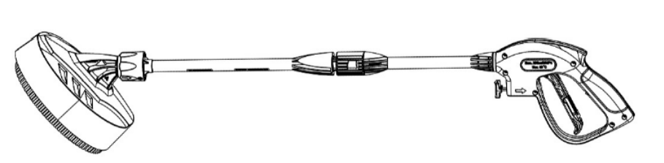
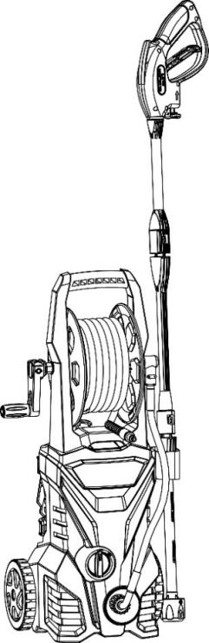
Warning: The extension (16) with the spray gun cannot be stored inside the hook as described above, as this may cause the machine to tip over.

Completing the cleaning

- Switch off the pressure washer with the operating switch (5) and press "OFF" to unplug the plug.
- Turn off the water supply and remove the device from the water drain.
- Operate the spray gun (10) until the device is no longer pressurized.
- Lock the trigger (19) of the spray gun with the locking system (18).
- Disconnect the high-pressure hose from the gun by pressing the locking button (20) and pulling the hose downwards from the gun.
- Roll up the whole high-pressure hose onto the reel (2).
- Store the device in a safe place, temperate place out of reach of children.
- Before a long period without use and winter storage, operate the device for approx. 5 seconds without draining water and without connecting the high-pressure hose. The pump is thus emptied of as much residual water as possible and the risk of damage due to the possible presence of frozen water within the device is nearly inexistent.

Care and Maintenance

- Before carrying out any maintenance and repair work, disconnect the power plug.
- Clean the housing only with a dry cloth and do not use detergents that could attack the housing.
- Remove the dirt filter from the water connection (9), clean it under water and replace it.
- The supplied cleaning needle (15) is used to clean the nozzle. After each use of the pressure washer, push the cleaning needle (15) through the nozzle from the front to remove any foreign material or deposits in the nozzle.

Storage

- Proceed to its cleaning and remove the hoses and accessories before storage. Check that there isn't any water in the pipes.
- Place the power cable on its hook and wrap completely the high-pressure hose.
- Store the machine, hoses and accessories together in a safe and dry place, protected from moisture and frost.
- The machine should be stored in order to be out of the reach of children.
Warranty

We guarantee this product for 2 full years.
The warranty period for this item starts on the day of purchase. You can prove the date of purchase by sending us the original receipt.
We insure over the entire warranty period:

- Free repair of possible malfunctions.
- Free replacement of damaged parts.
- Including the free service of our specialized personnel (i.e. free assembly by our technicians)

Provided that the damage is not due to improper use of the device.

Elimination

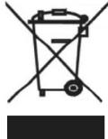
Used power tools and environmental protection

- If you ever use your electrical appliance so intensively that it must be replaced or if you no longer need it, you should dispose of it at a recycling centre.
- Information on the disposal of your electrical equipment can be obtained from local waste disposal companies or your administrative centres.
- Electrical appliances contain important recyclable raw materials. By bringing your electrical appliance to a recycling centre, you contribute to the reuse of valuable raw materials.
- Electrical appliances also contain elements which, if not disposed of properly, can cause damage to people and the environment.
- The symbol representing a crossed-out waste bin means that you are obliged to take the device involved to a sorting centre for electrical and electronic equipment for its recycling.


Declaration of conformity
HYUNDAI POWER PRODUCT
ZI, 32 rue aristide Bergès – 31270 Cugnaux - France
Declares that the machinery designated below:
HIGH-PRESSURE CLEANER
Ref.: HNHP1600-115AC
Serial number:
20180403841-20180405340
Complies with the provisions of the Directive “machinery” 2006/42/CE
and national laws transposing it:
Also complies with the following European directives:
EMC Directive 2014/30/EU
ROHS Directive 2011/65/EU
Directive on environmental noise emissions from equipment
intended for use outside buildings 2000/14/EC
Guaranteed sound power level: 98 dB(A)
Also complies with European standards, with national standards
and the following technical provisions:
EN 60335-1:2012+A11:2014
EN60335-2-79:2012
EN62233:2008
EN55014-1:2006+A1:2009+A2 :2011
EN55014-2:2015
EN61000-3-2 :2014
EN61000-3-3 :2013
Issued in Cugnaux, on 30/03/2018
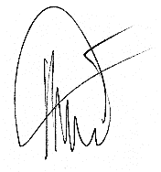Philippe MARIE / PDG



