Original Instructions >EN

1200W Tile Cutter
HCPR1200
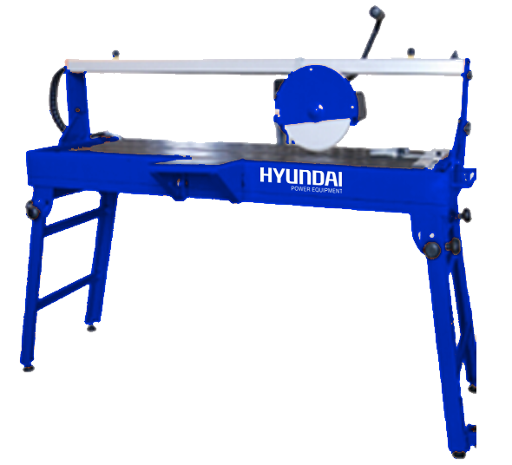


WARNING: Please read the manual carefully before using the unit!

HYUNDAI
32, rue Aristide Bergès - ZI 31270 Cugnaux – France
Licensed by Hyundai Corporation, Korea
PL

Introduction...
This manual was prepared in order to ensure user's safety. Please read it carefully before using the machine and keep it for future reference.

Your product
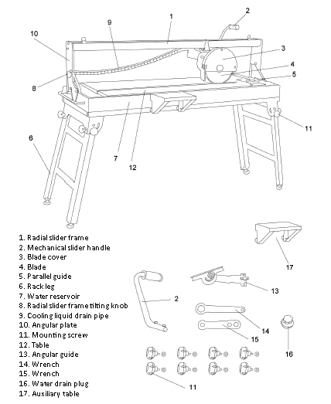EN

Specifications

>Voltage: 230 V ~ 50 Hz
>Rated input power: 1200 W S2 10 min
>No load speed: 2950/min
>Protection class: Class I
>Protection rating: IP54
>Blade dimensions: Ø230 x Ø25.4 x 2.4 mm
>Table dimensions: 950x390 mm
>Blade tilting range: 0º-45º
>Cutting depth at 90º-45 mm
>Cutting depth at 45º-42 mm
>Longitudinal cut: 920 mm
>Weight: 55 kg
Noise values
>Sound power level (LWA*):106 dB(A)
>Uncertainty KpA:3dB(A)
> Sound pressure level (LPA*): 93 dB(A)
>Uncertainty KwA: 3 dB(A)
Vibration level hand/arm: 3.6 m/s²
Uncertainty K: 1.5m/s²

The declared total vibration value was measured using standard test method and can be used for comparing tools. The declared total vibration value can also be used during initial exposure estimation.

WARNING: Depending on the actual way of using the tool, vibration values can be completely different from the declared values. The need of identifying personal protective equipment and operator protection is based on exposure estimation in actual working conditions (taking into consideration all parts of the work cycle, such as product downtime, idle work, and running time).

 | WARNING! Basic precautions should always be taken when using power tools in order to minimize risks of fire, electric shock and other injuries. Before using the machine please read all the provided instructions and keep them for future reference.

Symbols

CAUTION!!! DANGER
 RECOMMENDATION: USE HEARING PROTECTION
 RECOMMENDATION: USE EYE PROTECTION
 Not touch the blade of rotation
 Confirms compliance with all safety standards
 RECOMMENDATION READ THE MANUAL
 RECOMMENDATION USE PROTECTIVE GLOVES
 Do not dispose of old appliances with domestic rubbish .
General safety rules

WARNING! When using power tools, you should always take basic precautions in order to minimize risk of fire, electric shock, and other injuries. Before using the product please read all the provided instructions and keep them for future reference.

1. Keep the working area clean.
>Cluttered workbench and area around it invites accidents.
2. Please be aware of the conditions in the working area.
>Do not expose tools to rain.
>Do not use tools wet or damp places.
>Provide good lighting for the work place.
>Do not use tools around flammable liquids or gases.
3. Provide protection against electric shock.
>Avoid contact of body parts with grounded surfaces (such as pipes, heaters, furnaces, coolers).
4. Bystanders should keep away from the working area.
>Do not let any bystanders, especially children, or other people not taking part in the work activities, touch the tool, extension cord and keep them away from the working area.
5. Store tools appropriately when not in use.
>Tools that are not in use should be stored in a dry, isolated place out of the reach of children.
6. Do not overload the machine.
>Using device with a speed to which it was designed guarantees better and safer work.
7. Use only appropriate tools.
>Do not use small tools to perform heavy work. Do not misuse tools; for example do not use circular saws for cutting branches or trunks.
8. Dress accordingly.
>Do not wear loose clothing or jewellery, as they can get pulled by moving parts.
>When working outside, it is recommended to use anti slip footwear.
>Put protective cap on long hair.
9. Use protective gear.
>Put on protective goggles.
>If the work conditions demand it, use respiratory protection and face masks.
10. Connect dust removal equipment.
>If the tool allows the possibility of connecting dust removal and dust collecting equipment, please make sure that they are properly connected and used.
11. Never use the cord in a wrong way.
>Never pull the cord in order to unplug it.
>Keep the cord away from heat sources and sharp edges, protect from oil.
12. Protect yourself during work.
>Where possible, use vice to hold work pieces.
>It's safer than using hands.
13. Do not lean out.
>Keep good footing and good balance at all times.
14. Maintain tools with care
>Keep cutting tools sharp and clean, to make them work better and safer.
>Act according to the lubrication and accessory replacement recommendations. Check cords periodically, if damaged repair in an authorized service point. Check extension cords periodically and replace if damaged. Make sure to keep the handles clean and free of oil and grease.
15. Unplug tools.
>Unplug tools from power source when not in use, before servicing and during replacement of accessories, such as blades, drills and cutters.
16. Remember to collect wrenches and adjustment tools.
>Please have a habit of checking if adjustment wrenches are removed from the machine before turning it on again.
17. Avoid accidentally switching on the machine.
>When plugging in the machine, make sure the switch is in the “off” position.
18. Use extension cords designed for outdoor use.
>If the machine is used outdoors, use only extension cords designed to operate in such conditions and marked accordingly.
19. Always exercise caution.
>Maintain special attention, use common sense and do not use the machine when tired.
20. Check for damaged parts.
>Before running the tool again it should be thoroughly checked to determine if it can operate properly and that the execution of intended activities is possible.
>Check alignment of moving parts, fixing of moving parts, cracks, mounting method and all other conditions that could affect the machine's operation.
>If cover or other parts are damaged, they should be repaired or replaced in an authorized service point, unless this manual states otherwise.
>Change damaged switches in an authorized service point.
>Do not use the machine if a switch does not work.
21. Warning.
>Using accessories or attachments other than recommended in this manual can pose a risk of injury.
22. Machine repairs can only be performed only by a qualified professional.
>This power tool complies with relevant safety regulations.
Repairs should be carried out by qualified personnel using original spare parts, otherwise it can cause a significant risk to the user.

Specific safety rules

WARNING! When operating the machine it is recommended to use certified dust mask with replaceable filters.

>Please make sure that power tools are unplugged from power source, when not in use, before servicing, maintenance, or performing repairs and when replacing accessories, such as blades.
For cutting tiles use only impregnated diamond blades.
>Do not stop the blade by pressing the machine or pressing the blade laterally.
>Make sure to only use blades of appropriate type when working with the machine.
>Do not use blades that are bent or damaged, because it is very dangerous and can lead to a serious injury for the operator and bystanders, and damage the machine.
>Only use blades recommended by the manufacturer that are in good condition.
>Do not use blades bigger than stated in the manual; use blades that are exactly the same as the ones included with the machine. Rotational speed indicated on a blade should always be HIGHER than the speed of the machine.
>Please make sure, that the arrow mark on the blade is consistent with the direction of motor rotation. When replacing blades make sure that the flange surface smoothly adjoins the blade surface.
>Make sure, that the blade mounting bolt is tightened using included keys. Do not tighten too hard.
>You must not run the machine with blade touching the workpiece.
>Keep covers in their place and in good condition.
>Always keep blades in protective holders and clean flanges.
>Before cutting, please let the blade reach its full speed and let it run for a few seconds. In case of hearing unusual noise or experiencing noticeable vibration, immediately STOP the machine and investigate the cause.
>Never try to cut using free hand. Always make sure that the workpiece is securely pressed against the rear stop and table surface.
>Make sure, that the workpiece, that is being cut off has enough space to move to the sides.
>Otherwise you could cause the tile to break transversely to the blade. If the workpiece cannot be securely held by hand, use a jig or a clamp to keep it in place during cutting.
>Do not cut more than one piece at a time.
>Do not cut too small pieces, so you can safely press them against the rear stop using thumb and index finger. >Make sure that long worpieces are properly supported on both ends.
>Do not try to modify the machine or its accessories in any way.
>Do not push on the machine, let it work normally.
It will reduce wear of the machine.
>When using the machine put on approved hearing protection. In case of using angular guide, cuts should always be performed away from the operator.

WARNING! Do not cut material deeper than the maximum specified for the machine.
Unpack
WARNING! This package contains sharp objects. Be careful when unpacking. Two people are required for lifting, assembling and carrying the machine. Remove the machine from the packaging together with the included accessories.

>Carefully check and make sure that the machine is in a good condition and pay attention to all the accessories listed in this manual. You should also make sure that all the accessories are complete. If it turns out some parts are missing, the machine and the remaining elements should be returned to distributor in its original packaging.
>Do not discard the packaging, keep it for the entire warranty period and then, if possible, hand it over for recycling, otherwise dispose of it in the correct way.
>Do not let children play with empty plastic bags, due to the risk of suffocation.

WARNING! Do not connect the machine to power if it is incomplete. Not complying with this rule can lead to an accident and injuries.
o
Assembling rack legs
Unfold the four support legs (6) of the water reservoir (7) and tighten the screws of the four legs. Put the product on a flat surface.
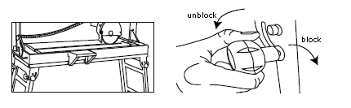

Installing angular guide
Mount the angular guide (13) on the parallel guide (5) using the mounting bolt.
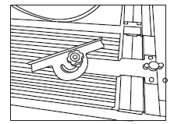
Placing the pump
Remove the table and place the pump in the water reservoir.
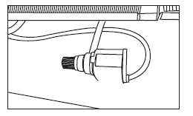

Installing water drain plug
Put the water drain plug (16) in the hole of the water reservoir.
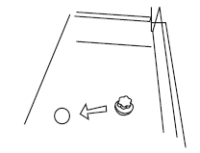

Installing mechanical slider handle
Mount the engine slider handle to the engine assembly frame and tighten the two bolts.

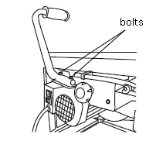

Installing auxiliary table
Mount the auxiliary table to the side of the water reservoir and set the two screws, to make sure that the auxiliary table and the main table on the same level.

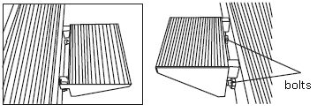

Filling the water reservoir
Fill the reservoir through the gap above the water pump, making sure that the pump inlet is fully submerged.
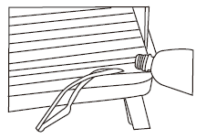
Starting and stopping
To start the machine, set the no-voltage switch in the “I” position.
To stop the machine, set the no-voltage switch in the “0” position.

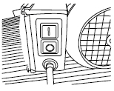

WARNING! Starting the machine will also make the cooling water pump run.

Connecting power
Put the plug in an appropriate socket.

WARNING! Check the voltage! The voltage must be consistent with the information given on the nameplate!

>The product is now ready to use.

WARNING! Do not use the product until it's safely mounted to a workbench.

Intended use
The tile cutting machine is designed exclusively for longitudinal and transverse cutting of ceramics, marble, clinker, etc. with square and rectangular cross sections. The machine is designed exclusively for we cutting. The included diamond circular blade is suitable for making cuts in ceramics, tiles, marble, fire bricks or clinker.
In order to cut granite or concrete slabs, a special purpose diamond blade will be required.

General operation rules
1. Cutting (fig.1)
Mark the cutting position on a workpiece; put the workpiece on the table, so that it perfectly adheres to the longitudinal guide (5) and adjust the workpiece to ensure the correct cut. Turn on the machine, grab the mechanical slider
handle and carry out the cut, smoothly moving the motor-blade assembly along the workpiece.
Note: Do not push on the blade, so it can cut with constant speed.
Warning! In order to ensure precision, clean the work surface before cutting.

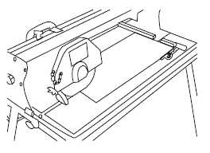
Fig. 1

WARNING! In order to ensure precision, clean the work surface before cutting.

2. Performing angular cut (fig. 2)
Repeat the same procedure as for straight cut, but additionally use the diagonal guide with the rear stop. Before performing the cut, make sure that the tile is firmly attached in the guide.

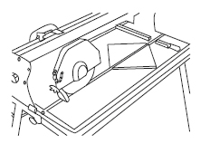
Fig. 2
L
3. Performing tilted cut (fig. 3)
Repeat the same procedure as for straight cut, but additionally tilt the cutting head by loosening two radial slider tilt knobs (8). Radial slider mechanism can then be tilted to the required position by referring to the angular guide on the angular plate (10). Before performing the cut, make sure that the tile is firmly attached.

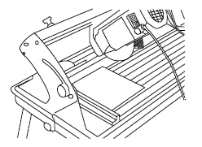
Fig. 3

4. Performing mixed cut (fig. 4)
Mixed cut is a combination of angular cut and tilted cut. To perform this action you need to follow the instructions for the angular cut and the tilted cut.

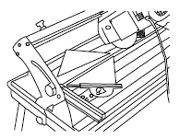
Fig. 4

After work
When all the activities related to cutting are finished, turn the machine off and unplug it, let it cool down and, before storing it, it is recommended to thoroughly clean it. Empty the water reservoir and remove from the reservoir and the table any dust deposits remaining after cutting tiles.

Golden rules of caring for the machine
1. Make sure that the power cord is not damaged.
2. Only use blades recommended by the manufacturer that are in good condition.
3. Repairs can only be performed only by a qualified professionals.
4. Completely fill up the water reservoir.
5. Clean the table before cutting.

Changing the blade
In order to remove the blade take off the front cover by removing four fixing screws (fig. 4) (4.1). Using wrenches of appropriate sizes (14, 15), use one to hold the motor shaft and the other to remove the nut securing the blade (fig. 5) (5.1). Take off the retainer flange of the blade. Thoroughly clean both flanges and rotating motor shaft and put the blade back on,
by repeating the removal procedure in reverse.

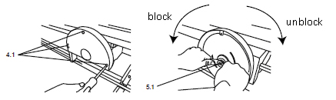

WARNING! Before carrying out maintenance or adjustments, the machine must be unplugged from power.
Cleaning
Empty the water reservoir and remove from the reservoir and the table any dust deposits remaining after cutting. Clean the tile cutter using clean, dry cloth. From time to time, depending on the degree of dust deposit accumulation, clean the water pump, making sure that filters are clean and not clogged.

Repair
This product does not contain any parts that could be repaired by the customer. For service and repairs turn to a qualified professional.
Power supply
If the power cord is damaged, it must be replaced by the manufacturer, its service agent or similarly qualified person, which will allow to avoid any risks.

Transportation
1. Before transporting and moving the product to any other location, turn it off and unplug the power.
2. Install transport covers, if applicable.
3. Protect the product from strong impacts or strong vibrations, that can occur during vehicle transport.
4. Protect the product from slipping and falling over.

Storage
1. Clean the product as described above.
2. Store the product and its accessories in a dry, frost-free place.
3. Always store the product in a place out of reach of children. The perfect storage temperature is between 10 and 30°C.
4. We recommend using the original packaging for storing the product or covering it with an appropriate cloth, to protect it from dust.

Troubleshooting
It is suspected, that faults are often caused by reasons that users can remove by themselves. That is why the product should be checked using this section. In most cases the problem can be quickly resolved.

Problem | Possible cause | Solution
1. Product does not start | 1.1. Power not connected  1.2. Damaged power cord or plug  1.3. Other electrical fault of the product | 1.1. Connect the power  1.2. Check by a qualified electrician  1.3. Check by a qualified electrician
2. Product does not reach full power | 2.1. Extension cord not suitable for the product  2.2. Power supply (eg. generator) voltage too low  2.3. Vents are blocked | 2.1. Use a suitable extension cord  2.2. Connect to another power supply  2.3. Clear the vents
3. Unsatisfactory work results | 3. Accessory not suitable for the material | 3. Use a suitable accessory



Declaration of conformity
HYUNDAI
ZI, 32 RUE ARISTIDE BERGES – 312070 CUGNAUX – FRANCE
Declares that the machinery designated below :
1200W Tile Cutter
Model : HCPR1200
Serial number : 20170504951-20170505146
Complies with the provisions of the Directive « machinery » 2006/42/CE and national laws transposing it :
Also complies with the following European directives :
EMC Directive 2014/30/EU
ROHS Directive 2011/65/EU
Also complies with European standards, with national standards and the following technical provisions :
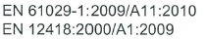
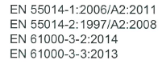
Done at Cugnaux, 21/02/2017
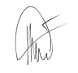

Philippe MARIE / PDG

