

Electric smoother
FTE710
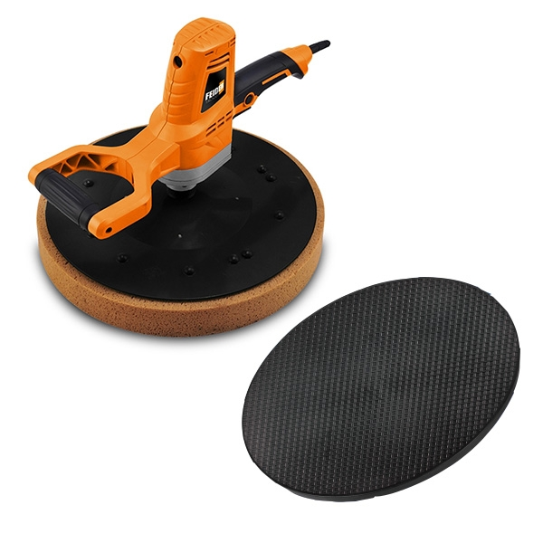

WARNING: READ THESE INSTRUCTIONS BEFORE USE THIS MACHINE

FEIDER France
32, rue Aristide Bergès-ZI 31270 Cugnaux, France

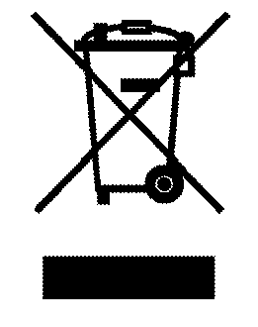

Please read carefully before use 

Safety regulations
Warning! Read all warnings and instructions! Use or operate without following warnings and instructions will cause electric shock, fire and / or serious injury. In all of the following warnings, the term "power tools" refers to the electric drive (wire) power tools or battery powered (wireless) power tools.
1) Keep these safety instructions in a safe place!
a) Keep the workplace clean and bright, chaotic and dark areas will cause accidents.
b) Do not operate electric tools in explosive environment, such as flammable liquid, gas or dust. The spark generated by an electric tool ignites the dust or gas.
c) Let the children and bystanders leave after the operation of electric tools. Lack of concentration can make you lose control of your tools.
2) Electrical safety
a) Power tool plugs must match the socket. Never change the plug in any way. Electric power tools to be grounded shall not use any changeover plug. The non - modified plug and matching socket will reduce the risk of electric shock.
b) Avoid contact with the ground surface, such as pipes, heat sinks and refrigerators. If your body grounding increases the risk of electric shock.
c) Do not expose electric tools to rain or wet conditions. Water into electric tools will increase the risk of electric shock.
d) No abuse of wire. Never use wire to carry, pull electric tools or pull out the plug. Keep wires away from heat, oil, sharp edges or moving parts. Damaged or winding cords increase the risk of electric shock.
e) When using power tools outdoors, use external flexible cords for outdoor use. Suitable for outdoor use will reduce the risk of electric shock.
f) If it is unavoidable to operate an electric tool in a wet environment, the residual current operated protective device (RCD) should be used. Using RCD can reduce the risk of electric shock.
3) Personal safety
a) Stay alert, pay attention to the operation and stay awake when operating the power tools. When you feel tired, or when there is a drug, alcohol or treatment response, do not operate electric tools. An inadvertent omission in the operation of an electric tool can cause serious bodily injury.
b) Use personal protective devices. Always wear goggles. Safety devices, such as the use of dust masks, anti slip safety shoes, safety helmets, hearing protection and other devices under appropriate conditions can reduce personal injury.
c)Prevent accidental start. Make sure that the switch is in the off position when connecting the power supply and / or battery case, picking up or carrying the tool. Insert the plug into the socket when the switch is off and the power is off.
d) Remove all key or wrench before power tool is turned on. The wrench or key left on the rotating part of the power tool will cause personal injury.
e)Don't stretch too long. Always pay attention to footing and body balance. In this case, the electric tool can be well controlled.
f) Dress appropriately. Do not wear loose clothing or jewelry. Keep your clothes, gloves and hair away from the moving parts. Loose clothes, accessories or may be caught in moving parts in the long hair.
g)If a device is provided for connection with the dust removing and dust collecting equipment, make sure they are in good condition and use properly. The use of these devices can reduce the risk of dust.
4) Power tool use and precautions
a)Do not abuse the power tools, according to the use of appropriate power tools. Choosing the right tools will make you work more efficiently and safely.
b) If the switch does not turn on or off the power supply, the power tool cannot be used. Electric tools that cannot be controlled by switches are dangerous and must be repaired.
c) The plug and / or the battery box and the tool must be removed from the power supply before any adjustment, replacement, or storage of the power tool is carried out. This protective measure will reduce the risk of accidental start of the tool.
d) Store unused electric tools outside the reach of children, and do not let people who are not familiar with the power tools or those who do not understand the operation of electric tools. Electric tools are dangerous in the hands of untrained users.
e) Maintenance of power tools. Check whether the moving parts are in place or stuck, check the damage of the parts and other conditions that affect the operation of the power tools. In case of damage, power tools should be repaired before use. Many accidents are caused by poor maintenance of electric tools.
f) Keep cutting tools sharp and clean. A well-maintained tool with a sharp edge is easy to hold and control.
g) The use of power tools, accessories, and tools in accordance with the instructions, taking into account the operating conditions and the work carried out. The use of electric tools for operations that do not conform to their use may cause danger.
5) Repair
a) Send your power tools to professional maintenance personnel and repair them with the same spare parts. This will ensure the safety of the power tools to be repaired.
According to the safety rules of the coarse polishing machine
􀁦 The machine can be used for dry grinding. If rain seeps into an electric machine, it can cause an electric shock.
􀁦 Make sure that the work area is not dusty, clean the dust from the machine and the suction hose. The accumulation of dust in the bag, in the pipe can easily affect the performance of the machine.
􀁦 Workplace must be kept clean. The different work dust is easy to produce chemical reaction after mixing. Light metal dust likely to cause fire or explosion.
􀁦 Do not use power tools that have been damaged. If the power cord is damaged in the work, do not touch the damaged wire, and immediately unplug the plug. Damaged wires can increase the risk of electric shock.
􀁦 During operations, hold the handle, do not put your hands on the surface to be worked, the hands should not touch the sanding surface.

Functional explanation
Read all warnings and instructions. Failure to comply with warning signs and instructions may cause electric shock, fire and / or other serious injury.
Use machines in accordance with regulations
DMJ-700F-5 grinding machine, design and production of two types of power tools, product safety and quality indicators according to GB3883.1 standards.
The utility model is characterized in that the utility model has the advantages of series excitation motor drive, light weight, large power, high efficiency, convenient operation, safety, etc.. The utility model is suitable for wet grinding on the concrete surface of the building walls, ceilings, etc., and the surface of the sand and stone walls, and the surface of the paint and cement.
Technical data
Rate Voltage 230~240(V)
Rate Frequency 50（Hz）
Rate input power 710(W)
Sanding speed 110(r/min)
Pad Size φ390(mm)

Product sketch
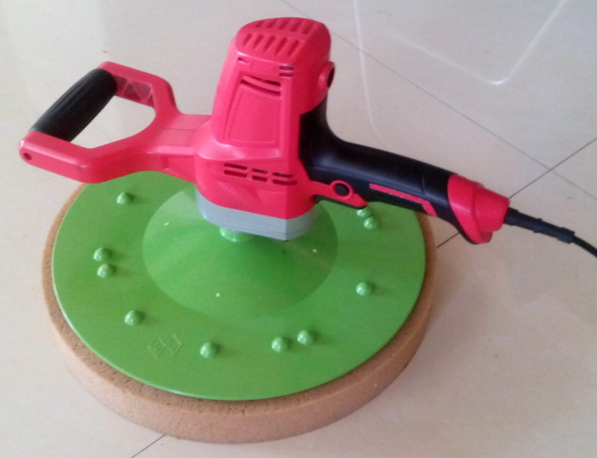

Assemble
􀁦 Be sure to pull the plug out of the socket before repairing or replacing the spare arts.

Replace grinding disk
The utility model is characterized in that the utility model is characterized in that a sponge disc, a plastic grinding disk and a plastic disk sticking plate are bonded together by a magic paste.
漠

敥⁰

Maintenance
Keep the tools clean, clean up the sundries and dust.
Often add grease (deceleration box) to keep the tool running flexible.
Check the power cord, plug, switch and so on to keep the tools in good condition.
The company's production of power tools are subject to strict quality inspection, if the machine is still in trouble, please turn the machine to the company's authorized customer service repair.
Carbon Brush replacement
There is a pair of auxiliary brushes in the random accessories. When the brush is worn to the limit, the brush should be replaced. Use the "one" screwdriver to reverse the brush cover counterclockwise, remove the original brush, fit the new brush into the brush holder and screw the cover.
j5

Operation Chart
ﱟᘀ

1. Install plastic adhesive tray (plastic adhesive disc on the output shaft, and then use a M6*12 cross countersunk head bolt fixed)
䩐

䩡2. Install the plastic grinding disc (glue the plastic polishing plate to the plastic adhesive plate)
䵨

3. Install the sponge tray (attach the sponge tray to the plastic plate)
6

Declaration of conformity

FEIDER FRANCE
ZI, 32 RUE ARISTIDE BERGES – 312070 CUGNAUX – France

States that the designated below machine:
Product: Electric smoother
Model: FTE710
Serial number:

Developed, designed and manufactured in accordance with the requirements of directives:
Machinery Directive 2006/42/EC
EMC Directive 2014/30/EC
ROHS Directive 2015/863/EU

Also meets the following standards:
EN 55014-1:2006/A2:2011
EN 55014-2 :2015
EN 61000-3-2 :2014
EN 61000-3-3 :2013

Responsible of the technical file: Olivier Patriarca

Philippe MARIE / PDG
Cugnaux, 01/03/2018



