Original Instructions >EN



**800W Tile Cutter**

**FST818**

**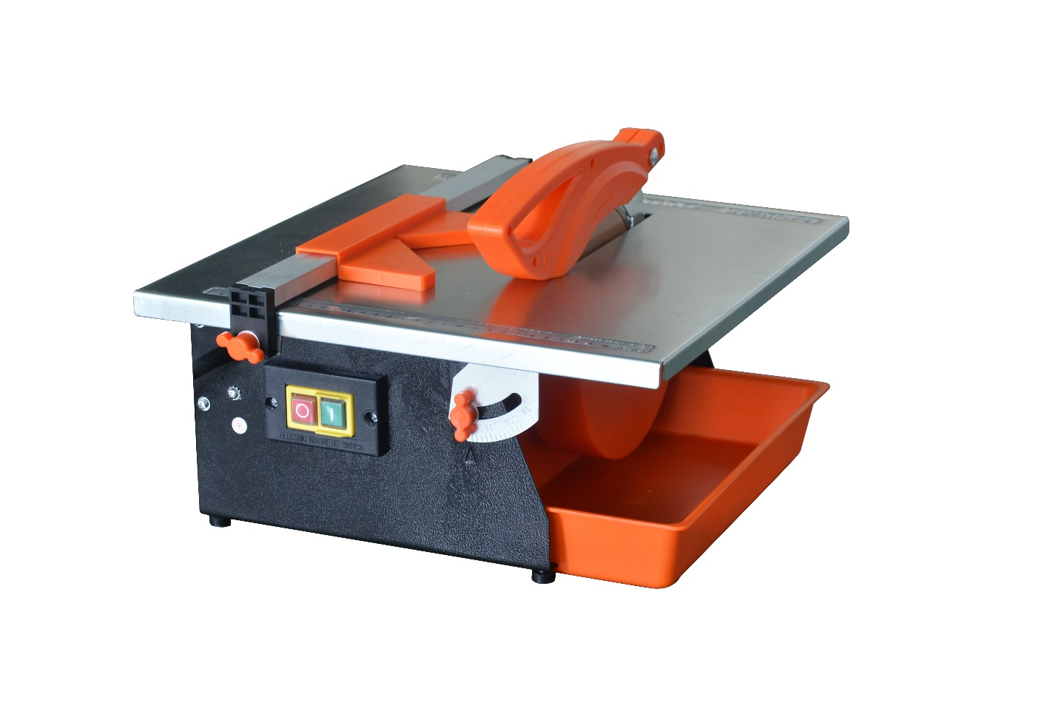**

**WARNING: Please read the manual carefully before using the unit!**

**FEIDER**

**ZI, 32, rue Aristide Bergès - ZI 31270 Cugnaux – France**

****

**1. Safety Instructions**

**WORK AREA SAFETY**

1. Keep work area clear. Clutter areas and benches invite injuries.

2. Consider work area environment. Do not expose tools to rain. Do not use tools in damp or wet locations. Keep work area well lit. Do not use tools in the presence of flammable liquids or gases.

3. Guard against electric shock. Avoid body contact with earthed or

grounded surfaces (e.g. pipes, radiators, ranges, refrigerators).

4. Keep other persons away. Do not let persons, especially children, not involved in the work touch the tool or the extension cord and keep them from the work area.

5. Store idle tools. When not in use, tools should be stored in a dry locked- up place, out of reach of children.

6. Do not force the tool. It will do the job better and safer at the rate for which it was intended.

7. Use the right tool. Do not force small tools to do the job of a heavy-duty tool. Do not use tools for purposes not intended; for example, do not use circular saws to cut tree limbs or logs.

8. Dress properly. Do not wear loose clothing or jeweler, they can be caught in moving parts. Non-skid footwear is recommended when working outdoors. Wear protective hair covering to contain long hair.

9. Use protective equipment. Use safety glasses. Use face or dust mask if working operations create dust.

10. Connect dust extraction equipment. If the tool is provided for the connection of dust extraction and collecting equipment, ensure these are connected and properly used.

11. Do not abuse the cord. Never yank the cord to disconnect it from the

socket, keep the cord away from heat, oil and sharp edges.

12. Secure work. Where possible use clamps or a vice to hold the work. It is safer than using your hand.

13. Do not overreach. Keep proper footing and balance always.

14. Maintain tools with care. Keep cutting tools sharp and clear for better and safer performance. Follow instruction for lubricating and changing accessories. Inspect tool cords periodically and if damages have them repaired by an authorized service facility. Inspect extension cords periodically and replace if damaged. Keep handles dry, clean and free from oil and grease.

15. Disconnect tools. When not in use, before servicing and when changing accessories such as blades, bits and cutters, disconnect tools from the power supply.

16. Remove adjusting keys and wrenches. From the habit of checking to see that keys and adjusting wrenches are removed from the tool before turning it on.

17. Avoid unintentional starting. Ensure switch is in “off” position when plugging in.

18. Use outdoor extension leads. When the tool is used outdoors, use only extension cords intended for outdoor use and so marked.

19. Stay alert. When what you are doing, use common sense and do not operate the tool when you are tired.

20. Check damaged parts. Before further use of tool, it should be carefully checked to determine that it will operate properly and perform its intended function. Check for alignment of moving parts, binding of moving parts, breakage of parts, mounting and any other conditions that may affect its operation. A guard or other part that is damaged should be properly repaired or replaced by an authorized service center unless otherwise indicated in this instruction manual. Have defective switches replaced by an authorized service center. Do not use the tool if the switch does not turn it on and off.

21. WARNING! The use of any accessory or attachment other than one recommended in this instruction manual may present a risk of personal injury.

22. Have your tool repaired by a qualified person. This electric tool complies with the relevant safety rules. Repairs should only be carried out by qualified persons using original spare parts, otherwise this may result in considerable danger to the user.

**ADDITIONAL SAFETY INSTRUCTIONS FOR YOUR TILE CUTTER**

1. Set up the machine on a level, non-slip surface. Make sure that the machine does not wobble.

2. Check that the voltage on the rating plate is the same as your supply voltage. Only then are you to insert the power plug in the socket outlet.

3. Always wear both eye and ear protection when using the machine. Ensure that the directional arrow marked on the blade corresponds with the rotational direction of the motor.

4. Wear safety gloves.

5. Never use cracked blade. Replace immediately.

6. Never use segmented blade.

7. Caution! The blade runs on after the machine is switched off!

8. Never apply side pressure to the blade to bring it to a halt.

9. Caution! The blade must be cooled with water at all times.

10. Always pull out the power plug before changing the blade.

11. Use only suitable blade.

12. Never leave the machine unattended in rooms with children.

13. Always pull out the power plug before examining the electric motor compartment system.

14. Remove the mains plug from socket before carrying out any adjustment, servicing.

15. If the supply cord is damaged, it must be replaced by the manufacturer, its service agent or similarly qualified persons to avoid a hazard.

16. With the machine disconnected from the power supply, rotate the blade by hand to ensure it is free from obstruction.

17. Always keep the blade securing arbor and collars clean.

18. Ensure that the blade-securing bolt is securely tightened with a suitable wrench.

19. Never try to cut freehand. Always ensure that the tile to be cut is pressed firmly against the parallel side fence.

20. Ensure that the work piece to be cut off has sufficient room to move sideways. Failure to do so may result in the off-cut binding against the blade.

21. Never cut more than one tile at a time.

22. Never cut pieces too small to be held securely against the side fence without leaving enough space for the hand to be a safe distance from the blade.

23. Ensure that the table and surrounding area are clear except for the tile to be cut.

24. Never fit substandard blades to the machine. Only fit correctly sized diamond blades.

25. Only use continuous rim diamond cutting-off wheel designed for cutting tiles.

26. Do Not use blades that are larger than specified, only use blades that are rated for the machine. The rotational speed shown on the blade should always be higher than the rotational speed of the Machine.

- Ensure that the directional arrow marked on the blade corresponds with the rotational direction of the motor. Whenever replacing blades ensure that the surface of the blade collar fits snugly against the surface of the blade.

- If the work piece cannot be held securely by hand, then use the jig or clamp to hold it in place whilst it is being cut.

- Never cut pieces that are too small to be held securely against the back fence with the thumb and index finger.

- Ensure that long work pieces are adequately supported at both ends.

- Keep the handles dry and free of grease. Slippery handles can lead to accidents.

Prevent overheating of the device and the work piece. Excess heat may damage the tool and the device.

> Shortly after being used, the tool may be very hot. Allow a hot tool to cool down. Touching a hot tool may cause burns.

> Never clean a hot tool with flammable liquids. There is a risk of fire and explosion.

> Store the unused power tool safely in a dry place that can be locked. This ensures that the power tool is not damaged because of storage and inexperienced persons do not operate it.

> Never leave the power tool before it has come to a complete standstill. Tools that continue to operate may cause injury.

26. Before cutting a tile, let the cutter blade run freely for a few seconds. If it makes an unfamiliar sound or vibrates excessively switch it off immediately and disconnect from the power supply. Investigate the cause or consult a qualified person for advice.

27. Let the blade reach full speed before commencing the cut.

28. Do not force the blade to cut the tile.

29. Let the blade come to a complete stop before removing any jammed or off cut material from around the blade area.

30. Use a residual circuit breaker on all 230V Power tools. This can help minimize the risk of an electrical shock if an earth fault or short circuits occurs.

31. If using a power cable extension, ensure that the cable is fully unwound and that its length is less than 30m. Lengths over 30m will affect the tools performance as a result of voltage drop.

32. To avoid the possibility of the tool plug or receptacle getting wet, position tile cutter away from receptacle and plug. The user should arrange a “drip loop” in the cord connecting the cutter to a receptacle. The “drip loop” is that part of the cord below the level of the receptacle, or the connector if an extension cord is used, to prevent water traveling along the cord and coming in contact with the receptacle.

33. If the plug or receptacle does get wet, DON’T unplug the cord. Disconnect the fuse or circuit breaker that supplies power to the tool. Then unplug and examine for presence of water in the receptacle.

34. If an extension cord is used, the drip loop must be before the cord connection and the extension cord connection must be placed on an elevated surface.

35. Secure work firmly against the miter guide or fence.

36. Never stand or have any part of your body in line with the path of the blade.

37. Never attempt to free a stalled blade without first turning the cutter OFF and disconnecting the cutter from the power source.

38. Avoid awkward operations and hand positions where a sudden slip could cause your hand to move into the cutting tool.

39. Make sure the work area has ample lighting to see the work and that no obstructions will interfere with safe operation before performing any work using the cutter.

40. Always turn off cutter before disconnecting it, to avoid accidental starting when reconnecting to power supply.

41. Do not operate with any guard disabled, damaged, or removed. Moving guards must move freely and close instantly.

42. The use of accessories or attachments not recommended by the manufacturer may result in a risk of injury to persons.

43. When servicing use only identical replacement parts.

44. Maintain labels and nameplates on the tool. These carry important safety

information.

45. For your own safety, read instruction manual before operating tile cutter:

• Wear eye, hearing, and breathing protection.

• Use wheel guard for every operation for which it can be used.

• Disconnect cutter before servicing, when changing blade and cleaning.

• Use tool only with smooth edge blade free of openings, grooves and teeth.

• Replace damaged blade before operating.

• Do not fill water tray above Max. water fill line.

1. **Assembly**

**SYMBOLS**

|  |  |  |  |
| --- | --- | --- | --- |
|  | Read the instruction manual |  | Wear safety gloves |
|  | Wear Safety shoes |  | Wear eye protection |
|  | Wear hearing protection |  | Wear a dust mask |
|  | Do not expose to rain | **C:\Users\Xiaodong_Zhang\Desktop\符号标准\当心割手.png** | Caution, risk of cutting |
|  | Disconnect main power before Maintenance |  | Continuous rim diamond cutting-off wheel ONLY! |
|  | This symbol warns of damage to the machine, environment or propert. | | |
| M42E06BG`V2K1T_{T{)@14P | The product complies with the applicable European Directives and an evaluation method of conformity fort this Directives was done | | |
| 3 | Take a power tool in the domestic waste! In accordance with European Directive 2012/19/EU on waste electrical and Electronic equipment and its implementation in national law, electric tools collected separately and environmentally friendly recycling is fed. Take advantage of the collection facilities. Ask your local government for the collection systems. If electrical appliances are disposed of, can be poisoned for years while the cause hazardous substances into the groundwater and entering the food chain, or flora and fauna | | |

1. **Product description**

**TECHNICAL SPECIFICATIONS**

Voltage: 230-240V~,50Hz

Rated input: 800W S2 10min

No-load speed: 2950min-1

Protection class: IPX4

Blade size: Ø180xØ22.2x2.2mm

Dimensions of table: 385x 395mm

Blade tilting range: 0°-45°

Depth of cut @90°: 34mm

Depth of cut @45°: 18mm

Mass of tool: 11.05kg

NOISE DATA

Sound power level (LWA\*):105 dB(A)

Uncertainty KPA :3dB

Noise pressure level (LPA\*):92dB(A)

Uncertainty KWA:3dB Vibration value <2.5 m/s2))

S2 corresponds to an operating time in minutes at the power given. For example, S2 10 minutes; This operation must be followed by a rest period to allow cooling the motor and optimizing the life of the machine.

- The level of acoustic intensity perceived by the user may exceed

92dB (A), making it necessary to use a noise-canceling headset.

- The total declared value of vibration has been measured in accordance with a standard test method and may be used for comparing one tool to another.

- The declared total value of vibrations can also be used to a preliminary

assessment of exposure.

- The vibration emission during actual use of the power tool can differ from the declared total value depending on the ways in which the tool is used; and of the need to identify safety measures to protect the operator that are based on an estimation of exposure in the actual conditions of use (taking account of all parts of the operating cycle such as the times when the tool is switched off and when it is running idle in addition to the trigger time)

**MACHINE PARTS (FIG A&B)**

❶. Table

❷. Disc

❸. Dividing knife

❹. Protective guard

❺. On/off switch

❻. Water tub

❼. Parallel guide rods

❽. Angle guide-

11. Adjustment of angle

13. Thermal protection

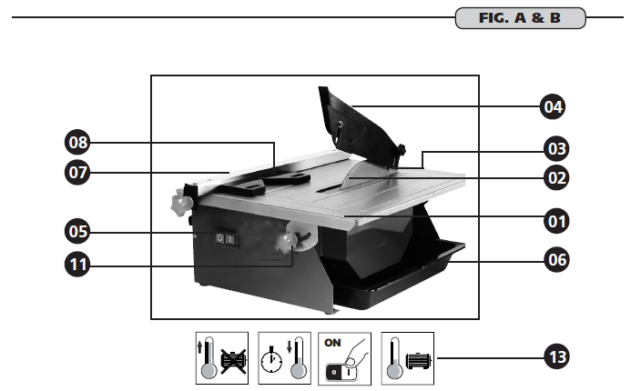

**CONTENTS OF BOX (FIG.C)**

**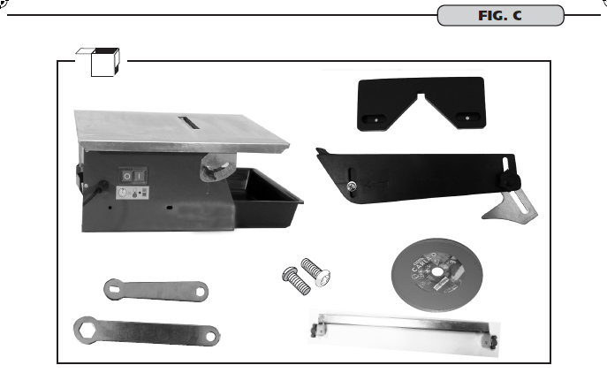**

**ASSEMBLING THE MACHINE (FIG.D**

**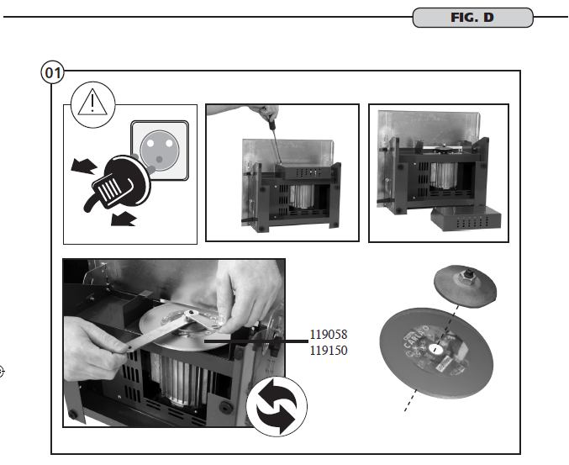**

**Mounting of disc (➀)**

****

**Mounting of dividing knife/ Mounting of guard (➁&➂)**

**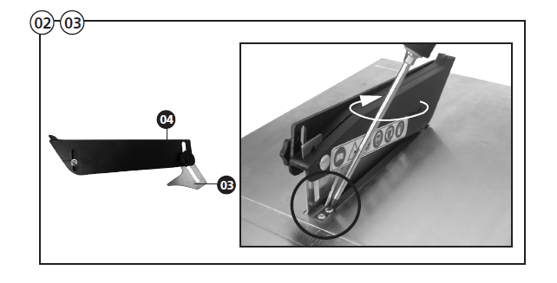**

**Mounting of the guides (➇)**

**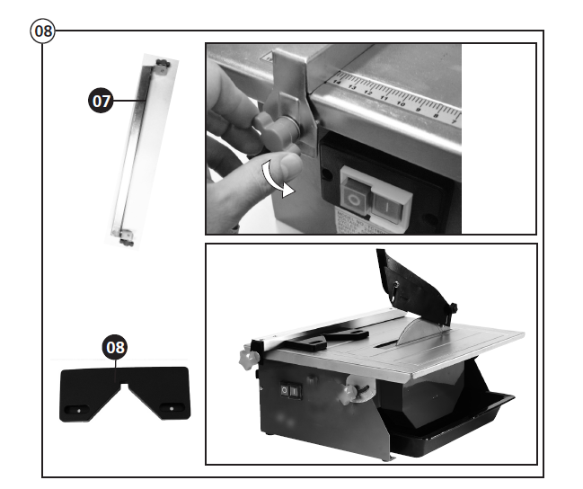**

**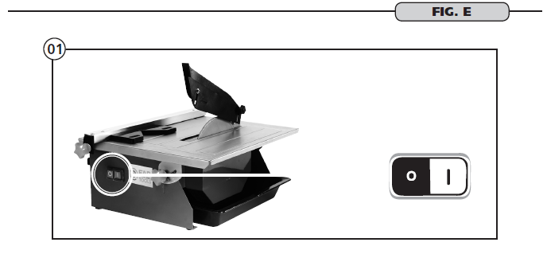FUNCTION OF THE MACHINE (FIG E)**

**Start-up(➀)**

****

**Angle of the table (➁)**

**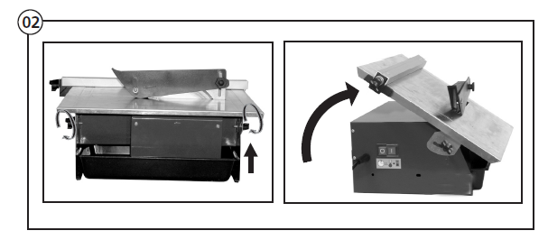**

**Fix the water tub and Placing in water (➂)**

**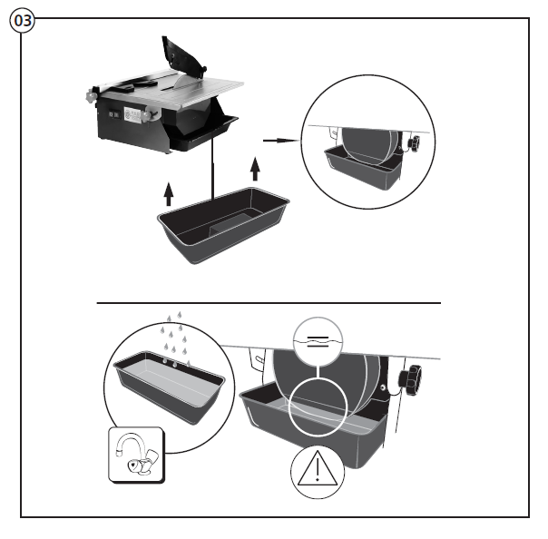**

**How to make a straight cut& How to make an angled cut (➄&➅)**

**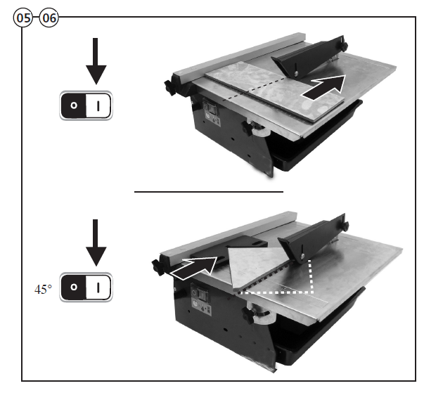**

1. **Use**

**INTENDED USE**

The electric tile cutter is designed for making straight and mitre cuts in ceramic tiles in accordance with the operating instructions and may not be used for any other purpose. The tile cutter is designed for DIY use only and is not suitable for commercial use or heavy duty use on building sites etc.

The manufacturer cannot be held responsible for damage or injury caused by using the machine for other than its intended purpose. Only continuous rim diamond blades which are suitable for the machine can be used.

Non-observance of the safety, assembly and operating instructions while operating the machine counts as misuse. Anyone who operates or services the machine must be familiar with these instructions and must be aware of possible dangers. Any applicable health and safety regulations must be followed.

The machine may not be modified. The manufacturer can accept no responsibility for damage or injury caused by modifications to the machine.

**GENERAL OPERATION**

Check to make sure the device is in safe operating condition:

• Check to make sure there are no visible defects.

• Check to make sure all device components are correctly mounted.

• Check to make sure the safety mechanisms are functioning properly.

• Check the function of switch.

• Check the cooling water level is sufficient.

• Check the working area is clear of obstructions.

Never reach into the work area of the rotating cutting wheel when the machine is running, apart from the operator nobody shall be within in the working area.

**WARNING!** Wait until the cutting shaft has reached its Maximum rotational speed and the cutting surface of the cutting wheel is supplied with cooling water before starting to cut.

**AFTER USING**

When all cutting has been completed, switch off the machine and disconnect power supply. After allow the machine to cool, and before storing, it is advisable to thoroughly clean the machine. Empty the water tank and clean away any tile slurry from inside the tank and on the table.

**4. Care & Maintenance**

1. Make sure the power cord is not damaged.

2. Only use blades that are recommended by the supplier and that are in good condition.

3. Repairs should be carried out by a professional.

4. The water tank must be fully filled between max. and min. water mark.

5. Clean the table before cutting.

MAINTENANCE

For safety reasons, each damaged (cracked) tool has to be replaced before using. Have all other work, in particular repairs, conducted by a trained technician. If the supply cord is damaged, it must be replaced by the manufacturer, its service agent or similarly qualified persons in order to avoid a hazard. Improperly performed work may cause damage to the machine and result in injury.

Prior to any maintenance and/or cleaning:

• Switch the machine off

• Let the machine cool down

• Pull out the plug.

• Empty the water tank and clean away any tile slurry from inside the tank and on the table.

• Clean the tile saw with a clean dry cloth from time to time depending on

the slurry accumulation.

1. 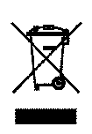**Recycling and Disposal**

Waste electrical products should not be disposed of with household waste. Please recycle where facilities exist. Check with your Local Authority or retailer for recycling advice.

1. **Repair**

This product does not contain any parts that can be repaired by the consumer. Contact an authorized service center or a similarly qualified person to have it checked and repaired.

1. **Storage**

• Switch the product off and disconnect it from the power supply.

• Clean the product as described above.

• Store the product and its accessories in a dark, dry, frost-free, well-

ventilated place.

• Always store the product in a place that is inaccessible to children. The

ideal storage temperature is between 10°C and 30°C.

• We recommend using the original package for storage or covering the product with a suitable cloth or enclosure to protect it against dust.

**8. Transportation**

1. Switch the product off and disconnect it from power supply before transportation.

2. Attach transportation guards, if applicable.

**3. Protect the product from any heavy impact or strong vibrations which may occur during transportation in vehicles.**

**4. Secure the product to prevent it from slipping or falling over.**

**9. Trouble Shooting**

Suspected malfunctions are often due to causes that the user can fix themselves. Therefore, check the product using this section. In most cases the problem can be solved quickly.

|  |  |  |
| --- | --- | --- |
| Problem | Possible cause | Solution |
| 1. Product does   not start | 1.1 PRCD protection  1.2 Not connected to power supply  1.3 Power cord or plug is defective  1.4 Other electrical defect  to the product | 1.1. Press the RESET Button  1.2 Connect to power supply  1.3 Check by a specialist  electrician.  1.4 Check by a specialist  electrician |
| 1. Product does   not reach full  power | 2.1 Extension cord not suitable  for operation with this product  2.2 Power source (e.g.  generator) has too low voltage  2.3 Air vents are blocked | 2.1Use a proper extension cord  2.2. Connect to another power source  2.3. Clean the air vents |
| 1. Unsatisfactory   result | 3.1 Accessory not suitable  for work piece material | 3.1. Use proper accessory |

**Declaration of Conformity**

We

**FEIDER**

**ZI, 32 RUE ARISTIDE BERGES – 312070 CUGNAUX – FRANCE**

Declare that the product:

Designation:800W Tile Cutter FST818

Serial number:

Complies with the essential health and safety requirements of the following Directives

EC Machinery Directive 2006/42/EC

The EMC Directive 2014/30/EU

2011/65/EU Restrictions of the Use of Certain Hazardous Substances in

Electrical and Electronic Equipment

2012/19/EU Waste Electrical and Electronic Equipment (WEEE)

Standards and technical specifications referred to:

EN 61029-1:2009/A11:2010

EN ISO 12100:2010

AfPS GS 2014:01 PAK

EN 55014-1:2006/A2: 2011

EN 55014-2:2015

EN 61000-3-2:2014

EN 61000-3-3:2013

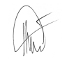Done at Cugnaux, 1003/2017

Philippe MARIE / PDG