

Please read this handbook carefully before using the tool

Intended use

This power tool is intended to be used for drilling holes and tightening or unscrewing screws.
This power tool may not be used to do other thing out of the described scope.

Explain the symbol:

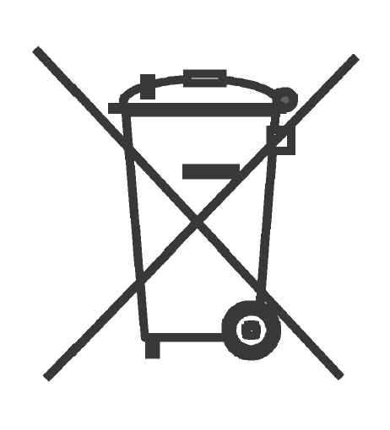 | Waste electrical products should not be disposed of with household waste. Please recycle where facilities exist. Check with your local authority or retailer for recycling advice.
 | “warning – To reduce the risk of injury, user must read instruction manual”
 | In accordance with essential applicable safety standards of European directives

General Power Tool Safety Warnings
WARNING Read all safety warnings and all instructions. Failure to follow the warnings and instructions may result in electric shock, fire and/or serious injury.
Save all warnings and instructions for future reference.
The term "power tool" in the warnings refers to your mains-operated (corded) power tool or battery-operated (cordless) power tool.

1) Work area safety
a) Keep work area clean and well lit. Cluttered or dark areas invite accidents.
b) Do not operate power tools in explosive atmospheres, such as in the presence of flammable liquids, gases or dust. Power tools create sparks which may ignite the dust or fumes.
c) Keep children and bystanders away while operating a power tool. Distractions can cause you to lose control.

2) Electrical safety
a) Power tool plugs must match the outlet. Never modify the plug in any way. Do not use any adapter plugs with earthed (grounded) power tools. Unmodified plugs and matching outlets will reduce risk of electric shock.
b) Avoid body contact with earthed or grounded surfaces, such as pipes, radiators, ranges and refrigerators. There is an increased risk of electric shock if your body is earthed or grounded.
c) Do not expose power tools to rain or wet conditions. Water entering a power tool will increase the risk of electric shock.
d) Do not abuse the cord. Never use the cord for carrying, pulling or unplugging the power tool. Keep cord away from heat, oil, sharp edges or moving parts. Damaged or entangled cords increase the risk of electric shock.
e) When operating a power tool outdoors, use an extension cord suitable for outdoor use. Use of a cord suitable for outdoor use reduces the risk of electric shock.
f) If operating a power tool in a damp location is unavoidable, use a residual current device (RCD) protected supply. Use of an RCD reduces the risk of electric shock.

3) Personal safety
a) Stay alert, watch what you are doing and use common sense when operating a power tool. Do not use a power tool while you are tired or under the influence of drugs, alcohol or medication. A moment of inattention while operating power tools may result in serious personal injury.
b) Use personal protective equipment. Always wear eye protection. Protective equipment such as dust mask, non-skid safety shoes, hard hat, or hearing protection used for appropriate conditions will reduce personal injuries.
c) Prevent unintentional starting. Ensure the switch is in the off-position before connecting to power source and/or battery pack, picking up or carrying the tool. Carrying power tools with your finger on the switch or energising power tools that have the switch on invites accidents.
d) Remove any adjusting key or wrench before turning the power tool on. A wrench or a key left attached to a rotating part of the power tool may result in personal injury.
e) Do not overreach. Keep proper footing and balance at all times. This enables better control of the power tool in unexpected situations.
f) Dress properly. Do not wear loose clothing or jewellery. Keep your hair, clothing and gloves away from moving parts. Loose clothes, jewellery or long hair can be caught in moving parts.
g) If devices are provided for the connection of dust extraction and collection facilities, ensure these are connected and properly used. Use of dust collection can reduce dust-related hazards.
h) Recommendation for the operator to wear hearing protection.

4) Power tool use and care
a) Do not force the power tool. Use the correct power tool for your application. The correct power tool will do the job better and safer at the rate for which it was designed.
b) Do not use the power tool if the switch does not turn it on and off. Any power tool that cannot be controlled with the switch is dangerous and must be repaired.
c) Disconnect the plug from the power source and/or the battery pack from the power tool before making any adjustments, changing accessories, or storing power tools. Such preventive safety measures reduce the risk of starting the power tool accidentally.
d) Store idle power tools out of the reach of children and do not allow persons unfamiliar with the power tool or these instructions to operate the power tool. Power tools are dangerous in the hands of untrained users.
e) Maintain power tools. Check for misalignment or binding of moving parts, breakage of parts and any other condition that may affect the power tool’s operation. If damaged, have the power tool repaired before use. Many accidents are caused by poorly maintained power tools.
f) Keep cutting tools sharp and clean. Properly maintained cutting tools with sharp cutting edges are less likely to bind and are easier to control.
g) Use the power tool, accessories and tool bits etc. in accordance with these instructions, taking into account the working conditions and the work to be performed. Use of the power tool for operations different from those intended could result in a hazardous situation.

5) Battery tool use and care
a) Recharge only with the charger specified by the manufacturer. A charger that is suitable for one type of battery pack may create a risk of fire when used with another battery pack.
b) Use power tools only with specifically designated battery packs. Use of any other battery packs may create a risk of injury and fire.
c) When battery pack is not in use, keep it away from other metal objects, like paper clips, coins, keys, nails, screws or other small metal objects, that can make a connection from one terminal to another. Shorting the battery terminals together may cause burns or a fire.
d) Under abusive conditions, liquid may be ejected from the battery; avoid contact. If contact accidentally occurs, flush with water. If liquid contacts eyes, additionally seek medical help. Liquid ejected from the battery may cause irritation or burns.

6) Service
a) Have your power tool serviced by a qualified repair person using only identical replacement parts. This will ensure that the safety of the power tool is maintained.

Drill Safety Warnings:

- Wear ear protectors when impact drilling. Exposure to noise can cause hearing loss.

- Use auxiliary handle(s), if supplied with the tool. Loss of control can cause personal injury.

- Hold power tool by insulated gripping surfaces, when performing an operation where the cutting accessory may contact hidden wiring. Cutting accessory contacting a "live" wire may make exposed metal parts of the power tool "live" and could give the operator an electric shock.

Screwdriver Safety Warning:

– Hold power tool by insulated gripping surfaces, when performing an operation where the fastener may contact hidden wiring. Fasteners contacting a "live" wire may make exposed metal parts of the power tool "live" and could give the operator an electric shock.

Special Safety Instructions for Battery packet and Charger
If under extreme conditions any electrolyte should escape from the battery, it's essential to avoid contact with skin. If electrolyte does come into contact with your skin, rinse it off with water. In the event of electrolyte contact with your eyes, it's essential to consult a doctor.
  - This appliance is not intended for use by persons with reduced physical, sensory or mental capabilities, or lack of experience and knowledge, unless they have been given supervision or instruction concerning use of the appliance by a person responsible for their safety.
  - Children should be supervised to ensure that they do not play with the appliance.
  - Before the use of the charger and the battery packet, read the instruction manual for it carefully.
  - During the charge process, the current used should correspond to the current of the battery charger.
  - Never let moisture, rain or splashed water reaches the charging location.
  - The ambient temperature must not exceed 40ºC. Never expose the device to direct insulation.
  - Storage-battery packet, which are defective or damaged or can no longer be recharged, must be disposed of as hazardous waste. Hand them over at a special collection point. Never harm our environment. Do not throw unusable storage-battery packet away into the domestic waste, into fire or into water.
  - If the electrical cable is damaged, the wire may only be replaced by the supplier or by his repair workshop. Have repairs carried out only by an authorized specialist only.
  - Use only storage-battery packet, which have been produced by the original manufacturer.
  - Always keep the surface of the charger free from dust and dirt.
  - Insert the battery packet into the charger. Follow the guidelines provided concerning polarity.
  - Always remove battery packet before working on the machine
  - When the battery packet is outside the drill, cover the contacts to avoid short circuits (e.g. from tools)
  - Do not throw batteries into water or fire, risk of explosion!
  - Protect the battery packet from impacts, and don't open it.
  - Never discharge the battery packet completely and recharge occasionally if not used for a prolonged period.
Residual risks
Even when the tool is used as prescribed it is not possible to eliminate all residual risk factors. The following hazards may arise in connection with the tool’s construction and design:
- Damage to lungs if an effective dust mask is not worn.
- Damage to hearing if effective hearing protection is not worn.
- Health defects resulting from vibration emission if the power tool is being used over longer period of time or not adequately managed and properly maintained.

WARNING! This machine produces an electromagnetic field during operation. This field may under some circumstances interfere with active or passive medical implants. To reduce the risk of serious or fatal injury, we recommend persons with medical implants to consult their physician and the medical implant manufacturer before operating this machine.

Technical Data

Model |  | KD712-T2180LI-A1
Rated Voltage |  | DC 18 V
No-load Speed |  | 0-400/0-1450 min⁻¹
Range of Drill Bit sizes |  | 2-13 mm
Declaration of the noise emission values according to EN 60745 (considered uncertainty 3 dB)
- Sound pressure level |  | 85.86 dB(A)
- Sound power level |  | 96.86 dB(A)
Declaration of the vibration emission according to EN 60745 (considered uncertainty 1.5 m/s²)
Impact drilling into concrete (m/s²) |  | 15.687
Drilling into metal (m/s²) |  | 2.370
Screwdriver without drill mode (m/s²) |  | 0.848
Slowly charging | Battery pack voltage | DC 18 V
Slowly charging | Charging Time | 1 h

Wear hearing protection while operating the power tool.
The declared vibration total value has been measured in accordance with a standard test method and may be used for comparing one tool with another.
The declared vibration total value may also be used in a preliminary assessment of exposure.
Warning
The vibration emission during actual use of the power tool can differ from the declared total value depending on the ways in which the tool is used.
There is the need to identify safety measures to protect the operator that are based on an estimation of exposure in the actual conditions of use (taking account of all parts of the operating cycle such as the times when the tool is switched off and when it is running idle in addition to the trigger time).

Product Features

KD712-T2180LI-A1
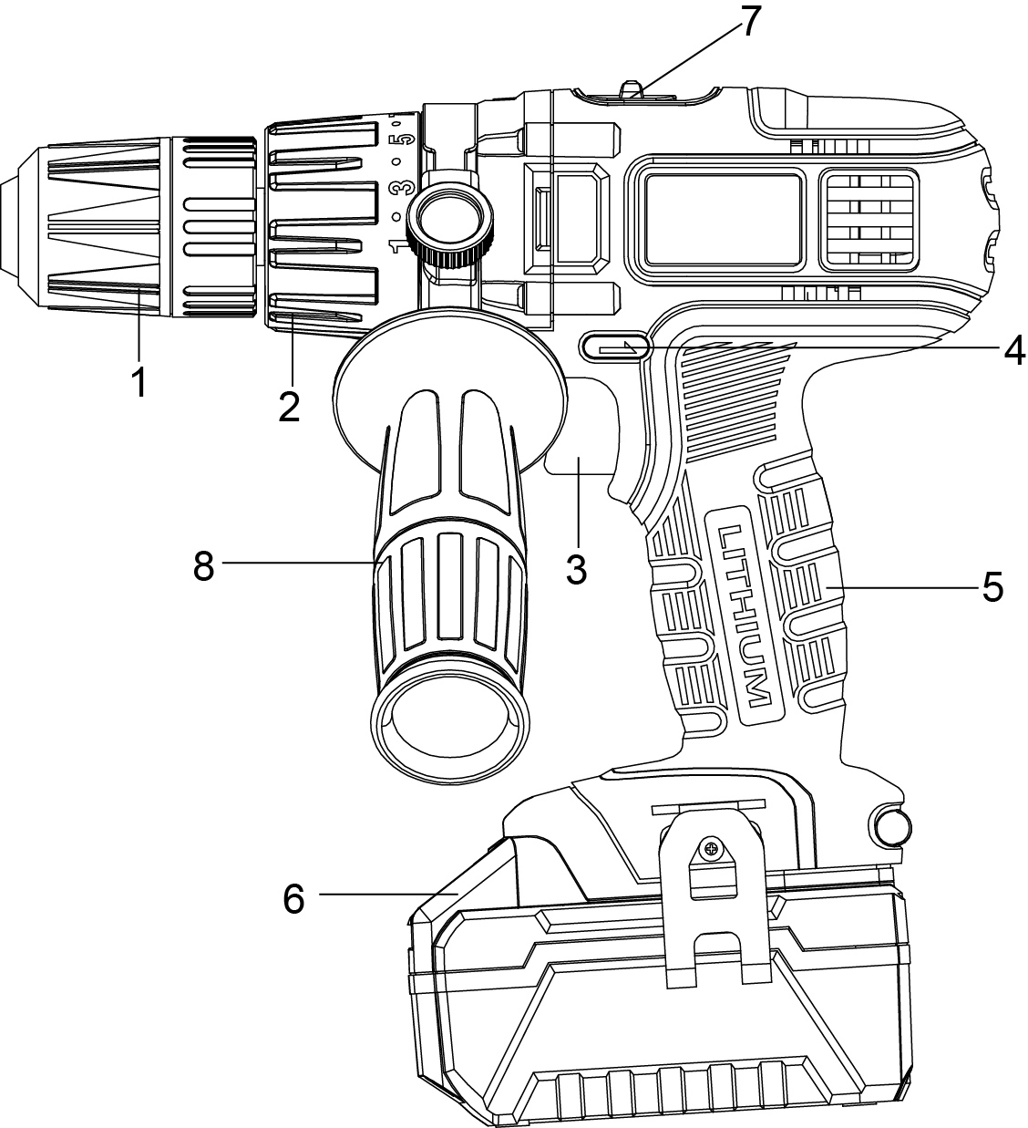

1. Keyless chuck
2. Torque selector
3. On/off switch with speed control
4. Left/Right switch
5. Handle
6. Battery pack
7. Speed selector
8. Auxiliary handle

Charging
- Put the battery pack in the charger stand. Make sure it is placed correctly ( + and - )
- Plug in the socket-outlet( 230-240V~)
- When the green indicator light lights up and the red indicator light winking, this means the battery pack is now being charged. Normally it will take 3-5 hour to fully charge the battery.
When the red indicator light stops winking, this means the battery is fully charged.
- Unplug the plug after charging

Caution
- Fully charge battery before first use. The battery will reach full capacity after being charged and discharged several times
- Avoid short periods of charging. Only charge battery pack when fully empty.
- Adaptor, charger and battery pack will be warm when charging. This is normal.

Inserting drill bits / screwdriver bits
- To insert a drill bit / screwdriver bit, hold the back section of the chuck and rotate the front section of the chuck
- Insert the drill bit / screwdriver bit into the chuck ( as far as possible )
- For screwdriver bits use an adaptor
- Select the correct screwdriver bit to avoid damaging the screw
- Firmly tighten the chuck by hand and check if the drill bit / screwdriver bit is seated firmly in the chuck
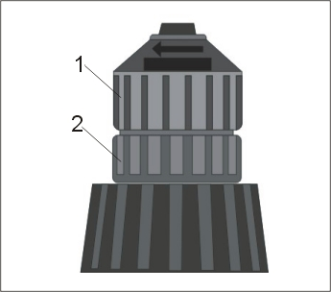
- Front section of chuck
- Back section of chuck

On/off switch
- To switch on the tool, press the on/off switch
- To switch off the tool, release the on/off switch

Left/right switch
/ shown on the left/righ switch
- Set the Left/right switch to or
- Change the direction of rotation only when the machine is not in operation

Caution
- Operating the machine with a low speed for a long time will increase the risk that the motor will be overheated. To prevent overheating, let the motor cool down regularly (Stop using the machine for 15 minutes)

Variable speed
- Applying more pressure to the On/off switch will increase the speed.
- Applying less pressure to the On/off switch will decrease the speed.

Lower/higher Speed selecting:
- Lower speed: switch Speed convert button to position “1”
- Higher speed: switch Speed convert button to position “2”

Torque setting
- The torque setting will help you regulate the driving power when using a screwdriver bit. This will help to prevent damage to the workpiece and/or screw.
- For drilling set the torque selector to the position indicated by the drill bit symbol.
- Advice: Always start with the lowest torque setting and increase if necessary.

Maintenance and Cleaning
Attention! Always remove the battery before carrying out any work on the machine.
To clean, always use a dry or moist, but not wet, towel. Many cleaning agents contain chemical substances which may cause damage to the plastic parts of the machine. Therefore do not use any strong or inflammable cleaners such as petrol, paint thinner, turpentine or similar cleaning agents.
Always keep air ventilation holes free of dust deposits to prevent overheating.



