
BRUSHLESS DRYWALL SANDER
ORIGINAL INSTRUCTION MANUAL
MODEL:FPG-INDUCTION


Feider France
ZI – 32, rue Aristide Bergès, 31270 Cugnaux, France
Made in P.R.C. 2016

WARNING! Please read all safety instructions and advises to lower the risk of injuries.

1, GENERAL POWER TOOL SAFETY WARNINGS

WARNING! Read all safety warnings and all instructions. Failure to follow the warnings and instructions may result in electric shock, fire and/or serious injury.
Save all warnings and instructions for future reference.
The term "power tool" in the warnings refers to your mains-operated (corded) power tool

1) Work area
a) Keep work area clean and well lit. Cluttered and dark areas invite accidents.
b) Do not operate power tools in explosive atmospheres, such as in the presence of flammable liquids, gases or dust. Power tools create sparks which may ignite the dust or fumes.
c) Keep children and bystanders away while operating a power tool. Distractions can cause you to lose control.

2) Electrical safety
a) Power tool plugs must match the outlet. Never modify the plug in any way. Do not use any adapter plugs with earthed (grounded) power tools. Unmodified plugs and matching outlets will reduce risk of electric shock.
b) Avoid body contact with earthed or grounded surfaces such as pipes, radiators, ranges and refrigerators. There is an increased risk of electric shock if your body is earthed or grounded.
c) Do not expose power tools to rain or wet conditions. Water entering a power tool will increase the risk of electric shock.
d) Do not abuse the cord. Never use the cord for carrying, pulling or unplugging the power tool. Keep cord away from heat, oil, sharp edges or moving parts. Damaged or entangled cords increase the risk of electric shock.
e) When operating a power tool outdoors, use an extension cord suitable for outdoor use. Use of a cord suitable for outdoor use reduces the risk of electric shock.
f) If operating a power tool in a damp location is unavoidable, use a residual current device (RCD) protected supply. Use of an RCD reduces the risk of electric shock.

3) Personal safety
a) Stay alert, watch what you are doing and use common sense when operating a power tool. Do not use a power tool while you are tired or under the influence of drugs, alcohol or medication. A moment of inattention while operating power tools may result in serious personal injury.
b) Use safety equipment. Always wear eye protection. Protective equipment such as dust mask, non-skid safety shoes, hard hat, or hearing protection used for appropriate conditions will reduce personal injuries.
c) Prevent unintentional starting. Ensure the switch is in the off-position before connecting to power source and/or battery pack, picking up or carrying the tool. Carrying power tools with your finger on the switch or plugging in power tools that have the switch on invites accidents.
d) Remove any adjusting key or wrench before turning the power tool on. A wrench or a key left attached to a rotating part of the power tool may result in personal injury.
e) Do not overreach. Keep proper footing and balance at all times. This enables better control of the power tool in unexpected situations.
f) Dress properly. Do not wear loose clothing or jewellery. Keep your hair, clothing and gloves away from moving parts. Loose clothes, jewellery or long hair can be caught in moving parts.
g) If devices are provided for the connection of dust extraction and collection facilities, ensure these are connected and properly used. Use of dust collection can reduce dust-related hazards.

4) Power tool use and care
a) Do not force the power tool. Use the correct power tool for your application. The correct power tool will do the job better and safer at the rate for which it was designed.
b) Do not use the power tool if the switch does not turn it on and off. Any power tool that cannot be controlled with the switch is dangerous and must be repaired.
c) Disconnect the plug from the power source before making any adjustments, changing accessories, or storing power tools. Such preventive safety measures reduce the risk of starting the power tool accidentally.
d) Store idle power tools out of the reach of children and do not allow persons unfamiliar with the power tool or these instructions to operate the power tool. Power tools are dangerous in the hands of untrained users.
e) Maintain power tools. Check for misalignment or binding of moving parts, breakage of parts and any other condition that may affect the power tools operation. If damaged, have the power tool repaired before use. Many accidents are caused by poorly maintained power tools.
f) Keep cutting tools sharp and clean. Properly maintained cutting tools with sharp cutting edges are less likely to bind and are easier to control.
g) Use the power tool, accessories and tool bits etc., in accordance with these instructions, taking into account the working conditions and the work to be performed. Use of the power tool for operations different from intended could result in a hazardous situation.

5) Service
a) Have your power tool serviced by a qualified repair person using only identical replacement parts. This will ensure that the safety of the power tool is maintained.

- SAFETY INSTRUCTION FOR ALL OPERATION

a)This power tool is intended to function as a sander. Read all safety warnings, instructions, illustrations and specifications provided with this power tool.
Failure to follow all instructions listed below may result in electric shock, fire and/or serious injury.
b) Operations such as grinding, wire brushing, polishing or cutting-off are not recommended to be performed with this power tool. Operations for which the power tool was not designed may create a hazard and cause personal injury.
NOTE List only those operations that were not included in the first warning. If all listed operations are recommended, then this warning may be omitted but all subsequent warnings must be given without an exclusion.
c) Do not use accessories which are not specifically designed and recommended by the tool manufacturer. Just because the accessory can be attached to your power tool, it does not assure safe operation.
d) The rated speed of the accessory must be at least equal to the maximum speed marked on the power tool. Accessories running faster than their rated speed can break and fly apart.
e) The outside diameter and the thickness of your accessory must be within the
capacity rating of your power tool. Incorrectly sized accessories cannot be adequately
guarded or controlled.
f) The arbour size of wheels, flanges, backing pads or any other accessory must properly fit the spindle of the power tool. Accessories with arbour holes that do not match the mounting hardware of the power tool will run out of balance, vibrate excessively and may cause loss of control.
g) Do not use a damaged accessory. Before each use inspect the accessory such as abrasive wheels for chips and cracks, backing pad for cracks, tear or excess wear, wire brush for loose or cracked wires. If power tool or accessory is dropped, inspect for damage or install an undamaged accessory. After inspecting and installing an accessory, position yourself and bystanders away from the plane of the rotating accessory and run the power tool at maximum no-load speed for one minute. Damaged accessories will normally break apart during this test time.
h) Wear personal protective equipment. Depending on application, use face shield,
safety goggles or safety glasses. As appropriate, wear dust mask, hearing
protectors, gloves and workshop apron capable of stopping small abrasive or
workpiece fragments. The eye protection must be capable of stopping flying debris
generated by various operations . The dust mask or respirator must be capable of filtrating particles generated by your operation. Prolonged exposure to high intensity noise may cause hearing loss.
i) Keep bystanders a safe distance away from work area. Anyone entering the work
area must wear personal protective equipment. Fragments of workpiece or of a broken accessory may fly away and cause injury beyond immediate area of operation.
j) Hold power tool by insulated gripping surfaces only, when performing an operation where the cutting accessory may contact hidden wiring or its own cord. Cutting accessory contacting a "live" wire may make exposed metal parts of the power tool "live" and shock the operator.
Position the cord clear of the spinning accessory. If you lose control, the cord may be
cut or snagged and your hand or arm may be pulled into the spinning accessory.
l) Never lay the power tool down until the accessory has come to a complete stop. The spinning accessory may grab the surface and pull the power tool out of your control.
m) Do not run the power tool while carrying it at your side. Accidental contact with the spinning accessory could snag your clothing, pulling the accessory into your body.
n) Regularly clean the power tool’s air vents. The motor’s fan will draw the dust inside the housing and excessive accumulation of powdered metal may cause electrical hazards.
o) Do not operate the power tool near flammable materials. Sparks could ignite these
materials.
p) Do not use accessories that require liquid coolants. Using water or other liquid
coolants may result in electrocution or shock.

3. Other safety instructions for all operations
Kickback and related warnings
Kickback is a sudden reaction to a pinched or attaching a rotating wheel, a bearing pad, brush or any other accessory. Pinching or hanging causes rapid stalling of the rotating accessory which in turn forced the tool Power out of control in the opposite direction of rotation of the accessory to the point of seizing.
For example, if an abrasive wheel is snagged or pinched by the workpiece, the edge of
the wheel that is entering into the pinch point can dig into the surface of the material,
causing jumps or expulsion of the grinding wheel. The wheel can jump towards
the operator or by moving away, as the direction of movement of the grinding wheel at the point of pinch. Abrasive wheels may also break under these conditions. Kickback is the result of misuse of the tool and / or procedures or conditions incorrect operation and can be avoided by taking proper precautions specified below.

a) Maintain firmly the power tool and position your body and arm for you allow to resist kickback forces. Always use auxiliary handle, where applicable, for maximum control of kickback or torque reaction during startup. The operator can control the reaction torques or forces rebound, if precautions are taken.
b) Never place your hand near the rotating accessory. The accessory can perform a bounce on your hand.
c) Do not place you in the area where power tool will move if kickback. The rebound pushes the tool in the opposite direction to movement of the wheel in point hooking.
d) Take special care when working corners, sharp edges etc.
Avoid twists and snaps of the accessory. Corners, edges or sharp twists tend to hang the rotating accessory and cause loss of control or kickback.
e) Do not attach a saw chain, blade wood carving saw chain or toothed saw blade. Such blades cause frequent rebounds and control losses.

4. Additional safety instructions for sanding operations
Set specific security guard for sanding
a) Do not use sandpaper too oversized for sanding discs.
Follow manufacturers' recommendations when selecting sanding paper. More abrasive paper extending beyond the sanding pad presents a laceration hazard and may cause a crash, tearing of the disc or kickback.

5, Warning symbol

 | WARNING-To reduce the risk of injury, user must read instruction manual.
 | Always wear ear protection
 | Always wear goggles
 | Always wear a breathing mask
 | In accordance with essential applicable safety standards of European directives
 | Class II product

6, DESCRIPTION:
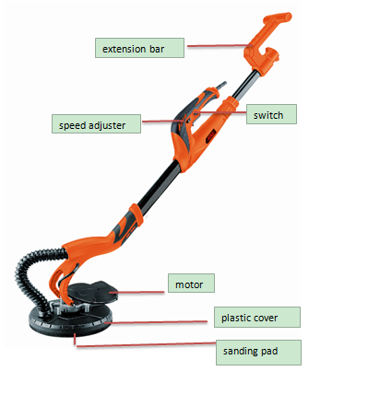

7, TECHNICAL SPECIFICATIONS
Voltage supply： 230V~
Power： 1010W
Frequency 50Hz
Speed: 1300-2000/min
Spindle thread hole： M6/M14
Protection class: II
Disc Diameter： 225mm
N.W: 3.7KGS
Lpa = 92,6 dB(A) ；KpA = 3 dB(A)
Lwa = 103,6 dB(A)； KwA = 3 dB(A)
For disc-type sander function:
Main handle: 4,794m/s² K=1.5 m/s²
Auxiliary handle:3,168 m/s²

For triangle orbital sander function:
Main handle: 7,914m/s² K=1.5 m/s²
Auxiliary handle:8,874 m/s²

Information
The declared vibration total value has been measured in accordance with a standard test method and may be used for comparing one tool with another;
The declared vibration total value may also be used in a preliminary assessment of exposure.
Warning:
that the vibration emission during actual use of the power tool can differ from the declared total value depending on the ways in which the tool is used; and
of the need to identify safety measures to protect the operator that are based on an estimation of exposure in the actual conditions of use (taking account of all parts of the operating cycle such as the times when the tool is switched off and when it is running idle in addition to the trigger time).
Wear hearing protection.

8, OPERATING INSTRUCTIONS

The Drywall Sander is designed for sanding walls and ceilings that are made of drywall or plaster. The Sander provides a superior finish, and is faster than conventional finishing methods for both new construction and renovation work. Clean-up time is minimized by the use of an external Vacuum Cleaner attached to the Sander.

8.1 HOW TO ASSEMBLE THE PAD

The hole angle of the plastic guard cover should be the same as mark shown on the cover.
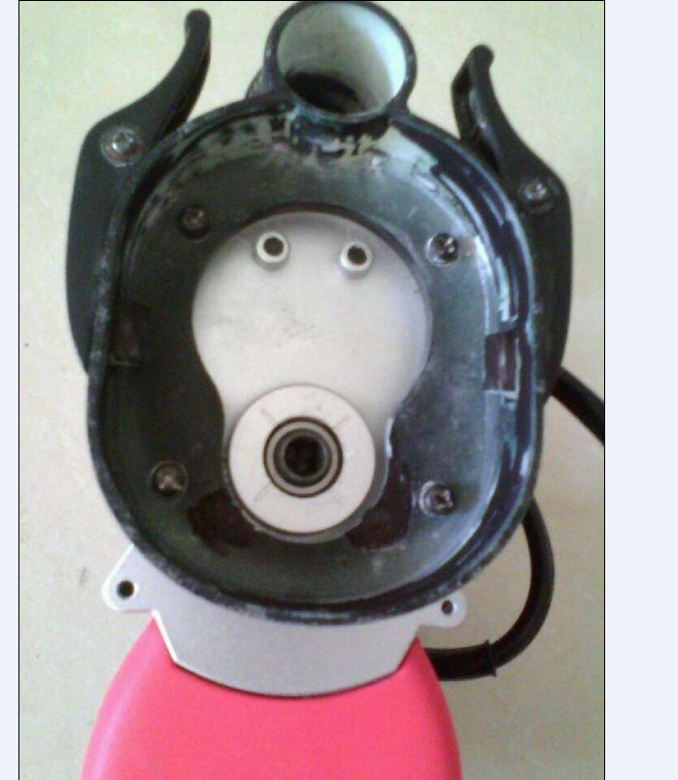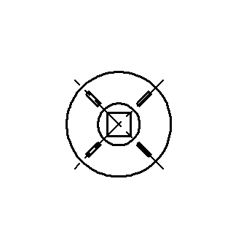

Connect pads into machine
- Place the outshaft of pad into the hole of the plastic guard cover, Place the vacuum pipe holes into the vacuum hole of pads.
- Press two small clamp block to put sanding pad in place, and ensure two clips lock hook on the block insert into the slot in the pad.
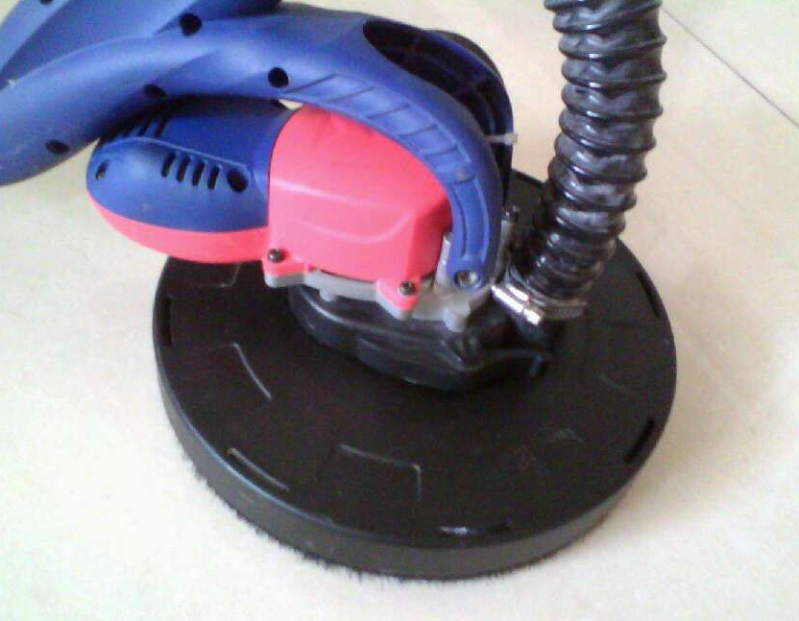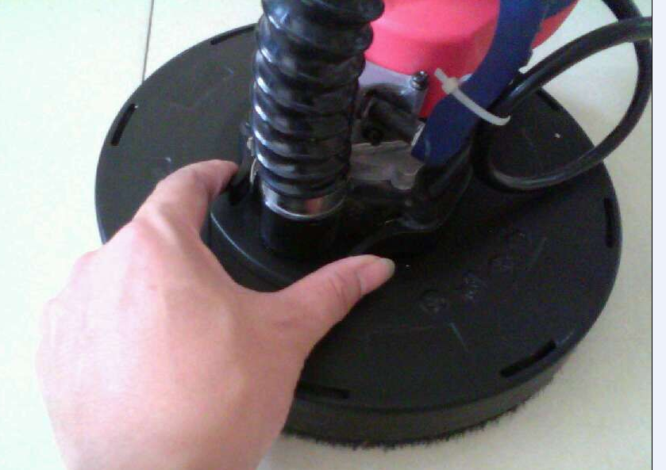

c.Press the two small clamp block , to make the sanding pad take off when need to change another pad

8.2 ABRASIVE DISC SELECTION

The drywall sander is shipped with set of sanding paper(80/100/120/150/180/240 grit) abrasive disc installed. This abrasive is suitable for most applications. Abrasive discs of 120 grit and 240 grit are available for situations requiring a smoother finish.

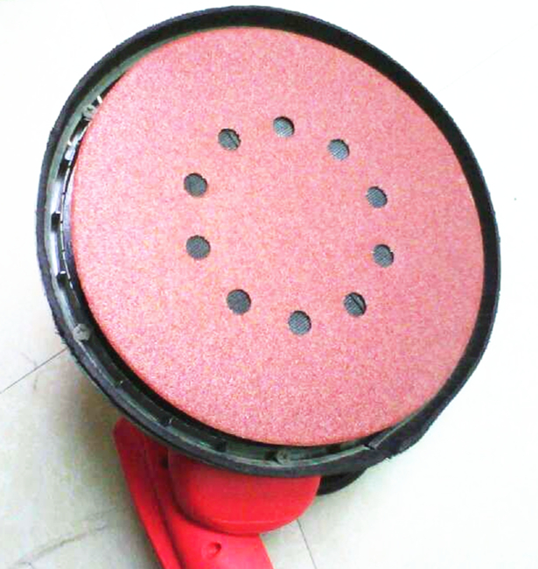

Choose sandpaper
According to the material and the grinding effect, select the appropriate sandpaper
Material | using | Grit
Pigment | Removal of pigment layer | 40
Paint | Removal of paint | 60
Filling agent | Grinding bottom pigment (such as finishing bottom) | 80
Interstitial material | Removal Brush paint, grinding residues | 100
Pigment layer drips and convex | Removal brushing mark, and residual paint | 120
Flat bottom material | Good finished sanding for new painting | 180-240

8.2 HOW TO HOLD A DRYWALL SANDER
The Drywall Sander should be held with both hands on the main tube as shown in picture. The hands may be positioned anywhere along the main tube to provide the best combination of reach and leverage for the particular application.
CAUNTION: Keep hands on Main Tube. Do not place hand into area around the sanding head. The sanding heads swivels in multiple directions and could pinch hand.


Handle
Tube
8.3 CONNECT DRYWALL SANDER TO VACUUM CLEANER
The following items are furnished with the Drywall Sander.
- One vacuum hose: 4m long (includes a standard 38mm vacuum cleaner connector on end and a special swivel connector on the Sander end), with a static dissipating feature to dissipate static electrical charges that are sometimes experienced when recovering drywall dust.
- One 38mm to 47mm adapter (adapts the 38mm hose connector to fit a 47mm vacuum cleaner).
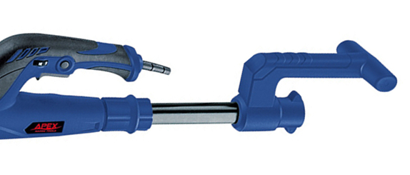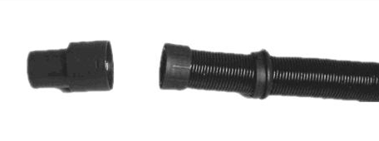
9, INSTALLAS FOLLOWS:
1). Install a special drywall dust bag into your vacuum cleaner, following the instructions supplied with the vacuum cleaner.
CAUTION: Failure to use a dust bag rated for drywall dust will increase the level of airborne dust particles in the work area. Continued and prolonged exposure to high concentrations of airborne dust may affect the respiratory system function.
2). Connect the vacuum hose to the Drywall Sander. Open the Drywall Sander's hose connector by turning the large nut , counterclockwise a couple of turns. Push the vacuum hose swivel connector into the Drywall Sander connector and seal firmly. Turn the large nut clockwise to tighten connector.
3). Install the six "hook & loop" type straps, to prevent tangling of the Sander cord and the vacuum hose. Lay the cord and the vacuum hose out parallel to each other. Space the straps at approximately two foot intervals, beginning two feet from the Drywall Sander. Wrap the long end of each strap around the vacuum hose and close, Then wrap the short end of each strap around the cord and close.
4). Connect the vacuum hose to your vacuum cleaner: Use the 38ram to 47rnnrn adapter if necessary, if your vacuum cleaner requires a special connector (something other than the standard 38rnm to 47rnm connectors supplied with the Drywall Sander), contact your vacuum cleaner supplier for the proper adapter.
10, TO START AND STOP DRYWALL SANDER
Make sure power circuit voltage is the same as shown on the specification plate on the Sander, and that the Sander switch is OFF. Connect Sander to power circuit.
The Drywall Sander is equipped with a “rocker” type switch . The lop end of the switch button is
labeled OFF, and the bottom end et the button is labeled ON. To start the Sander: depress the bottom (ON) end of the switch button, To stop the Sander depress the top (OFF) end of the switch button.
11, SPEED CONTROL
The Drywall Sander is equipped with a variable speed control. The speed is adjusted by turning the control knob. The control knob is numbered "1" through "5" with "I" being the slowest speed (approximately 1000 RPM)and "5" being the fastest speed {approximately 2000 RPM).
Use the higher speed settings for fast stock removal. Use the lower speed selling to reduce removal rate for more precise control.
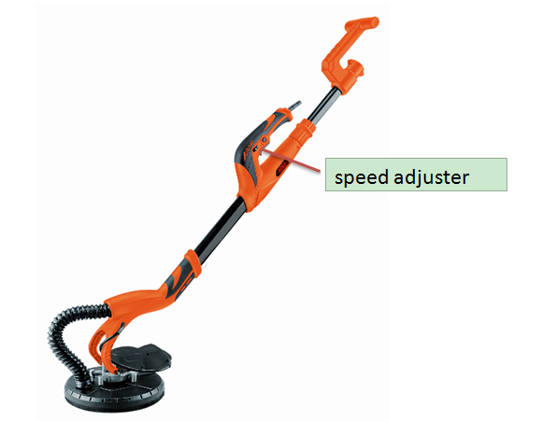
12, ASSEMBLE FOR LONGER HANDLE

13, SANDING DRYWALL
The Drywall Sander has a unique articulating sanding head: the head can swivel in multiple directions, allowing
the abrasive pad to conform to the work surface This enables the operator to sand the
top, middle and bottom of a wall or ceiling joint without changing: his position.
1). Turn vacuum cleaner switch ON.
CAUTION:Wear a respirator approved for "Dust and Mist".
2). Turn Drywall Sander switch 0N.
3). Position Drywall Sander lightly against work surface (apply just enough pressure to align the sanding head with the work surface).
4). Apply additional pressure to engage the abrasive pad to the work surface: while moving the Sander in an overlapping pattern to smooth the drywall compound down to a "featheredge'.
Apply ONLY enough pressure to keep the abrasive pad flat against the work. Excessive pressure can cause unacceptable swirl marks and unevenness in the work surface.
Keep the Sander in constant motion while abrasive pad is in contact with the work surface. Use a steady, sweeping motion. Stopping the Sander (on the work), or moving the Sander erratically can cause unacceptable swirl marks and unevenness in the work surface.
NOTE: Do not allow rotating abrasive pad to contact sharp protrusions. Contact with protruding objects (nails, screws, electrical boxes, etc,), can severely damage the abrasive pad.

14, ABRASIVE PAD REPLACEMENT
CAUTION: DISCONNECT SANDER FROM POWER SOURCE.
1). Grasp the abrasive pad and the sander housing (clamping the pad to the housing), to prevent pad rotation.
2). Rotate the pad retaining nut, counterclockwise and remove.
3). Lift off the large metal washer , and the abrasive pad
NOTE: When the abrasive pad , is lifted off the Sander: the abrasive back-up disc is exposed. Please note that this back-up disc is also covered with an abrasive material.
This abrasive material is ONLY used to prevent "slippage" between the back-up disc and the foam
backed abrasive pad, it is NOT suitable for use as a sanding abrasive. DO NOT USE THE SANDER "
WITHOUT A PROPER ABRASIVE PAD INSTALLED (to prevent severe damage to the work).
4). Position new abrasive pad to the back-up disc, making sure that the center hole in the abrasive disc is
centered on the hub of the back-up disc.
5). Position !he large metal washer the retaining nut to the Sander.
6). Rotate the retaining nut clockwise to hand tighten (while holding the abrasive pad).

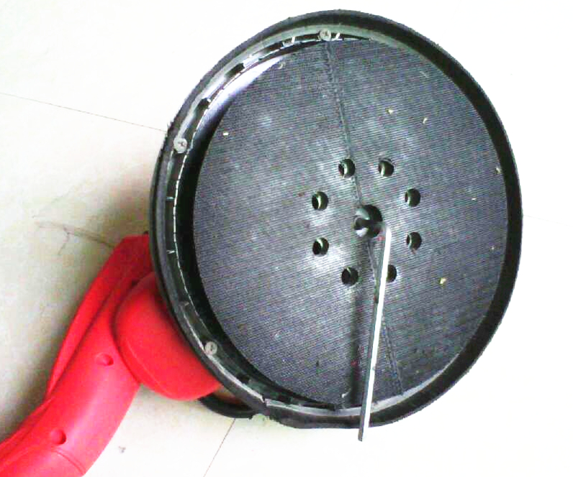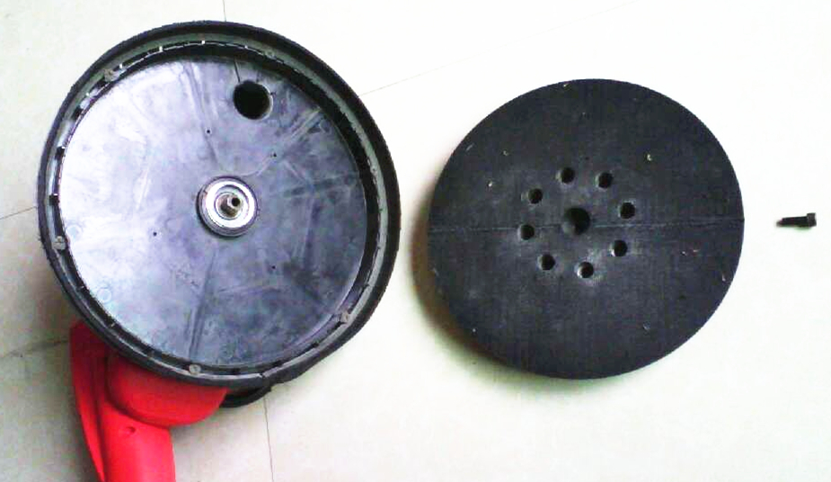
BRUSH-TYPESKIRT
A brush-type skirt surrounds the abrasive pad. This skirt serves two purposes: (1) The skirt extends below the surface of the abrasive pad so that it contacts the work surface first. This positions the sanding head parallel to the work surface before the abrasive contacts the work, preventing the abrasive from "gouging" the work. (2) The skirt also helps contain the drywall dust until the vacuum cleaner pulls it away.
CAUTION: DISCONNECT SANDER FROM POWER CIRCUIT.
To replace skirt: (1) Remove abrasive pad (see ABRASIVE PAD REPLACEMENT). (2) Use phillips screwdriver to remove the six retaining screws (3) Lift the skirt out of housing. (4) Position new skirt to housing and install the six retaining screws. (5) Replace the abrasive pad.

15,Maintenance
Kept clean tools, clean up debris and dust.
Often change grease (gearbox, the bearing) holding tool flexible operation.
Always check the power cord, plugs, switches, etc., the tool in good condition.
This tool passed rigorous quality inspection, if the machine is still a failure occurs, please send it it an authorized customer service (SWAP)for repair.

16, ENVIRONMENT
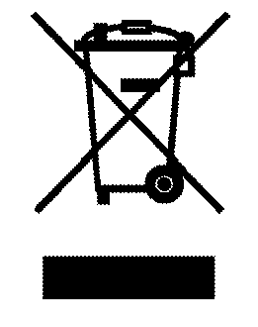
CAUTION! This product has been marked with a symbol relating to removing electric and electronic waste. This means that this product shall not be discarded with household waste but that it shall be returned to a collection system which conforms to the European WEEE Directive. Contact your local authorities or stockist for advice on recycling. It will then be recycled or dismantled in order to reduce the impact on the environment. Electric and electronic equipment can be hazardous for the environment and for human health since they contain hazardous substances.

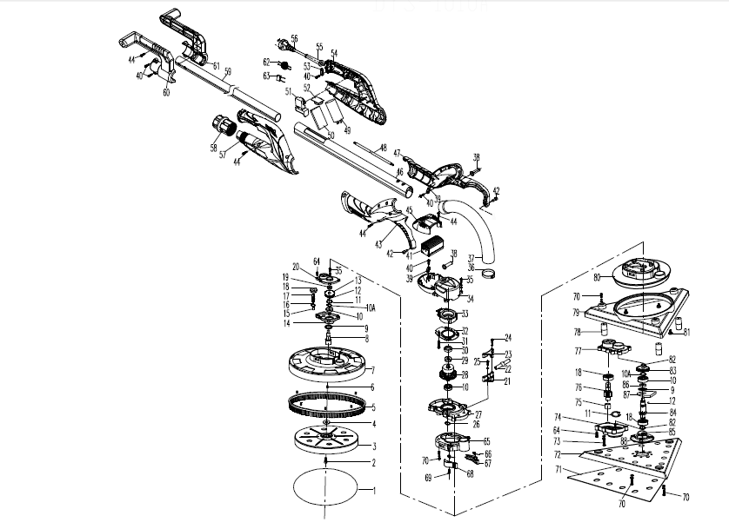

NO. | Spare parts | QTY | NO. |  | QTY
1 | sandpaper | 1SET | 45 | back cover | 1
2 | screw M6*1 | 1 | 46 | main tube | 1
3 | adhibit tray | 1 | 47 | left support arm | 1
4 | wool mat | 1 | 48 | four-core wire | 1
5 | nylon brush/skirt | 1 | 49 | large capacitive | 1
6 | spring | 6 | 50 | control board | 1
7 | plastic disc | 1 | 51 | switch | 1
8 | spindle | 1 | 52 | variable speed control | 1
9 | oil sealing | 1 | 53 | cable plate | 1
10 | bearing 6001 | 3 | 54 | Left Handle | 1
10A | circlip-external ∮12 | 2 | 55 | cable cover | 1
11 | circlip ∮28 | 2 | 56 | cable blug | 1
12 | steel ballS∮3 | 2 | 57 | right Handle | 1
13 | big gear | 1 | 58 | locknut | 1
14 | gear seat | 1 | 59 | Telescopic tube | 1
15 | bearing HK0509 | 1 | 60 | right rear handle | 1
16 | circlip-external ∮9 | 1 | 61 | left rear handle | 1
17 | pad shaft | 1 | 62 | inductance | 1
18 | bearing 6000RS | 3 | 63 | capacity | 1
19 | bearing 607 | 1 | 64 | screw ST3.9*22 | 8
20 | gear cover | 1 | 65 | connect cover | 1
21 | ball set | 1 | 66 | spring | 2
22 | ball rod | 1 | 67 | left block | 1
23 | ball cover | 1 | 68 | left block | 1
24 | screw M4*20 | 3 | 69 | screw ST3.9*12 | 2
25 | screw M5*12 | 2 | 70 | screw M4*12 | 4
26 | circlip-external ∮12 | 1 | 71 | triangle sanding paper | 1SET
27 | Gear hsg | 1 | 72 | triangle sanding pad | 1
28 | armature | 1 | 73 | screw M4*18 | 2
29 | bearing 608RS | 1 | 74 | gear seat | 1
30 | bearing cover | 1 | 75 | bearingHK0810 | 1
31 | cross-flat screw ST3-30 | 4 | 76 | gear shaft | 1
32 | Wind loop | 1 | 77 | gear box cover | 1
33 | stator | 1 | 78 | dampling column | 3
34 | Motor shell | 1 | 79 | triangle outside cover | 1
35 | screw m4*14 | 6 | 80 | triangle inside cover | 1
36 | hoop | 1 | 81 | screw ST3.9*11 | 6
37 | hose | 1 | 82 | circlip-external ∮10 | 1
38 | protect cover | 2 | 83 | big gear | 1
39 | cable plate | 2 | 84 | outshaft | 1
40 | cross-flat screw ST4*12 | 5 | 85 | o ring | 1
41 | controller | 1 | 86 | shaft cover | 1
42 | hex screw M6*14 | 2 | 87 | balance block | 1
43 | right support arm | 1 | 88 | bearing set | 1
44 | cross-flat screw ST4*16 | 31

17, CE DECLARATION OF CONFORMITY
FEIDER
ZI, 32 rue aristide Bergès – 31270 Cugnaux - France
Tel : +33 (0)5.34.502.502 Fax : +33 (0)5.34.502.503
States that the designated below machine:
Product:Drywall sander
Model:FPG-INDUCTION
Serial number: 20160901736-20160902135
is in confirmity with the essential requirements and other relavant provisions of the applicable European Directives,based on the application of European harmonized standerds.Any unauthorized modification of the apparatus voids this declaration.
European Directives(including, if applicable,their amendments up to the date of signature):
Machinery Directive 2006/42/EC
EMC Directive 2014/30/EC
ROHS Directive 2011/65/EU
European harmonized standerds(including,if applicable,their amendments up to the date of signature):
EN60745-1:2009/A11:2010
EN60745-2-3:2011/A2:2014
EN60745-2-4:2009/A11:2011
EN55014-1:2006/A2:2011
EN55014-2:2015
EN61000-3-2:2014
EN61000-3-3:2013
EN 62321:2009
Done at Cugnaux:05/05/2016
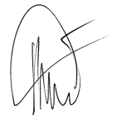
Philippe MARIE/PDG

