**ORIGINAL INSTRUCTIONS**

**CORDLESS ANGLE GRINDER**

**Model: FM20V115**

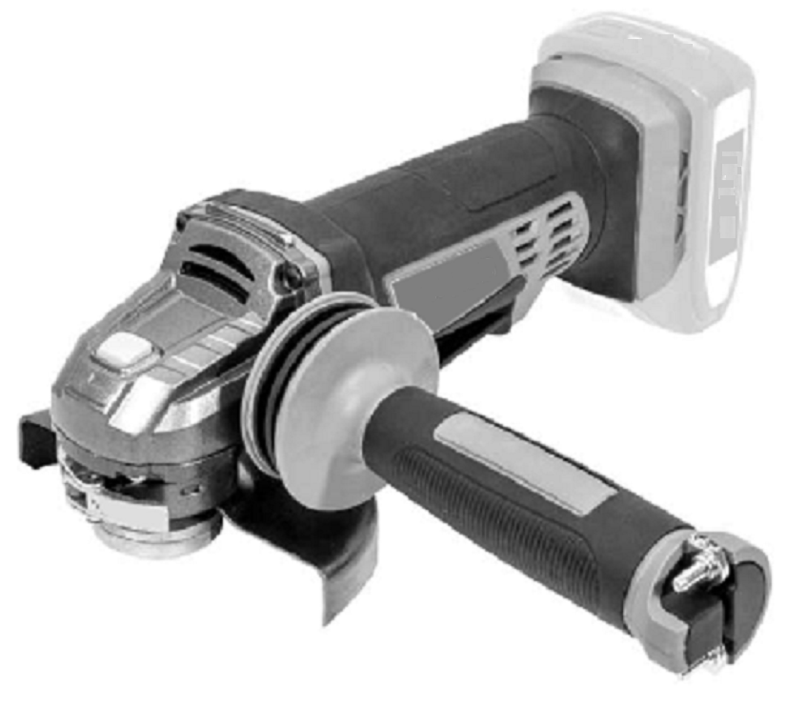

**Warning: Please read the manual carefully before using the unit!**

**BUILDER SAS**

**32, rue Aristide Bergès - ZI 31270 Cugnaux - France**



**MADE IN PRC 2019**

1. **SAFETY WARNINGS**

**GENERAL TOOLS SAFETY WARNINGS**

** WARNING Read all safety warnings and all instructions.** *Failure to follow the warnings and instructions may result in electric shock, fire and/or serious injury*.

**Save all warnings and instructions for future reference.** *The term "power tool" in the warnings refers to your mains-operated (corded) power tool or battery-operated (cordless) power tool.*

1. **Work area safety**
   1. **Keep work area clean and well lit**. *Cluttered or dark areas invite accidents.*
   2. **Do not operate power tools in explosive atmospheres, such as in the presence of flammable liquids, gases or dust.** *Power tools create sparks which may ignite the dust or fumes.*
   3. **Keep children and bystanders away while operating a power tool.** *Distractions can cause you to lose control.*
2. **Electrical safety**
   1. **Power tool plugs must match the outlet. Never modify the plug in any way. Do not use any adapter plugs with earthed (grounded) power tools.** *Unmodified plugs and**matching outlets will reduce risk of electric shock.*
   2. **Avoid body contact with earthed or grounded surfaces, such as pipes, radiators, ranges and refrigerators.** *There is an increased risk of electric shock if your body is**earthed or grounded.*
   3. **Do not expose power tools to rain or wet conditions.** *Water entering a power tool will increase the risk of electric shock.*
   4. **Do not abuse the cord. Never use the cord for carrying, pulling or unplugging the power tool. Keep cord away from heat, oil, sharp edges or moving parts.** *Damaged**or entangled cords increase the risk of electric shock.*
   5. **When operating a power tool outdoors, use an extension cord suitable for outdoor use.** *Use of a cord suitable for outdoor use reduces the risk of electric shock.*
   6. **If operating a power tool in a damp location is unavoidable, use a residual current device (RCD) protected supply.** *Use of an RCD reduces the risk of electric shock.*
3. **Personal safety**
   1. **Stay alert, watch what you are doing and use common sense when operating a power tool. Do not use a power tool while you are tired or under the influence of drugs, alcohol or medication.** *A moment of inattention while operating power tools**may result in serious personal injury.*
   2. **Use personal protective equipment. Always wear eye protection.** *Protective equipment such as dust mask, non-skid safety shoes, hard hat, or hearing protection used for appropriate conditions will reduce personal injuries.*
   3. **Prevent unintentional starting. Ensure the switch is in the off-position connecting to power source and/or battery pack, picking up or carrying the tool.** *Carrying power tools with your finger on the switch or energizing power tools that have**the switch on invites accidents.*
   4. **Remove any adjusting key or wrench before turning the power tool on.** *A wrench or a key left attached to a rotating part of the power tool may result in personal injury.*
   5. **Do not overreach. Keep proper footing and balance at all times.** *This enables better control of the power tool in unexpected situations.*
   6. **Dress properly. Do not wear loose clothing or jewelry. Keep your hair, clothing and gloves away from moving parts.** *Loose clothes, jewelry or long hair can be**caught in moving parts.*
   7. **If devices are provided for the connection of dust extraction and collection facilities, ensure these are connected and properly used.** *Use of dust collection can**reduce dust-related hazards*.
4. **Power tool use and care**
   1. **Do not force the power tool. Use the correct power tool for your application.** *The correct power tool will do the job better and safer at the rate for which it was designed.*
   2. **Do not use the power tool if the switch does not turn it on and off.** *Any power tool that cannot be controlled with the switch is dangerous and must be repaired.*
   3. **Disconnect the plug from the power source and/or the battery pack from the power tool before making any adjustments, changing accessories, or storing power tools.** *Such preventive safety measures reduce the risk of starting the power**tool accidentally.*
   4. **Store idle power tools out of the reach of children and do not allow persons unfamiliar with the power tool or these instructions to operate the power tool.** *Power tools are dangerous in the hands of untrained users.*
   5. **Maintain power tools. Check for misalignment or binding of moving parts,****breakage of parts and any other condition that may affect the power tool’s****operation. If damaged, have the power tool repaired before use.** *Many accidents are caused by poorly maintained power tools.*
   6. **Keep cutting tools sharp and clean.** *Properly maintained cutting tools with sharp cutting edges are less likely to bind and are easier to control.*
   7. **Use the power tool, accessories and tool bits etc. in accordance with these instructions, taking into account the working conditions and the work to be performed.** *Use of the power tool for operations different from those intended could result in a hazardous situation.*

**Battery tool use and care**

1. **Recharge only with the charger specified by the manufacturer.** *A charger that is suitable for one type of battery pack may create a risk of fire when used with another battery pack.*
2. **Use power tools only with specifically designated battery packs**. *Use of any other battery packs may create a risk of injury and fire.*
3. **When battery pack is not in use, keep it away from other metal objects, like paper clips, coins, keys, nails, screws or other small metal objects that can make a connection from one terminal to another.** *Shorting the battery terminals together may cause burns or a fire.*
4. **Under abusive conditions, liquid may be ejected from the battery; avoid contact. If contact accidentally occurs, flush with water. If liquid contacts eyes, additionally seek medical help**. *Liquid ejected from the battery may cause irritation or burns.*
5. **Service**
   1. **Have your power tool serviced by a qualified repair person using only identical replacement parts*.*** *This will ensure that the safety of the power tool is maintained.*

**Safety instructions for all operations**

**Safety Warnings Common for Grinding, Sanding, Wire Brushing, Polishing or Abrasive**

**Cutting-Off Operations**

1. **This power tool is intended to function as a grinder or cut-off tool. Read all safety warnings, instructions, illustrations and specifications provided with this power tool.** *Failure to follow all instructions listed below may result in**electric shock, fire and/or serious injury.*
2. **Operations such as sanding, wire brushing or polishing are not** **recommended to be performed with this power tool.** *Operations for which the power* *tool was not designed may create a hazard and cause personal injury.*
3. **Do not use accessories which are not specifically designed and recommended by the tool manufacturer.** *Just because the accessory can be attached to your power tool, it**does not assure safe operation.*
4. **The rated speed of the accessory must be at least equal to the maximum speed marked on the power tool.** A*ccessories running faster than their rated speed can break**and fly apart.*
5. **The outside diameter and the thickness of your accessory must be within the capacity rating of your power tool.** *Incorrectly sized accessories cannot be adequately**guarded or controlled.*
6. **Threaded mounting of accessories must match the grinder spindle thread. For accessories mounted by flanges, the arbour hole of the accessory must fit the locating diameter of the flange.** *Accessories that do not match the mounting hardware of the power tool will run out of balance, vibrate excessively and may cause loss of control.*
7. **Do not use a damaged accessory. Before each use inspect the accessory such as abrasive wheels for chips and cracks, backing pad for cracks, tear or excess wear, wire brush for loose or cracked wires. If power tool or accessory is dropped, inspect for damage or install an undamaged accessory. After inspecting and installing an accessory, position yourself and bystanders away from the plane of the rotating accessory and run the power tool at maximum no-load speed for one minute.** *Damaged accessories will normally break apart during this test time.*
8. **Wear personal protective equipment. Depending on application, use faces shield, safety goggles or safety glasses. As appropriate, wear dust mask, hearing protectors, gloves and workshop apron capable of stopping small abrasive or workpiece fragments.** *The eye protection must be capable of stopping flying debris**generated by various operations. The dust mask or respirator must be capable of filtrating**particles generated by your operation. Prolonged exposure to high intensity noise may**cause hearing loss.*
9. **Keep bystanders a safe distance away from work area. Anyone entering the work area must wear personal protective equipment.** *Fragments of workpiece or of a broken**accessory may fly away and cause injury beyond immediate area of operation.*
10. **Hold the power tool by insulated gripping surfaces only, when performing an operation where the cutting accessory may contact hidden wiring***. Cutting accessory contacting a "live" wire may make exposed metal parts of the power tool "live" and could give the operator an electric shock.*
11. **Position the cord clear of the spinning accessory.** *If you lose control, the cord may be cut or snagged and your hand or arm may be pulled into the spinning accessory.*
12. **Never lay the power tool down until the accessory has come to a complete stop.** *The spinning accessory may grab the surface and pull the power tool out of your control.*
13. **Do not run the power tool while carrying it at your side.** *Accidental contact with the spinning accessory could snag your clothing, pulling the accessory into your body.*
14. **Regularly clean the power tool’s air vents.** *The motor’s fan will draw the dust inside the housing and excessive accumulation of powdered metal may cause electrical hazards.*
15. **Do not operate the power tool near flammable materials.** *Sparks could ignite these materials.*
16. **Do not use accessories that require liquid coolants.** *Using water or other liquid coolants may result in electrocution or shock.*

**Further safety instructions for all operations**

**Kickback and Related Warnings**

Kickback is a sudden reaction to a pinched or snagged rotating wheel, backing pad, brush or any other accessory. Pinching or snagging causes rapid stalling of the rotating accessory which in turn causes the uncontrolled power tool to be forced in the direction opposite of the accessory’s rotation at the point of the binding.

For example, if an abrasive wheel is snagged or pinched by the workpiece, the edge of the wheel that is entering into the pinch point can dig into the surface of the material causing the wheel to climb out or kick out. The wheel may either jump toward or away from the operator, depending on direction of the wheel’s movement at the point of pinching. Abrasive wheels may also break under these conditions.

Kickback is the result of power tool misuse and/or incorrect operating procedures or conditions and can be avoided by taking proper precautions as given below.

1. **Maintain a firm grip on the power tool and position your body and arm to allow you to resist kickback forces. Always use auxiliary handle, if provided, for maximum control over kickback or torque reaction during start-up.** *The operator can control**torque reactions or kickback forces, if proper precautions are taken.*
2. **Never place your hand near the rotating accessory.** *Accessory may kickback over your hand.*
3. **Do not position your body in the area where power tool will move if kickback occurs.** *Kickback will propel the tool in direction opposite to the wheel’s movement at the**point of snagging.*
4. **Use special care when working corners, sharp edges etc. Avoid bouncing and snagging the accessory.** *Corners, sharp edges or bouncing have a tendency to snag the**rotating accessory and cause loss of control or kickback.*
5. **Do not attach a saw chain woodcarving blade or toothed saw blade.** *Such blades create frequent kickback and loss of control.*

**Additional safety instructions for grinding and cutting-off operations**

**Safety Warnings Specific for Grinding and Abrasive Cutting-Off Operations:**

1. **Use only wheel types that are recommended for your power tool and the specific guard designed for the selected wheel.** *Wheels for which the power tool was not**designed cannot be adequately guarded and are unsafe.*
2. **The grinding surface of centre depressed wheels must be mounted below the plane of the guard lip.** *An improperly mounted wheel that projects through the plane of the**guard lip cannot be adequately protected.*
3. **The guard must be securely attached to the power tool and positioned for maximum safety, so the least amount of wheel is exposed towards the operator.** *The guard**helps to protect the operator from broken wheel fragments, accidental contact with wheel**and sparks that could ignite clothing.*
4. **Wheels must be used only for recommended applications. For example: do not grind with the side of cut-off wheel.** *Abrasive cut-off wheels are intended for peripheral**grinding, side forces applied to these wheels may cause them to shatter.*
5. **Always use undamaged wheel flanges that are of correct size and shape for your selected wheel.** *Proper wheel flanges support the wheel thus reducing the possibility of**wheel breakage. Flanges for cut-off wheels may be different from grinding wheel flanges.*
6. **Do not use worn down wheels from larger power tools.** *Wheel intended for larger power tool is not suitable for the higher speed of a smaller tool and may burst.*

**Additional safety instructions for cutting-off operations**

**Additional Safety Warnings Specific for Abrasive Cutting-Off Operations:**

1. **Do not “jam” the cut-off wheel or apply excessive pressure. Do not attempt to make an excessive depth of cut.** *Overstressing the wheel increases the loading and**susceptibility to twisting or binding of the wheel in the cut and the possibility of kickback or**wheel breakage.*
2. **Do not position your body in line with and behind the rotating wheel.** *When the wheel, at the point of operation, is moving away from your body, the possible kickback may propel the spinning wheel and the power tool directly at you.*
3. **When wheel is binding or when interrupting a cut for any reason, switch off the power tool and hold the power tool motionless until the wheel comes to a complete stop. Never attempt to remove the cut-off wheel from the cut while the wheel is in motion otherwise kickback may occur.** *Investigate and take corrective action to**eliminate the cause of wheel binding.*
4. **Do not restart the cutting operation in the workpiece. Let the wheel reach full speed and carefully re-enter the cut.** *The wheel may bind, walk up or kickback if the power tool**is restarted in the workpiece.*
5. **Support panels or any oversized workpiece to minimize the risk of wheel pinching and kickback.** *Large workpieces tend to sag under their own weight. Supports must be**placed under the workpiece near the line of cut and near the edge of the workpiece on**both sides of the wheel.*
6. **Use extra caution when making a “pocket cut” into existing walls or other blind areas.** *The protruding wheel may cut gas or water pipes, electrical wiring or objects that**can cause kickback.*

**Additional safety warnings:**

1. Check that the maximum speed indicated on the grinding disc corresponds to the maximum speed of the machine. The speed of the machine must not exceed the value on the grinding disc.
2. Make sure that the dimensions of the grinding disc correspond to the specifications of the machine.
3. Make sure that the grinding disc has been mounted and fastened properly. Do not use reducing rings or adapters to make the grinding disc fit properly.
4. Do not use the machine for grinding workpieces with a maximum thickness exceeding the maximum grinding depth of the grinding disc.
5. Do not use grinding discs for deburring.
6. When grinding discs have to be mounted on the thread of the spindle, make sure that the spindle has sufficient thread. Make sure that the spindle is sufficiently protected and does not touch the grinding surface.
7. Before use, inspect the grinding disc for any damage. Do not use grinding discs which are cracked, ripped or otherwise damaged.
8. Before use, let the machine run idle for 30 seconds.
9. Immediately switch off the machine in case of abnormal vibrations or occurrence of another defect. Carefully inspect the machine and grinding disc before switching the machine on again.
10. Make sure that sparks do not put people into danger or that they contact highly flammable substances.
11. Make sure that the workpiece is sufficiently supported or clamped. Keep your hands away from the surface to be cut.
12. Always wear safety goggles and hearing protection. Also use a helmet when appropriate.
13. Ensure that mounted wheels and points are fitted in accordance with the manufacturer's instructions.
14. Ensure that blotters are used when they are provided with the bonded abrasive product and when they are required.
15. The tool must be always used with the guard. Never use the tool without the guard.
16. For tools intended to be fitted with threaded hole wheel, ensure that the thread in the wheel is long enough to accept the spindle length.
17. Ensure that ventilation openings are kept clear when working in dusty conditions. If it should become necessary to clear dust, first disconnect the tool from the mains supply (use non-metallic objects) and avoid damaging internal parts.

**Symbols**

 Refer to the instructions manual

 Wear ear protection

 Wear eyes protection

WEEE symbol for disposal

1. **THE PRODUCT**
2. **Description**

2

1



11

9

10

8

7

6

5

4

3

1. Hand grip
2. Li-on Battery （not in package）
3. wrench for disk installation
4. Side handle
5. Guard
6. Backing washer
7. Disc clamping nut
8. guard clamp lever
9. ON/OFF trigger with safety latch
10. Spindle lock
11. Battery release catch
12. **Technical data**

|  |  |
| --- | --- |
| **Model** | FM20V115 |
| **Voltage** | 20V dc. |
| **Rated speed in revolution per minute** | 10000/min |
| **Rated capacity in mm** | Ø115mm |
| **Spindle thread size** | M14 |
| **Sound pressure level Lpa** | 88 dB(A), K=3 dB(A) |
| **Sound power level Lwa** | 99 dB(A) , K=3 dB(A) |
| **Vibration value** | 4.9 m/s2,K=1,5 m/s² |

Information

* The declared vibration total value has been measured in accordance with a standard test method and may be used for comparing one tool with another;
* The declared vibration total value may also be used in a preliminary assessment of exposure.

Warning

* The vibration emission during actual use of the power tool can differ from the declared total value depending on the ways in which the tool is used;
* It is necessary to identify safety measures to protect the operator that are based on an estimation of exposure in the actual conditions of use (taking account of all parts of the operating cycle such as the times when the tool is switched off and when it is running idle in addition to the trigger time).

**Intended use**

This angle grinder is designed for grinding and roughing metal such as metal or stone. The capacity of the tool is 125 mm maximum. Specially design to work with Hyundai range of battery and charger.

Do not use this tool for commercial purposes; it is only for a private household use.

1. **OPERATION**

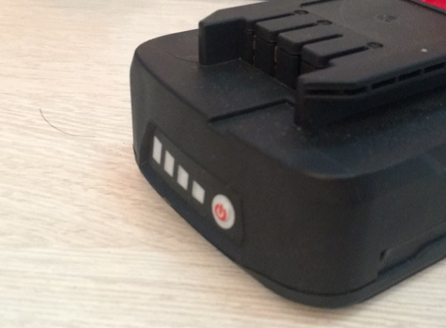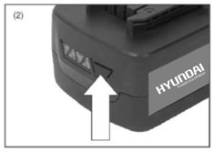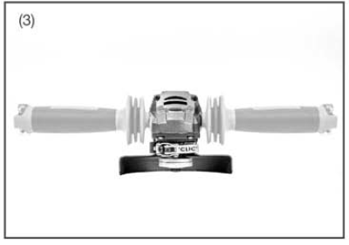

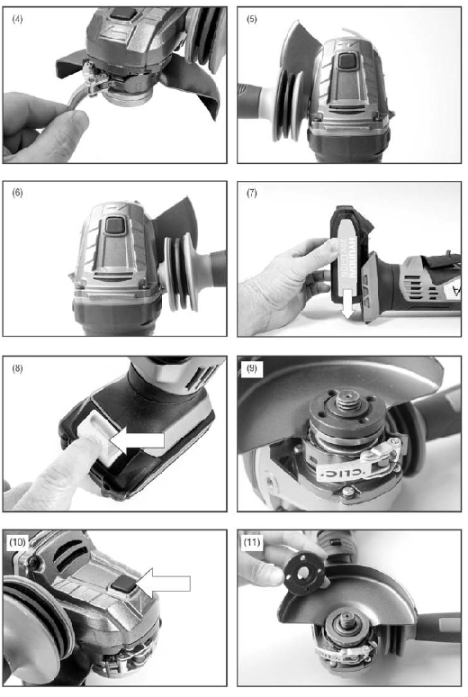

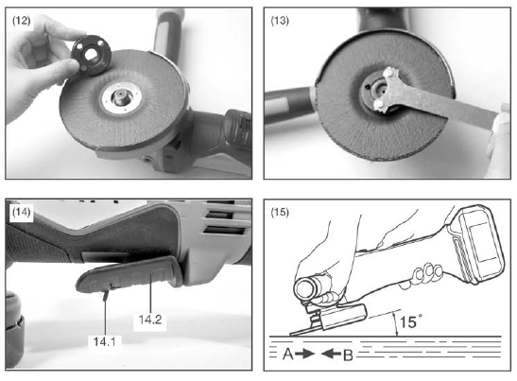

1. **Charge**

1). Take the battery pack out of the equipment. Do this by pressing the side pushlock buttons.

2). Check that your mains voltage is the same as that marked on the rating plate of the battery charger. Insert the power plug of the charger into the socket outlet. The RED LED will then begin to light.

3). Insert the battery pack into the battery charger .then the red LED on charger will begin to Green flash light.

4). You will find a label with “Charger indicator” of the LED indicator on the charger.

The battery pack can become a little warm during the charging. This is normal.

If the battery pack fails to charge, check:

* Voltage at the power socket
* Whether there is good contact at the charging contacts.
* Whether the battery pack is warm or not, The battery protection system will not allow the battery to be charged if the battery temperature is over 40℃ after use, allow the battery pack to cool to room temperature before commencing with the charging.

If the battery pack still fails to charge, send the charging unit and the battery pack to our customer service center.

To ensure that the battery pack provides long service, you should take care to recharge it promptly. You must recharge the battery pack when you notice that the power of the cordless vacuum drops. Never allow the battery pack to become fully discharged. This will cause it to develop a defect.

Battery capacity indicator

Press the switch for the battery capacity indicator . The battery capacity indicator shows the charge status of the battery using 4 LEDs as following:

All 4 LEDs are lit:

The battery is fully charged.

3 LED(s) are lit:

The battery has approx 75% remaining charge.

2 LED(s) are lit:

The battery has approx 50% remaining charge.

1 LED is lit:

The battery will be empty soon, please recharge the battery.

Charger indicator

|  |  |
| --- | --- |
| Indicator status | Explanations and actions |
|  | Ready for use  The charger is connected to the mains and is ready for use; there is no battery pack in the charger. |
|  | Charging  The charger is charging the battery pack in charge mode. |
|  | Battery pack is full of charge.  Charging is finished and battery pack in the charger. |
|  | The temperature of battery is too high or too low, the charger is under protection status. The charging function can be recovered after the temperature is normal. |
|  | Unrecoverable battery malfunction. |

### Assembly

### WARNING: Be sure that the tool is switched off and the battery is removed from the tool before assembly.

### Installing the handle

### The handle can be installed to either side of the tool (Fig. 3). Screw the handle in the hole. Be sure that the handle is well installed but it is no need to over tighten.

### Guard adjustment

### Never use the angle grinder without the guard in place and properly adjusted!

* Unlock the guard clamp lever (Fig. 4).
* Rotate the guard to the correct position as shown in figures 5 and 6.
* Lock the guard clamp lever and retighten clamp screw securely if needed.

WARNING! Never place the guard so that it is on the front of the angle grinder. This could serious injuries.

Never use the tool without the guard. It has been designed for use only with the guard installed.

**Installing battery pack**

Slide the battery pack into the tool base, fig7. Make sure that the battery pack snaps into place and that battery pack is secured in the tool before beginning operation.

Improper installation of battery pack can cause damage.

**Removing the battery pack**

Push the battery release catch (fig 8). While holding down the battery release catch, slide the battery pack away from the tool.

**Removing the disc clamping nut**

Depress the spindle lock button (fig 10). Use a wrench, insert the pins into the holes on the disc clamping nut. Turn the wrench anticlockwise to release the disc clamping nut.

If the disc backing washer is removed it must be replaced the correct way round. The correct way to fit this onto the shaft can be seen in Fig 11.

NOTE: There are different types of discs used for different applications. Select the correct one for the work being done. Make sure the disc backing washer flats are located correctly with the flats on the shaft. The grinding disc should be placed onto the angle grinder with the writing facing upwards

**Installing new disc**

Place the disc over the shaft locating it onto the disc backing washer. It can be seen that the backing washer has a raised lip.

The hole in the disc should match the diameter of the raised lip, keeping the disc mounted central. Refit the disc clamping nut (fig 12). Tighten with fingers until the disc is clamped. Depress the spindle lock and using the supplied wrench (Fig 13). Tighten the locking washer in clockwise direction until the disc is firmly clamped but do not over tighten. Release the spindle lock and turn the angle grinder over.

**WARNING!** Always install grinding disc and abrasive with the depressed center against the backing washer. Failure to do so will cause the grinding disc to crack when tightening the disc clamping nut. This could result in serious personal injury because of loose articles breaking off and being thrown from the angle grinder. Do not over tighten.

1. **Starting and stopping (pic. 14)**

**CAUTION! Before inserting the battery into the tool, always check to see that the trigger switch actuates properly and return to the OFF position when the trigger is depressed.**

To start the tool, pull back the safety lever (14.1) towards the rear of the machine and then squeeze the ON/OFF trigger (14.2).

To stop the tool, release the trigger

1. **Operation**

**WARNING!** It should never be necessary to force the tool. The weight of the tool applies adequate pressure. Forcing and excessive pressure could cause dangerous disc breakage.

Always replace disc if the tool is dropped while grinding.

Never band or hit grinding disc or wheel onto the workpiece

Avoid bouncing and snagging the disc, especially when working corners, sharp edges. This can cause loss control and kickback.

Never use tool with wood cutting blades and others saw blades. Such blades when used on a grinder frequently kick and cause loss of control leading to personal injury.

After operation, always switch off the tool and wait until the wheel has come to a complete stop before putting the tool down.

If the tool is operated continuously until the battery is discharged, allow the tool to rest for 15 minutes before proceeding with a fresh battery.

**Grinding**

Secure all work before beginning any operation.

Secure small workpiece in a vise or clamp to a workbench.

They key to efficient operation is controlling the pressure and surface contact between the grinding wheel and workpiece.

Always hold the tool firmly with one hand on housing and the other on the side handle. Turn the tool on and then apply the disc to the workpiece.

In general, keep the edge of the disc at an angle of about 15 degrees to the workpiece surface (fig 15). During the break-in-period with a new disc, do not work the grinder in the B direction or it will cur into the workpiece. Once the edge of the wheel has been rounded of by use, the wheel may be worked in both A and B direction.

If the angle grinder is held is one sport too long, it will gouge and cut grooves in the workpiece.

If the angle grinder is held at too sharp an angle, it will also gouge the workpiece because of concentration of pressure on a small area.

Use enough pressure to keep the angle grinder from chattering or bouncing. Heavy pressure will decrease its speed and put a strain on the motor.

Normally the weight of the tool alone is adequate for most grinding jobs.

Use the light pressure when grinding jagged edges or loose bolts where this in the potential for the angle grinder to snag on the metal edge.

Lift the angle grinder away from the workpiece before turning the angle grinder off.

1. **MAINTENANCE AND STORAGE**
2. **Maintenance**

* Clean the housing only with a damp cloth. Do not use solvents! Then wipe thoroughly.
* Check the condition of the tool. If the tool is damaged or has malfunction, do not use it and bring it to a qualified service for inspection or reparation.
* To maintain the optimum battery power, we recommend that the battery be discharged and recharged every two months.

1. **Storage**

Remove the battery from the tool.

Store the tool in a dry place and protected from freezing, the ambient temperature should not exceed 50◦c. Put it out of the reach of children.

1. **DISPOSAL**

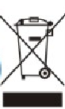Electric power tools, as well as their accessories and packaging, must each be able to follow an appropriate recycling pathway. Only for the countries of the European Union:

Do not throw away your electrical appliance with the household waste! In accordance with the European Directive 2012/19/EU on waste electrical and electronic equipment and its implementation in national laws, power tools that can no longer be used must be separated and follow an appropriate recycling pathway.

**Warranty**

We guarantee this product for 2 full years.

The warranty period for this item starts on the day of purchase. You can prove the date of purchase by sending us the original receipt.

We insure over the entire warranty period:

• Free repair of possible malfunctions.

• Free replacement of damaged parts.

• Including the free service of our specialized personnel (i.e. free assembly by our technicians)

Provided that the damage is not due to improper use of the device.

To help you with your product, we invite you to use this link or call us on +33 (0)9 70 75 30 30:

https://services.swap-europe.com/contact

You must create a "ticket" via their platform:

• Register or create your account

• Indicate the reference of the tool

• Choose the subject of your request

• Explain your problem

• Attach these files: Invoice or receipt, identification plate photo (serial number), photo of the part you need (eg broken transformer plug pins)



1. **CE DECLARATION**



**Declaration of conformity**

BUILDER

ZI, 32 RUE ARISTIDE BERGES – 312070 CUGNAUX – FRANCE

Declares that the machinery designated below:

**CORDLESS ANGLE GRINDER**

**Model: FM20V115**

Serial number: 20191259736-20191260135

Is in conformity with the requirements of the **Directive Machine 2006/42/EC** and to the followings Europeans Directives:

**EMC Directive 2014/30/EU**

**ROHS Directive (EU)2015/863 amending 2011/65/EU**

This tool is also in conformity with the following these standards:

**EN 60745-1: 2009+A11:2010**

**EN 60745-2-3:2011+A2:2013+A11:2014+A12:2014+A13:2015**

**EN 55014-1:2006+A1:2009+A2:2011**

**EN 55014-2:2015**

Responsible of the technical file: Mr Michel Krebs

Cugnaux, 07/11/2019



Philippe MARIE / PDG