
Instruction Manual
Angle Grinder
Model FM115



BJ2011


7
3
1
2
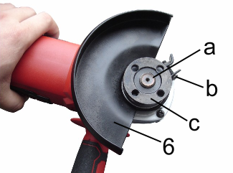
5
4
6

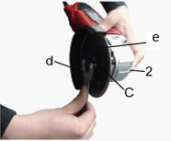 Fig3 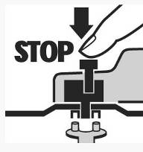Fig4

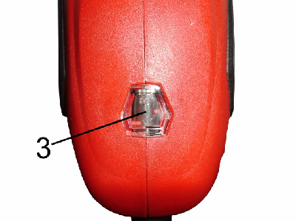 Fig5 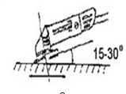fig6
General Power Tool Safety Warnings
WARNING：Read all safety warnings and all instructions. Failure to follow the warnings and instructions may result in electric shock, fire and/or serious injury.
Save all warnings and instructions for future reference.
The term "power tool" in the warnings refers to your mains-operated (corded) power tool or battery-operated (cordless) power tool.
1) Work area safety
a) Keep work area clean and well lit. Cluttered or dark areas invite accidents.
b) Do not operate power tools in explosive atmospheres, such as in the presence of flammable liquids, gases or dust. Power tools create sparks which may ignite the dust or fumes.
c) Keep children and bystanders away while operating a power tool. Distractions can cause you to lose control.
2) Electrical safety
a) Power tool plugs must match the outlet. Never modify the plug in any way. Do not use any adapter plugs with earthed (grounded) power tools. Unmodified plugs and matching outlets will reduce risk of electric shock.
b) Avoid body contact with earthed or grounded surfaces, such as pipes, radiators, ranges and refrigerators. There is an increased risk of electric shock if your body is earthed or grounded.
c) Do not expose power tools to rain or wet conditions. Water entering a power tool will increase the risk of electric shock.
d) Do not abuse the cord. Never use the cord for carrying, pulling or unplugging the power tool. Keep cord away from heat, oil, sharp edges or moving parts. Damaged or entangled cords increase the risk of electric shock.
e) When operating a power tool outdoors, use an extension cord suitable for outdoor use. Use of a cord suitable for outdoor use reduces the risk of electric shock.
f) If operating a power tool in a damp location is unavoidable, use a residual current device (RCD) protected supply. Use of an RCD reduces the risk of electric shock.
3) Personal safety
a) Stay alert, watch what you are doing and use common sense when operating a power tool. Do not use a power tool while you are tired or under the influence of drugs, alcohol or medication. A moment of inattention while operating power tools may result in serious personal injury.
b) Use personal protective equipment. Always wear eye protection. Protective equipment such as dust mask, non-skid safety shoes, hard hat, or hearing protection used for appropriate conditions will reduce personal injuries.
c) Prevent unintentional starting. Ensure the switch is in the off-position before connecting to power source and/or battery pack, picking up or carrying the tool.
Carrying power tools with your finger on the switch or energizing power tools that have the switch on invites accidents.
d) Remove any adjusting key or wrench before turning the power tool on. A wrench or a key left attached to a rotating part of the power tool may result in personal injury.
e) Do not overreach. Keep proper footing and balance at all times. This enables better control of the power tool in unexpected situations.
f) Dress properly. Do not wear loose clothing or jewellery. Keep your hair, clothing and gloves away from moving parts. Loose clothes, jewellery or long hair can be caught in moving parts.
g) If devices are provided for the connection of dust extraction and collection facilities, ensure these are connected and properly used. Use of dust collection can reduce dust-related hazards.
4) Power tool use and care
a) Do not force the power tool. Use the correct power tool for your application. The correct power tool will do the job better and safer at the rate for which it was designed.
b) Do not use the power tool if the switch does not turn it on and off. Any power tool that cannot be controlled with the switch is dangerous and must be repaired.
c) Disconnect the plug from the power source and/or the battery pack from the power tool before making any adjustments, changing accessories, or storing power tools. Such preventive safety measures reduce the risk of starting the power tool accidentally.
d) Store idle power tools out of the reach of children and do not allow persons unfamiliar with the power tool or these instructions to operate the power tool. Power tools are dangerous in the hands of untrained users.
e) Maintain power tools. Check for misalignment or binding of moving parts, breakage of parts and any other condition that may affect the power tools operation. If damaged, have the power tool repaired before use. Many accidents are caused by poorly maintained power tools.
f) Keep cutting tools sharp and clean. Properly maintained cutting tools with sharp cutting edges are less likely to bind and are easier to control.
g) Use the power tool, accessories and tool bits etc. in accordance with these instructions, taking into account the working conditions and the work to be performed. Use of the power tool for operations different from those intended could result in a hazardous situation.
5) Service
a) Have your power tool serviced by a qualified repair person using only identical replacement parts. This will ensure that the safety of the power tool is maintained.
Safety Warnings Common for Grinding or Abrasive Cutting-Off Operations
a) This power tool is intended to function as a grinder. Read all safety warnings, instructions, illustrations and specifications provided with this power tool.
Failure to follow all instructions listed below may result in electric shock, fire and/or serious injury.
b) Operations such as sanding, wire brushing, polishing are not Recommended to be performed with this power tool. Operations for which the power tool was not designed may create a hazard and cause personal injury.
c) Do not use accessories which are not specifically designed and recommended by the tool manufacturer. Just because the accessory can be attached to your power tool, it does not assure safe operation.
d) The rated speed of the accessory must be at least equal to the maximum speed marked on the power tool. Accessories running faster than their rated speed can break and fly apart.
e) The outside diameter and the thickness of your accessory must be within the capacity rating of your power tool. Incorrectly sized accessories cannot be adequately guarded or controlled.
f) The inner diameter of wheels, flanges, backing pads or any other accessory must properly fit the spindle of the power tool. Accessories with inner holes that do not match the mounting hardware of the power tool will run out of balance, vibrate excessively and may cause loss of control.
g) Do not use a damaged accessory. Before each use inspect the accessory such as abrasive wheels for chips and cracks, backing pad for cracks, tear or excess wear, wire brush for loose or cracked wires. If power tool or accessory is dropped, inspect for damage or install an undamaged accessory. After inspecting and installing an accessory, position yourself and bystanders away from the plane of the rotating accessory and run the power tool at maximum no-load speed for one minute.
Damaged accessories will normally break apart during this test time.
h) Wear personal protective equipment. Depending on application, use face shield, safety goggles or safety glasses. As appropriate, wear dust mask, hearing protectors, gloves and workshop apron capable of stopping small abrasive or workpiece fragments. The eye protection must be capable of stopping flying debris generated by various operations. The dust mask or respirator must be capable of filtrating particles generated by your operation. Prolonged exposure to high intensity noise may cause hearing loss.
i) Keep bystanders a safe distance away from work area. Anyone entering the work area must wear personal protective equipment. Fragments of workpiece or of a broken accessory may fly away and cause injury beyond immediate area of operation.
j) Hold power tool by insulated gripping surfaces only, when performing an operation where the cutting accessory may contact hidden wiring or its own cord. Cutting accessory contacting a "live" wire may make exposed metal parts of the power tool "live" and shock the operator.
k) Position the cord clear of the spinning accessory. If you lose control, the cord may be cut or snagged and your hand or arm may be pulled into the spinning accessory.
l) Never lay the power tool down until the accessory has come to a complete stop. The spinning accessory may grab the surface and pull the power tool out of your control.
m) Do not run the power tool while carrying it at your side. Accidental contact with the spinning accessory could snag your clothing, pulling the accessory into your body.
n) Regularly clean the power tool’s air vents. The motor’s fan will draw the dust inside the housing and excessive accumulation of powdered metal may cause electrical hazards.
o) Do not operate the power tool near flammable materials. Sparks could ignite these materials.
p) Do not use accessories that require liquid coolants. Using water or other liquid coolants may result in electrocution or shock.
NOTE：The above warning does not apply for power tools specifically designed for use with a liquid system.
Kickback and Related Warnings
Kickback is a sudden reaction to a pinched or snagged rotating wheel, backing pad, brush or any other accessory. Pinching or snagging causes rapid stalling of the rotating accessory which in turn causes the uncontrolled power tool to be forced in the direction opposite of the accessory’s rotation at the point of the binding.
For example, if an abrasive wheel is snagged or pinched by the workpiece, the edge of the wheel that is entering into the pinch point can dig into the surface of the material causing the wheel to climb out or kick out. The wheel may either jump toward or away from the operator, depending on direction of the wheel’s movement at the point of pinching. Abrasive wheels may also break under these conditions.
Kickback is the result of power tool misuse and/or incorrect operating procedures or conditions and can be avoided by taking proper precautions as given below.
a) Maintain a firm grip on the power tool and position your body and arm to allow you to resist kickback forces. Always use auxiliary handle, if provided, for maximum control over kickback or torque reaction during start-up. The operator can control torque reactions or kickback forces, if proper precautions are taken.
b) Never place your hand near the rotating accessory. Accessory may kickback over your hand.
c) Do not position your body in the area where power tool will move if kickback occurs. Kickback will propel the tool in direction opposite to the wheel’s movement at the point of snagging.
d) Use special care when working corners, sharp edges etc. Avoid bouncing and snagging the accessory. Corners, sharp edges or bouncing have a tendency to snag the rotating accessory and cause loss of control or kickback.
e) Do not attach a saw chain woodcarving blade or toothed saw blade. Such blades create frequent kickback and loss of control.
Additional Safety Warnings Specific for Abrasive Cutting-off Operations
a) Do not “jam” the cut-off wheel or apply excessive pressure. Do not attempt to make an excessive depth of cut. Overstressing the wheel increases the loading and susceptibility to twisting or binding of the wheel in the cut and the possibility of kickback or wheel breakage.
b) Do not position your body in line with and behind the rotating wheel. When the wheel, at the point of operation, is moving away from your body, the possible kickback may propel the spinning wheel and the power tool directly at you.
C) When wheel is binding or when interrupting a cut for any reason, switch off the power tool and hold the power tool motionless until the wheel comes to a complete stop. Never attempt to remove the cut-off wheel from the cut while the wheel is in motion otherwise kickback may occur. Investigate and take corrective action to eliminate the cause of wheel binding.
d) Do not restart the cutting operation in the workpiece. Let the wheel reach full speed and carefully reenter the cut. The wheel may bind, walk up or kickback if the power tool is restarted in the workpiece.
e) Support panels or any oversized workpiece to minimize the risk of wheel pinching and kickback. Large workpieces tend to sag under their own weight. Supports must be placed under the workpiece near the line of cut and near the edge of the workpiece on both sides of the wheel.
e) Use extra caution when making a “pocket cut” into existing walls or other blind areas. The protruding wheel may cut gas or water pipes, electrical wiring or objects that can cause kickback.
Safety Warnings Specific for Grinding Operations：
a) Use only wheel types that are recommended for your power tool and the specific guard designed for the selected wheel. Wheels for which the power tool was not designed cannot be adequately guarded and are unsafe.
b) The guard must be securely attached to the power tool and and positioned for maximum safety, so the least amount of wheel is exposed towards the operator. The guard helps to protect operator from broken wheel fragments and accidental contact with wheel.
C) Wheels must be used only for recommended applications. For example: do not grind with the side of cut-off wheel. Abrasive cut-off wheels are intended for peripheral grinding, side forces applied to these wheels may cause them to shatter.
d) Always use undamaged wheel flanges that are of correct size and shape for your selected wheel. Proper wheel flanges support the wheel thus reducing the possibility of wheel breakage. Flanges for cut-off wheels may be different from grinding wheel flanges.
e) Do not use worn down wheels from larger power tools. Wheel intended for larger power tool is not suitable for the higher speed of a smaller tool and may burst.
Special safety regulations
Check that the ventilation slots are not blocked. Always secure the item to be worked with cramps or the like. Never hold the item to be worked by hand.
Always use the correct type of grinding disc for the type of work to be performed.
Never use discs with a Maximum RPM less than that of the tool.
Never use oversized discs.
Never use damaged or worn discs, or discs that cannot be easily fitted to the grinder spindle. Never use an adapter ring or the like to fit discs with holes that are too large for the grinder spindle.
Never place your hand or fingers near the disc while the grinder is running.
Keep the power cable well clear of the working area.
Keep the handles and the grinder as a whole free of oil, grease, water and other liquids.
Never put the grinder down until the disc has completely stopped rotating.
Do not touch the item to be worked or metal filings until they have cooled.
Do not use the grinder to work items made of magnesium.
.SYMBOLS
The rating plate on your tool may show certain symbols.
These represent import information about the product or instructions on its use.
 | Conforms to relevant safety standards.
 | Read the instruction manual.
 | Wear hearing protection.
 | Wear eye protection.
 | Wear respiratory protection.
 | ClassⅡdevice .This device must not be earthed.
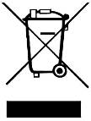 | Do not dispose of old appliances with  domestic rubbish

READ AND SAVE ALL INSTRUCTAION FOR FUTURE USE
Technical specifications
Model | FM115
Rated voltage /frequency | 230V~ 50HZ
Rated power (W) | 710
Dia．of disc (mm) | 115
No load speed (r/min) | 10500
Drive spindle thread | M14
Standard accessories | Side handle-- 1 pc Spanner --- 1pc Wheel guard --1pc

WARNING:
- The vibration emission during actual use of the power tool can differ from the declared total value depending on the ways in which the tool is used, and
- Before using the product, please wear suitable gloves, firmly grasp it in the right condition, keep good awareness, and avoid long time operating,
Functional Description（Fig1）
- On/off button
- Spindle lock
- Indicator light
- Side handle
- Cable sleeve
- Wheel guard
- Main handle
Preparation for use（Fig2&3）
WARNING: Prior to assembly and adjustment always pull out the power plug from the mains socket.
Remove the outer flange (c) and inner flange from the spindle (a). Attach the wheel guard (6) to the front cover and fit the inner flange on the spindle. Move the shield to the desired position, and tighten it with the screw (b).
The wheel guard(6) must be positioned to protect the user if the disc (d)shatters during use.
Check that the spindle lock (2) is not locked and that the spindle can freely rotate.
Fit the side handle (4) on the left or right side of the grinder, depending on whether it is to be used by a left-handed or right-handed person. Check that the handle is securely fitted.
Switch the grinder on using the on/off button , and let it run for 30 seconds to check that it is working correctly and that there are no abnormal vibrations. Stop the grinder immediately if heavy vibration occurs, and investigate the cause.
Fixing grinding disc（Fig3&4）
Pull out the power plug.
Depress and hold down the spindle lock（2） to tighten the spindle. Turn the shaft until it was locked. Remove the outer flange (c) and tighten the flange using the special wrench (d) provided.
Fit the desired disc (e) on the inner flange and replace the outer flange and tighten the flange. Release the spindle lock.
WARNING: only use wheels with maximum safe operating speed rated at or above the RPM listed on the "WARNING"selection of the tool`s nameplate .This speed is based on the strength of the wheel,allowing for a reasonable measure of safety,It is not meat to imply a best or most efficient operating speed ,Do not exceed the Maximum Safe Operating Speed.
Indicator light（Fig5）
Connect the plug with power. the indicator light(3) will be light. That show the machine electrify.
Motor
It is vital for the motor to be well ventilated during operation. Be sure to keep the ventilation holes clean at all times.
Use(Fig.6)
Hold the main handle (7) and side handle（4）firmly and switch on. Avoid blocking the ventilation slots with your hand, as this may cause the grinder to overheat. Let the disc reach full speed.
Apply the grinder to the item. Maximum effect is achieved when the grinder is held at an angle of 15-30°in relation to the item. Move the grinder gently along the item. Give the grinder time to work. It is rarely necessary to press the disc hard against the surface to be worked.
Sparks can occur in the motor compartment during use. This is normal and does not mean the grinder is defective.
Switch off the grinder after use.
Cleaning and maintenance
The grinder can be cleaned by wiping its exterior parts with a dry cloth. Filings and dust can be removed using compressed air. Do not use water for cleaning! Ensure the ventilation slots are free of dust and dirt.
Never use corrosive or abrasive detergents, as they may attack the plastic parts of the machine.
Recycling
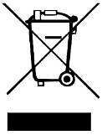

Meaning of crossed –out wheeled dustbin:
Do not dispose of electrical appliances as unsorted municipal waste, use separate collection facilities. Contact you local government for information regarding the collection systems available. If electrical appliances are disposed of in landfills or dumps, hazardous substances can leak into the groundwater and get into the food chain, damaging your health and well-being.


Déclaration  de conformité
FEIDER FRANCE
32 rue aristide Bergès –Z1 31270 Cugnaux - France
Tel : +33 (0)5.34.508.508 Fax : +33 (0)5.34.508.509
Déclare que la machine désignée ci-dessous :
Angle grinder: 115MM. 710W
FM115
Numéro de série : from :20130406407 to 20130406659
Est conforme aux dispositions de la directive « machine » 2006/42/CE et aux réglementations nationales la transposant ;
Est également conforme aux dispositions des directives européennes suivantes :
A la Directive Basse Tension 2006/95/CE
A la Directive CEM 2004/108/CE
A la directive d’émission de bruit
Est également conforme aux normes européennes, aux normes nationales et aux dispositions techniques suivantes :
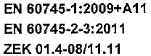
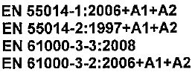

Fait à Cugnaux, le 05/03/2013
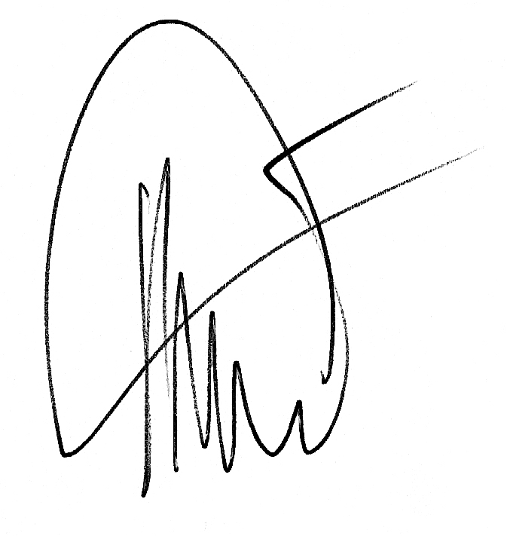

Philippe MARIE / PDG

