Instruction manual

PLASTER BOX
Model: FAP250

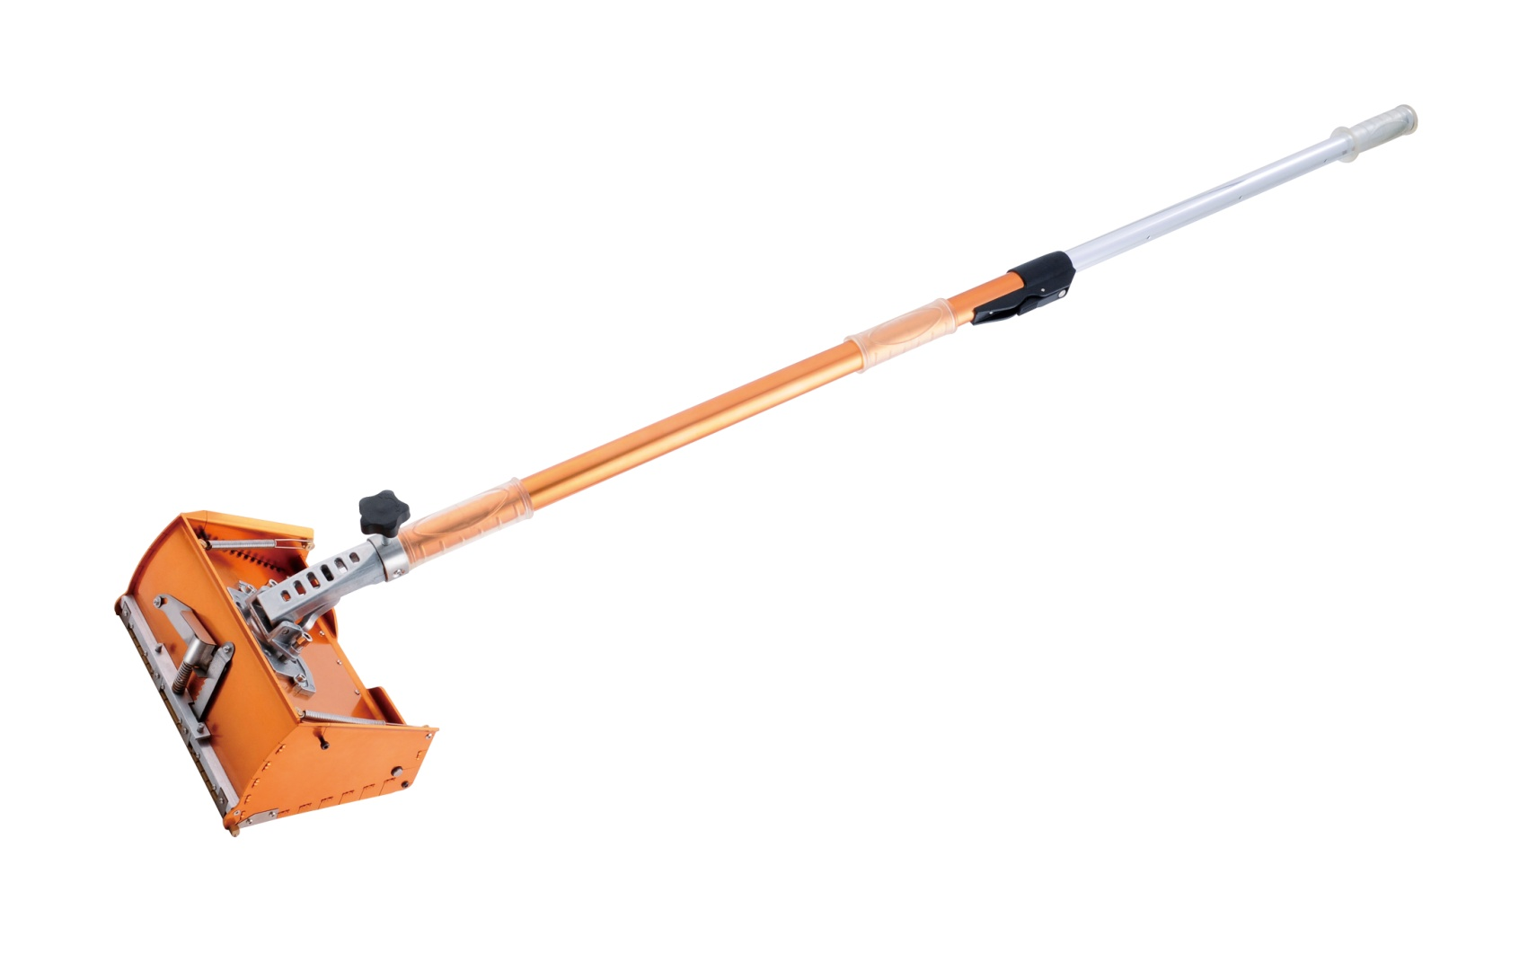

FEIDER FRANCE
32, rue Aristide Bergès - ZI 31270 Cugnaux - France
The Plaster boxes are designed to apply the correct amount of joint compound over taped, flat joints when used in conjunction with a Plaster box Handle. The Plaster Box is also available to make filling your plaster box quicker and easier.

Tech data:
Length of plaster box: 250mm
Length of handle:1020-1620mm( adjust in 4 positions)

Assembling:
- Make sure the Plaster box blade is the thickness of a fingernail (1 – 1.5mm) above the skids. The blade can be adjusted using screws on the blade holder to obtain the necessary height.
- Test that the blade holder can move up and down freely.
Blade
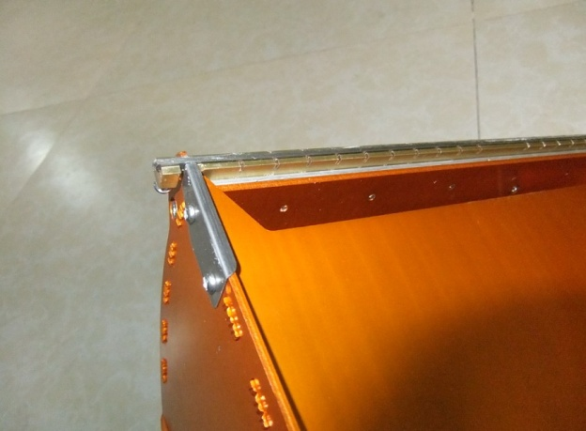
Side board

- Attach your Plaster box Handle by sliding it onto the box and tightening the two wing nuts.
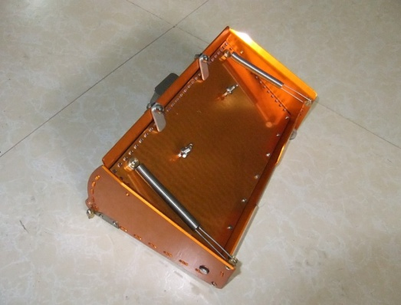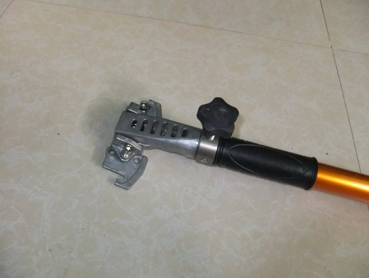
- permanent seat

wing nut
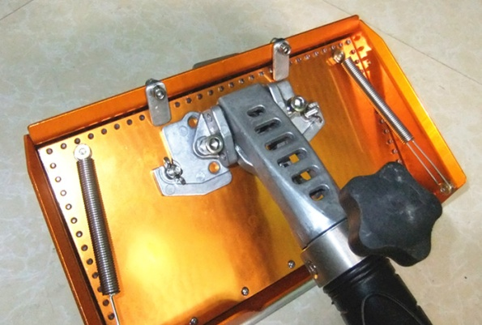

Adjust the tension on the blade holder to suit the gauge of compound which is to be used in the machine.
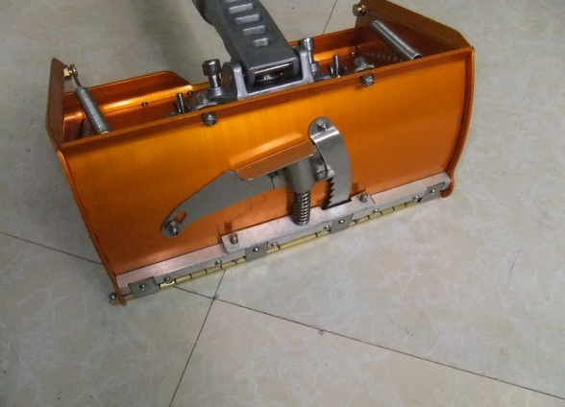
- Tension Adjuster

- Assemble with the handle
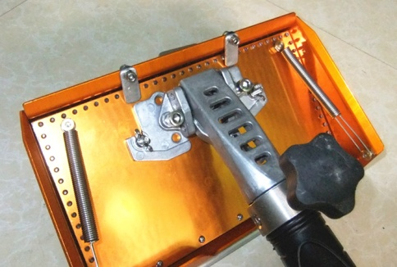
Loading
Before loading of compound to avoid release, cover the mouth of box with board; after loading, take the board off then to use.
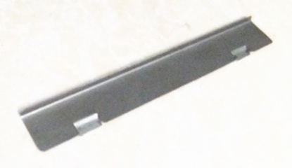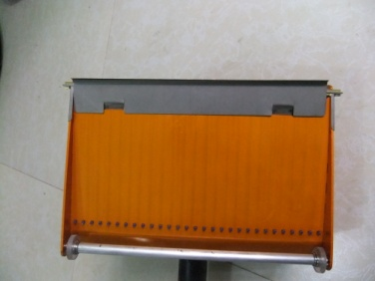
Compound can be loaded into the Plaster box either with the aid of a Loading Pump and appropriate filler nozzle or by hand.
Loading by Hand
1. Open the lid.
2. Evenly fill the Plaster Box with compound using a joint knife. Do not overfill.
3. Close the lid.
4. Remove any excess compound.
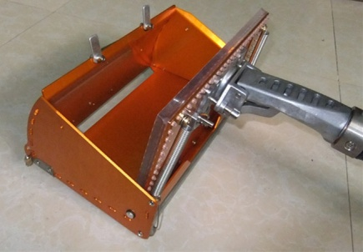

Using
- Set the box at a slight angle from the handle and tighten the button to fix the angle, so the head remains stationary.
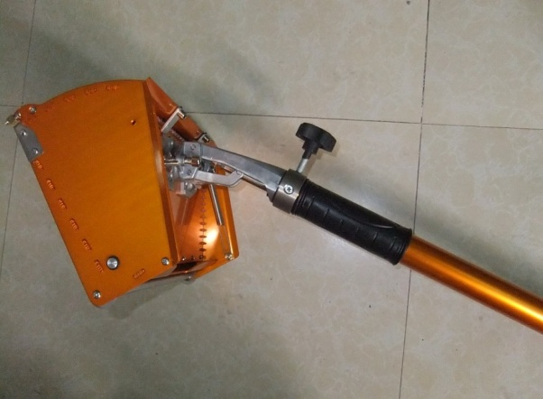
- Fix Nut

- Place the plaster box on the joint and while applying pressure, release the button allowing the box and the handle to find its own natural position.
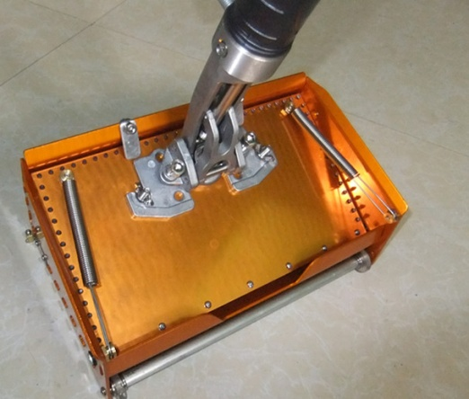
3. Adjust the length of handle: push the button to extend the length (max:1620mm) .
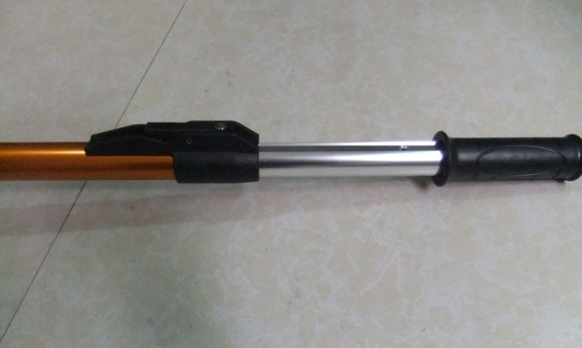
- Extend Button
- Operation picture.
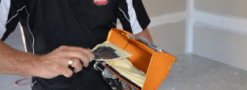
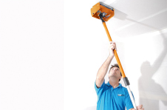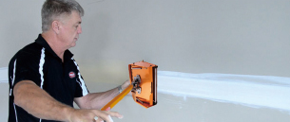
General Maintenance
PB-9
To protect and lubricate your Plaster Box, use a silicon spray. Do not use solvents to clean your Plaster box as they will damage the wiper seals and reduce performance. Regular wear parts should be replaced as needed.

Plaster Box Blade
If the Plaster box Blade cannot be adjusted to the required height it will need to be replaced by following these simple steps.
- Tighten the screws on the blade holder so that the blade is forced out of the blade holder groove.
- Remove the blade from the blade holder. If there is resistance, a screwdriver can be used to gently lever it out.
- Remove all dry joint compound from under the blade and in and around the blade holder using a wire brush.
- Bend the new blade into a slight ‘w’ shape, this keeps the blade secure.
- Adjust the screws on the blade holder so the blade is the thickness of a fingernail (1-1.5mm) above the skids. (refer to illustration from 'before use' regarding the width of the Plaster Box Blade).

Problem - The Box is leaving edges.
- Cause - The Plaster Box blade is not correctly adjusted.
- Solution - Check the Plaster box blade is set 1 – 1.5mm above the skids. This setting can be
- done by tightening the AT042 on the side of the brass blade holder.
Problem - The joint compound has a pothole effect.
- Cause - The coat is too thick.
- Solution - Adjust the blade setting by increasing the tension on the ratchet. This will
- remove the excess compound and leave a smooth finish for minimal sanding.
Problem - The Box is leaving hollow joints.
- Cause - The coat is too thin.
- Solution - Adjust the blade setting by decreasing the tension on the ratchet.

