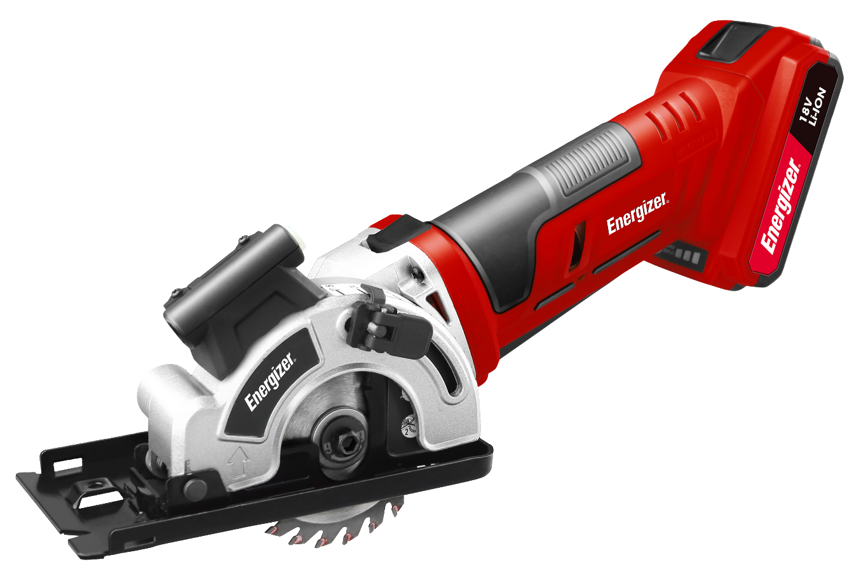

POWER TOOL SAW
USER GUIDE
1
©2018 Energizer. Energizer and certain graphic designs are trademarks of Energizer Brands,
LLC and related subsidiaries and are used under license by Builder SAS.
All other brand names are trademarks of their respective owners.
Neither Builder SAS nor Energizer Brands, LLC is affiliated with the respective owners of their trademarks

Thanks for choosing the POWER TOOL SAW!
You're excited to power up, so we'll keep this brief. Let's get started!

3
DESCRIPTION OF THE SYMBOLS
The use of symbols in this manual is intended to draw y our attention to possible risks. The safety symbols and the explanations that accompany them must be perfectly understood. The warnings in themselves do not remove the risks and cannot replace correct actions for preventing accidents.
This symbol, marking a point of safety, indicates a caution, warning or danger. Ignoring this warning can result in an accident to yourself or others. To limit the risks of injury, fire or electrocution, always follow the recommendations indicated.
WARNING – To reduce the risk of injury, user must read instruction manual
Complies with relevant EU regulations.
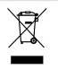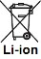WARNING Always wear eye protection, eye protection, dust mask and gloves when using the product.

The crossed-out wheeled bin symbol indicates that the item should be disposed of separately from household waste. The item should be handed in for recycling in accordance with local environmental regulations for waste disposal. By separating a marked item from household waste, you will help reduce the volume of waste sent to incinerators or land-fill and minimize any potential negative impact on human health and the environment.

Class II transformer.
4

Read instruction manual before any use.

For indoor use only.

Polarity of the output terminal.

Do not immerse the battery into water.

Do not expose battery to flame. They will explode and cause injury.

Do not expose the battery to excessive heat more than 40 °C. Do not charge or stock the battery where the temperature is below 0° or more than 40 °C.

Li-ion battery.

Recyclable waste.
5

GENERAL POWER TOOL SAFETY WARNINGS

WARNING Read all safety warnings and all instructions. Failure to follow the warnings and instructions may result in electric shock, fire and/or serious injury.
Save all warnings and instructions for future reference.
The term "power tool" in the warnings refers to your mains-operated (corded)
power tool or battery-operated (cordless) power tool.

1) Work area safety
a) Keep work area clean and well lit. Cluttered or dark areas invite accidents.
b) Do not operate power tools in explosive atmospheres, such as in the presence of flammable liquids, gases or dust. Power tools create sparks which may ignite the dust or fumes.
c) Keep children and bystanders away while operating a power tool.
Distractions can cause you to lose control.

2) Electrical safety
a) Power tool plugs must match the outlet. Never modify the plug in any way. Do not use any adapter plugs with earthed (grounded) power tools. Unmodified plugs and matching outlets will reduce risk of electric shock.
b) Avoid body contact with earthed or grounded surfaces, such as pipes, radiators, ranges and refrigerators. There is an increased risk of electric shock if your body is earthed or grounded.
c) Do not expose power tools to rain or wet conditions. Water entering a power tool will increase the risk of electric shock.
d) Do not abuse the cord. Never use the cord for carrying, pulling or unplugging the power tool. Keep cord away from heat, oil, sharp edges or moving parts. Damaged or entangled cords increase the risk of electric shock.
e) When operating a power tool outdoors, use an extension cord suitable for outdoor use. Use of a cord suitable for outdoor use reduces the risk of electric shock.
f) If operating a power tool in a damp location is unavoidable, use a residual current device (RCD) protected supply. Use of an RCD reduces the risk of electric shock.

3) Personal safety
a) Stay alert, watch what you are doing and use common sense when operating a power tool. Do not use a power tool while you are tired or under the influence of drugs, alcohol or medication. A moment of
6

inattention while operating power tools may result in serious personal injury.
b) Use personal protective equipment. Always wear eye protection.
Protective equipment such as dust mask, non-skid safety shoes, hard hat, or hearing protection used for appropriate conditions will reduce personal injuries.
c) Prevent unintentional starting. Ensure the switch is in the off-position before connecting to power source and/or battery pack, picking up or carrying the tool. Carrying power tools with your finger on the switch or energizing power tools that have the switch on invites accidents.
d) Remove any adjusting key or wrench before turning the power tool on. A wrench or a key left attached to a rotating part of the power tool may result in personal injury.
e) Do not overreach. Keep proper footing and balance at all times.
This enables better control of the power tool in unexpected situations.
f) Dress properly. Do not wear loose clothing or jewellery. Keep your hair, clothing and gloves away from moving parts. Loose clothes, jewellery or long hair can be caught in moving parts.
g) If devices are provided for the connection of dust extraction and collection facilities, ensure these are connected and properly used. Use of dust collection can reduce dust-related hazards.

4) Power tool use and care
a) Do not force the power tool. Use the correct power tool for your application. The correct power tool will do the job better and safer at the rate for which it was designed.
b) Do not use the power tool if the switch does not turn it on and off.
Any power tool that cannot be controlled with the switch is dangerous and must be repaired.
c) Disconnect the plug from the power source and/or the battery pack from the power tool before making any adjustments, changing accessories, or storing power tools. Such preventive safety measures reduce the risk of starting the power tool accidentally.
d) Store idle power tools out of the reach of children and do not allow persons unfamiliar with the power tool or these instructions to operate the power tool. Power tools are dangerous in the hands of untrained users.
e) Maintain power tools. Check for misalignment or binding of moving parts, breakage of parts and any other condition that may affect the power tool’s operation. If damaged, have the power tool repaired before use. Many accidents are caused by poorly maintained power tools.
7

f) Keep cutting tools sharp and clean. Properly maintained cutting tools with sharp cutting edges are less likely to bind and are easier to control.
g) Use the power tool, accessories and tool bits etc. in accordance with these instructions, taking into account the working conditions and the work to be performed. Use of the power tool for operations different from those intended could result in a hazardous situation.

5) Service
a) Have your power tool serviced by a qualified repair person using only identical replacement parts. This will ensure that the safety of the power tool is maintained.
b) Caution!
If the replacement of the supply cord is necessary, this has to be done by the manufacturer or his agent in order to avoid a safety hazard.

SPECIAL SAFETY INSTRUCTIONS
a) DANGER: Keep hands away from cutting area and the blade. Keep your second hand on auxiliary handle, or motor housing. If both hands are holding the saw, they cannot be cut by the blade.
b) Do not reach underneath the work-piece. The guard cannot protect you from the blade below the work-piece.
c) Adjust the cutting depth to the thickness of the work-piece. Less than a full tooth of the blade teeth should be visible below the work-piece.
d) Never hold piece being cut in your hands or across your leg. Secure the work-piece to a stable platform. It is important to support the work properly to minimize body exposure, blade binding, or loss of control.
e) Hold the power tool by insulated gripping surfaces only, when performing an operation where the cutting tool may contact hidden wiring or its own cord. Contact with a "live" wire will also make exposed metal parts of the power tool "live".
f) When ripping, always use a rip fence or straight edge guide. This improves the accuracy of cut and reduces the chance of blade binding.
g) Always use blades with correct size and shape (diamond versus round) of arbour holes. Blades that do not match the mounting hardware of the saw will run eccentrically, causing loss of control.
h) Never use damaged or incorrect blade washers or bolt. The blade washers and bolt were specially designed for your saw, for optimum performance and safety of operation.
8

Further safety instructions for all saws
Kickback causes and related warnings
Kickback is a sudden reaction to a pinched, bound or misaligned saw blade, causing an uncontrolled saw to lift up and out of the work-piece toward the operator;

When the blade is pinched or bound tightly by the kerf closing down, the blade stalls and the motor reaction drives the unit rapidly back toward the operator;
if the blade becomes twisted or misaligned in the cut, the teeth at the back edge of the blade can dig into the top surface of the wood causing the blade to climb out of the kerf and jump back toward the operator.

Kickback is the result of saw misuse and/or incorrect operating procedures or conditions and can be avoided by taking proper precautions as given below.

a) Maintain a firm grip with both hands on the saw and position your arms to resist kickback forces. Position your body to either side of the blade, but not in line with the blade. Kickback could cause the saw to jump backwards, but kickback forces can be controlled by the operator, if proper precautions are taken.
b) When blade is binding, or when interrupting a cut for any reason, release the trigger and hold the saw motionless in the material until the blade comes to a complete stop. Never attempt to remove the saw from the work or pull the saw backward while the blade is in motion or kickback may occur. Investigate and take corrective actions to eliminate the cause of blade binding.
c) When restarting a saw in the work-piece, center the saw blade in the kerf and check that saw teeth are not engaged into the material. If saw blade is binding, it may walk up or kickback from the work-piece as the saw is restarted.
d) Support large panels to minimize the risk of blade pinching and kickback.
Large panels tend to sag under their own weight. Supports must be placed under the panel on both sides, near the line of cut and near the edge of the panel.
e) Do not use dull or damaged blades. Unsharpened or improperly set blades produce narrow kerf causing excessive friction, blade binding and kickback.
f) Blade depth and bevel adjusting locking levers must be tight and secure before making cut. If blade adjustment shifts while cutting, it may cause binding and kickback.
g) Use extra caution when sawing into existing walls or other blind areas. The protruding blade may cut objects that can cause kickback.
9

EXTRA SAFETYREGULATIONSCONCERNING BATTERY
• To ensure the longest battery life and best battery performance, always charge the battery when the temperature is between 18-24°C. Do not charge the battery pack when the temperature is below 0°C, or above
40°C. This is important. Failure to observe this safety rule could cause serious damage to the battery pack.
• Do not incinerate the battery pack even if it is seriously damaged or can no longer hold a charge. The battery pack can explode in a fire.
• A small leakage of liquid from the battery pack m ay occur under extreme usage or temperature. This does not necessarily indicate a failure of the battery pack. However, if the outer seal is broken and this leakage comes into contact with your skin:
Wash the affected area quickly with soap and water.
Neutralize the liquid with a mild acid such as lemon juice or vinegar. If the leakage gets in your eyes:
Flush your eyes with clean water for a minimum of 10 minutes and seek immediate medical attention. Inform the medical staff that the liquid is a 25-35% solution of potassium hydroxide.
• Never attempt to open the battery pack for any reason. If the plastic housing of the battery pack breaks open or cracks, immediately discontinue its use and do not recharge it.
• Do not s tore or carry a s pare battery pack in a pocket or toolbox or any other place where it may come into contact with metal objects. The battery pack may be short circuited causing damage to the battery pack, burns or a fire. If storing or disposing the battery pack, cover the terminals with a heavy insulation tape to ensure short circuit cannot occur. Batteries, when stored for a long period of time, will discharge.
• Do not s tore or us e the tool and battery pack in locations w here the temperature may reach or exceed 40°C such as alongside sheds or metal structures in the summer.
• Allow the battery pack to cool down after charging. Do not place it in a hot environment such as a metal shed or open trailer left in the sun.
• Only charge the battery with the charger supplied.
• Do not put the battery pack near fire or high temperature position.
• Do not splash or immerse in water or other liquids. This may cause premature cell failure.
• When transporting individual batteries, make sure that the battery terminals are protected and well insulated from materials that could contact them and cause a short circuit.
• The best storage place is one that is cool and dry away from direct sunlight and excess heat or cold.
• If the battery pack has been stored for a long time, you should activate the battery pack first before using it.
• The battery is to be disposed of safely.
10

EXTRA SAFETYREGULATIONSCONCERNINGBATTERY CHARGER

• This appliance can not be used by children aged from 8 years and above and persons with reduced physical, sensory or mental capabilities or lack of experience and knowledge.
• Children shall not play with the appliance.
• Cleaning and user maintenance shall not be made by children without supervision.
• For indoor use only
• Warning do not recharge non-rechargeable batteries
• This charger should be used only to charge battery pack B01003-B
• If the supply cord is damaged, it must be replaced by the manufacturer, its service agent or similarly qualified persons in order to avoid a hazard.
• Before using the charger, read all the instructions and cautionary markings on the charger and battery pack as well as the instructions on the battery pack.
• Only charge your battery pack indoors as the charger is designed for indoor use only.
• DANGER: If the battery pack is cracked or damaged in any other way, do not insert it in the charging base. There is a danger of electric shock or electrocution.
• WARNING: Do not allow any liquid to come into contact with the charger. There is a danger of electric shock.
• The charger is not intended for any use other than charging the exact type
of rechargeable battery pack as supplied with the charger. Any other use may result in the risk of fire, electric shock or electrocution.
• The charger and battery pack supplied with it are specifically designed to work together. Do not attempt to charge the battery pack with any other charger than the one supplied.
• Do not place any object on top of the charger as it could cause overheating.
Do not place the charger near any heat source.
• Pull on the charger to disconnect it from the power source. Do not pull on the lead.
• Make sure that the charger lead is positioned where it will not be stepped on, tripped over or otherwise subjected to damage or stress.
• Do not use an extension cord unless it is absolutely necessary. The use of an improper ex tension cord could cause the risk of fire, electric s hock or electrocution.
• Do not use the charger if it has been subjected to a heavy knock, dropped or otherwise dam aged in any way. Take the charger to an authorized service center for a check or repair.
11
• Do not disassemble the charger. Take i t t o an authorized service center when service or repair is required. Incorrect re-assembly may result in the risk of fire, electric shock or electrocution.
• To reduce the risk of an electric shock, unplug the charger from the power supply before attempting to clean it. Removing the battery pack alone does not reduce the risk.
• The charger is designed for use from a standard household electrical supply. Do not attempt to connect the charger to a supply with a different voltage.
• The charger is not intended for us e by persons (including children) with reduced physical, sensory or mental capabilities, or lack of experience and knowledge, unless they have been given supervision or instruction concerning use of the charger by a person responsible for their safety.
• Children should be supervised to ensure that they do not play with the charger.
• Do not expose charger to rain or snow.
• Do not mount charger on wall or permanently affix charger to any surface.
The charger is intended to use on a flat, stable surface (i.e. table top, bench top)
• Never attempt to connect two chargers together.
• Never insert any objects into the charger’s air vents. Electric shock or damage to the battery charger may result.
• Disconnect the charger from the outlet before attempting any c leaning.
This will reduce the risk of electric s hock. Removing the battery pack will not reduce this risk.
• Do not charge non-rechargeable batteries.

INTENDED USE
The machine is intended for ripping and ross-cutting wood and other materials in straight cutting lines, while resting firmly on the work piece.

TECHNICAL SPECIFICATIONS

Model | US09-1180
Voltage | 18V
No-load speed | 2300/min
Blade size | 85mm
Cutting capacity
wood | 27mm
Aluminum | 3mm
12

PVC pipe(radius) | 13mm
Tile | 8mm
Steel plate | 0.9mm
Sound pressure level(LpA) | 95.0 dB(A) KpA: 3 dB
Sound power level(LwA) | 106.0 dB(A) KpA: 3 dB
Vibration equivalent chiseling value | ah, CHeq:=2.252 m/s2 K=1.5 m/s2

NOISE/VIBRATION INFORMATION
Measured sound values determined according to EN 60745.
Wear hearing protection!

Vibration total values (triax vector sum) determined according to EN 60745: The vibration emission level given in this information sheet has been measured in accordance with a standardized test given in EN 60745 and may be used to compare one tool with another.
It may be used for a preliminary assessment of exposure.
The declared vibration emission level represents the main applications of the tool. However, if the tool is used for different applications, with different accessories or poorly maintained, the vibration emission may differ. This may significantly increase the exposure level over the total working period.
An estimation of the level of exposure to vibration should also take into account the times when the tool is switched off or when it is running but not actually doing the j ob. This m ay significantly reduces the exposure level over the total working period.
Identify additional safety measures to protect the operator from the effects of vibration such as: maintain the tool and the accessories, keep the hands warm, organization of work patterns.
13

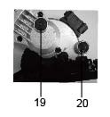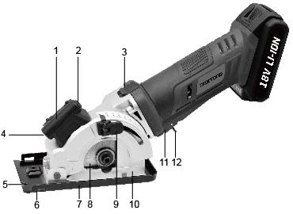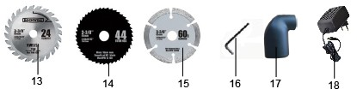LIST OF MAIN PART

1. Battery storage cover | 2. Laser switch
3. Shield push button | 4. Laser
5. Blade alignment indicator | 6. Parallel guide
7. Base plate | 8. Saw blade
9. Depth adjustment lever | 10. Protective blade guard
11. On/Off switch | 12. Protective switch
13. Diamond disc | 14. HSS blade
15. TCT saw blade | 16. hex key
17. outlet pipe | 18. charger
19. Spindle lock button | 20. dust extraction outlet

OPERATION

Trigger switch
Your switch is locked off to prevent accidental starting. Depress shield push button (3) then on/off s witch (11) and release shield push button (3). Your switch is now on. Release the on/off switch to turn the switch.

Changing the saw blade
• Wear protective gloves when mounting he saw blade. Danger of injury exists when touching the saw blade.
• Only use saw blades that correspond with the characteristic data given in the operating instructions.
14

• Do not use grinding discs as the cutting tool under any circumstances.

Removing the blade
Note: Remove the battery before remove the blade
• Adjust depth lock lever (9) to max position
• Press the spindle lock button (19) and keep it depressed.
• Loosen the blade bolt with the Hex Key (16) by turning it clockwise.
• Remove the out flange.
• Push the shield push button (3) and manually retract back the base plate
(8) and hold it firmly. Remove the saw blade (8).

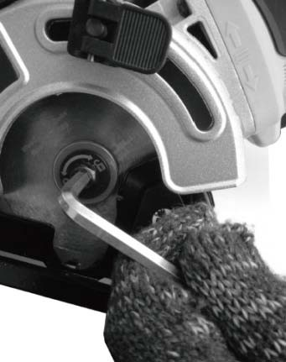

Mounting the blade
Note: Remove the battery before mount the blade
• Check to make sure the blade surface and flanges are clean before reinstalling. Place the blade onto the inner flange and spindle making sure the arrow on the bade matches the arrow direction o n t he fixed upper guard (7).
• Push the shield push button (3) and manually retract back the base plate (7) and hold it firmly. Depress the piddle lock but ton (19) and mount the saw blade (8). Insert the out flange over the spindle and tighten it (turning counter-clockwise) with hex key (16).
• Check that the blade is securely fastened by continuing to hold down the spindle lock button (19) and attempting to manually rotate the blade. If installed correctly, the blade should not spin.
• For best cutting results, use a saw blade suited t o t he material and cut quality desired.

Adjusting the cutting depth
• Release the depth adjustment lever (9) by lifting it up.
• Manually push the base plate (11) up or down to the desired depth on the scale.
• Push the depth adjustment lever (9) bac k d own to lock the base plate at the desired depth.
15

• Always add 3 mm to the depth of cut to ensure the blade has enough clearance to cut completely through the material.

Parallel guide
• The parallel guide is used for making long, straight rip cuts.
• Slide the parallel guide through the parallel guide (6) to the desired cutting distance and tighten the clamping screw to lock into position. Do not over tighten. It can be used from either side of the base plate (7).

Outlet pipe
Your saw includes an outlet pipe (17) that attaches to the dust extraction outlet (20) on the saw. This adapter port can be attached to a vacuum cleaner. The use of the vacuum is strongly recommended as it keeps the work area clean, dramatically increases cut visibility and reduces airborne dust. It also keeps dust out of the working element of the guard.

Charging the battery
WARNING: Place the battery pack and charger on a flat nonflammable surface and away from flammable material when re-charging the battery pack
1. Insert the plug on the charging unit into a power socket and turn the power on if required
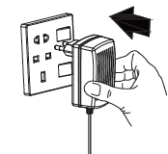

2. The charging output interface inserts battery of charging port.
Note: The battery will require 1 hours charging time after normal use. If the battery is fully run down the charging time will be 1 hour.
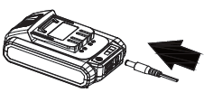

3. The process of charging battery pack, red light and yellow light and green light in turn.
Note: The red light alone means battery pack less power.
Red and yellow light means battery pack more than half of the electricity. When red and yellow and green light, battery pack is fully charged
16

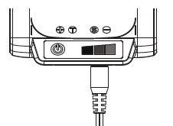
4. Charging treasure function: Insert the USB interface, the other end connected to mobile phone LED lights, fan, etc. according to the

used

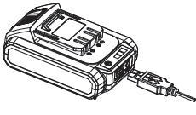

Working hints for your tool
If y our power tool becomes too hot, please run your circular saw no load for
2-3 minutes to cool the motor. Avoid prolonged usage at very low speeds. Protect saw blades against impact and shock. Cutting with extreme force can significantly reduce the performance capability of the tool and reduces the service life of the saw blade. Sawing performance and cutting quality depend essentially on the condition and the tooth count of the saw blade. Therefore, use only sharp saw blades that are suited for the material being cut.

Making cross cuts and rip cuts

WARNING: To avoid sudden kick-back, never start with the stationary blade in contact with the work. Always start the saw and allow it to reach full speed before plunging into work material.
a) Always use your saw with your hands positioned correctly.
WARNING: Always maintain proper control of the s aw to make sawing safer and easier. Loss of control of the saw could cause an accident resulting in possible serious injury.
b) When making cross or rip cuts, align your line of cut with the center of the
“V” notch located on the front of the saw’s base.
c) Since the thickness of blades varies, make a trial cut in scrap material along the guideline to determine how much, if any, you should offset the blade from the guideline to allow for the blade thickness to get an accurate cut.
17

Making rip cuts
Always use a guide when making long rip cuts with your saw. You can use any suitable straight edge clamped to the work or the parallel guide that is included with your saw.

Pocket cutting (soft materials only)
This operation requires much skill with a saw and must only be carried out by a qualified person
WARNING: The blade teeth are exposed during this operation so proceed with extreme caution. Clearly mark the area to be cut. Set the depth of cut on the saw. Position the saw over the marked area with the front edge of the base plate resting on the work surface and cutting guide aligned with marked line on workpiece. Ensure the blade is not touching but is close to the work surface. The moving lower guard must be rotated open by using l ever. Switch the saw on and gently swing the blade down into the material but maintain a pi voting force on the front edge of the base. The moving lower guard can now be released for normal action of the guard. DO N OT bind the blade in the cut; push the saw blade forward at a r ate where the blade is not laboring. When the cut is complete, release the trigger safety release and switch and let the blade come to a complete stop. DO NOT REMOVE the saw and blade from the workpiece while the blade is moving. This could damage
your cut (kerf), cause kickback and loss of control, resulting in injury.

MAINTENANCE
Keep the ventilation openings clear and clean the product regularly. If something unusual occurs during use, switch off the supply. Inspect and repair the tool before using it again.
Repair of the tool must only be carried out by a qualified repair technician.
Repair or maintenance by unqualified personnel can lead to a risk of injury.
Use only identical spare parts for repairing a tool. Care and cleaning
Clean the housing only with a damp cloth-do not uses any solvents! Dry thoroughly
afterwards.

STORING
Store the machine, operating instructions and where necessary the accessories in the original packaging. In this way you will always have all the information and parts ready to hand.
Pack the device well or use the original packaging in order to avoid transit damage. Always keep the machine in dry place.
18

WARRANTY

The manufacturer guarantees the product against defects in materials and workmanship for a period of 2 years from the date of purchase to the original purchaser. The guarantee applies when the product is used as a home tool. The guarantee is not extended for failures due to normal wear and tear.

The manufacturer agrees to replace the spare parts that are classified as defective by a designated distributor. The manufacturer will not accept responsibility for the replacement of the machine, either partially or in full, and / or consequential damages.

The warranty does not cover failures due to:
• Insufficient maintenance.
• Incorrect assembly, adjusting or operation of the product.
• Spare parts subject to wear and tear.

The guarantee does not extend either to:
• Cost of freight and packaging.
• The use of the tool for any other purpose than intended.
• Use and maintenance of the machine in a manner not described in the user's manual.

As part of our policy of continuous product improvement, we reserve the right to alter or modify specifications without prior notice. As a result, the product may differ from the information contained herein, but any alteration will only be implemented without prior notice if it is classified as an improvement of the previous specification.

READ THIS MANUAL CAREFULLY BEFORE USING THE APPLIANCE.

When ordering spare parts, please inform the part number or code, this can be found in the part list included in this manual.

Keep the purchase receipt; without it no guarantee will be valid.

19
In order to get help about your mini saw, we invite you to go through this link or to call us by phone +33 (0)8.20.20.22.68:

https://services.swap-europe.com/contact

You need to create a "ticket" via their platform.

- Login or create your account
- Put your tool reference
- Choose the subject of your request
- Explain your problem
- Attache these files: the invoice or receipt, the nameplate picture (serial number), the picture of the part you need (for example: pins on the transformer plug that broke away)

We offer you a warranty extension to 1 year. To profit it, please follow the below proceeding:

- Connect on the website:
- Insert your contact details
- Register your tool with:
- The reference
- The serial number
- The date you bought the tool
- Generate automatically the PDF warranty certificate and print it.

20

Déclaration de conformité

BUILDER SAS

32 rue aristide Bergès –Z1 31270 Cugnaux - France
Tel : +33 (0)5.34.508.508 Fax : +33 (0)5.34.508.509

Declares that the machine designated below :
SAW
EZSP18VL2A

Serial number :
Complies with the provisions of the Directive « machinery » 2006/42/CE and national laws transposing it :
Also complies with the following European directives :
EMC Directive 2014/30/EU
ROHS Directive 2011/65/EU
Also complies with the European standards, with national standards and the following technical provisions :
EN 60745-1 :2009+A11 :2010
EN 60745-2-1 :2010
EN 60745-2-2 :2010
EN55014-1 :2006+A1 :2009+A2 :2011
EN 55014-2 :2015

Fait à Cugnaux, le 05/03/2018
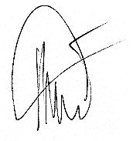

Philippe MARIE / PDG
21

