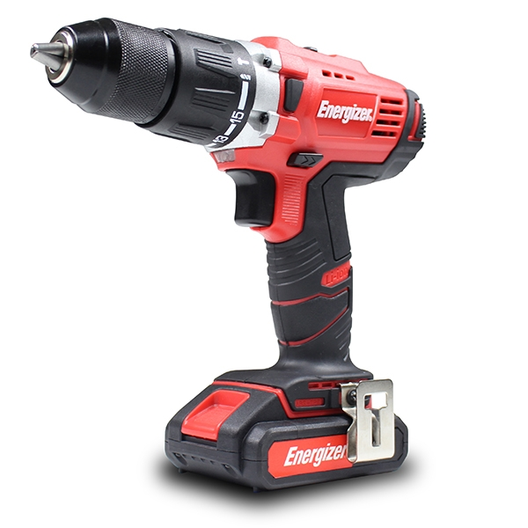
USER GUIDE
CORDLESS DRILL
EZPP18V

©2018 Energizer. Energizer and certain graphic designs are trademarks of Energizer Brands, LLC and related subsidiaries and are used under license by Builder SAS. All other brand names are trademarks of their respective owners. Neither Builder SAS nor Energizer Brands, LLC is affiliated with the respective owners of their trademarks.

Thanks for choosing the EZP Series!
You're excited to power up, so we'll keep this brief. Let's get started!

Drill warnings:

WARNING: Read all safety warnings and all instructions. Failure to follow the warnings and instructions may result
in electric shock and/or injury. Save all warnings and instructions for future reference.
Work area safety
- Keep your work area clean and well lit. Cluttered benches and dark areas invite accidents.
- Do not operate power tools in explosive atmospheres, such as in the presence of flammable liquids, gases, or dust. Power tools create sparks which may ignite dust or fumes.
- Keep bystanders and children away while operating a power tool. Distractions can cause you to lose control.

Electrical safety
- Power tool plugs must match the outlet. Never modify the plug in any way. Do not use any adapter plugs with earthed (grounded) power tools. Unmodified plugs and matching outlets will reduce risk of electric shock.
- Avoid bodily contact with grounded surfaces such as pipes, radiators, ranges and refrigerators. There is an increased risk of electric shock if your body is grounded.
- Do not expose power tools to rain or wet conditions. Water entering a power tool will increase the risk of electric shock.
- Do not abuse the cord. Never use the cord to carry the tools or pull the plug from an outlet. Keep cord away from heat, oil, sharp edges or moving parts. Replace damaged cords immediately. Damaged cords increase the risk of electric shock.
- When operating a power tool outdoors, use an extension cord suitable for outdoor use. Use of a cord suitable for outdoor use reduces the risk of electric shock.
- If operating a power tool in a damp location is unavoidable, use a Ground Fault Circuit Interrupter (GFCI) protected supply. Use of a GFCI reduces the risk of electric shock.

Personal safety
- Stay alert, watch what you are doing and use common sense when operating a power tool. Do not use the tool while tired or under the inﬂuence of drugs, alcohol, or medication. A moment of inattention while operating power tools may result in serious personal injury.
- Use personal protective equipment. Always wear eye protection. Safety equipment such as a dust mask, non-slip safety shoes, hard hat, or hearing

protection used for appropriate conditions will reduce personal injuries.
  - Prevent unintentional starting. Ensure the switch is in the off- position before connecting to the power source and/or battery pack, picking up or carrying the tool. Carrying power tools with your finger on the switch or energizing power tools that have the switch on invites accidents.
  - Dress properly. Do not wear loose clothing or jewellery. Keep your hair, clothing, and gloves away from moving parts. Loose clothes, jewellery, or long hair can be caught in moving parts.
  - Remove adjusting keys or spanners before turning the tool on. A spanner or a key that is left attached to a rotating part of the tool may result in personal injury.
  - Do not overreach. Keep proper footing and balance at all times. This enables better control of the power tool in unexpected situations.
  - Only use safety equipment that has been approved by an appropriate standards agency. Unapproved safety equipment may not provide adequate protection.

Power tool use and care
  - Do not force tools. Use the correct tool for your application. The correct tool will do the job better and safer at the rate for which it is designed.
  - Do not use a power tool if the
switch does not turn it on or off. Any power tool that cannot be controlled with the switch is
dangerous and must be repaired.
- Disconnect the plug from the power source and/or the battery pack from the power tool before making any adjustments, changing accessories, or storing the tool. Such preventive safety
measures reduce risk of starting the tool accidentally.
- Store idle power tools out of the reach of children and other untrained persons. Power tools are dangerous in the hands of untrained users.
- Maintain tools with care. Check for misalignment or binding of moving parts, breakage of parts and any other condition that may affect the power tool’s operation.
If damaged, have the power tool repaired before use. Many accidents are caused by poorly maintained power tools.
- Keep cutting tools sharp and clean. Properly maintained tools with sharp cutting edges are less likely to bind and are easier to control.
- Use only accessories that are recommended by the manufacturer for your model.
Accessories that may be suitable for one tool may become hazardous when used on another tool.

Battery tool use and care
- Ensure the switch is in the off position before inserting the battery pack. Insert the battery

pack into power tools that have the switch on invites accidents.
  - Recharge only with the charger specified by the manufacturer. A charger that is suitable for one type of battery pack may create a risk of fire when used with another battery pack.
  - Use power tools only with specifically designated battery packs. Use of any other battery packs may create a risk of injury and fire.
  - When battery pack is not in use, keep it away from other metal objects like paper clips, coins, keys, nails, screws, or other small metal objects that can make a connection from one terminal
to another. Shorting the battery terminals together may cause burns or a fire.
  - Under abusive conditions, liquid may be ejected from the
battery, avoid contact. If contact accidentally occurs, flush with water. If liquid contacts eyes, additionally seek medical help. Liquid ejected from the battery may cause irritation or burns.

Service
  - Have your power tool service by qualified repair person using only identical replacement parts. This will ensure that the safety of the
power tool is maintained.

Additional warnings applicable for drills
  - Use auxiliary handles supplied with the tool. Loss of control can cause personal injury.
- Hold power tools by insulated gripping surfaces when performing an operation where the cutting tool may contact hidden wiring or its own cord. Contact with a “live” wire will make exposed metal parts of the tool “live” and shock the operator.
- Use clamps or other practical way to secure and support the work piece to a stable platform. Holding the work by hand or against your body is unstable and may lead to loss of control.
- Do not drill, fasten or break into existing walls or other blind areas where electrical wiring may exist. If this situation is unavoidable, disconnect all fuses or circuit breakers feeding this work site.
- Always wear safety goggles or eye protection when using this tool. Use a dust mask or
respirator for applications which generate dust.
- Use thick cushioned gloves and limit the exposure time by taking frequent rest periods. Vibration caused by hammer-drill action may be harmful to your hands and arms.
- Secure the material being drilled. Never hold it in your hand or across legs. Unstable support can cause the drill bit to bind causing loss of control and injury.
- Disconnect battery pack from tool before making any assembly, adjustments or changing accessories. Such preventive safety measures reduce the risk of starting the tool accidentally.

  - Position the cord clear of rotating bit. Do not wrap the cord around your arm or wrist. If you lose control and have the cord wrapped around your arm or wrist it may entrap you and cause injury.
  - Position yourself to avoid being caught between the tool or side handle and walls or posts. Should the bit become bound or jammed in the work, the reaction torque of the tool could crush your hand or leg.
  - If the bit becomes bound in the work piece, release the trigger immediately, reverse the direction of rotation and slowly squeeze the trigger to back out the bit. Be ready for a strong reaction torque. The drill body will tend to twist in the opposite direction as the drill bit is rotating.
  - Do not grasp the tool or place your hands too close to the spinning chuck or drill bit. Your hand may be lacerated.
  - When installing a drill bit, insert the shank of the bit well within the jaws of the chuck. I f the bi t is not inserted deep enough, the grip of the jaws over the bit is reduced and the loss of control is increased.
  - Do not use dull or damaged bits and accessories. Dull or damaged bits have a greater tendency to bind in the work piece.
  - When removing the bit from the tool avoid contact with skin and use proper protective gloves when grasping the bit or
accessory. Accessories may be hot after prolonged use.
- Do not run the drill while carrying it at your side. A spinning drill bit could become entangled with clothing and injury may result.

WE RECOMMENDTHAT THE OPERATOR WEARS HEARING PROTECTION.
- The declared vibration total value has been measured in accordance with standard test method and may be used for comparing one tool with another.
- The declared vibration total value may also be used in a preliminary assessment of exposure.
- Warning: The vibration emissions during actual use of the power tool can differ from the declared total value depending on the ways in which the tool is used, and of the need to identify safety measures to protect the operator that are based on an estimate of exposure in the actual conditions of use (taking account of all parts of the operating cycle such as times when the tool is switched off and when it is running idle in addition to trigger time).

LpA (acoustic pressure) | 77.8dB(A) (KWA=3 dB)
LwA (acoustic pressure) | 88.8dB(A) (KWA=3 dB)
Vibration | 0.670m/s² (K=1.5m/s²)

Battery warnings:

  - Before using battery charger, read all instructions and cautionary markings on battery charger, battery pack, and product using battery.
  - This appliance should never used by children or persons with reduced physical, sensory or mental capabilities or lack of experience and knowledge. Children shall not play with the appliance.
  - If the supply cord is damaged, it must be replaced by the manufacturer, its service agent or a similarly qualified person in order to avoid a hazard.
  - Use only the charger which accompanied your product or direct replacement as listed in the catalogue or this manual. Do not substitute any other charger. Use only same supplier approved chargers with your product. See Technical Speciﬁcations.
  - Do not disassemble charger or operate the charger if it has received a sharp blow, been dropped or otherwise damaged
in any way. Incorrect reassembly may result in a risk of electric shock, electrocution or ﬁre.
- Do not recharge battery in damp or wet environment. Do not expose charger to rain or snow. If battery case is cracked or otherwise damaged, do not insert into charger. Battery short or ﬁre may result.
- Charge only same supplier approved rechargeable batteries (BP09 - 180). See Technical Speciﬁcations. Other types of batteries may burst causing personal injury and damage.
- Charge battery pack in temperatures above 0ºc and below 45ºc. Store tool and battery pack in locations where temperatures will not exceed 45ºc. This is important to prevent serious damage to the battery cells.
- Pull the plug rather than cord when disconnecting charger or when disconnecting cords using the daisy chain feature. This will reduce risk of damage to electric plug and cord.
- Make sure that cord is located so that it will not be stepped on, tripped over, or otherwise subjected to damage or stress.
- Do not use an extension cord unless it is absolutely necessary. Use of improper extension cord could result in risk of ﬁre, electric shock.
- Disconnect the charger from the outlet before attempting any cleaning. This will reduce the risk

of electric shock. Removing the battery pack will not reduce this risk.
  - The charger is designed to operate on standard household electrical power (220-240 volts, 50-60 Hz AC only). Do not attempt to use it on any other voltage.
  - This power unit is intended to be correctly orientated in a vertical or floor mount position.
  - Do not incinerate the battery pack even if it is severely damaged
or is completely worn out. The battery pack can explode in a fire. Toxic fumes and materials are created when lithium ion battery packs are burned.
  - Do not charge or use battery in explosive atmospheres, such as in the presence of flammable liquids, gases or dust. Inserting or removing the battery from the charger may ignite the dust or fumes.
  - If battery contents come into contact with the skin, immediately wash area with
mild soap and water. If battery liquid gets into the eye, rinse water over the open eye for 15 minutes or until irritation ceases. If medical attention is needed, the battery electrolyte is composed of a mixture of liquid organic carbonates and lithium salts.
  - Contents of opened battery cells may cause respiratory irritation. Provide fresh air. If symptoms persist, seek medical attention.
- WARNING: Burn hazard. Battery liquid may be flammable if
exposed to spark or flame.
- Charge the battery packs only in the charger which accompanied your product.
- DO NOT splash or immerse in water or other liquids. This may cause premature cell failure.
- Do not store or use the tool and battery pack in locations where the temperature may reach or exceed 45˚C (such as outside sheds or metal buildings in summer).
- When batteries are not in tool or charger, keep them away from metal objects. For example, to protect terminals from shorting DO NOT place batteries in a tool box or pocket with nails, screws, keys, etc. Fire or injury may result.
- DO NOT put batteries into fire or expose to high heat. They may explode.

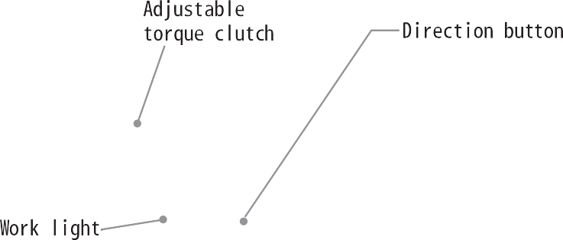
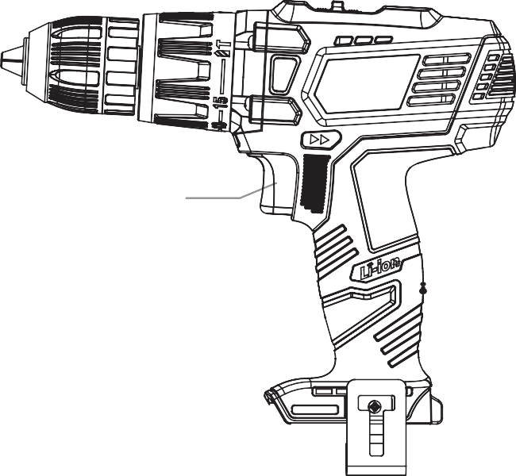

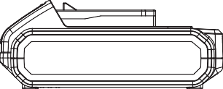

Charging a battery

WARNING: Place the battery pack and charger on a flat non-flammable surface and away from ammable material when re- charging the battery pack
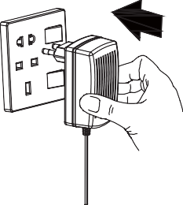

1. Insert the plug on the charging unit into a power socket and turn the power on if required.

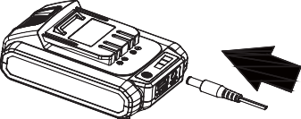
- The charging output interface insert battery of charging port.
Note: The battery will require 1 hours charging time after normal use. If the battery is fully run down the charging time will be 1 hours.

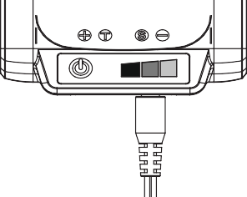
- The process of charging battery pack,red light and yellow light and green light in turn.
Note:When the red light alone,said battery pack less power.
When red and yellow lights,said battery pack more than half of the electricity.
When red light and yellow light and green light on, said battery pack is fully charged

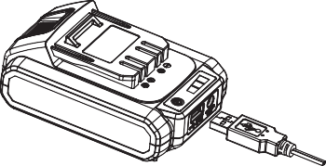
- Charging treasure function:
Insert the USB interface, the other end connected to mobile phone LED lights, fan, etc., according to the used

Using your drill

IMPORTANT: Before starting inspect your drill bit to ensure there is no excessive wear and that it is sharp. Never use a drill bit if it is damaged or blunt.
Check that the drill bit is correctly fitted in the chuck and is the correct type for the material you wish to drill a hole in.

Drilling wood
Ensure the piece of work you want to drill into is firmly anchored in place. Hold the drill in a straight line with the end of the drill bit.
Apply enough pressure to keep the drill bit cutting through the wood.
When drilling through wood with a twist bit it may over heat if you do not clean any chips and wood dust out of the flutes (grooves in the drill bit). To do this:
- Stop the drill by taking your finger off the power trigger.
- Switch the direction button into reverse then press the trigger until the drill bit is clear of the wood.
- Use a brush to remove any scraps or dust from the drill bit. DO NOT use your fingers.
- Switch the direction button into forward to continue drilling into piece of work.
Note: If you are drilling into a piece of wood that is likely to splinter you may want to use a ‘back-up’ block of wood place behind the piece you are drilling.
You will drill a cleaner hole if you ease up on the pressure just before the bit breaks through the back of the wood. Turn the wood over and complete the hole.

Drilling metal

There are two main things to remember when drilling through metal.
- The harder the material, the greater the pressure you need to apply to the drill.
- The harder the material, the slower the speed of the drill needs to be.

Below are a few tips to help when drilling through metal.
- Lubricate the tip of the drill bit occasionally with cutting oil except when drilling soft metals such as aluminium, copper or cast iron.
- If the hole you wish to drill is quite large, drill a smaller hole first then enlarge to the final size. This is generally a faster method in the long run.
- Maintain enough pressure to assure that the drill bit does not just spin in the hole. This will make the drill bit blunt and shorten its life.

Battery technical specification

Battery pack | 18V DC 2000mAh Li-ion battery pack
Charging time | 1 hour
Charger adapter input | 100-240V AC 50-60Hz
Charger adapter output | 21V DC 2.2A

Drill technical specification

Rated voltage | 18V
No Load speed | 0-400/0-1500rpm
Max. torque | 58Nm
Chuck capacity | 2 to13mm
Torque setting | 15+Drilling+Impact

WARRANTY

The manufacturer warrants the product against defects in materials and workmanship for a period of 2 years from the date of purchase to the original purchaser. The guarantee applies when the product is used as a home tool. The warranty does not extend for failures due to normal wear and tear.

The manufacturer agrees to replace the spare parts that are classified as defective by a designated distributor. The manufacturer will not accept responsibility for the replacement of the machine, either partially or in full, and / or consequential damages.

The warranty does not cover failures due to:
• Insufficient maintenance.
• Assembly, adjustment or abnormal operation of the product.
• Spare parts that are subject to wear.

Nor does the guarantee extend to:
• Cost of freight and packaging.
• The use of the tool for any other purpose than for which it was designed
• Use and maintenance of the machine in a manner not described in the user's manual.

As part of our policy of continuous product improvement, we reserve the right to alter or modify specifications without prior notice. As a result, the product may differ from the information contained herein, but any alteration will only be implemented without prior notice if it is classified as an improvement of the previous specification.

READ THE MANUAL CAREFULLY BEFORE USING THE MACHINE.

When ordering spare parts, please quote the part number or code, this can be found in the parts list included in this manual.

Keep the purchase receipt; Without it, no guarantee will be valid.

In order to get help about your Cordless Drill, we invite you to go through this link or to call us by phone +33 (0)8.20.20.22.68:

https://services.swap-europe.com/contact

You need to create a "ticket" via their platform.

- Login or create your account
- Put your tool reference
- Choose the subject of your request
- Explain your problem
- Attach these files: the invoice or receipt, the nameplate picture (serial number), the picture of the part you need (for example: pins on the transformer plug that broke away)

We offer you a warranty extension to 1 year. To profit it, please follow the below proceeding:

- Connect on the website:
- Insert your contact details
- Register your tool with:
  - The reference
  - The serial number
  - The date you bought the tool
- Generate automatically the PDF warranty certificate and print it.

Déclaration de conformité

BUILDER SAS

32 rue aristide Bergès –Z1 31270 Cugnaux - France
Tel : +33 (0)5.34.508.508 Fax : +33 (0)5.34.508.509

Declares that the machine designated below :
CORDLESS DRILL
EZPP18V

Serial number :
Complies with the provisions of the Directive « machinery » 2006/42/CE and national laws transposing it :
Also complies with the following European directives :
EMC Directive 2014/30/EU
ROHS Directive 2011/65/EU
Also complies with the European standards, with national standards and the following technical provisions :
EN 60745-1 :2009+A11 :2010
EN 60745-2-1 :2010
EN 60745-2-2 :2010
EN55014-1 :2006+A1 :2009+A2 :2011
EN 55014-2 :2015

Fait à Cugnaux, le 05/03/2013
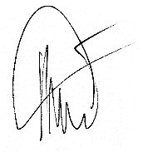

Philippe MARIE / PDG

