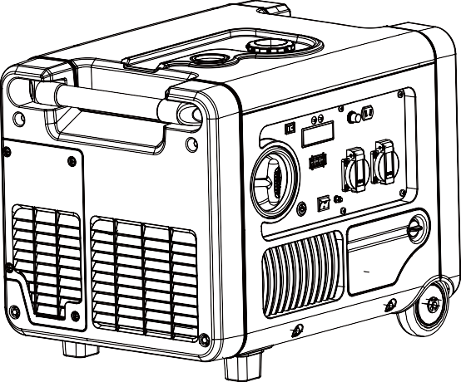

CHONGQING HEYA TECHNOLOGY CO., LTD.

HY4000EFI, HY4000i, HY4000IR, HY4000SEi, HY4000IES, ST4000i, ST4000IR, EZV4000i, EZV4000, DG40i, DG4.0i, DT40i, GG40i, GG40Ei, GG4000i, DT4000EFi, DT4000i, EVO40Ei

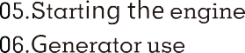

INSTRUCTIONS

To ensure personal and property safety, please carefully read the following.

Read this manual carefully- familiarize yourself with the appliance. Follow all operational notes and restrictions, and take note of possible hazards of this device.
Place the appliance on stable surfaces only.
The load must not exceed the power marked on the rating label of the generator. Overloading may result in damage to, or a shorter life of the appliance.
The motor must not be operated with excessive rotary speed. The operation of the motor with excessive rotary speed raises the risk of injury. Parts which affect the rotary speed must not be altered or

replaced.
Do not operate or store the appliance in wet or humid surroundings or on highly conductive surfaces such as metal coatings or steel constructions.
Do not operate or store the appliance in wet or humid surroundings.

DANGER

POISONOUS GAS
Engine exhaust gas is poisonous; don’t operate in an unventilated room. When installed in ventilated room, additional requirement for ﬁre and explosion protection shall be observed.

Gasoline is highly ﬂammable and easily ignited!

Don’t refuel during operation;
Don’t refuel while smoking or near naked
ﬂames;
Don’t spill fuel;
Store fuel in containers speciﬁcally designed
for this purpose;
Refuel outdoors only and don’t smoke while refueling;
Add fuel before starting the engine. Never remove the cap of the fuel tank or add gasoline while the engine is running or when the engine is hot;
If gasoline is spilled, don’t attempt to start the engine but move the machine away from the area of spillage and avoid creating any source of ignition until petrol vapours have dissipated;
Replace all fuel tank and container caps
securely;
Always turn generator off before refueling.
Allow generator to cool for at least 2 minutes before removing fuel cap. Loosen cap slowly to relieve pressure in tank.
Do not overﬁll gas tank. Gas may expand during operation. Do not ﬁll to the top of the tank.
Always check for spilled gas before operating. Empty gasoline tank before storing or
transporting the generator.
Before transporting, turn fuel valve to off and disconnect spark plug.

This generator produces powerful voltage, which can result in electrocution!
ALWAYS ground the generator before using it (see the “Ground the Generator” portion of the “PREPARING THE GENERATOR FOR USE”
section).
Generator should only be plugged into electrical devices, either directly or with an

extension cord. When using extension lines or mobile distribution networks the total length of lines for a cross section of 1.5 mm2 should not exceed 60 m; for a cross section of
2.5 mm2 this should not exceed 100 m. NEVER connect to other power sources. Do not use in rainy or wet conditions. Do not touch bare wires or receptacles (outlets).
Protect children by keeping them at a safe distance from the generating set. Do not allow children or non-qualied persons to operate.
Electrical equipment (including lines and plug connections) should not be defective. The generating set must not be connected to other power sources, such as the power company supply mains.
Protection against electrical shock depends on circuit breakers specially matched to the generating set. If the circuit breakers require replacement they must be replaced with a circuit breaker having identical ratings and performance characteristics.
Due to high mechanical stresses only tough
rubber-sheathed exible cable or the equivalent should be used.
The user that he shall conform to regulations of electrical safety applicable to the place where the generating sets are used.
The generator ground terminal is connected to the frame of the generator, the metal non- current carrying parts of the generator, and ground terminal of each receptacle. Before using the ground terminal, consult a qualied electrician or electrical inspector for local applicable regulations.
Connections for standby power to a building electrical system must be made by a qualied electrician. The connection must isolate the generator power from utility power, and must comply with all applicable laws and electrical codes. A transfer switch, which isolates the generator power from utility power is available through qualied equipment following local laws and regulations.
This generator produces heat when running!

Some parts of the internal combustion engine are hot and may cause burns. Do not touch hot surfaces. Pay attention to the warnings on the generating set.
Allow generator to cool several minutes after use before touching engine or areas which heat during use.
CAUTION

Do not turn on electrical devices until after they are connected to the generator.
Turn off all connected electrical devices before stopping the generator.
Do not operates the generator in potential explosive condition

Misuse of this generator can damage it or shorten its life!

Use generator only for its intended purposes. Operate only on dry, level surfaces; do not operate the generator underground.
Allow generator to run for several minutes before connecting electrical devices.
Shut off and disconnect any malfunctioning devices from generator.
Do not exceed the load capacity of the generator by plugging in more electrical devices than the unit can handle.
the user that he shall conform to regulations of electrical safety applicable to the place where the generating sets are used

the user in the case of re-supply by generating sets of an installation, depending on existing protective measures in this installation and applicable regulations.

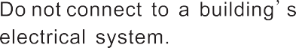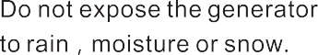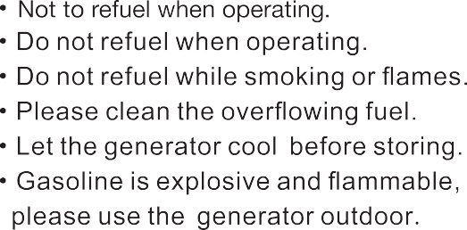

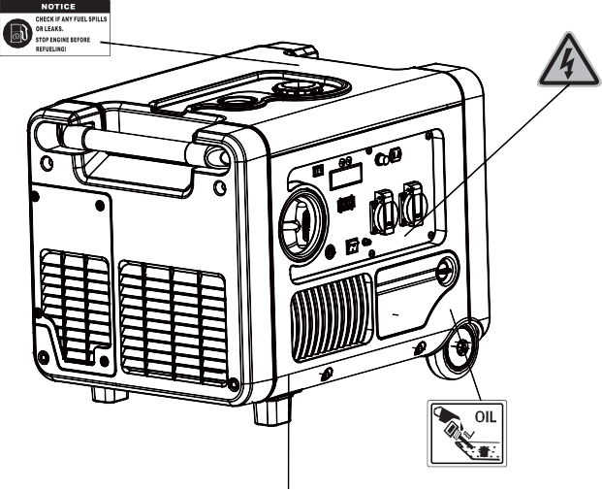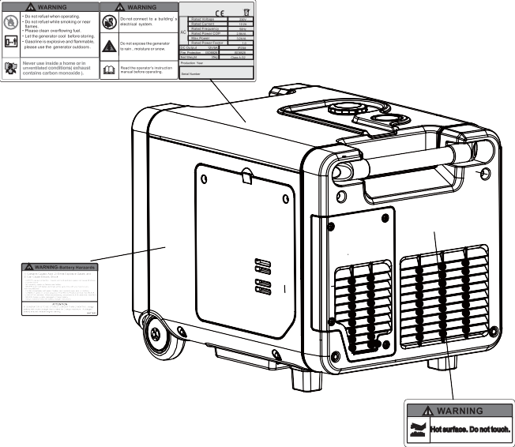

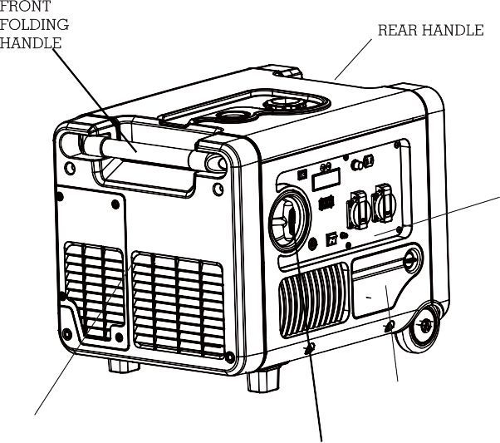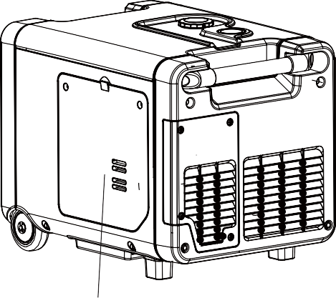

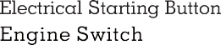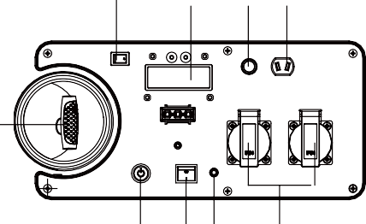

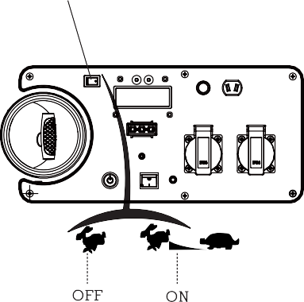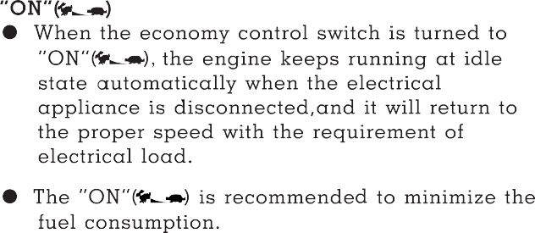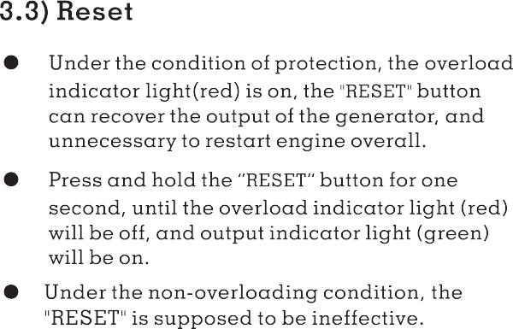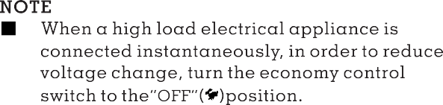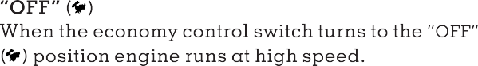

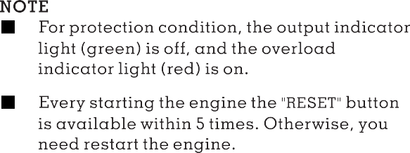
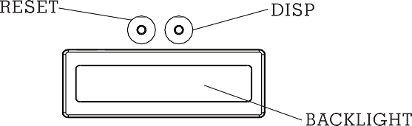
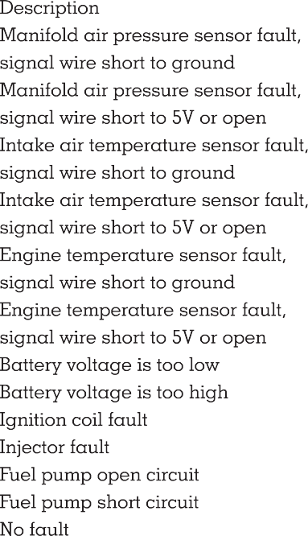
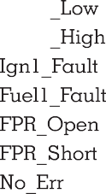
Press the multifunctional button,The generator's multifunctional screen displays the engine's cumula- tive working time, engine revolution, output voltage & power, EFI components diagnosis information.

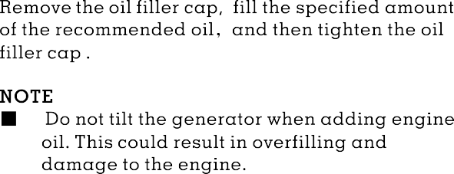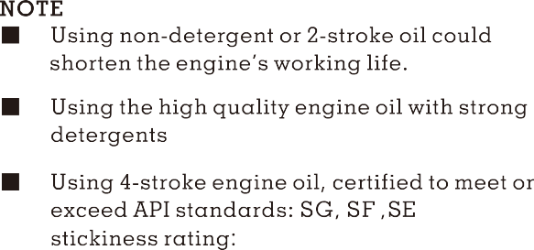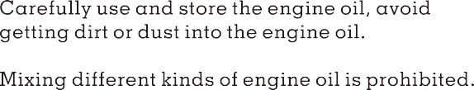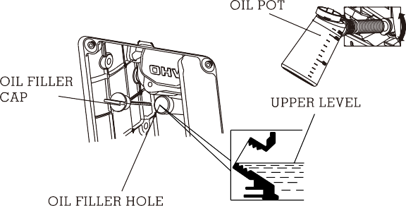

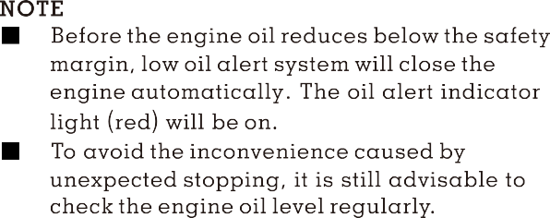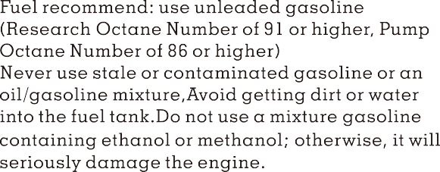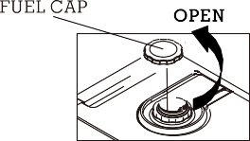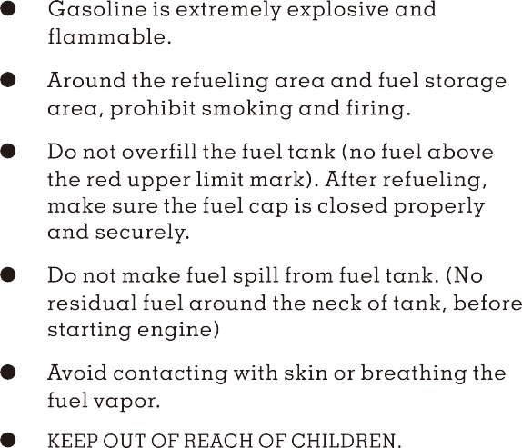

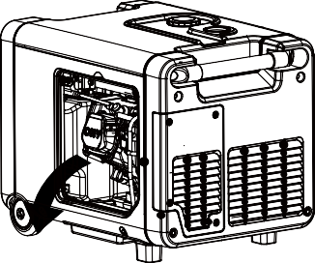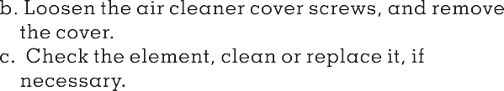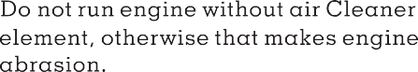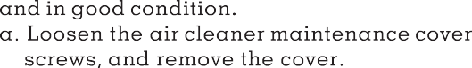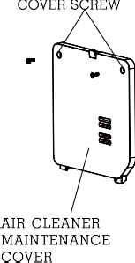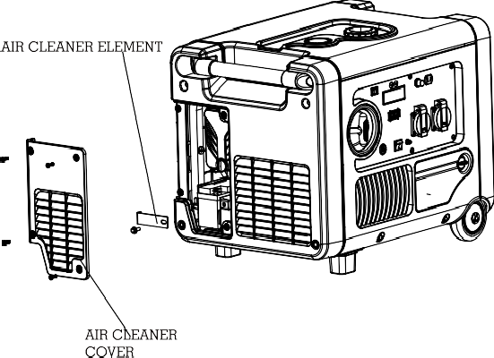

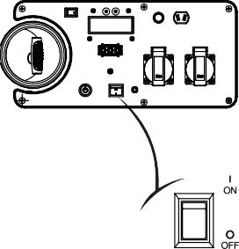
<<14>>
WARNING

Never use inside a home or the unventilated condition.

5.1) Recoil start
ENGINE SWITCH
NOTE
Before starting engine, disconnect load with
AC receptacle.
Fueling at the first time, refueling, or storing for a long time, the Engine Switch should
firstly be opened for ten or twenty seconds, in
order to the enough fuel enter into external fuel pump.
5.1.1) Turn the engine switch to “ON” position .
For some models, the generator provides with three types of starting system: recoil start, electric start, remote start. Please operate your generator based on you purchased
5. STARTING THE ENGINE

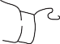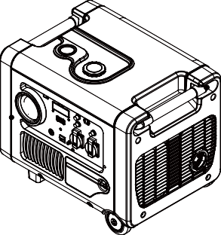
<<15>>
NOTE
When the engine switch turn to “RUN/ON ” position, the engine will enter the stand-by starting mode. Starting the engine within
15mi n, otherwise, the mode will be ineffective.
If the generator re-enters the stand-by starting mode again, the engine switch should be return to “OFF ”, and then turn to “RUN/ON ”.
NOTE
Return the starter grip slowly by hand. Do not make the starter grip spring back quickly.
5.2) Electric start,
STARTER GRIP
If the generator stops and can not restart, check the oil level firstly.
If oil indicator light turns on red, and flicker during running, or lights turns on when starting, need to add oil.
■
NOTE
NOTE
Turn on engine switch to "ON" position and wait for 3 to 5 seconds, in order to let fuel pump running 3~5 seconds and set up 300kPa fuel pressure
5.1.4) Pull the starter grip slowly until it is engaged, then pull it quickly.

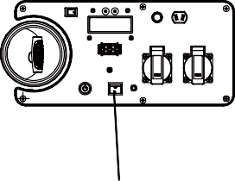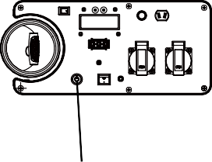
<<16>>
NOTE
Turn on engine switch to "ON" position and wait for 3 to 5 seconds, in order to let fuel pump running 3~5 seconds and set up 300kPa fuel pressure
5.2.1) Turn the engine switch to“ON ” position.
5.2.2） Press the Electrical Starting Button to start.
CAUTION
For equipping with electrical starting system of the generator, if the generator does not equip with the battery or the battery wares out, the generator can not be start by any starting mode.

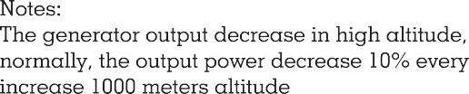

NOTE
- If the generator stops and can not restart, check the oil level firstly.
If the oil alert indicator light (red) is on during the generator running, it need to add oil.

Electronic Fuel Injection Modification for High Altitude Operation

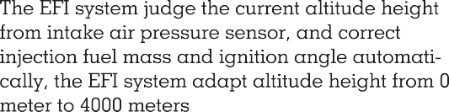

<<17>>

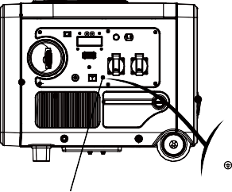

6. GENERATOR USE

WARNING

Be sure to ground the generator when the connected electrical appliance is grounded.
Do not connect to the building’s electrical system, in order to avoid the electric shocks and fires.

EARTH MARK
GROUND TERMINAL

<<18>>

<<19>>
6.1.3) Turn ECON SW to “OFF” ( ) position and then start engine
NOTE
- The DC receptacle can be used while the AC power is in use. If use both at same time, be sure not to exceed the total power for AC and DC.
- Most of motor appliances require more than their rated wattage, when starting.
battery terminal.
and black lead to negative
●
6.1.2) Connect the DC terminals to battery terminals with the charging cable
CAUTION
Connect red lead to positive battery terminal
battery terminals.
from the negative
The DC receptacle, 15-30V under no load condition, may be used for charging 12V battery only.
NOTE
- In DC operation, turn the ECON SW to the “OFF” ( ) position.
6.1.1) Disconnect the vehicle battery ground cable
For continuous operation, do not exceed the rated out-put power of generator.
Do not make parallel connection with other generators.
Do not connect an extension to the exhaust pipe.
When an extension cable is required, be sure to use a tough rubber sheathed flexible cable (according to IEC245 or equivalent standards). The maxmin length of the extension cable: 60m for cable of 1.5mm2; 100m for cable of 2.5mm2 .
Keep away from other electric cables or wires.
●

●

●

●
6.1) DC Application
WARNING

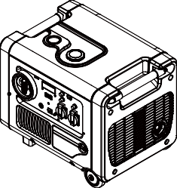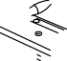
<<20>>
The battery can release the explosive gases Keep the battery away from spark/fire. Charge the battery in ventilated condition.
Battery electrolyte contains sulfuric acid that will cause severe burn of skin and eyes.
Therefore it is necessary to wear the protective
clothing and mask.
If battery electrolyte gets into eyes flush thoroughly with warm water for 15min at least and call a doctor immediately
If you swallow a little of battery electrolyte accidentally flush thoroughly with water your mouth and then drink large quantities of water or milk with magnesia or vegetable oil and call a doctor immediately
KEEP OUT REACH OF CHILDREN
●
●
NOTE

- Do not start the automobile engine when the generator is still connected to the battery, otherwise the generator will be damaged.
Disconnecting the charging cable
- Stop the engine.
- Disconnect the black lead from the negative battery terminal.
- Disconnect the red lead from the positive battery terminal.
●
CHARGING CABLE
●

●
WARNING

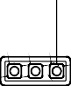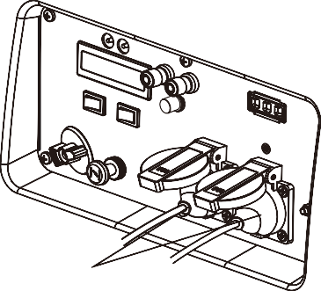
<<21>>
NOTE
- Confirm all electrical appliances are in good working condition before connecting them to the generator. If an electrical appliance becomes abnormal, sluggish, or stops suddenly, shut off the generator engine immediately, and disconnect the appliance.
PLUG
  - AC applications

    - Start engine and make sure the output indicator light (green) is on.
    - Confirm all electrical appliances are switched off, and connect the appliance plugs to the generator receptacles.
NOTE
- To obtain the best working and longest working life of the generator, a new generator is supposed to run for 20 hours at 50% rated load.
OUTPUT LIGHT (GREEN)
NOTE
- While using the AC power, you can use that DC power at the same time.

6.3) Output and Overload Indicator
In normal operating, output indicator light (green) will remain on.
If the generator is overload (over 3.5kVA), or the connected appliance is short-circuit, the output
indicator light (green) is off, and overload
indicator light (red) is on. The AC output will be switched off, but engine is still running.
If the overload indicator light (red) is on, disconnect the electrical appliances firstly, then stop the engine, and start it again. If the overload indicator light (red) is OFF and the output indicator light (green) is ON, reconnect the electrical appliances. Otherwise stop the engine and check the generator.
6.4) Oil alert system
The oil alert system is designed to prevent engine damage caused by an insufficient amount of oil in the crankcase. Before the oil level in the crankcase falls below a safe limit, ECU
system will automatically shut down the engine (the engine switch remains in the “On“ or
" RUN/ REMOTE " position).
If the oil alert system shuts down the engine, the oil alert indicator light (red) will be on. Check the engine oil level.
OIL ALERT INDICATOR LIGHT ( RED)

OVERLOAD INDICATOR LIGHT(RED)
OUTPUT INDICATOR LIGHT (GREEN)
<<22>>

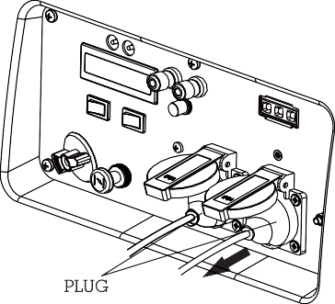

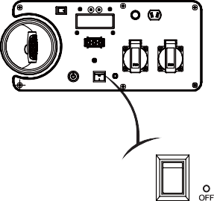

- STOPPING THE ENGINE
Recoil start
To stop the engine in an emergency, turn the engine switch to the “OFF”position.

  - Switch off the connected electrical appliances, and pull out their plugs.

ENGINE SWITCH

  - Turn the engine switch to the “OFF” position.

<<23>>

8. MAINTENANCE
The purpose of the maintenance and adjustment schedule is to keep the generator in the beset operating condition.

WARNING

Stop the engine before performing any maintenance. If the engine must run, be sure the area is well ventilated. The exhaust contains poisonous carbon monoxide gas.
Use genuine HEYA or equivalent quality components to replace the wear components.

Maintenance Schedule
NOTE
- Service more frequently when used in dusty areas.
- These items should be serviced by your servicing dealer, unless you have the proper tools and are mechanically proficient. Refer to use manual for service procedures.
- For commercial use, long hours of operation to determine proper maintenance intervals.

  - Change Oil
Drain the oil rapidly and completely while the engine is still warm.
    - Loosen screws of the oil maintenance cover, and remove the cover.
    - Remove the oil dipstick and the bottom rubber.
<<25>>

Spark plug | Replace |  |  |  |  | Ⓢ
Spark arrester |  |  |  |  | ⊙
Valve Clearance | Check-adjust |  |  |  |  | Ⓢ+(2)
Combustion Chamber | Clean | After every 300 hrs(2)
Fuel tank& filter | Clean | Every year(2)
Fuel line | Check | Every 2 years ( Replace if necessary)(2)

 | Regular Service Period (3) |  |  | Each use | First month or  10 hrs. | Every 3  months or  50 hrs. | Every 6  months or  100 hrs. | Every  2 years or  300 hrs.
 | Item
Engine oil |  | Check level |  | Ⓢ
 |  | Change |  |  | Ⓢ |  | Ⓢ
Air cleaner |  | Check |  | Ⓢ
 |  | Clean |  |  |  | Ⓢ+(1)
Spark plug |  | Check-adjust |  |  |  |  | Ⓢ

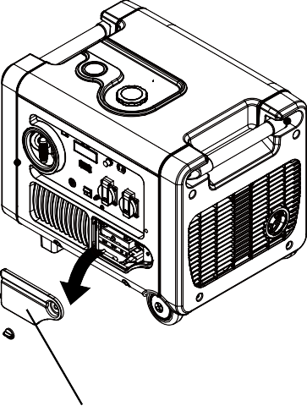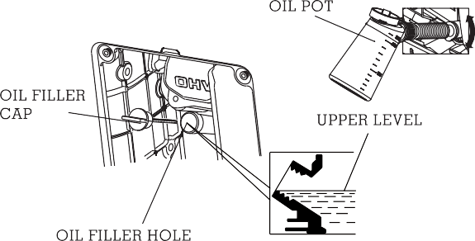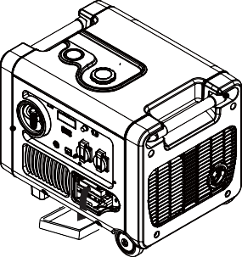
<<26>>
    - Refill the recommended oil, and check the oil level.
    - Reinstall the oil dipstick and tight it. After oil change, wash your hands with soap.
OIL
MAINTENANCE COVER
Tighten oil drain plug with 25-30 N.m
OIL
DRAIN PLUG
    - Place oil collection pan under oil drain plug.
    - Remove the oil drain plug, and drain oil into the oil collection pan completely.
    - Reinstall the oil drain plug.

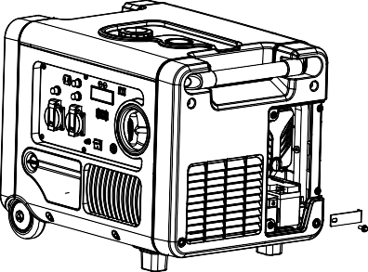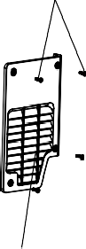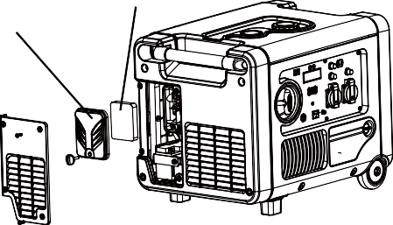
<<27>>
AIR CLEANER COVER
AIR CLEANER ELEMENT
Do not use gasoline or low ignition point solvents for cleaning. They are flammable and explosive under certain conditions.
NOTE
Never run the generator without air cleaner, otherwise that result in engine abrasion rapidly.
8.2.1) Loosen three screws of the air cleaner maintenance cover, and remove the cover.
8.2.2)Loosen the air cleaner cover screws and remove the cover.
WARNING
AIR CLEANER MAINTENANCE COVER
8.2) Air Cleaner Service
A dirty air cleaner will restrict air flow into the carburetor.Clean and maintain the air cleaner regularly, especially in the extremely dusty areas.
COVER SCREW
NOTE
For conforming to the environment requirement, the used oil will be put into a sealed container and then be transported to the service station for recycler. Do not throw it into the trash or pour it on the ground.

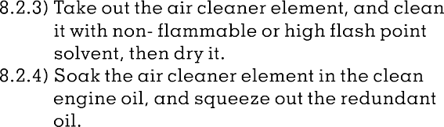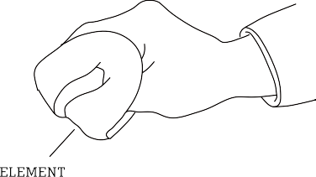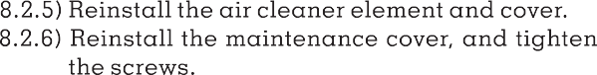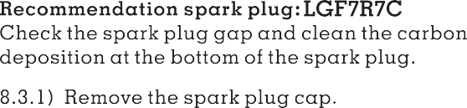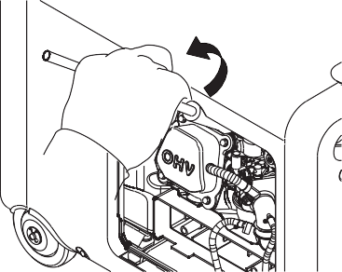

<<29>>
NOTE
only be maintained professional servic- ing dealer, can not be maintained by user
The spark arrester must be maintained every 100h service.
8.4.1)Remove the screws, and remove the muffler guard.
    - Measure the spark plug gap with a feeler gauge. The normal value:0.6-0.7mm(0.024- 0.028in). Adjust the gap by bend one of the electrode carefully.
    - Reinstall the spark plug carefully, by hand, to avoid cross-threading. A new spark plug should be tightened 1/2 turn with a spanner. A used Spark plug should be tightened 1/8 to 1/4 turn with spanner.
The spark plug must be securely tightened. Tightening in wrong way will cause spark plug hot, even damage the engine.
- Never use a spark plug with an improper heat range.

8.4) Spark Arrester Maintenance

WARNING
0.60-0.70mm
(0.024-0.028in)
    - Reinstall the spark plug cap
    - Reinstall the spark plug maintenance cover.

NOTE
■
    - Take off the spark plug with the spark plug
spanner.
    - Visual inspection the spark plug. Change a new one if its insulator cracked or chipped.
Clean it with a wire brush if the spark plug is reused.

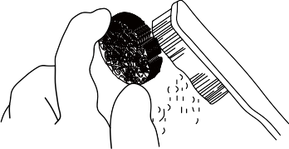
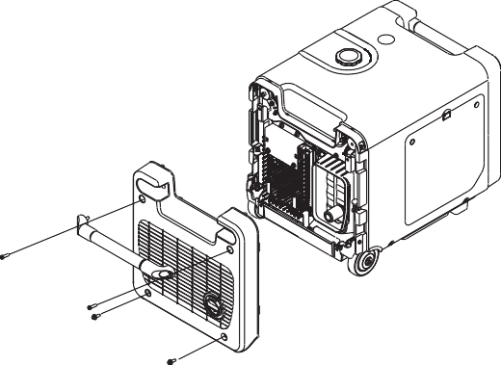
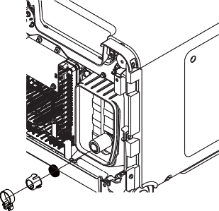
8.4.3)Use a brush to remove carbon deposits from the spark arrester . If the spark arrester is wear, replace it.
8.4.4)Reinstall the spark arrester and muffler guard.
8.4.2)Take off the spark arrester from the muffler after the engine cool down.
8.5 Replace battery and fuse
For some models, equip with electrical starting system and starting battery. If the battery does not deliver, purchase it from your dealer.
Battery specifications

Voltage | Capacity | Dimension
 |  | L≤108mm
12V | 1.6Ah | W≤57mm
H≤86mm

<<30>>

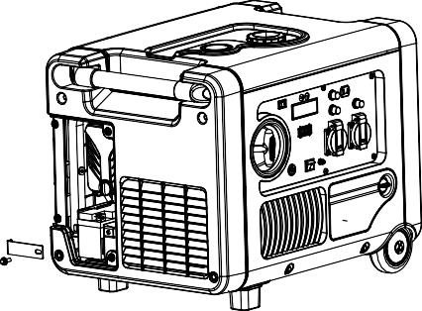
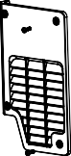
NOTE
- When the engine is running, the battery will be charge by the charging system of
generator.
- The battery shall be charge for storage a long period. For using other charging system, the
charging current less than 0.15c amperes (c: battery rated capacity) .

Replace the battery procedure
    - Loosen the screws of the battery maintenance cover, remove the cover.
    - Unhook the battery belt.
    - Remove the black cable from battery negative(-) terminal, and then remove the red cable from battery positive(+) terminal.
    - Remove the battery from battery tray, and replace a new one.
    - Reconnect red cable to battery positive(+) terminal, and reconnect black cable to battery negative(+) terminal.

    - Hook the battery belt, and reinstall the cover.

NOTE
- Do not dismantle, open or shred cells.
- Do not short-circuit a cell or battery.
- Do not expose cells or batteries to heat or fire.
- Keep cells and batteries clean and dry.
- When disposing of secondary cells or batteries, keep cells or batteries of differentelectrochemical systems separate from each other.
- Battery usage by children should be supervised.
- Dispose of properly.
- Use the correct charging procedure.

<<31>>

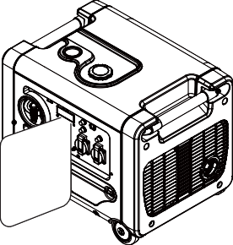
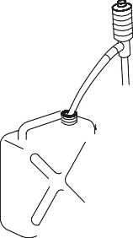
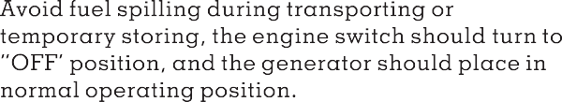

Storing for a long period:

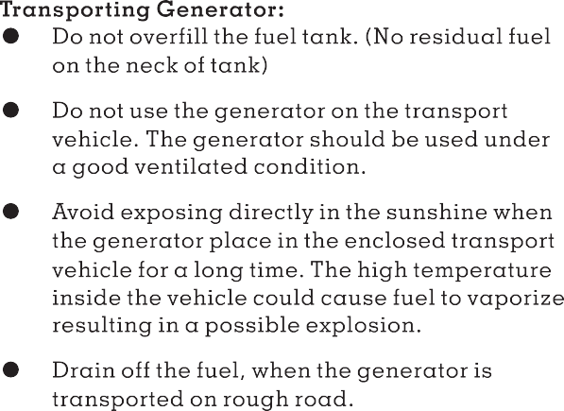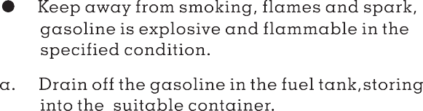

<<32>>

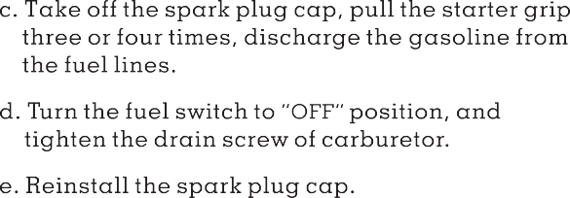
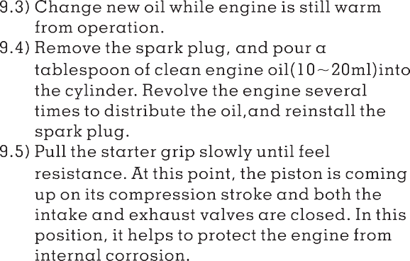
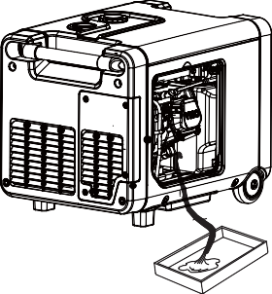
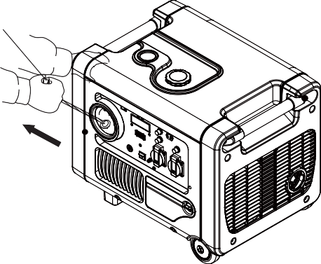

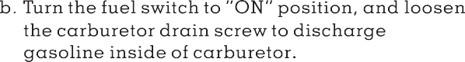

STARTER GRIP

<<33>>

10.TROUBLESHOOTING

When the engine can not be started:
Is there fuel in the tank? Refill the fuel tank
YES NO
Are the engine switch ? Turn the engine switch ON
YES NO
Is there enough oil in the Add the recommended oil engine? NO
YES
Is the spark plug in good Clean, readjust gap condition? NO and dry the spark plug.
YES Replace it if necessary
If the engine still does not start, contact with an authorized service agent

Appliance does not operate：
Is the output indicator
light ON? NO
Is the overload indicator
YES light ON? Contact with an
YES NO authorized service agent DC receptacle without any electricity：
Check the electrical Contact with an Check the electrical appliance Change or replace the appliance appliance for any fault. NO authorized service agent for any fault YES

YES
NO Contact with an
Stop engine and then replace or repair the appliance authorized service agent
<<34>>
Restart the engine

11. TECHNICAL SPECIFICATIONS
Noise level is measured when the ECON. SW is turned to ‘’ ON ‘’( )
LwA shows the guaranteed sound power tested by 2000/14/EC.
The noise level in “dB/7m” is the arithmetic mean value of sound press level (LpA) in eight directions measured 7 meters away from the generator.
The noise level may vary in different environments.
<<35>>

 | Specifications | Parameters
ENGINE | Model | HY170FA-EFI
 | Type | 4-stroke, overhead valve,  single cylinder, forced-air cooling
 | Engine Displacement | 223mL
 | Bore*Stroke | 70mm*58mm
 | Compression Ratio | 8.5:1
 | Rated power | 5.0kW/3600rpm
 | Ignition System | Full transistor
 | Start System | Recoil starter/electric starter/
 | Fuel Type | Gasoline without lead
 | Oil Capacity | 0.6L
 | Oil Model | SE 15W-30
GENERATOR | Model | HY4000EFI, HY4000i, HY4000IR, HY4000SEi, HY4000IES, ST4000i, ST4000IR, EZV4000i, EZV4000, DG40i, DG4.0i, DT40i, GG40i, GG40Ei, GG4000i, DT4000EFi, DT4000i, EVO40Ei
 | Rated Frequency | 50Hz
 | Rated Voltage | 230V
 | Rated Current | 15.2A
 | Rated Speed | 3600min-1
 | Rated Output Power COP | 3.5kW
 | Max. Output Power MAX | 3.8kW

OTHER SPECIFICATIONS | DC Output | 12V/5A
 | Fuel Tank Volume | 7.8L
 | Continuous Running Time | 7.0h
 | Fuel Consumption | 500g/kW.h
 | Working Ambient Temperature | -20 ~40
 | Max. Altitude | 4000m
 | ﹡Noise Lw A | 97dB(A)/4m
 | ﹡﹡ Noise Lp A | 60dB(A)/7m
 | Dimensions (L*W*H ) | 592mm*575mm*500mm
 | Net Weight | 50Kg

<<36>>

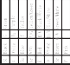

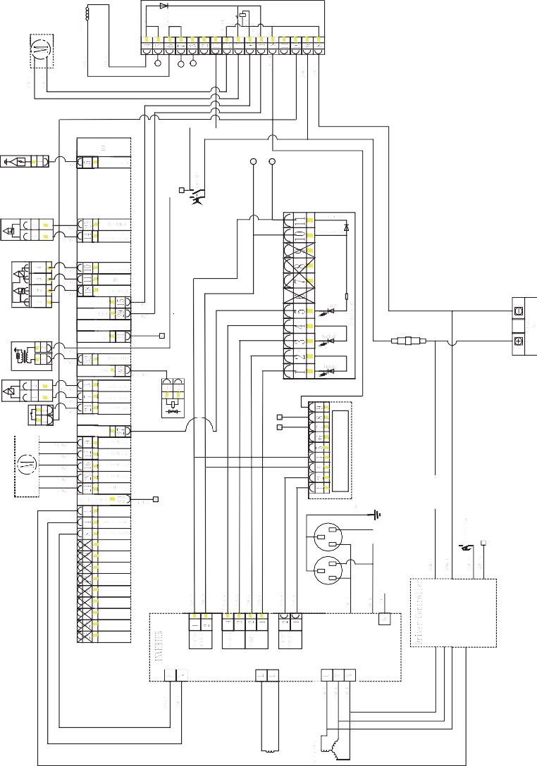

12 WIRING DIAGRAMS

13. APPENDIX

13.1) Environment Correction
The standard condition of rated power output: Altitude:0m
Ambient temperature:25oC
Relative humidity:30%
NOTE: Relative humidity 60% correction factorC- 0.01；
Relative humidity 80% correction factorC -0.02；
Relative humidity 90% correction factorC- 0.03；
Relative humidity 100% correctionfactorC-
0.04；
Factor of environment correction:
Example：
Rated power（PN）3.5kVA generator(Altitude: 1000m) Ambient temperature: 35℃，Relative humidity: 80%
P=Pn*(C-0.02)=3.5*(0.82-0.02)=2.8 kVA
<<38>>

Altitude(m) | Ambient temperature℃
 | 25 | 30 | 35 | 40 | 45
0 | 1 | 0.98 | 0.96 | 0.93 | 0.90
500 | 0.93 | 0.91 | 0.89 | 0.87 | 0.84
1000 | 0.87 | 0.85 | 0.82 | 0.80 | 0.78
2000 | 0.75 | 0.73 | 0.71 | 0.69 | 0.66
3000 | 0.64 | 0.62 | 0.60 | 0.58 | 0.56
4000 | 0.54 | 0.52 | 0.50 | 0.48 | 0.46

13.2) Noise and Access
Noise emission measure according to ISO 8528-10, EN ISO 3744, European Directive 2000/14/EC with amendment 2005/88/EC
Model of generator set: HY4000EFI, HY4000i, HY4000IR,
HY4000SEi, HY4000IES, ST4000i, ST4000IR, EZV4000i, EZV4000, DG40i, DG4.0i, DT40i, GG40i, GG40Ei, GG4000i, DT4000EFi, DT4000i, EVO40Ei
Sound Pressure Level: 75dB(A) Guaranteed Sound Power Level：97dB(A) Measurement Uncertainty K: 1.7dB(A)
The quoted figures are emission levels and are not necessarily safe working levels. Whilst there is a correlation between the emission and exposure levels, this cannot be used reliably to determine whether or not further precautions are required.
Factors that influence the actual level of exposure of work-force include the characteristics of the work room, the other sources of noise, etc, i.e. the number of machines and other adjacent processes, and the length of time for which an operator is exposed to the noise. Also the

permissible exposure level can vary from county. This information, however, will enable the user of the machine to make a better evaluation of the hazard and risk.

<<39>>

14. CONSUMER INFORMATION

Consumer Service Information
Service dealers are trained professionally. They should be able to answer any questions you have. If the dealer does not solve your problems, please discuss them with the manager of the dealer. Most of your problems are solved in this way.
If you are dissatisfied with the decision of the manager of the dealer, contact with the Customer Relations Department of HEYA.

<<40>>

EC DECLARATION OF CONFORMITY

For the following machinery:

Product name : Inverter generator
Commercial name : N/A
Function : Low-power generating set
Type : Gasoline

Model number : HY4000EFI, HY4000i, HY4000IR, HY4000SEi, HY4000IES, ST4000i, ST4000IR, EZV4000i, EZV4000, DG40i, DG4.0i, DT40i, GG40i, GG40Ei, GG4000i, DT4000EFi, DT4000i, EVO40E
Serial number :

is herewith confirmed to fulfill all the relevant provisions of
- Machinery Directive (2006/42/EC)

and the following harmonized standard have been complied with:
- EN ISO 8528-13:2016

is herewith confirmed to fulfill all the relevant provisions of
- Electromagnetic Compatibility Directive (2014/30/EU)

and the following harmonized standard have been complied with:
- EN 61000-6-1:2007; EN 55012:2007+A1

is herewith confirmed to fulfill all the relevant provisions of
- Noise Emission Directive by equipment for use outdoors (2000/14/EC + 2005/88/EC)

Conformity Assessment Procedure: 2000/14/EC, amended by 2005/88/EC- Annex VI

Model | HY4000EFI, HY4000i, HY4000IR, HY4000SEi,  HY4000IES, ST4000i, ST4000IR, EZV4000i, EZV4000, DG40i, DG4.0i, DT40i, GG40i, GG40Ei, GG4000i, DT4000EFi, DT4000i, EVO40Ei
Measured sound power level | 96dB(A)
Guarantee sound power level | 97dB(A)

Responsible for marking this declaration is the
Manufacture’s Name : Chongqing Heya Technology Co., Ltd.
Manufacturer’s Address : No. 11 Jiangxi Road, Nan'an District, Chongqing 401336, P. R. China

Person responsible for compiling the technical files established within the EU
Name, Surname : -
Address : -

Person responsible for making this declaration
Name, Surname : Han Chen
Position/Title : Certificate Engineer
Place : Chongqing
Date : 2017-09-11

CHONGQING HEYA TECHNOLOGY CO., LTD.

Add:No.11 Jiangxi Road, Nan’an District, Chongqing, China PC: 401336 Tel: (+86) 023-68605339 Fax: (+86) 023-6860 5338
Web: www.heyatech.com V01-150615

