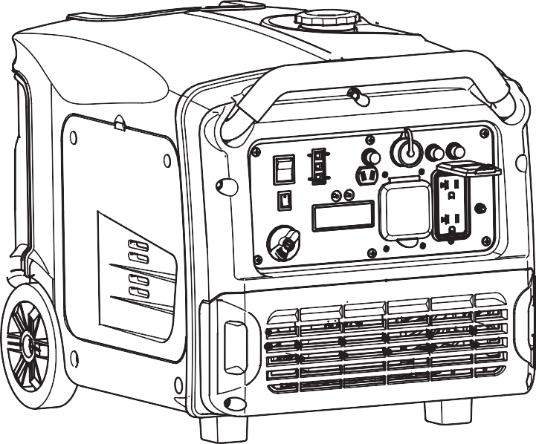

CHONGQING HEYA TECHNOLOGY CO., LTD.

- HEYA reserves the right of modification of product and revision of the manual without any notice.

- Take this manual as a part of the generator. If the generator is resold, it is required to take the manual
alone with the generator.

- This manual contains how to correctly operate the generator, please read carefully before using the generator. Correct and safe operation will guarantee your safety and extend the working life of generator.
- HEYA will continuously innovate and develop its products both in design and quality,although it is the newest revised manual, maybe the content in this manual might have slight difference from the real product.
- Please contact your retailer if you have any questions or doubts.
”are respectively trade mark and registered trade mark of HEYA Technology Co.,
- “HEYA” and “
Ltd.
- The copyright of this instruction belongs to HEYA Technology Co., Ltd.
- It is prohibited from reproducing, transferring, distributing any content in the manual without a written approval from HEYA Technology Co., Ltd.
Thanks for your purchasing HEYA Inverter Generator

Stop the engine 20
21
21
23
24
25
27
29
30
31
32
32
33
34
CONTENT
04
06
07
08
08
RESET 09
Hour-meter 09
10
10
11
12
13
15
16
18
19
19

1.SAFETY INFORMATION

To ensure personal and property safety, please carefully read the following information.

WARNING

- Read and understand the user manual before using the generator.
- The emission of engine contains poisonous carbon monoxide. Use the generator in the ventilated condition.
- Do not touch the hot muffler, when the generator is running, or before cooling.
- Gasoline is explosive and flammable in the specified conditions when refueling, the generator needs to be stopped and be kept cigarette and fire source away.
- Do not connect to the building’s electrical system or other generator, in order to avoid the electric shocks and fires.
- The running generator must keep one meter distance with constructions and other

electrical appliances at least.
- Place the generator on the leveled surface, in order to avoid overturning or spilling fuel.
- Children and pets should be keep away the operation area.
- Do not operate with wet hand.
- Do not expose the generator to rain, moisture or snow.
- Place the generator at least 1 m away from buildings or other equipments during operation.
- The major repair work should be carried out only by professionally trained person.
- Do not use the generator in underground working
- Do not use the generator in potentially explosive atmospheres
- Use personal protective equipment: glove, mask, earplugs, when you operate or maintain the generator

<<04>>

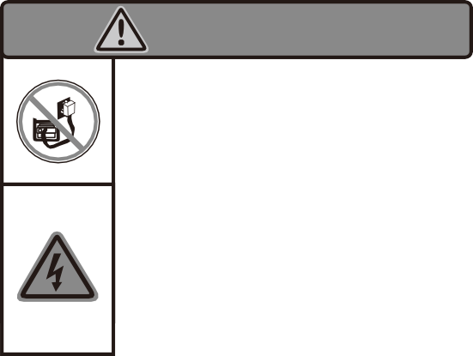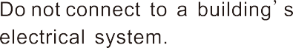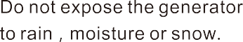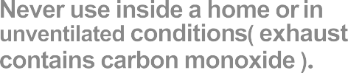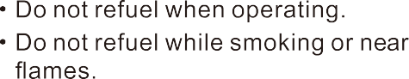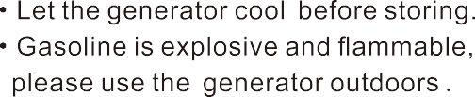

SAFETY LABEL:

<<05>>

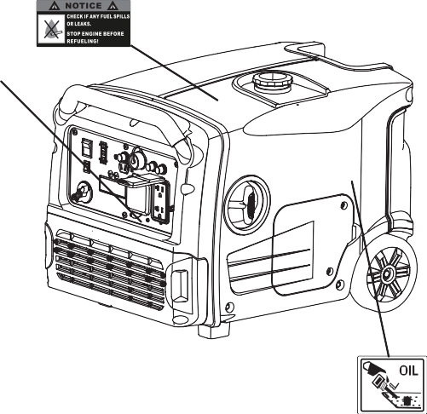

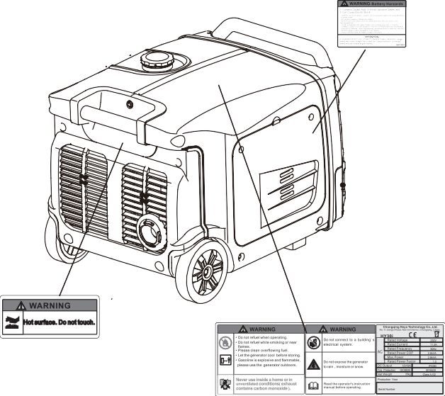

2. SAFETY LABEL LOCATIONS

<<06>>

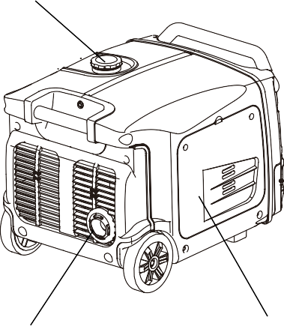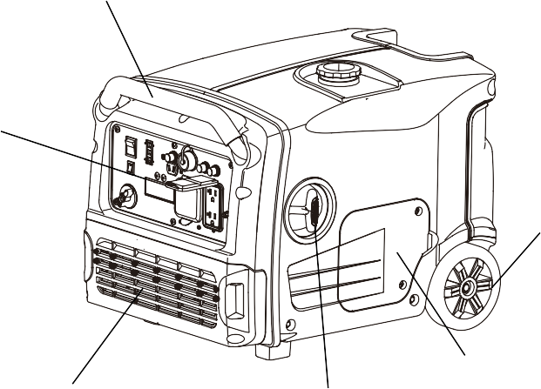
<<07>>
AIR CLEANER MAINTENANCE COVER
MUFFLER
OIL MAINTENANCE
STARTER GRIP COVER
BATTERY MAINTENANCE COVER
WHEEL
CONTROL PANEL
FUEL CAP
HANDLE

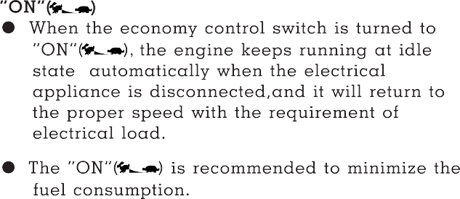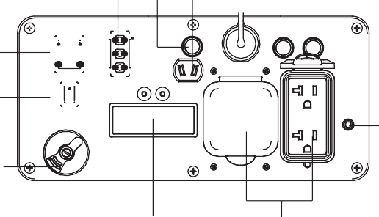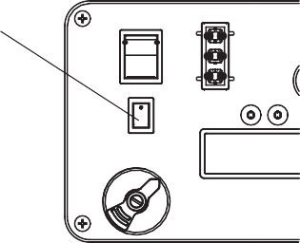
<<08>>
- Hourmeter
- DC Terminal
- DC Protector
- Indicator Lights
- ECON. SW
- Fuel Switch
- Engine Switch
- AC Receptacle
- Ground Terminal
8
1
6
9
5
7
2
3
4

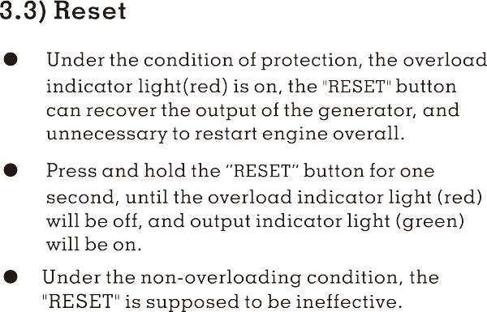

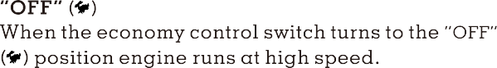

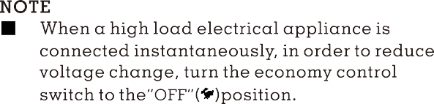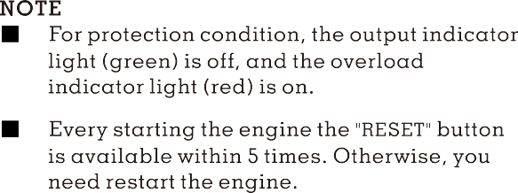
3.4) Hour-meter

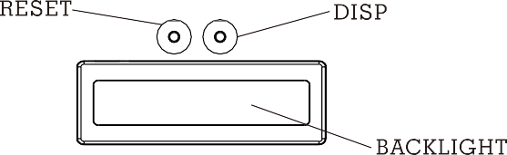

- Press the “DISP” button to display the voltage/frequency of output, the engine speed and cumulative working time.
- Press the “DISP” button, the back-light of hour- meter will be on, and it will be off without operating the button for 10S.

<<09>>

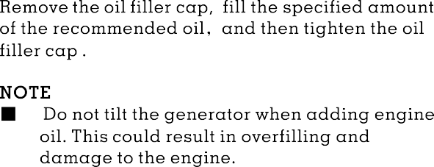
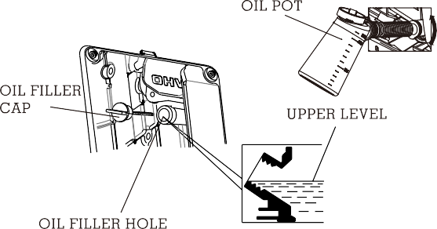
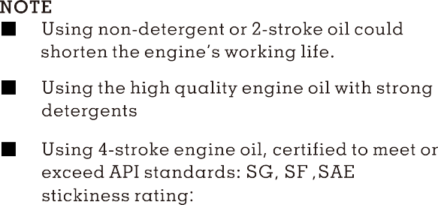

Oil Capacity:0.6L 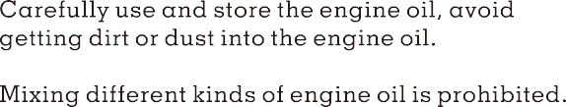
<<10>>

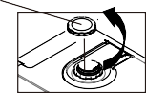
<<11>>
Gasoline is extremely explosive and flammable.
Around the refueling area and fuel storage area, prohibit smoking and firing.
Do not overfill the fuel tank (no fuel above the red upper limit mark). After refueling, make sure the fuel cap is closed properly and securely.
Do not make fuel spill from fuel tank. (No residual fuel around the neck of tank, before starting engine)
Avoid contacting with skin or breathing the fuel vapor.
KEEP OUT OF REACH OF CHILDREN.
●

●

●
●
4.2) Check Fuel Level
Fuel recommend: use unleaded gasoline (Research Octane Number of 91 or higher, Pump Octane Number of 86 or higher)
Never use stale or contaminated gasoline or an oil/gasoline mixture,
Avoid getting dirt or water into the fuel tank.
Do not use a mixture gasoline containing ethanol or methanol; otherwise, it will seriously damage the engine.
●
■
●
Fuel Capacity: 7.4L
WARNING
■

THE LOWEST FUEL LEVEL
E
THE HIGHEST FUEL LEVEL
F
UPPER LIMIT MARK
margin, low oil alert system will close the engine automatically. The oil alert indicator light (red) will be on.
To avoid the inconvenience caused by unexpected stopping, it is still advisable to check the engine oil level regularly.
Before the engine oil reduces below the safety margin, low oil alert system will close the
engine automatically. The oil alert indicator light (red) will be on.
To avoid the inconvenience caused by
unexpected stopping, it is still advisable to check the engine oil level regularly.
■
- Before the engine oil reduces below the safety
OPEN
FUEL CAP
NOTE

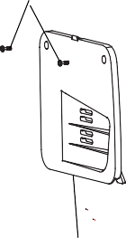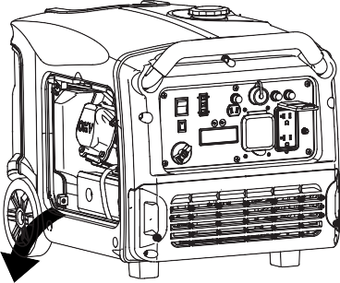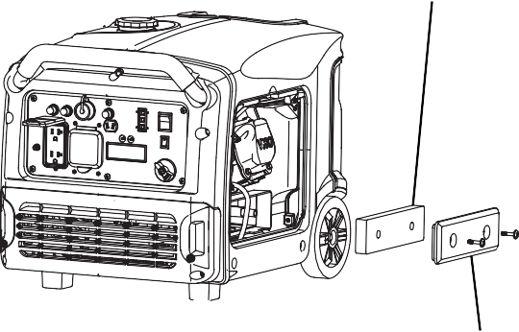
<<12>>
- Loosen the air cleaner cover screws, and remove the cover.
- Check the element, clean or replace it, if necessary.
NOTE
- Do not run engine without air Cleaner element, otherwise that makes engine abrasion.
AIR CLEANER MAINTENANCE COVER
AIR CLEANER COVER
COVER SCREW
AIR CLEANER ELEMENT
4.3)Check Air Cleaner
Check the air cleaner element to be sure it is clean and in good condition.
a. Loosen the air cleaner maintenance cover screws, and remove the cover.

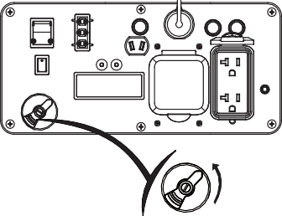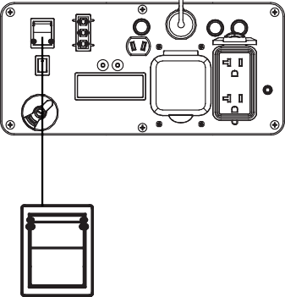
<<13>>
STOP
RUN/REMOTE

START
WARNING

- Never use inside a home or the unventilated condition.
5.1) Turn the fuel switch to the “ON” position.
OFF

5.2) Turn the engine switch to “ RUN/REMOTE” position.
ON
- For some models, the generator provides with three means to starting the engine: recoil starter, local electrical starting, wireless remote electrical starting.
NOTE
- Before starting engine, disconnect load with AC receptacle.
- Fueling at the first time, refueling, or storing for a long time, the Fuel Switch should firstly be opened for ten or twenty seconds, in order to the enough fuel enter into carburetor.
5. STARTING THE ENGINE

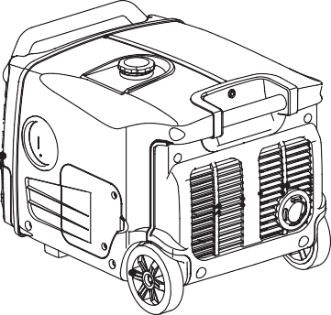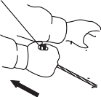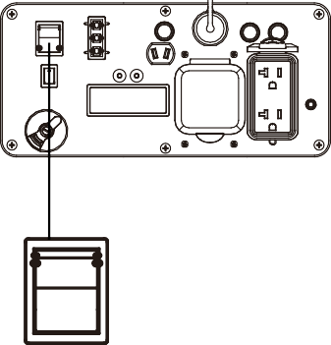
START
<<14>>
b) Local electrical starting
Turn the engine switch to “START” position, and then let the engine switch return to “RUN/REMOTE” position.

STOP

RUN/REMOTE
NOTE
Return the starter grip slowly by hand. Do not make the starter grip spring back quickly.
NOTE
When the engine switch turn to “RUN/REMOTE” position, the engine will enter the stand-by starting mode. Starting the engine within 15min, otherwise, the mode will be ineffective. If the generator re-enters the stand-by starting mode again, the engine switch should be return to “STOP”, and then turn to “RUN/REMOTE”.

5.3) Choose one of the starting modes to start the engine.
CAUTION
For equipping with electrical starting system of the generator, if the generator does not equip with the battery or the battery wares out, the generator can not be start by any starting mode.
a) Manual starting
Pull the starter grip slowly until it is engaged, then pull it quickly.
STARTER GRIP

NOTE
  - Engine switch should not stay “START” position more than 1 seconds during starting.
c) Wireless remote electrical starting
Press “START” ( ) button of the controller once.

NOTE
  - The controller operate distance less than 8m without any obstacles, or less than 3m with one obstacle.
  - The battery of controller can be used for 2 years. If the battery wares out, replace a new one.

Caution
Every generator delivers one controller with generator. If the controller miss, contact your dealer to purchase and decode a new one.
NOTE
- If the generator stops and can not restart, check the oil level firstly.
- If the oil alert indicator light (red) is on during the generator running, it need to add oil.

Carburetor Modification for High Altitude Operation
At high altitude, the standard carburetor air-fuel mixture will be too rich. Performance will decrease, and fuel consumption will increase. A very rich mixture will also foul the spark plug and cause hard starting.
If the generator operates at high altitude, change the main-nozzle or adjust the idling-screw of carburetor.
If the generator always operates at altitude above

<<15>>

1 000 meters contact with an authorized HEYA servicing to modify the carburetor
Generator output power should be modified according to the altitude and ambient temperature The correction factor refers to chapter 13.

WARNING

  - If the carburetor has been modified for high altitude operation, the air-fuel mixture will be too lean for low altitude use. Operation at low altitude may cause the engine to overheat and result in serious engine damage. The carburetor needs return to original specifications.

6. GENERATOR USE

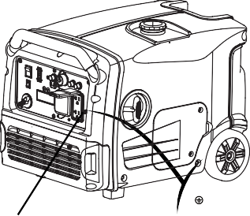
WARNING

- Be sure to ground the generator when the connected electrical appliance is grounded.
- Do not connect to the building’s electrical system, in order to avoid the electric shocks and fires.

GROUND TERMINAL
EARTH MARK

<<16>>
The DC receptacle, 15-30V under no-load condition, may be used for charging 12V battery only.
NOTE
- In DC operation, turn the ECON.SW to the “OFF” ( ) position.
    - Disconnect the vehicle battery ground cable from the negative(-) battery terminals.
    - Connect the DC terminals to battery terminals with the charging cable.
CAUTION
Connect red lead to positive (+) battery terminal and black lead to negative (-) battery terminal.
    - Turn ECON.SW to “OFF” ( ) position, and then start engine.
- For continuous operation, do not exceed the rated out-put power of generator.
- Do not make parallel connection with other generators.
- Do not connect an extension to the exhaust pipe.
- When an extension cable is required, be sure to use a tough rubber sheathed flexible cable (according to IEC245 or equivalent standards). The maxmin length of the extension cable: 60m for cable of 1.5mm2 ; 100m for cable of 2.5mm2 .
- Keep away from other electric cables or wires.

NOTE
- The DC receptacle can be used while the AC power is in use. If use both at same time, be sure not to exceed the total power for AC and DC. (AC:2.6kVA, DC:5A)
- Most of motor appliances require more than their rated wattage, when starting.
6.1) DC Application
WARNING

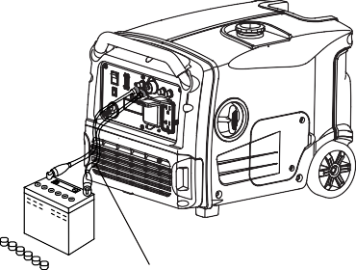
<<17>>
●
Stop the engine.
Disconnect the black lead from the negative battery terminal.
Disconnect the red lead from the positive battery terminal.
3)
The battery can release the explosive gases Keep the battery away from spark/fire. Charge the battery in ventilated condition.
Battery electrolyte contains sulfuric acid that will cause severe burn of skin and eyes.
Therefore it is necessary to wear the protective
clothing and mask.
If battery electrolyte gets into eyes flush thoroughly with warm water for 15min at least and call a doctor immediately
If you swallow a little of battery electrolyte accidentally flush thoroughly with water your mouth and then drink large quantities of water or milk with magnesia or vegetable oil and call a doctor immediately
KEEP OUT REACH OF CHILDREN
●

●

●
CHARGING CABLE
NOTE
●
- Do not start the automobile engine when the generator is still connected to the battery, otherwise the generator will be damaged.
Disconnecting the charging cable
1)
2)
WARNING

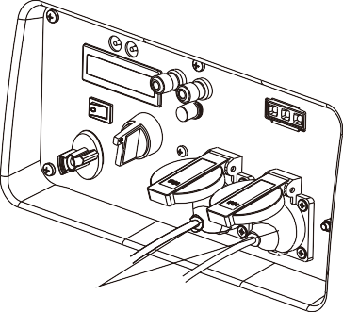
NOTE
- While using the AC power, you can use that DC power at the same time.
- Overload indicator light is on, disconnect
load, press “RESET” button to recover the output of generator.

OVERLOAD INDICATOR LIGHT(RED)
6.2) AC applications
PLUG
    - Start engine and make sure the output indicator light (green) is on.
    - Confirm all electrical appliances are switched off, and connect the appliance plugs to the generator receptacle.
NOTE
- To obtain the best working and longest working life of the generator, a new generator is supposed to run for 20 hours at 50% rated load.
NOTE
■
Confirm all electrical appliances are in good
working condition before connecting them to the generator. If an electrical appliance becomes abnormal, sluggish, or stops suddenly, shut off the generator engine immediately, and disconnect the appliance.
<<18>>

6.3) Output and Overload Indicator
In normal operating, output indicator light (green) will remain on.
If the generator is overload (over 2.6kVA), or the connected appliance is short-circuit, the output indicator light (green) is off, and overload
indicator light (red) is on. The AC power will be switched off, but engine is still running.
If the overload indicator light (red) is on, disconnect the electrical appliances firstly, then stop the engine, and start it again. If the overload indicator light (red) is off and the output indicator light (green) is on, reconnect the electrical appliances. Otherwise stop the engine and check the generator.
6.4) Oil alert system
The oil alert system is designed to prevent engine damage caused by an insufficient amount of oil in the crankcase. Before the oil level in the crankcase falls below a safe limit, the oil alert system will automatically shut down the engine (the engine switch remains in the “RUN/REMOTE“position).
If the oil alert system shuts down the engine, the oil alert indicator light (red) will be on. Check the engine oil level.
OIL ALERT INDICATOR LIGHT ( RED)

OVERLOAD INDICATOR LIGHT(RED)
OUTPUT INDICATOR LIGHT (GREEN)
<<19>>

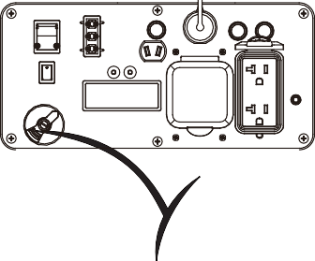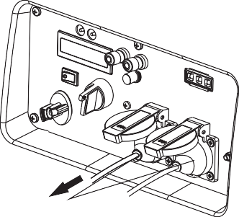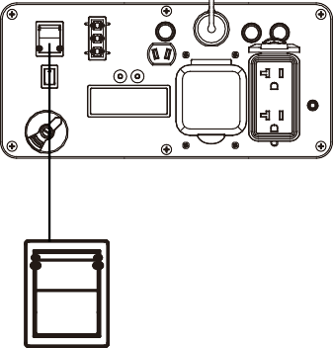
<<20>>
OFF
ON
PLUG

7.2) Turn the engine switch to the “STOP” position, or press the “STOP” ( ) button of the controller.
NOTE
- The controller operate distance less than 8m without any obstacles, or less than 3m with one obstacle.
STOP

RUN/REMOTE

START
7.3) Turn the fuel switch to the “OFF” position.
To stop the engine in an emergency, turn the engine switch to the “STOP” position immediately.

7.1) Switch off the connected electrical appliances, and pull out their plugs.
7. STOPPING THE ENGINE

8. MAINTENANCE
The purpose of the maintenance and adjustment schedule is to keep the generator in the beset operating condition.

WARNING

Stop the engine before performing any maintenance. If the engine must run, be sure the area is well ventilated. The exhaust contains poisonous carbon monoxide gas.
Use genuine HEYA or equivalent quality components to replace the wear components.

Maintenance Schedule
NOTE
- Service more frequently when used in dusty areas.
- These items should be serviced by your servicing dealer, unless you have the proper tools and are mechanically proficient. Refer to HEYA manual for service procedures.
- For commercial use, long hours of operation to determine proper maintenance intervals.

  - Change Oil
Drain the oil rapidly and completely while the engine is still warm.
    - Loosen screws of the oil maintenance cover, and remove the cover.
    - Remove the oil dipstick and the bottom rubber.
<<21>>

Spark plug | Replace |  |  |  |  | Ⓢ
Spark arrester |  |  |  |  | ⊙
Valve Clearance | Check-adjust |  |  |  |  | Ⓢ+(2)
Combustion Chamber | Clean | After every 300 hrs(2)
Fuel tank& filter | Clean | Every year(2)
Fuel line | Check | Every 2 years ( Replace if necessary)(2)

 | Regular Service Period (3) |  |  | Each use | First month or  10 hrs. | Every 3  months or  50 hrs. | Every 6  months or  100 hrs. | Every  2 years or  300 hrs.
 | Item
Engine oil |  | Check level |  | Ⓢ
 |  | Change |  |  | Ⓢ |  | Ⓢ
Air cleaner |  | Check |  | Ⓢ
 |  | Clean |  |  |  | Ⓢ+(1)
Spark plug |  | Check-adjust |  |  |  |  | Ⓢ

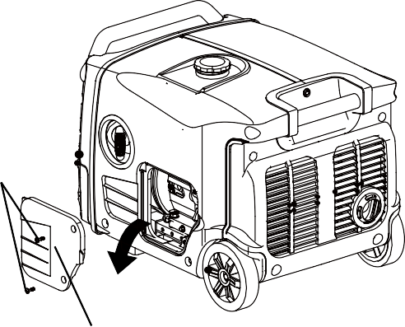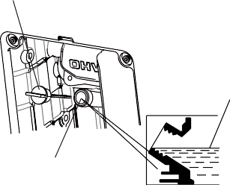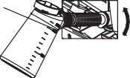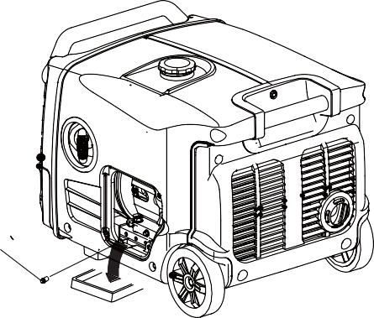
<<22>>
OIL FILLER HOLE
    - Refill the recommended oil, and check the oil level.
    - Reinstall the oil dipstick and tight it. After oil change, wash your hands with soap.
AIR CLEANER MAINTENANCE COVER
UPPER LEVEL

Oil Capacity: 0.6L
COVER SCREW
OIL POT
OIL FILLER CAP
OIL RULER BOLT
    - Place oil collection pan under oil drain plug.
    - Remove the oil drain plug, and drain oil into the oil collection pan completely.
    - Reinstall the oil drain plug.

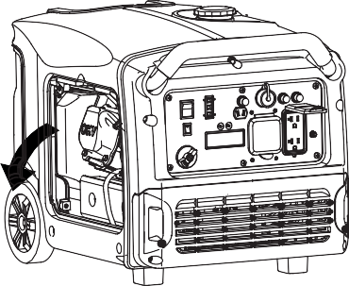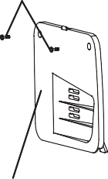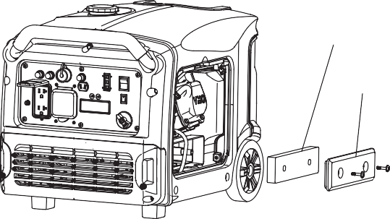
<<23>>
AIR CLEANER COVER
AIR CLEANER ELEMENT
Do not use gasoline or low ignition point solvents for cleaning. They are flammable and explosive under certain conditions.
NOTE
Never run the generator without air cleaner, otherwise that result in engine abrasion rapidly.
8.2.1) Loosen three screws of the air cleaner maintenance cover, and remove the cover.
8.2.2) Loosen the air cleaner cover screws and
remove the cover.
WARNING
AIR CLEANER MAINTENANCE COVER
8.2) Air Cleaner Service
A dirty air cleaner will restrict air flow into the carburetor.Clean and maintain the air cleaner regularly, especially in the extremely dusty areas.
COVER SCREW
NOTE
For conforming to the environment requirement, the used oil will be put into a sealed container and then be transported to the service station for recycler. Do not throw it into the trash or pour it on the ground.

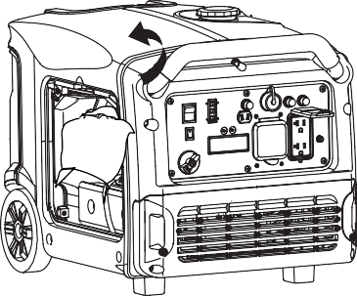
<<24>>
8.2.5) Reinstall the air cleaner element and cover. 8.2.6) Reinstall the maintenance cover, and tighten
the screws.
ELEMENT
8.3) Spark Plug Service
Recommendation spark plug: F7TC
Check the spark plug gap and clean the carbon deposition at the bottom of the spark plug.
8.3.1) Remove the spark plug cap.
    - Take out the air cleaner element, and clean
it with non- flammable or high flash point
solvent, then dry it.
    - Soak the air cleaner element in the clean engine oil, and squeeze out the redundant oil.

<<25>>
The spark arrester must be maintained every 100h service.
8.4.1)Remove the screws, and remove the muffler guard.
    - Measure the spark plug gap with a feeler gauge. The normal value:0.6-0.7mm(0.024- 0.028in). Adjust the gap by bend one of the electrode carefully.
    - Reinstall the spark plug carefully, by hand, to avoid cross-threading. A new spark plug should be tightened 1/2 turn with a spanner. A used Spark plug should be tightened 1/8 to 1/4 turn with spanner.
WARNING
NOTE
- The spark plug must be securely tightened. Tightening in wrong way will cause spark plug hot, even damage the engine.
- Never use a spark plug with an improper heat range.

8.4) Spark Arrester Maintenance
0.60-0.70mm
(0.024-0.028in)
    - Reinstall the spark plug cap
    - Reinstall the spark plug maintenance cover.
    - Take off the spark plug with the spark plug
spanner.
    - Visual inspection the spark plug. Change a new one if its insulator cracked or chipped.
Clean it with a wire brush if the spark plug is reused.

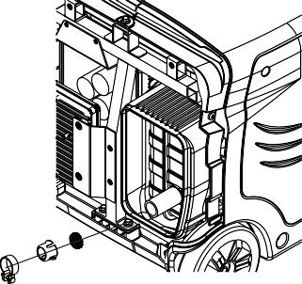
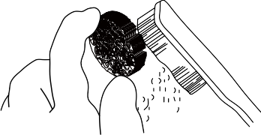
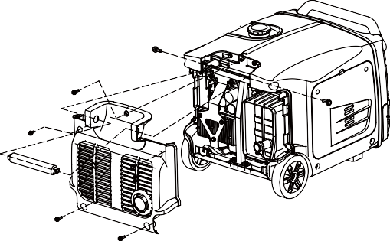
8.4.3)Use a brush to remove carbon deposits from the spark arrester . If the spark arrester is wear, replace it.
8.4.2)Take off the spark arrester from the muffle after the engine cool down.
8.4.4)Reinstall the spark arrester and muffle guard.
8.5 Replace battery and fuse
For some models, equip with electrical starting system and starting battery. If the battery does not deliver, purchase it from your dealer.

Battery specifications
<<26>>

Voltage | Capacity | Dimension
 |  | L≤138mm
12V | 7Ah | W≤66mm
 |  | H≤88mm

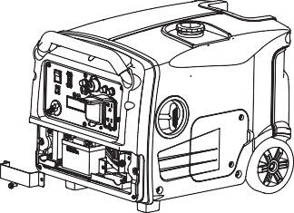
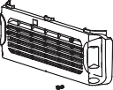
NOTE
  - When the engine is running, the battery will be charge by the charging system of
generator.
  - The battery shall be charge for storage a long period. For using other charging system, the
charging current less than 0.15c amperes (c: battery rated capacity) .

Replace the battery procedure
    - Loosen the screws of the battery maintenance cover, remove the cover.
    - Unhook the battery belt.
    - Remove the black cable from battery negative(-) terminal, and then remove the red cable from battery positive(+) terminal.
    - Remove the battery from battery tray, and replace a new one.
    - Reconnect red cable to battery positive(+) terminal, and reconnect black cable to battery negative(+) terminal.

    - Hook the battery belt, and reinstall the cover.

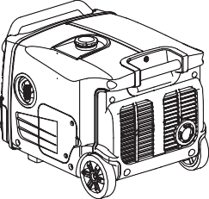
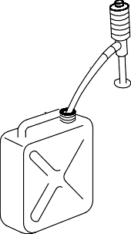
9.TRANSPORTING/STORING

Avoid fuel spilling during transporting or
temporary storing, the engine switch should turn to “OFF’ position, and the generator should place in normal operating position.

WARNING

Transporting Generator:
- Do not overfill the fuel tank. (No residual fuel on the neck of tank)
- Do not use the generator on the transport vehicle. The generator should be used under a good ventilated condition.
- Avoid exposing directly in the sunshine when the generator place in the enclosed transport
vehicle for a long time. The high temperature
inside the vehicle could cause fuel to vaporize
resulting in a possible explosion.
- Drain off the fuel, when the generator is transported on rough road.

Storing for a long period:

  - Make sure the storage area without excessive humidity and dust.
  - Drain off the fuel.
WARNING

- Keep away from smoking, flames and spark, gasoline is explosive and flammable in the specified condition.
a. Drain off the gasoline in the fuel tank,storing into the suitable container.

<<27>>

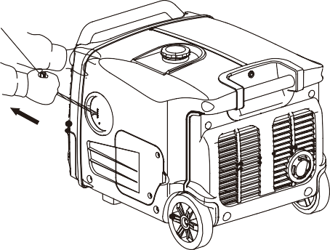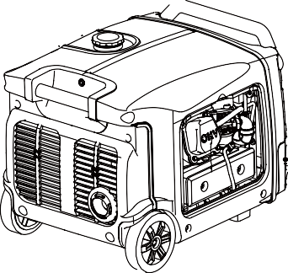
<<28>>
  - Change new oil while engine is still warm from operation.
  - Remove the spark plug, and pour a tablespoon of clean engine oil(10~20ml)into the cylinder. Revolve the engine several
times to distribute the oil,and reinstall the spark plug.
  - Pull the starter grip slowly until feel resistance. At this point, the piston is coming up on its compression stroke and both the
intake and exhaust valves are closed. In this position, it helps to protect the engine from internal corrosion.
- Take off the spark plug cap, pull the starter grip three or four times, discharge the gasoline from the fuel lines.
- Turn the fuel switch to “OFF” position, and tighten the drain screw of carburetor.
- Reinstall the spark plug cap.
b Turn the fuel switch to “ON” position, and loosen the carburetor drain screw to discharge gasoline inside of carburetor.
STARTER GRIP

<<29>>
NO
YES
YES
NO
NO
YES
YES
NO
DC receptacle without any electricity：
YES
NO
YES
NO
YES
YES
NO
NO
YES
NO
YES
YES
NO
NO
When the engine can not be started:
Appliance does not operate：
10.TROUBLESHOOTING
Contact with an authorized HEYA dealer
If the engine still does not start, contact with an authorized HEYA dealer
Push the DC circuit protector ON.
Is the DC circuit protector OFF?
Is the spark plug in good condition?
Clean, readjust gap and dry the spark plug. Replace it if necessary
Change or replace the appliance
Check the electrical appliance for any fault
Add the recommended oil
Is there enough oil in the engine?
Reset the engine switch(Turn to STOP, then to RUN/REMOTE)
Is stand-by starting mode exceed 15min?
Restart the engine
Stop engine and then replace or repair the appliance
Turn the engine switch to “RUN/REMOTE”
Is the engine switch in” RUN/REMOTE” ?
Contact with an authorized HEYA dealer
Check the electrical appliance for any fault.
Turn the fuel switch on
Is the fuel switch on?
Contact with an authorized HEYA dealer
Is the overload indicator light ON?
Refill the fuel tank
Is there fuel in the tank?
Is the output indicator light ON?

11. TECHNICAL SPECIFICATIONS
Noise level is measured when the ECON.SW is turned to ‘’ ON ‘’( )
- : LwA shows the guaranteed sound power tested by 2000/14/EC.
- ﹡ : The noise level in “dB/7m” is the arithmetic mean value of sound press level (LpA) in four directions measured 7 meters away from the
generator.
The noise level may vary in different environments.
<<30>>

 | Specifications | Parameters
ENGINE | Model | DJ170F
 | Type | 4-stroke, overhead valve,  single cylinder, forced-air cooling
 | Engine Displacement | 208ml
 | Bore*Stroke | 70.0mm*54.0mm
 | Compression Ratio | 8.5:1
 | Rated power | 4.0kW/3600min-1
 | Ignition System | Full transistor
 | Start System | Recoil starter& Electrical starting&  Wireless remote starting
 | Fuel Type | Gasoline without lead
 | Oil Capacity | 0.6L
 | Oil Model | SE 15W-30
GENERATOR | Model | HY30i
 | Rated Frequency | 50Hz
 | Rated Voltage | 120V
 | Rated Current | 23.3A
 | Rated Speed | 3600min-1
 | Rated Output Power | 2.6kVA
 | Max. Output Power | 2.8kVA

OTHER SPECIFICATIONS | DC Output | 12V/5A
 | Fuel Tank Volume | 7.4L
 | Continuous Running Time | 7.0h
 | Fuel Consumption | 490g/kW.h
 | Working Ambient Temperature | -20 ~40
 | Max. Altitude | 1000m
 | ﹡Noise Lw A | 90dB/4m
 | ﹡﹡ Noise Lp A | 54~59dB/7m
 | Dimensions (L*W*H ) | 580mm* 508mm *450mm
 | Net Weight | 35kg

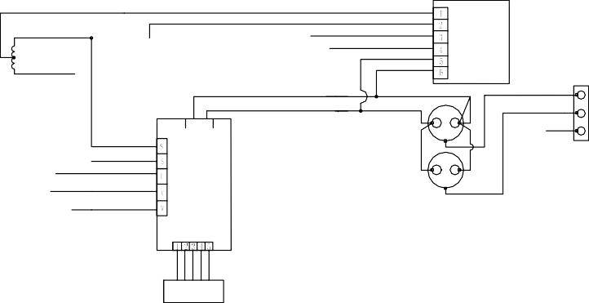
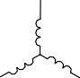
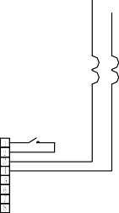
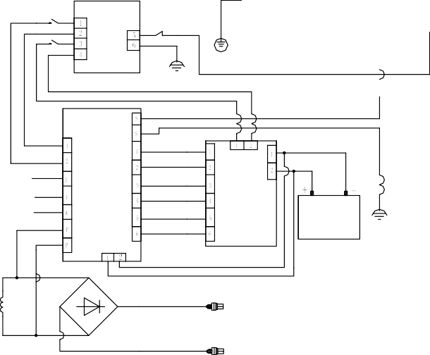
<<31>>
DC
Connector
Aux.
Winding 2
plug
Winding
Trigger Oil sensor Spark Ignition
Ignition Winding
Battery 12V 7Ah
Booster Plate
Actuator
Stepper Motor
Engine Switch
AC
Receptacle
ECON.SW
Main Winding
Ground Terminal
Aux.
Winding 1
Hourmeter
Ignition Module
INVERTER
12 WIRING DIAGRAMS
.

13. APPENDIX
13.1) Environment Correction
The standard condition of rated power output: Altitude:0m
Ambient temperature:25o C
Relative humidity:30%
NOTE: Relative humidity 60% correction factorC- 0.01；
Relative humidity 80% correction factorC -0.02；
Relative humidity 90% correction factorC- 0.03；
Relative humidity 100% correctionfactorC-
0.04；
Factor of environment correction:
Example：
Rated power（PN）2.6kVA generator(Altitude: 1000m) Ambient temperature: 35℃ ，Relative humidity: 80%
P=Pn*(C-0.02)=2.6*(0.82-0.02)=2.08kVA
<<32>>

Altitude(m) | Ambient temperature℃
 | 25 | 30 | 35 | 40 | 45
0 | 1 | 0.98 | 0.96 | 0.93 | 0.90
500 | 0.93 | 0.91 | 0.89 | 0.87 | 0.84
1000 | 0.87 | 0.85 | 0.82 | 0.80 | 0.78
2000 | 0.75 | 0.73 | 0.71 | 0.69 | 0.66
3000 | 0.64 | 0.62 | 0.60 | 0.58 | 0.56
4000 | 0.54 | 0.52 | 0.50 | 0.48 | 0.46

<<33>>
operator is exposed to the noise. Also the permissible exposure level can vary from county. This information, however, will enable the user of the machine to make a better evaluation of the hazard and risk.
13.2) Noise and Access
Noise emission measure according to ISO 8528-10, EN ISO 3744, European Directive 2000/14/EC with amendment 2005/88/EC
Model of generator set: HY30i Sound Pressure Level: 68dB(A)
Guaranteed Sound Power Level：90dB(A) Measurement Uncertainty K: 1.7 dB(A)
The quoted figures are emission levels and are not necessarily safe working levels. Whilst there is a correlation between the emission and exposure levels, this cannot be used reliably to determine whether or not further precautions are required.
Factors that influence the actual level of exposure of work-force include the characteristics of the work room, the other sources of noise, etc, i.e. the number of machines and other adjacent processes, and the length of time for which an

14. CONSUMER INFORMATION

Consumer Service Information
Service dealers are trained professionally. They should be able to answer any questions you have. If the dealer does not solve your problems, please discuss them with the manager of the dealer. Most of your problems are solved in this way.
If you are dissatisfied with the decision of the manager of the dealer, contact with the Customer Relations Department of HEYA Technology Co., Ltd.

You can Email or call:
Chongqing HEYA Technology Co., Ltd.
Add: No.11 Jiangxi Road, Nan’an District, Chongqing, China
Tel: (+86) 023-68605339
Fax: (+86) 023-6860 5338
PC: 401336

When you email or call, please give us the information: Model and serial number
Date of purchase
Detailed description of the problems
Dealer contact information and yours: name, address, and telephone number

<<34>>

: Larry Chen
: Test Manager
Person responsible for making this declaration
Name, Surname Position/Title
Person responsible for compiling the technical files established within the EU Name, Surname:
Address:
401336, P.R. China
Authorized Rep's Name :
Authorized Rep's Address :
: Chongqing Heya Technology Co., Ltd.
: No. 11 Jiangxi Road, Nan'an District, Chongqing
Authorized representative established within the EU

Manufacture's Name
Manufacturer'sAddress
Responsible for marking this declaration is the:
Manufacturer
EN 61000-6-2:2005; EN 61000-6-4:2007
EC DECLARATION OFCONFORMITY
For the following machinery: Product name: INVERTER GENERATOR Model: HY30i
is herewith confirmed to fulfill all the relevant provisions of Machinery Directive (2006/42/EC) and comply with Low-Voltage Directive (2006/95/EC), Electromagnetic Compatibility Directive (2004/108/EC) and Noise Emission Directive (2000/14/EC, amended by 2005/88/EC)
and the following harmonized standard have been complied with:
- EN 12601:2010;
-
-
<<35>>

Tel: (+86) 023-68605339 Fax: (+86) 023-6860 5338
Web: www.heya-invertergenerator.com
PC: 401336
Add:No.11 Jiangxi Road, Nan’an District, Chongqing, China
CHONGQING HEYA TECHNOLOGY CO., LTD.

