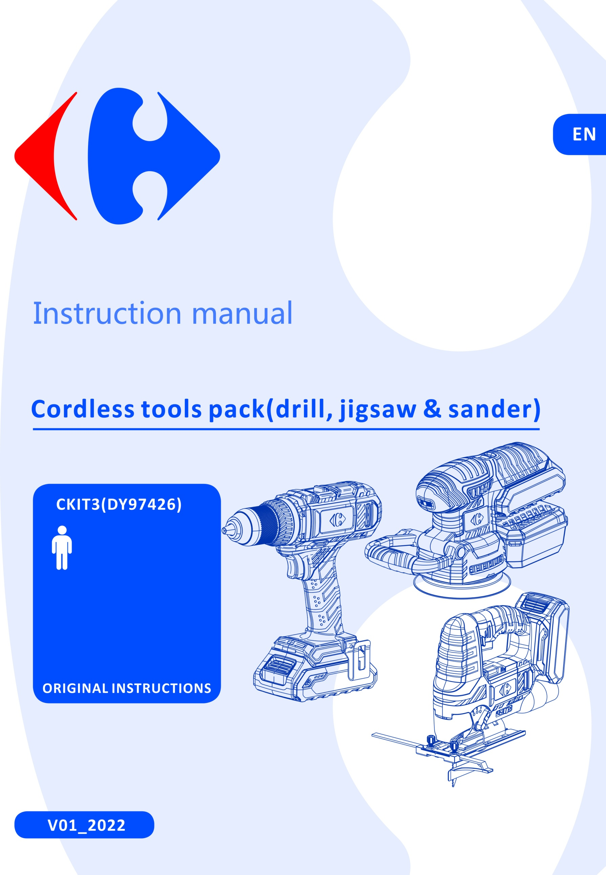



|  |
| --- |
| **Congratulation on your purchase.**  **The quality team at CARREFOUR cares for its products to meet conformity and performances.**  **Paying close attention to your satisfaction, our experts work all day on the improvement of our products.** |



|  |
| --- |
| For assembly and/or maintenance and/or use of your product, you can use:  F:\2016-2019 订单资料\BULL\Caffefour IM chart\1_pictograms\hammer.jpg F:\2016-2019 订单资料\BULL\Caffefour IM chart\1_pictograms\screwdriver_001.jpg  These products are available in CARREFOUR stores. |



|  |
| --- |
| For a better use of your new device, we recommend you to read carefully this Instruction Manual and keep it for record.  Keep it carefully for future reference.  Please also find information about the scraping of the product in this Instruction Manual. |



|  |
| --- |
| Before installing or using this product, please read carefully the safety measures after the table of contents. |

**Pictograms used**

|  |  |
| --- | --- |
| F:\2016-2019 订单资料\BULL\Caffefour IM chart\1_pictograms\danger.jpg | Warning symbols with information on damage and injury prevention. |
|  | Read the operation instructions carefully. |
|  | Read and understand all instructions before operating the product. Follow all warnings and safety instructions. |
| F:\2016-2019 订单资料\BULL\Caffefour IM chart\1_pictograms\WEEE icon.jpg | Electrical products must not be disposed of with the domestic waste. |
|  | Protect the rechargeable battery from sunlight and heat (max.50ºC) . |
|  | Protect the rechargeable battery from water and moisture. |
|  | Protect the rechargeable battery from fire. |
|  | The charger is for indoor use only. |
|  | Miniature fuse |
|  | Protection class II (double insulation) |
|  | Wear hearing protection. |
|  | Wear safety glasses. |
|  | Wear a mask! |

**CONTENTS**

[SAFETY INSTRUCTIONS 5](#_Toc77357426)

Scope of the delivery……………………………………………………………………………………………………………………….10

[CORDLESS DRILL 11](#_Toc77357441)

[CORDLESS JIG SAW 19](#_Toc77357443)

[CORDLESS Obital Sander 28](#_Toc77357444)

[DISPOSAL 34](#_Toc77357450)

[DECLARATION OF CONFORMITY 35](#_Toc77357451)

[WARRANTY 36](#_Toc77357453)

[PRODUCT FAILURE 37](#_Toc77357454)

[WARRANTY EXCLUSIONS 38](#_Toc77357455)

# SAFETY INSTRUCTIONS

### GENERAL POWER TOOL SAFETY WARNINGS

**WARNING Read all safety warnings, instructions, illustrations and specifications provided with this power tool.** *Failure to follow all instructions listed below may result in electric shock, fire and/or serious injury*.

### Save all warnings and instructions for future reference.

*The term "power tool" in the warnings refers to your mains-operated (corded) power tool or battery-operated (cordless) power tool.*

### Work area safety

* 1. **Keep work area clean and well lit**. *Cluttered or dark areas invite accidents.*
  2. **Do not operate power tools in explosive atmospheres, such as in the presence of flammable liquids, gases or dust.** *Power tools create sparks which may ignite the dust or fumes.*
  3. **Keep children and bystanders away while operating a power tool.** *Distractions can cause you to lose control.*

### Electrical safety

* 1. **Power tool plugs must match the outlet. Never modify the plug in any way. Do not use any adapter plugs with earthed (grounded) power tools.** *Unmodified plugs and matching outlets will reduce risk of electric shock.*
  2. **Avoid body contact with earthed or grounded surfaces, such as pipes, radiators, ranges and refrigerators.** *There is an increased risk of electric shock if your body is earthed or grounded.*
  3. **Do not expose power tools to rain or wet conditions.** *Water entering a power tool will increase the risk of electric shock.*
  4. **Do not abuse the cord. Never use the cord for carrying, pulling or unplugging the power tool. Keep cord away from heat, oil, sharp edges or moving parts.** *Damaged or entangled cords increase the risk of electric shock.*
  5. **When operating a power tool outdoors, use an extension cord suitable for outdoor use.** *Use of a cord suitable for outdoor use reduces the risk of electric shock.*
  6. **If operating a power tool in a damp location is unavoidable, use a residual current device (RCD) protected supply.** *Use of an RCD reduces the risk of electric shock.*

### Personal safety

* 1. **Stay alert, watch what you are doing and use common sense when operating a power tool. Do not use a power tool while you are tired or under the influence of drugs, alcohol or medication.** *A moment of inattention while operating power tools may result in serious personal injury.*
  2. **Use personal protective equipment. Always wear eye protection.** *Protective equipment such as a dust mask, non-skid safety shoes, hard hat or hearing protection used for appropriate conditions will reduce personal injuries.*
  3. **Prevent unintentional starting. Ensure the switch is in the off-position before connecting to power source and/or battery pack, picking up or carrying the tool.** *Carrying power tools with your finger on the switch or energising power tools that have the switch on invites accidents.*
  4. **Remove any adjusting key or wrench before turning the power tool on.** *A wrench or a key left attached to a rotating part of the power tool may result in personal injury.*
  5. **Do not overreach. Keep proper footing and balance at all times.** *This enables better control of the power tool in unexpected situations.*
  6. **Dress properly. Do not wear loose clothing or jewellery. Keep your hair and clothing away from moving parts.** *Loose clothes, jewellery or long hair can be caught in moving parts.*
  7. **If devices are provided for the connection of dust extraction and collection facilities, ensure these are connected and properly used.** *Use of dust collection can reduce dust-related hazards*.
  8. **Do not let familiarity gained from frequent use of tools allow you to become complacent and ignore tool safety principles.** *A careless action can cause severe injury within a fraction of a second.*

### Power tool use and care

* 1. **Do not force the power tool. Use the correct power tool for your application.** *The correct power tool will do the job better and safer at the rate for which it was designed.*
  2. **Do not use the power tool if the switch does not turn it on and off.** *Any power tool that cannot be controlled with the switch is dangerous and must be repaired.*
  3. **Disconnect the plug from the power source and/or remove the battery pack, if detachable, from the power tool before making any adjustments, changing accessories, or storing power tools.** *Such preventive safety measures reduce the risk of starting the power tool accidentally.*
  4. **Store idle power tools out of the reach of children and do not allow persons unfamiliar with the power tool or these instructions to operate the power tool.** *Power tools are dangerous in the hands of untrained users.*
  5. **Maintain power tools and accessories. Check for misalignment or binding of moving parts, breakage of parts and any other condition that may affect the power tool’s operation. If damaged, have the power tool repaired before use.** *Many accidents are caused by poorly maintained power tools.*
  6. **Keep cutting tools sharp and clean.** *Properly maintained cutting tools with sharp cutting edges are less likely to bind and are easier to control.*
  7. **Use the power tool, accessories and tool bits etc. in accordance with these instructions, taking into account the working conditions and the work to be performed.** *Use of the power tool for operations different from those intended could result in a hazardous situation.*
  8. **Keep handles and grasping surfaces dry, clean and free from oil and grease.** *Slippery handles and grasping surfaces do not allow for safe handling and control of the tool in unexpected situations.*

### Battery tool use and care

* 1. **Recharge only with the charger specified by the manufacturer**. *A charger that is suitable for one type of battery pack may create a risk of fire when used with another battery pack.*
  2. **Use power tools only with specifically designated battery packs.** *Use of any other battery packs may create a risk of injury and fire.*
  3. **When battery pack is not in use, keep it away from other metal objects, like paper clips, coins, keys, nails, screws or other small metal objects, that can make a connection from one terminal to another**. *Shorting the battery terminals together may cause burns or a fire.*
  4. **Under abusive conditions, liquid may be ejected from the battery; avoid contact. If contact accidentally occurs, flush with water. If liquid contacts eyes, additionally seek medical help**. *Liquid ejected from the battery may cause irritation or burns.*
  5. **Do not use a battery pack or tool that is damaged or modified**. *Damaged or modified batteries may exhibit unpredictable behaviour resulting in fire, explosion or risk of injury.*
  6. **Do not expose a battery pack or tool to fire or excessive temperature**. *Exposure to fire or temperature above 130 °C may cause explosion.*
  7. **Follow all charging instructions and do not charge the battery pack or tool outside the temperature range specified in the instructions.** *Charging improperly or at temperatures outside the specified range may damage the battery and increase the risk of fire.*

### Service

* 1. **Have your power tool serviced by a qualified repair person using only identical replacement parts.**

*This will ensure that the safety of the power tool is maintained.*

* 1. **Never service damaged battery packs.** *Service of battery packs should only be performed by the manufacturer or authorized service providers.*

### DRILL SAFETY WARNINGS

1. **Wear ear protectors when impact drilling**. *Exposure to noise can cause hearing loss.*
2. **Use auxiliary handle(s), if supplied with the tool**. *Loss of control can cause personal injury.*
3. **Brace the tool properly before use.** *This tool produces a high output torque and without properly bracing the tool during operation, loss of control may occur resulting in personal injury.*
4. **Hold power tool by insulated gripping surfaces, when performing an operation where the cutting accessory may contact hidden wiring**. *Cutting accessory contacting a "live" wire may make exposed metal parts of the power tool "live" and could give the operator an electric shock.*

### SAFETY INSTRUCTIONS WHEN USING LONG DRILL BITS

1. **Never operate at higher speed than the maximum speed rating of the drill bit.** *At higher speeds, the bit is likely to bend if allowed to rotate freely without contacting the workpiece, resulting in personal injury.*
2. **Always start drilling at low speed and with the bit tip in contact with the workpiece.** *At higher speeds, the bit is likely to bend if allowed to rotate freely without contacting the workpiece, resulting in personal injury.*
3. **Apply pressure only in direct line with the bit and do not apply excessive pressure.** *Bits can bend causing breakage or loss of control, resulting in personal injury.*

### ADDITIONAL INSTRUCTIONS FOR DRILL

1. Keep all safety devices, air vents and the motor housing free of dirt and dust as far as possible. Wipe the equipment with a clean cloth or blow it with compressed air at low pressure
2. We recommend that you clean the device immediately each time you have finished using it
3. Clean the equipment regularly with a moist cloth and some soft soap. Do not use cleaning agents or solvents; these could attack the plastic parts of the equipment. Ensure that no water can seep into the device. The ingress of water into an electric tool increases the risk of an electric shock.
4. The electrical current used must correspond to the specifications of the battery charger; read carefully the instructions and technical specifications of the charger and the battery.
5. Never allow moisture, rain or splash to reach the recharging location.
6. The ambient temperature should never exceed 50°C. Never expose the unit to direct sunlight.
7. A faulty or damaged battery pack or no longer accepting a load must be disposed of at a special collection point. Respect the environment. Do not dispose of an unusable battery pack with household waste in the fire or in water.
8. Always keep the surface of the charger free of dust and dirt.
9. Always remove the battery pack before performing any operation or maintenance on the device.
10. Use a dust collector to collect the dust when the will produce a considerable amount of dust. Follow the instruction manual of the collector dust to know how to install and how to use it.

### RESIDUAL RISKS FOR DRILL

Even with use of the tool as described, it is impossible to eliminate all residual risk factors. The following hazards may be present in connection with the construction and design of the tool:

1. Pulmonary lesions if an effective mask is not worn.
2. Hearing damage if effective hearing protection is not worn.
3. Body injuries caused by vibration emissions if the electrical appliance is used improperly or for a prolonged or poorly maintained period.

**WARNING!** This device produces an electromagnetic field during operation. This field may interfere in certain circumstances with active or passive medical implants. To reduce the risk of serious or fatal injury, we recommend that people with medical implants consult with their physician and the medical implant manufacturer before using this device.

**Safety instructions for reciprocating saws**

1. **Hold the power tool by insulated gripping surfaces, when performing an operation where the cutting accessory may contact hidden wiring.** *Cutting accessory contacting a "live" wire may make exposed metal parts of the power tool "live" and could give the operator an electric shock.*
2. **Use clamps or another practical way to secure and support the workpiece to a stable platform.** *Holding the workpiece by hand or against your body leaves it unstable and may lead to loss of control.*

**SPECIAL SAFETY INSTRUCTIONS FOR JIG SAWS**

**Important!**

**Use of any accessories or attachments other than those supplied or recommended in these operating instructions can mean the risk of injury.**

1. When using jig saws ear protectors and a face mask should be worn. Exposure to noise can cause damage to hearing.
2. Do not use the jig saw to cut asbestos or materials containing asbestos.
3. Do not leave power tools running unattended. Always switch off and do not put down or leave until it has stopped completely.
4. Long hair must be covered. Do not work in loose fitting clothing.
5. Be careful when working on walls. Damage to power supply lines, gas or water pipes can lead to dangerous situations. Use appropriate detectors to establish whether there are concealed wires or pipes in the working area.
6. Secure the work piece. The work piece is only secure if it is held by work-holding devices or in a vice.
7. Caution: saw blades can get very hot.
8. Saw blades must be kept sharp and in good condition. Replace partially fractured and broken saw blades immediately.
9. Work calmly and evenly with the jig saw. You will thus avoid accidents and the saw blades and the jig saw will last longer.
10. Do not use for cutting pipes or cables.
11. Do not use cracked, blunt or damaged blades.
12. Do not start the saw if no blade is fitted.
13. Check there are no obstructions in/on the surface under the item to be cut.
14. Do not attempt to cut items thicker than the maximum cutting depth of the blade, or where there is insufficient space for the blade under the item.
15. The saw’s metal parts may become conductive if the saw comes into contact with a live wire. Therefore, only hold the saw by its insulated handle.
16. Check that the ventilation slots are not blocked.
17. Never remove dust, obstructions or the like from the work area while the blade is operating.
18. Never stop the saw blade by applying pressure to the saw or to the side of the blade.
19. Do not lift the saw from the item being cut if the blade is still running.
20. Never place the saw on a table or workbench if it has not stopped completely.
21. The saw blade will continue to run a short time after the machine has been switched off.

### Specific safety instructions for Sander

1. **Secure the workpiece.** A workpiece securely held by a clamping device or vice is much safer than one held in one hand**.**
2. **Do not rest your hands next to or in front of the appliance and the area being worked as there is a risk of injury if you slip**.
3. **RISK OF FIRE DUE TO FLYING SPARK！**Sanding metal causes sparks to be produced. Therefore, make sure that nobody is at risk and that no combustible materials are located in the immediate vicinity of where you are working.
4. **WARNING! TOXIC VAPOURS!** Working with the tool can produce harmful/toxic dusts that represent a health hazard for the person operating the appliance and for any other people in the area.
5. **WARNING! RISK DUE TO DUST!** When working for extended periods of time on wood and in particular, materials that produce dust that is hazardous to health, connect the appliance to a suitable external dust extraction appliance. **Wear Safety goggles and a protective dust mask!**
6. **Provide sufficient ventilation when working on plastics, paints, lacquers, etc.**
7. **Do not soak the materials or the area to be processed with liquids containing solvents.**
8. **Never work on moistened materials or damp surfaces.**
9. **Hold the two handles of the appliance when operating**.
10. **Avoid sanding lead paint or other harmful materials.**
11. **Materials containing asbestos must not be processed. Asbestos is a known carcinogen.**
12. **Avoid contact with the sanding sheet while the appliance is running**
13. **Do not use the appliance without a sanding sheet fitted.**
14. **Never use the appliance for other purposes and only use original parts/accessories. Using attachments or accessory tools other than those recommended in the operating instructions can lead to a risk of injury.**
15. **Always allow the appliance to come to a complete standstill before putting it down.**
16. **The appliance must always be kept clean, dry and free from oil or grease.**

### Vibration and noise reduction FOR SANDER

To reduce the noise and vibration emission, limit the time of operation, use low-vibration and low noise operating modes as well as wear personal protective equipment.

Take the following points into account to minimize the vibration and noise exposure risks:

1. Only use the product as intended by its design and these instructions
2. Ensure that the product is in good condition and well maintained
3. Use correct attachments for the product and ensure they are in good condition
4. Keep tight grip on the handles surface
5. Plan your work schedule to spread any high vibration tool use across a longer period of time.

### Residual Risk FOR SANDER

Even if properly operating and handling this product in accordance with all the safety requirements, potential risks of injury and damage remain. Due to its construction and build, this tool may present the following hazards:

1. There is risk of a short-circuit due to liquids penetrating the housing. Do not immerse the product and the accessories in water. Make sure that no water or other liquids can enter the housing.
2. Ear damage if working without ear protection
3. The harmful /toxic dusts produced during operation pose the risk to the health of the operator and persons in the vicinity. Wear eye protection and a dust mask.
4. Keep a sufficient distance from heat sources.
5. The appliance is not a toy and does not belong in the hands of children.

**Warning!**

During operating, the product generates an electromagnetic field which, under certain circumstances, may impair the functionality of active or passive medical implants. To reduce the risk of serious or lethal injuries, we recommend that persons with medical implants consult their doctor and the manufacturer of their medical implant before operating the electric tool.

### Special safety instructions for battery-operated tools

1. **Ensure that the tool is switched off before inserting the battery.** Inserting a battery into a tool that is switched on may result in accidents.
2. **Recharge the batteries indoors only because the battery charger is designed for indoor use only**. Risk of electric shock.
3. **To reduce the electric shock hazard, unplug the battery charger from the mains before cleaning the charger**.
4. **Do not subject the battery to strong sunlight over long periods and do not leave it on a heater.** Heat damages the battery and this is risk of explosion.
5. **Allow a hot battery to cool before charging**.
6. **Do not open up the battery and avoid mechanical damage to the battery. Risk of short circuit and fumes may be emitted that irritate the respiratory tract.** Ensure fresh air and seek medical assistance in the event of discomfort.
7. **Do not use non-rechargeable battery.** This could damage the appliance.
8. **The recommended ambient temperature range for the charging system during charging is from 4ºC to 40 ºC**.
9. **The recommended ambient temperature range for tool and battery storage is from 0ºC to 50 ºC**.
10. **The recommended ambient temperature range for tool and battery use is from -5ºC to 50 ºC**.
11. **Remove the battery from the device before storage.**
12. **Electrolyte leaking from the cells can cause damage to the skin, clothes or any other items exposed to it. If the electrolyte contacts the skin or clothes, wash thoroughly with clean water. If the electrolyte enters into the eyes, do not rub the eyes but flush them immediately with copious amounts of clean water such as tap water, and immediately consult a doctor.**
13. **Do not disassemble or modify the battery, which can cause short-circuiting between cells or between the cell and its wiring, and disables the battery’s safety protection system. These can lead to electrolyte leakage, overheating or a cell or battery, bursting and fire.**
14. **Avoid casual or inadvertent shorting of a battery with metallic objects such as: wire, tools, neckless or hairpins, which can cause short-circuiting, which cause excess current flow, electrolyte leakage, heating of cells or batteries, bursting and fire.**
15. **Keep battery away from a fire or heat. The insulation materials will melt and the gas release vent and protection system will be damaged, causing electrolyte leakage, bursting and possibly fire.**
16. **Not allow the battery to contact with water or gets wet, it may short-circuit, overheat, rust or lose its functions.**
17. **Do not expose the battery to mechanical shock, for example, by dropping, throwing or crushing, causing electrolyte leakage, cell and battery heating, bursting and fire.**
18. **Avoid the battery to directly connect to electric source such as a car lighter socket, or car battery, which may cause excess current to flow at high voltage and can cause electrolyte leakage, overheating of a cell or battery, bursting and fire.**

**Safety instructions for charger**

1. This charger can be used by children aged from 8 years and above and persons with reduced physical, sensory or mental capabilities or lack of experience and knowledge if they have been given supervision or instruction concerning use of the charger in the safe way and understand the hazards involved. Children shall not play with the charger. Cleaning and user maintenance of the charger shall not be made by children without adult supervision.
2. If the supply cord is damaged, it must be replaced by the manufacturer, its service agent or similarly qualified persons in order to avoid a hazard.
3. Only use this charger CBA20V2A to charge the battery pack CCH20V.
4. To charge the battery, use only the charger supplied
5. Never charge non-rechargeable batteries.
6. During charging the batteries must be placed in a well ventilated area.

# Scope of the delivery

Carefully unpack the cordless drill and check that it is complete:

* 1x Battery-operated cordless drill
* 1 x SL/PH drill bit
* 1 x belt clip
* 1x Battery-operated Cordless Jig Saw
* 1 x saw blade for wood HCS
* 1 x saw blade for Al HSS
* 1 x saw blade for metal HSS
* 1 x Rip fence
* 1 x adaptor for dust extraction
* 1 x protection cover
* 1 x Sliding block
* 1 x Anti-splinter guard
* 1 x Allen wrench
* 1 x Battery-operated cordless orbital sander
* 1 x battery pack 2.0Ah
* 1 x battery charger
* 4 x random orbital sanding discs (grain size 60/80/120/240)
* 1 x dust box
* 1 x reducer for external dust extraction appliance
* 1x Instruction manual

# CORDLESS DRILL

### PRODUCT DESCRIPTION



(Fig. A)

Battery

****

(Fig. B)

### Overview (Fig. A)

1. Keyless drill chuck
2. Torque selection
3. Gear selection (2 speed levels)
4. Switch for clockwise / counter-clockwise rotation, lock
5. On/off switch
6. Handle
7. Attachment for belt clip
8. Battery pack
9. Battery charger
10. RED Charge control LED
11. Bits
12. Belt clip
13. GREEN charge control LED
14. Battery level indication (LED)
15. Battery release buttons
16. Battery holder
17. LED work lamp
18. Battery charge level button

**Device Description**

The cordless drill has two speed levels: while the first speed level is suitable for screwing, drilling can be performed using the second speed level.

The integrated torque selection, including one drilling setting, allows you to use the optimum power for every application, adapted to the material and screw size.

The keyless drill chuck with automatic spindle lock further enables an easy and tool-free exchange of the insertion tools.

The integrated LED work lamp offers an improved illumination of the workpiece or working surface, and the optionally mountable belt clip facilitates transport and provides faster access to the device.

The battery comes with its own battery level indication. As a result, you can check the current charging status without having to connect it to the device.

**Technical data**

|  |  |
| --- | --- |
| Rated voltage | 20V d.c. |
| Rated no-load speed n0 | 0-400/min, 0-1400/min |
| Torque setting | 25+1 |
| Chuck Range | Max. 13mm |
| Max. drilling Diameter | Wood 30mm  Metal 13mm |
| Max. torque | 45Nm |
| Weight | 1.66kg |
| **Battery pack** | CBA20V2A |
| Type | Li-ion |
| Rated voltage | 20V d.c. |
| Capacity | 2.0Ah (40Wh) |
| **Battery charger** | CCH20V |
| Rated input | 230-240V~, 50Hz |
| Rated input Power | 65W |
| Rated output | 21.5V d.c. |
| Charging current | 2.4A |
| Charging time | Approx. 60min |
| Protection class | II |
| **Noise emission value** |  |
| Noise measurement value determined in accordance with EN 62841-2-1 | |
| LPA | 67.23dB(A) |
| Uncertainty K | 5dB |
| LWA | 78.23dB(A) |
| Uncertainty K | 5dB |
| **Vibration emission value** |  |
| Vibration value determined in accordance with EN 62841-2-1 | |
| ah,D | 2.6 m/s2 |
| Uncertainty K | 1.5 m/s2 |

* The declared vibration total values and the declared noise emission values have been measured in accordance with a standard test method and may be used for comparing one tool with another.
* The declared vibration total values and the declared noise emission values may also be used in a preliminary assessment of exposure.

**WARNINGS**

* The vibration and noise emissions during actual use of the power tool can differ from the declared values depending on the ways in which the tool is used especially what kind of workpiece is processed;
* It is necessary to identify safety measures to protect the operator that are based on an estimation of exposure in the actual conditions of use (taking account of all parts of the operating cycle such as the times when the tool is switched off and when it is running idle in addition to the trigger time)

**INTENDED USE**

The product is designed for

1. Screwing in and loosening screws
2. Drilling in wood, plastic, ceramic and metal.

Any other uses or modification to the product are deemed to be improper usage and may result in serious physical injury. The manufacturer accepts no responsibility for damage(s) attributable to misuse. This product is designed for use by adults and not intended for commercial use.

**Unpacking**

1. Unpack all parts and lay them on a flat stable surface
2. Make sure the delivery contents are complete and free of damage. If you find that parts are missing or show damage, do not use the product but contact your dealer/service center. Do not use the product unless missing parts have been delivered in addition or defective parts have been replaced. Using an incomplete or damaged product represents a hazard to people and property.
3. Ensure that you have all the accessories and tools needed for assembly and operation.

**Charging the battery pack (Fig. B)**

**Note:**

1. **The battery can be damaged in case of improper charging.**
2. **Remove the charger's mains plug before inserting or removing the battery.**

The battery is partially charged upon delivery to avoid damage to the battery caused by a deep discharge. Prior to initial start-up and when the battery is low, the battery should be charged. To do so, please proceed as follows (Fig. B):

1. Slide the battery pack (8) onto the charger (9) upside down till it locks in place.
2. Insert the mains plug of the charger (9) into a properly fused mains socket. The RED charge control LED (10) is illuminated; and charging requires approx. 60min.
3. Wait until the RED charge control LED (10) goes out and green charge control LED (13) is illuminated, the battery is fully charged.
4. Hold onto the mains plug while pulling the power cable of the charger out of the mains socket. The battery pack (8) and the charger (9) may have become warm during charging, allow the battery to cool down to room temperature.
5. Take the battery (8) out of the charger (9) by pressing and holding the battery release button (15) and pulling the battery pack (8) out of the charger (9).

**Removing /Inserting the battery**

1. Set the switch for clockwise/counter-clockwise rotation (4) to center position (lock).
2. Insert the battery pack (8), place it on a guide track and push it back into the battery holder (16). It will audibly snap in.
3. Detach the battery pack (8) from the tool, press the battery release button (15) on the battery pack (8) and pull the battery out.

**Checking the battery charging level**

The battery comes with an integrated battery level indication.

The battery status is displayed as follows by the three LEDs of the battery level indication (LED) (14).

|  |  |
| --- | --- |
| **LED color** | **Meaning** |
| Green-Orange-Red | Maximum charge/power |
| Orange-Red | Medium charge / power |
| Red | Weak charge – Recharge the battery |

Press on the battery charge level button (18) on the battery pack (8). You can read the battery status from the battery level indication (LED) (14).

**Tool Change**

The device is equipped with a fully automatic spindle lock. When the tool is at a standstill, the motor drive train is locked so that the keyless drill chuck can be opened. Please proceed as follows to remove or insert tools:

1. Set the switch for clockwise/counter-clockwise rotation (4) to center position (lock).
2. Turn the keyless drill chuck (1) counter-clockwise to open it.
3. If necessary, take the drill bit out of the drill chuck.
4. Insert the appropriate (drill) bit into the drill chuck (1).
5. Tighten the keyless drill chuck (1) by turning clockwise.

**Torque selection /drilling setting**

Using the torque selection (2), you can choose the desired, optimal torque setting.

1. Select a low torque for smooth-running screws or soft materials.
2. Select a high torque for tight screws and hard materials as well as unscrewing.
3. For drilling, select the drilling setting indicated by the symbol 

**Note: Do not use the drilling setting for screwing**

**Two-speed level**

**Note: Only use the gear selection when the device is at a standstill! Otherwise the device might be damaged.**

1. Slide the gear selection (3) to the desired position.
2. Speed level 1: speed of up to 400/min, suitable for all screwing applications.
3. Speed level 2: speed of up to 1400/min, suitable for drilling.

**Mounting the belt clip**

**Optionally you can mount the belt clip included in the scope of delivery to the device.**

1. Set the switch for clockwise/counter-clockwise rotation (4) to center position (lock).
2. Loosen the screw at the attachment (7) for the belt clip.
3. Fasten the belt clip (12) to the belt clip attachment (7) by means of the screw.

**OPERATION**

**Tips and notes on handling the cordless drill**

**General information**

1. Check the tool in the keyless drill chuck for correct fit before every application. It must be firmly locked and centered in the drill chuck.
2. Screw bits are marked with their size and shape. If you are unsure, check whether the bit can be firmly tightened in the keyless drill chuck without clearance.
3. The center position of the switch for clockwise/counter-clockwise rotation (lock) is suited for work breaks or (drill) bit exchange.

**Screwing**

1. In case of soft wood, screws can be screwed in without pre-drilling.
2. In case of hard wood or large screws, it is recommended to use a drill for pre-drilling.
3. When using countersunk screws, the drill hole should be countersunk beforehand.
4. Especially smaller screws and bits may be damaged when selecting an excessive torque and /or speed at the tool.

**Drilling in General**

1. Take short breaks regularly during drilling, when doing so, take the drill bit out of the drill hole so that the drill bit can cool down.
2. Secure the workpiece in a tensioning device or vice.
3. Select the speed depending on the material characteristics and the size of the drill bit:
4. High speed for small drilling diameter or soft material
5. Low speed for large drilling diameter or hard material
6. Use a suitable aid to mark the intended location of the drill hole.
7. Select a low speed for spudding.

**Drilling in metal**

1. Use suitable metal drill bits (e.g. drill bits made of high-speed steel (HSS))
2. For large drilling diameter, use a smaller drill bit for pre-drilling.
3. To achieve ideal results, the drill bit should be cooled with a suitable lubricant.
4. Metal drill bits may also be used for drilling in plastic.

**Drilling in wood**

1. Use drill bits suitable for wood.
2. Place a block of wood under the workpiece or drill in from both sides so that the wood cannot break off when it is being drilled through.
3. Use a wood drill bit with centering tip. For deep drill holes, use an auger bit; for large drilling diameters, use a Forstner bit.

**Selecting the rotational direction**

**Note:** Only change the rotational direction when the device is at a standstill! Otherwise the device might be damaged.

Motor rotation direction can be changed by means of the switch for clockwise/counter-clockwise rotation (4).

1. Press switch for clockwise /counter-clockwise rotation (4) in all the way on that side towards which the motor shall rotate
2. Screwing in
3. Unscrewing
4. Carry out a short test run to see whether the rotational direction matches the intended application. A wrong rotational direction may damage the tool and /or workpiece.
5. If required, set the switch for clockwise/counter-clockwise rotation (4) to center position (lock) to block the on/off switch (5).

**Switching ON and OFF**

The device has an infinitely variable speed control. The more firmly you push the on/off switch (5), the higher the speed is.

1. Check whether the tool clamped in and the torque setting selected are suitable for the intended application.
2. Check whether the workpiece is secured and the worktop prepared correspondingly.
3. Press and hold the on/off switch (5) during screwing or drilling.
4. The LED work lamp (17) is illuminated.
5. Release the on/off switch (5) to stop the device.

**CLEANING & MAINTENANCE**

**WARNING! Risk of injury. Always switch the device off and remove the battery before carrying out any work on the device.**

1. The device should be cleaned before and after each use.
2. The device does not have to be lubricated after cleaning.
3. Clean the device with a soft, damp and lint-free cloth. Ensure that no moisture enters the housing. Protect electrical components from moisture. Do not use any aggressive cleaning agent such cleaning sprays, solvents, alcohol-based or abrasive cleaners to damped the cloth.
4. Dry the device with a soft, lint-free cloth
5. Dry the bits with a soft- lint-free cloth.
6. Remove any drilling dust and if applicable, wood chips from the keyless drill chuck.
7. Keep the connection terminals on the device and charger clean.
8. Keep the ventilation openings free from dust deposits to prevent overheating of the motor.

**Storage**

Before storing the device, observe the following:

1. Switch off the device by setting the switch for clockwise /counter-clockwise rotation to center position (lock)
2. Hold onto the mains plug while pulling the power cable of the charger out the mains socket.
3. Allow the device to cool down.
4. Remove the battery form the device.
5. Remove the tool from the tool holder.
6. Clean the devices as described in the maintenance part.
7. For storing the device, use the transport case included in the scope of the delivery in order to protect the device from external influences.
8. Do not store Li-ion battery with are completely discharged. Storing discharged battery can lead to a deep discharge and thus damage the battery.

**Transport**

For transport the device, use the transport case included in the scope of the delivery in order to protect the device from external influences.

1. Switch off the device by setting the switch for clockwise /counter-clockwise rotation to center position (lock).
2. Hold onto the mains plug while pulling the power cable of the charger out the mains socket.
3. Allow the device to cool down.
4. Remove the battery form the device.
5. Remove the tool from the tool holder
6. Protect the product from any heavy impact or strong vibrations which may occur during transportation in vehicles

**Available accessories**

**WARNING! Only use accessories and additional equipment specified in the operating manual. Using insertion tools or accessories other than those specific in the operating manual may cause a risk of injury. Only get the accessories from the Service Centre.**

|  |  |  |
| --- | --- | --- |
| **Spare charger & battery pack for 20V platform** | | |
| Charging time | Battery Pack CBA20V2A 2Ah | Battery Pack CBA20V4 4Ah |
| Charger CCH20V | 60min | 120min |
| All 20V team shares the compatible charger and battery pack of 20V platform. | | |

**TROUBLESHOOTING**

**WARNING! Only perform the steps described within these instructions. All further inspection, maintenance and repair work must be performed by an authorized service center or a similarly qualified specialist if you cannot solve the problem yourself. Suspected malfunctions are often due to causes that the users can fix themselves. Therefore check the product using this section. In most cases the problem can be solved quickly**

|  |  |  |
| --- | --- | --- |
| **Problem** | **Possible cause** | **Corrective action** |
| The tool won’t start | Battery discharged | Recharge battery |
| Battery not inserted | Insert battery |
| On/Off switch defective | Send in to Service Centre for repair |
| Battery terminals on dirt | Remove the dirt. |
| Drill bit does not penetrate or hardly penetrate the materials | Not correct torque setting | Select the correct torque, the drilling setting should be selected. |
| Speed setting | Increase the speed to the higher level |
| Wrong drill bit | Change to correct drill bit |
| Wrong rotation | Check and change to right rotation |
| The materials characteristics is not suitable | Check the materials and make sure the materials are suitable for the drill bits |
| On/off switch cannot be pressed | The switch for clockwise/ counter-clockwise rotation is in the center position | Check the position of the switch for clockwise/ counter-clockwise rotation, set the desired rotational direction to unlock the tool |
| On/off switch defective | Send it to Service Centre for repair |

**Note: if your device does not operate correctly after these check, please contact the Service Center.**

**CORDLESS jia saw**

**PRODUCT DESCRIPTION**

(Fig. A)

**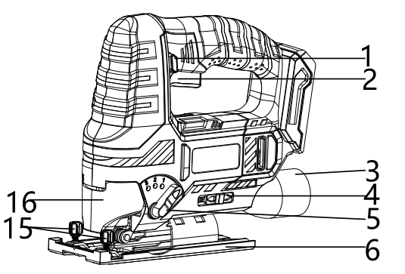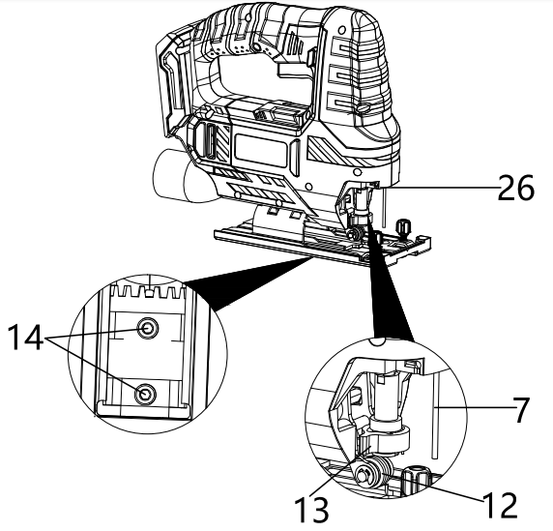**

**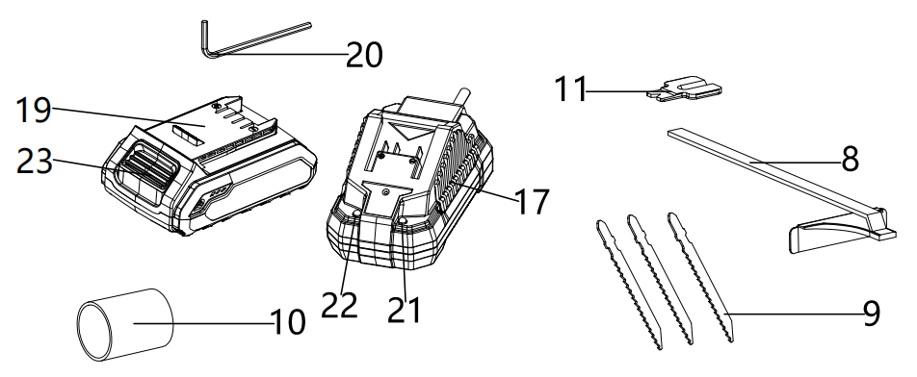**

**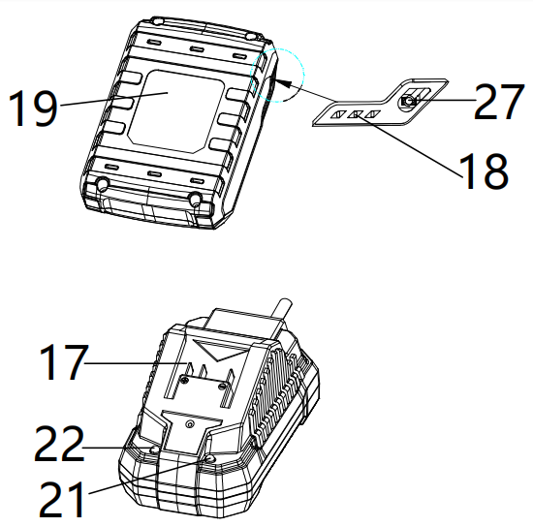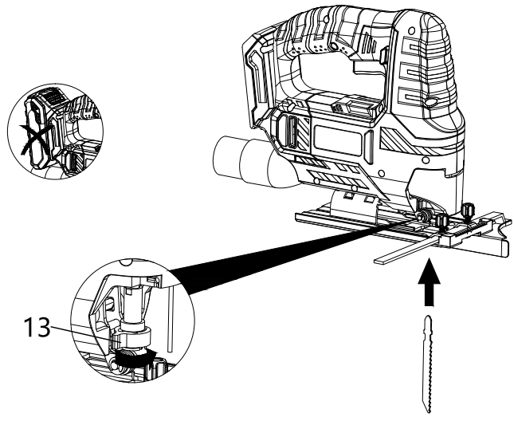**

(Fig. C)

(Fig. B)

**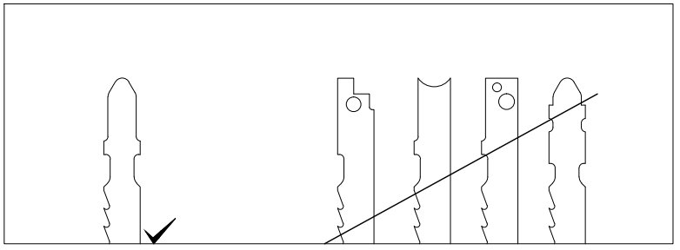**

(Fig. E)

(Fig. F)

**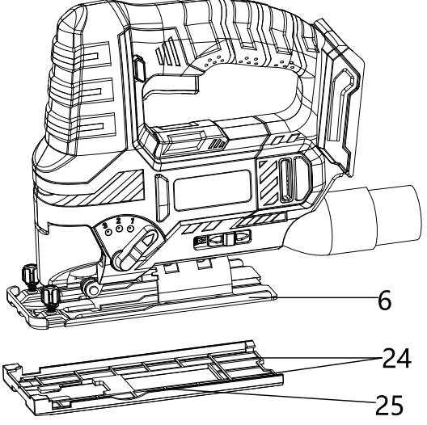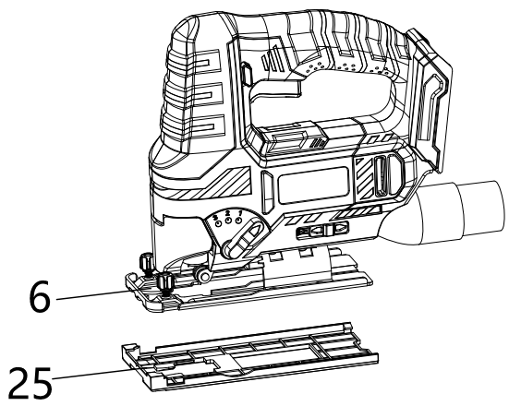**

(Fig. G)

### 

(Fig. I)

### 

(Fig .H)

### Overview (Fig. A)

1. Lock-off button
2. ON/OFF switch
3. Dust extraction connection
4. Splinter blow-off/suction selector switch
5. Pendulum action selector switch
6. Base plate with removable sliding block
7. Protection pin
8. Rip fence
9. Saw blade set
10. Adaptor for dust extraction
11. Anti-splinter guard
12. Guide roller
13. Quick-release chuck
14. Locking screws for base plate
15. Lock screws for rip fence
16. Protection cover
17. Charger
18. Battery level indication (LED)
19. Battery
20. Allen wrench
21. RED Charge control LED
22. GREEN charge control LED
23. Battery release buttons
24. Two fastening clips
25. Sliding block
26. LED work lamp
27. Battery charge level button

### Device Description

The cordless jig saw is suited for varied sawing operations with a quick sawing progress due to the adjustable pendulum action.

The anti-splinter guard ensures tear-free cuts. The pendulum action can be set to 3 levels, or switched off if required.

The saw blades can be exchanged without tools. The base plate can be adjusted with an Allen wrench and allows for cutting angles of 15°, 30° and 45°.

The work area is illuminated by an LED.

The battery comes with its own battery level indication. As a result, you can check the current charging status without having to connect it to the device.

Furthermore, the device is equipped with a fan function for a cutting line without sawdust and with an integrated connection for effective external vacuum cleaner.

**Technical data**

|  |  |
| --- | --- |
| Rated voltage | 20V d.c. |
| Rated no-load speed n0 | 0-2700/min |
| Cutting angle | 0° / 15° / 30° / 45° |
| Max. cutting capacity | Wood 80mm  Steel 5mm  Aluminum 12mm |
| Max. stroke | 20mm |
| Weight (without charger) | 2.15kg |
| **Battery pack** | **CBA20V2A** |
| Type | Li-ion |
| Rated voltage | 20V d.c. |
| Capacity | 2.0Ah (40Wh) |
| **Battery charger** | **CCH20V** |
| Rated input | 230-240V~, 50Hz |
| Rated input Power | 65W |
| Rated output | 21.5V d.c. |
| Charging current | 2.4A |
| Charging time | Approx. 60min |
| Protection class | II |
| **Noise emission value** |  |
| Noise measurement value determined in accordance with EN 62841-2-11 | |
| LPA | 79dB(A) |
| Uncertainty K | 5dB |
| LWA | 90dB(A) |
| Uncertainty K | 5dB |
| **Vibration emission value** |  |
| Vibration value determined in accordance with EN 62841-2-11 | |
| Cutting bore mode: ah,B | 11.4 m/s2 |
| Cutting sheet metal mode: ah,M | 9.3 m/s2 |
| Uncertainty K | 1.5 m/s2 |

* The declared vibration total values and the declared noise emission values have been measured in accordance with a standard test method and may be used for comparing one tool with another.
* The declared vibration total values and the declared noise emission values may also be used in a preliminary assessment of exposure.

**WARNINGS**

* The vibration and noise emissions during actual use of the power tool can differ from the declared values depending on the ways in which the tool is used especially what kind of workpiece is processed; and
* It is necessary to identify safety measures to protect the operator that are based on an estimation of exposure in the actual conditions of use (taking account of all parts of the operating cycle such as the times when the tool is switched off and when it is running idle in addition to the trigger time)

### INTENDED USE

The product is designed for

1. Straight and curved cuts at angular workpieces made of wood, plastic and light metal while keeping base plate contact,
2. Mitre cuts up to an angle of 45° at angular workpieces made of wood, plastic and light metal, whilst adhering to the technical data.

This product is not intended for processing damp wood, glass or stone. And it is not for commercial use. Any other uses or modification to the product are deemed to be improper usage and may result in serious physical injury. The manufacturer accepts no responsibility for damage(s) attributable to misuse. This product is designed for use by adults and not intended for commercial use.

### Unpacking

1. Unpack all parts and lay them on a flat stable surface
2. Make sure the delivery contents are complete and free of damage. If you find that parts are missing or show damage, do not use the product but contact your dealer/service center. Do not use the product unless missing parts have been delivered in addition or defective parts have been replaced. Using an incomplete or damaged product represents a hazard to people and property.
3. Ensure that you have all the accessories and tools needed for assembly and operation.

### Charging the battery pack (Fig. B)

**Note:**

1. **The battery can be damaged in case of improper charging.**
2. **Remove the charger's mains plug before inserting or removing the battery.**

The battery is partially charged upon delivery to avoid damage to the battery caused by a deep discharge. Prior to initial start-up and when the battery is low, the battery should be charged. To do so, please proceed as follows (Fig. B):

1. Slide the battery pack (19) onto the charger (17) upside down till it locks in place.
2. Insert the mains plug of the charger (17) into a properly fused mains socket. The RED charge control LED (21) is illuminated; and charging requires approx. 60min.
3. Wait until the RED charge control LED (21) goes out and green charge control LED (22) is illuminated, the battery is fully charged.
4. Hold onto the mains plug while pulling the power cable of the charger out of the mains socket. The battery pack (19) and the charger (17) may have become warm during charging, allow the battery to cool down to room temperature.
5. Take the battery (19) out of the charger (17) by pressing and holding the battery release button (23) and pulling the battery pack (8) out of the charger (17).

### Removing /Inserting the battery

1. Slide the battery pack (19), place it on a guide track and push it back into the battery holder. It will audibly snap in.
2. Detach the battery pack (19) from the tool, press the battery release button (23) on the battery pack (19) and pull the battery off the tool.

### Checking the battery charging level

The battery comes with an integrated battery level indication.

The battery status is displayed as follows by the three LEDs of the battery level indication (LED) .

|  |  |
| --- | --- |
| **LED color** | **Meaning** |
| Green-Orange-Red | Maximum charge/power |
| Orange-Red | Medium charge / power |
| Red | Weak charge – Recharge the battery |

Press on the battery charge level button (27) on the battery pack (19). You can read the battery status from the battery level indication (LED) (18).

### Changing the saw blade (Fig. C &D)

**WARNING! Risk of injury. Always switch the device off and remove the battery before carrying out any work on the device.**

**Wearing the appropriate protective gloves when inserting or exchanging the saw blade.**

To do so, please proceed as follows:

1. remove the battery pack (19) from the device.
2. Detach the protective cover (16).
3. Turn the quick-release chuck (13) to the side and hold it in this position.
4. If a saw blade is inserted, remove the saw blade from the quick-release chuck.
5. Insert the saw blade into the quick-release chuck. Make sure that the teeth of the saw blade point to the front and that the saw blade is seated in the guide roller (12).
6. Push the saw blade into the quick-release chuck up to the stop. Use a suitable sawblade with single lug shank.
7. Let go of the quick-release chuck. The quick-release chuck must return to its initial position.
8. Check whether the saw blade is properly locked in place.
9. Reattach the protective cover (16).
10. Refit the battery pack (19).

### Mounting / removing the sliding block (Fig. E)

1. To protect the surface of the material to be processed, the sliding block is already preassembled. You may remove the sliding block if required.
2. Remove the battery (19) from the device (see Removing the battery).
3. Release the two fastening clips (24) at the rear.
4. Slowly push the sliding block (25) forward while carefully detaching the front part of the sliding block from the base plate (6).
5. Pull the sliding block (25) downwards carefully.
6. To reattach the sliding block (25), first push it onto the front part of the base plate (6).
7. Then let the fastening clips (24) lock in place at the rear.
8. Check the sliding block (25) for tight fit.
9. Refit the battery (19; see Insert the battery)

### Mounting / removing the anti-splinter guard (Fig. F)

1. The anti-splinter guard serves to avoid tearing of the surface when sawing in wood. The anti-splinter guard can only be used in combination with certain types of saw blades and at a cutting angle of 0°. You may remove it if required, e.g. if you want to make a mitre cut.
2. The anti-splinter guard is already preassembled.
3. Remove the battery (19) from the device (see Removing the battery).
4. First remove the sliding block (see Mounting / removing the sliding block).
5. Remove the anti-splinter guard (11) from the base plate (6) by carefully pushing the anti- splinter guard outwards.
6. To reinsert the anti-splinter guard (11), carefully push it into the recess of the base plate from below until the anti-splinter guard locks in place. When doing so, make sure that the smooth side of the anti-splinter guard points away from the device.
7. Refit the battery (19; see Insert the battery).

### Adjusting the cutting angle

1. The cutting angle can be adjusted to the left or right at angles of 0° / 15° / 30° / 45°.
2. Remove the battery (19) from the device (see Removing the battery).
3. First, remove the anti-splinter guard (11) and the protective cover (16).
4. Loosen the locking screws for base plate (14) at the bottom of the device using the Allen wrench (20).
5. Slide the base plate to the rear until it can be freely rotated.
6. Set the desired cutting angle. The number of degrees to be set is engraved on the base plate.
7. Slide the base plate back to the front until the toothing engages.
8. Tighten the locking screws for base plate (14) at the bottom of the device using the Allen wrench (20).
9. Check the base plate for tight fit.
10. Refit the battery (19; see Insert the battery).

### Mounting the rip fence

The rip fence can be fastened on both sides of the device.

1. Remove the battery (19) from the device (see Removing the battery).

2. Loosen the locking screws for rip fence (15) at the slot.

Make sure not to unscrew the locking screws completely.

3. Slide the rip fence (8) into the slot with the marking pointing up.

4. Move the rip fence (8) into the desired position.

5. Tighten the locking screws for rip fence (15).

6. Refit the battery (19; see Insert the battery).

### Adjusting the pendulum action (Fig.G)

You can adjust the pendulum movement of the saw blade. Levels 1 to 3 allows for a faster work progress and level 0 (pendulum movement off) enables fine and clean cutting edges.

The ideal pendulum level for the respective application can be determined by way of field- testing. Please observe the following instructions:

1. If you want to obtain a fine and clean cutting edge, preferably select a low pendulum level or switch off the pendulum action completely.
2. Switch off the pendulum action when processing thin materials.
3. Work at a low pendulum level when processing hard materials.
4. For soft materials or when sawing wood with the grain you can work with the maximum pendulum level.
5. Set the pendulum action selector switch (5) to the desired level. The higher the level, the larger the pendulum stroke. The pendulum action can also be adjusted during operation.

**OPERATION**

**Tips and notes on handling the jig saw**

### General information

1. Keep the venting slots clear to prevent the motor from overheating.
2. Check the tool in the tool holder for proper fit before every application. The tool must be firmly locked in place in the designated holding fixtures in the tool holder.
3. Before every application, make sure that you have selected the correct tool for the intended use.

### Sawing

1. Only use intact, flawless saw blades. Bent, blunt or otherwise damaged saw blades could break.
2. When sawing lightweight construction materials, make sure to observe the legal regulations and recommendations of the material manufacturers.
3. Before sawing wood, chipboards, building materials etc. with HCS blades, check the above for foreign objects, e.g. nails, screws or similar. If required, remove the foreign objects or use HSS saw blades.
4. Use a narrow saw blade when sawing tight curves.
5. The saw blade should not be longer than required for the intended cut.

### Switching ON and OFF

**Wear your personal protective equipment when working with the device.**

1. Check whether the fixed saw blade, the pendulum action and the cutting angle are suitable for the intended application.

2. Check whether the workpiece is secured and the worktop prepared correspondingly.

3. Position the base plate with removable sliding block (6) on the workpiece.

4. Press the start lock (1) to be able to actuate the on/off switch.

5. Press the on/off switch (2) and hold it during operation.

- The device operates with the previously selected settings.

- The LED work lamp (26) is illuminated.

6. Let go of the on/off switch (2) to stop the device. The LED work lamp (26) goes out.

### Setting the splinter blow-off/suction function (Fig. H)

You can choose whether the splinters shall be blown off towards the front or sucked off with an optionally connectable vacuum cleaner.

1. Make sure that the protective cover (16) is mounted.

2. Slide the blow-off/suction function selector switch (4) to the left to suck the splinters in using an external vacuum cleaner, or to the right to blow the splinters away.

### Connecting the dust extraction system (Fig. I)

You can connect a vacuum cleaner to the device. The adapter included in the scope of delivery allows to connect smaller pipe diameter.

Use a special vacuum cleaner to suck off harmful or toxic materials.

1. If required, attach the adapter for dust extraction (10) to the dust extraction connection (3).

2. For an optimum dust extraction, insert the anti-splinter guard if possible.

3. Connect a suitable vacuum cleaner (e.g. industrial vacuum cleaner) to the dust extraction.

4. Slide the splinter blow-off/suction selector switch (4) to the left to the position for dust extraction.

### CLEANING & MAINTENANCE

**WARNING! Risk of injury. Always switch the device off and remove the battery before carrying out any work on the device.**

1. The device should be cleaned before and after each use.
2. The device does not have to be lubricated after cleaning.
3. Clean the device with a soft, damp and lint-free cloth. Ensure that no moisture enters the housing. Protect electrical components from moisture. Do not use any aggressive cleaning agent such cleaning sprays, solvents, alcohol-based or abrasive cleaners to damped the cloth.
4. Dry the device with a soft, lint-free cloth
5. Dry the saw blades with a soft- lint-free cloth.
6. Remove any dust deposits, and if applicable, wood chips or material residues from the quick-release chuck.
7. Keep the connection terminals on the device and charger clean.
8. Keep the ventilation openings free from dust deposits to prevent overheating of the motor.

### Storage

Before storing the device, observe the following:

1. Switch off the device
2. Hold onto the mains plug while pulling the power cable of the charger out the mains socket.
3. Allow the device to cool down.
4. Remove the battery form the device.
5. Remove the saw blade.
6. Clean the devices as described in the maintenance part.
7. For storing the device, use the transport case included in the scope of the delivery in order to protect the device from external influences.
8. Do not store Li-ion battery with are completely discharged. Storing discharged battery can lead to a deep discharge and thus damage the battery.

### Transport

Use the transport case to transport the device in order to protect the device from external influences.

1. Switch off the device and pull the power cable of the charger out the mains socket.
2. Allow the device to cool down.
3. Remove the battery form the device.
4. Remove the saw blade.
5. Protect the product from any heavy impact or strong vibrations which may occur during transportation in vehicles

### Available accessories

**WARNING! Only use accessories and additional equipment specified in the operating manual. Using insertion tools or accessories other than those specific in the operating manual may cause a risk of injury. Only get the accessories from the Service Centre.**

|  |  |  |
| --- | --- | --- |
| **Spare charger & battery pack for 20V platform** | | |
| Charging time | Battery Pack CBA20V2A 2Ah | Battery Pack CBA20V4 4Ah |
| Charger CCH20V | 60min | 120min |
| All 20V team shares the compatible charger and battery pack of 20V platform. | | |

### TROUBLESHOOTING

**WARNING! Only perform the steps described within these instructions. All further inspection, maintenance and repair work must be performed by an authorized service center or a similarly qualified specialist if you cannot solve the problem yourself. Suspected malfunctions are often due to causes that the users can fix themselves. Therefore check the product using this section. In most cases the problem can be solved quickly**

|  |  |  |
| --- | --- | --- |
| **Problem** | **Possible cause** | **Corrective action** |
| The tool won’t start | Battery discharged | Recharge battery |
| Battery not inserted | Insert battery |
| On/Off switch defective | Send in to Service Centre for repair |
| Battery terminals on dirt | Remove the dirt. |
| The saw blade experiences difficulties penetrating the material to be processed or the sawing performance is insufficient | Saw blade is not firmly locked in the place | Fix the saw blade firmly |
| The pendulum setting is not suitable for the material to be processed | Set the correct pendulum. |
| Saw blade is worn | Replace a new one |
| Wrong saw blade for the processed material. | Choose the correct saw blade. |
| The device becomes hot | Too much pressure on the device when sawing | Reduce the pressure during sawing |
| The saw blade is not suitable for the task to be carried out. | Change to the suitable saw blade. |

**Note: if your device does not operate correctly after these check, please contact the Service Center.**

# CORDLESS Obital Sander

### PRODUCT DESCRIPTION

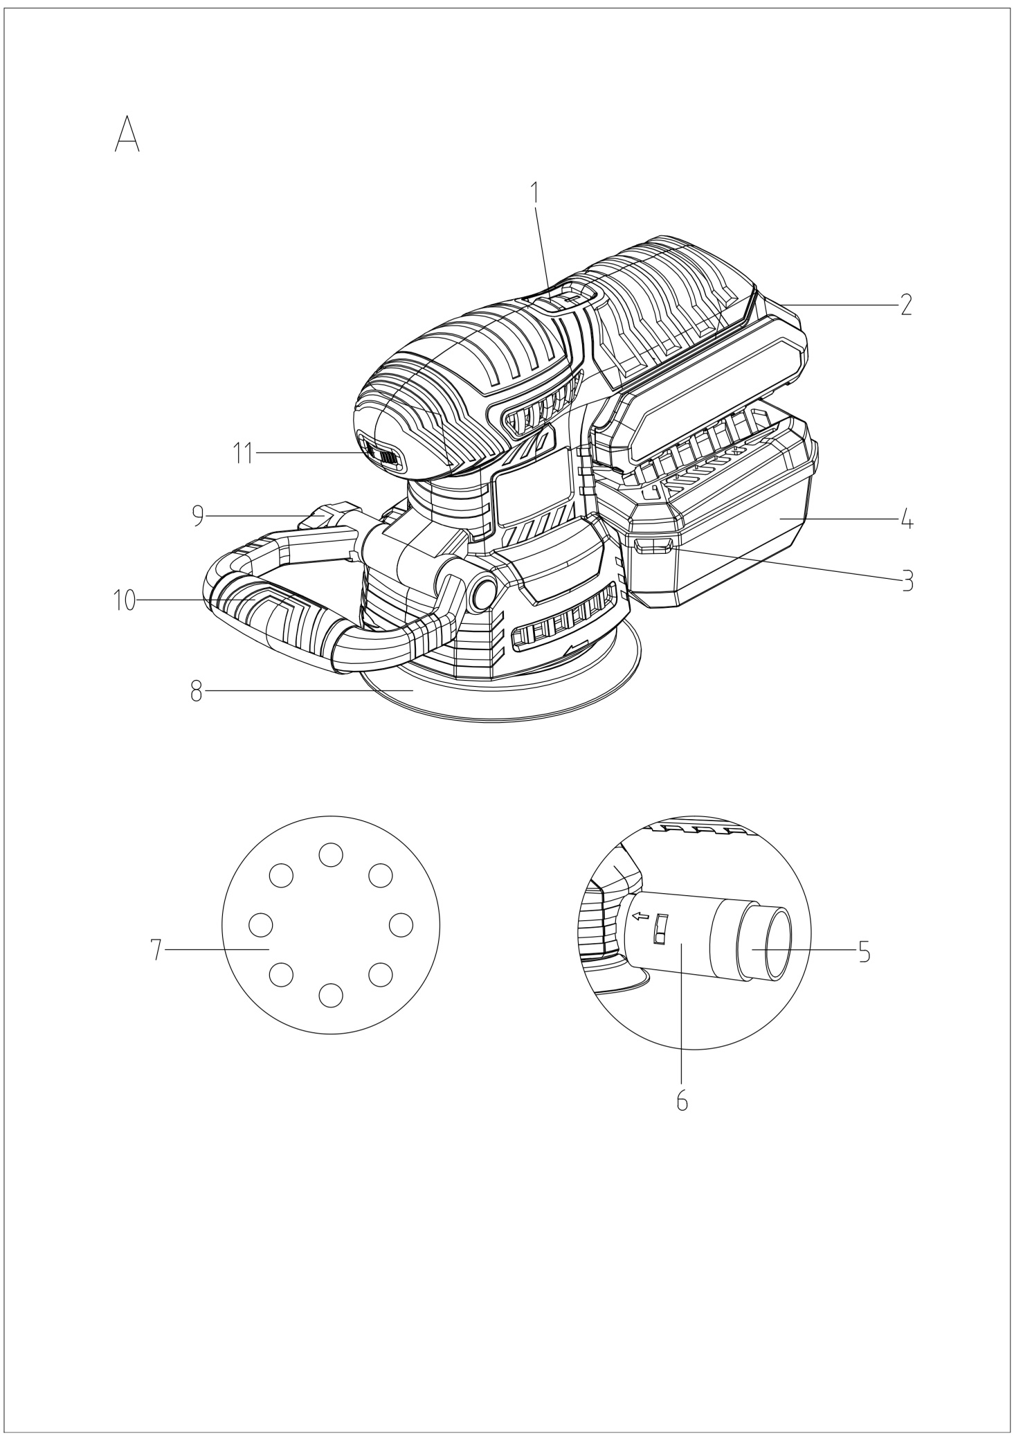

(Fig.A)

**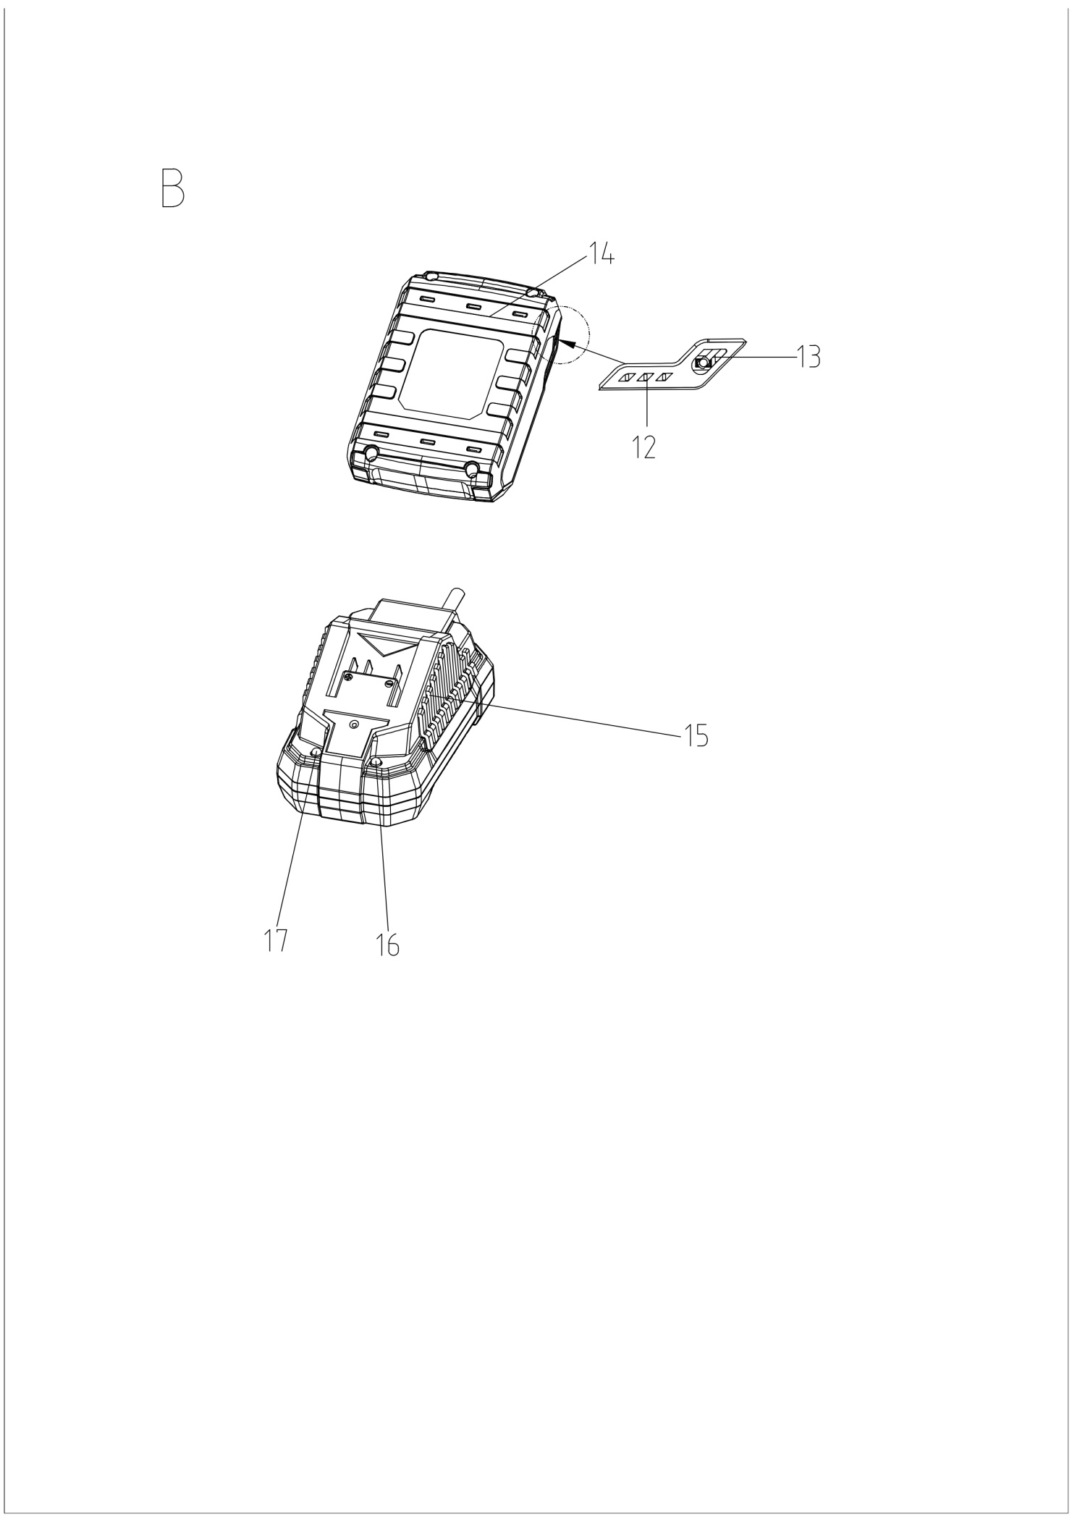**

**Overview (Fig.A)**

1. ON/OFF switch
2. Battery release button
3. Tab on the dust box
4. Dust box
5. Reducer for external extraction appliances
6. Adapter fitting
7. Sanding sheet
8. Sanding plate
9. Screw
10. Additional handle
11. Speed setting wheel
12. Battery level indication (LED)
13. Battery charge level button
14. Battery pack
15. Charger
16. RED Charge control LED
17. GREEN charge control LED

**Introduction**

The operating instructions contain important information on safety, use and disposal. It is essential that you read the instructions before assembling, operation and maintaining the product. Use the product only as described and for the applications specified. Keep this manual safely and in the event that the product is passed on, hand over all documents to the third party.

**Technical data**

|  |  |
| --- | --- |
| Rated voltage | 20V d.c. |
| Rated no-load speed n0 | 3000-12000/min |
| Sanding sheet | Φ125mm |
| Weight (without charger) | 1.7kg |
| **Battery pack** | **CBA20V2A** |
| Type | Li-ion |
| Rated voltage | 20V d.c. |
| Capacity | 2.0Ah (40Wh) |
| **Battery charger** | **CCH20V** |
| Rated input | 230-240V, 50Hz |
| Rated input Power | 65W |
| Rated output | 21.5V d.c. |
| Charging current | 2.4A |
| Charging time | Approx. 60min |
| Protection class | II |
| **Noise emission value** |  |
| Noise measurement value determined in accordance with EN 62841-2-4 | |
| LPA | 86.27dB(A) |
| Uncertainty K | 3dB(A) |
| LWA | 97.27dB(A) |
| Uncertainty K | 3dB(A) |
| **Vibration emission value** |  |
| Vibration value determined in accordance with EN 62841-2-1 | |
| ah,D | 11.8 m/s2 |
| Uncertainty K | 1.5 m/s2 |

* The declared vibration total values and the declared noise emission values have been measured in accordance with a standard test method and may be used for comparing one tool with another.
* The declared vibration total values and the declared noise emission values may also be used in a preliminary assessment of exposure.

**WARNING**

* The vibration and noise emissions during actual use of the power tool can differ from the declared values depending on the ways in which the tool is used especially what kind of workpiece is processed; and
* It is necessary to identify safety measures to protect the operator that are based on an estimation of exposure in the actual conditions of use (taking account of all parts of the operating cycle such as the times when the tool is switched off and when it is running idle in addition to the trigger time)

**INTENDED USE**

This product is suitable for the dry sanding of wood, plastic, metal, filler and also painted surfaces. Any other uses or modification to the product are deemed to be improper usage and may result in serious physical injury. The manufacturer accepts no responsibility for damage(s) attributable to misuse. This product is designed for use by adults and not intended for commercial use.

**Unpacking**

1. Unpack all parts and lay them on a flat stable surface
2. Make sure the delivery contents are complete and free of damage. If you find that parts are missing or show damage, do not use the product but contact your dealer/service centre. Do not use the product unless missing parts have been delivered in addition or defective parts have been replaced. Using an incomplete or damaged product represents a hazard to people and property.
3. Ensure that you have all the accessories and tools needed for assembly and operation.

**Charging the battery pack (Fig. B)**

**Note:**

* **The battery can be damaged in case of improper charging.**
* **Remove the charger's mains plug before inserting or removing the battery.**

The battery is partially charged upon delivery to avoid damage to the battery caused by a deep discharge. Prior to initial start-up and when the battery is low, the battery should be charged. To do so, please proceed as follows (Fig. B):

1. Slide the battery pack (14) onto the charger (15) upside down till it locks in place.
2. Insert the mains plug of the charger (17) into a properly fused mains socket. The RED charge control LED (16) is illuminated; and charging requires approx. 60min.
3. Wait until the RED charge control LED (16) goes out and green charge control LED (17) is illuminated, the battery is fully charged.
4. Hold onto the mains plug while pulling the power cable of the charger out of the mains socket. The battery pack (14) and the charger (15) may have become warm during charging, allow the battery to cool down to room temperature.
5. Take the battery (14) out of the charger (15) by pressing and holding the battery release button (2) and pulling the battery pack (14) out of the charger (15).

**Removing /Inserting the battery**

1. Slide the battery pack (14), place it on a guide track and push it back into the battery holder. It will audibly snap in.
2. Detach the battery pack (14) from the tool, press the battery release button (2) on the battery pack (14) and pull the battery off the tool.

**Checking the battery charging level**

The battery comes with an integrated battery level indication.

The battery status is displayed as follows by the three LEDs of the battery level indication (LED) (12).

|  |  |
| --- | --- |
| **LED color** | **Meaning** |
| Green-Orange-Red | Maximum charge/power |
| Orange-Red | Medium charge / power |
| Red | Weak charge – Recharge the battery |

Press on the battery charge level button (13) on the battery pack (14). You can read the battery status from the battery level indication (LED) (12).

**Selecting a sanding sheet**

**WARNING! Wearing the protective gloves and a dust mask!**

1. the material removal rate and surface quality are determined by the grain strength of the sanding sheet.
2. Please note that you need to use the appropriate sanding sheet with different grains for working different materials.

**Fitting / removing the sanding sheet**

**WARNING! Remove the battery pack before carrying out any work!**

1. You can attach the sanding sheet (7) to the sanding plate using the Velcro.
2. Make sure that the extraction holes on the sanding sheet (7) match up with those on the sanding plate (8).
3. Removing sanding sheets fitted using Velcro.

**Dust extraction**

1. **Dust box**

* Connection: Slide the dust box (4) onto the appliance as far as the stop.
* Removal: pull the dust box (4) off the appliance.

**Note: to achieve optimum dust extraction, the dust box (4) should be emptied regularly.**

1. **Reducer**

* Connecting: push the reducer for external extraction appliance (5) into the adapter fitting (6). And push the hose from a suitable dust extraction appliance (e.g. a workshop vacuum cleaner) onto the reducer for external extraction appliances (5).
* Removal: pull the hose of the vacuum cleaner off the reducer for external extraction appliance (5) and remove it.

**OPERATION**

**NOTE: always switch on the appliance before contact with the material and then apply the tool to the workpiece.**

**Adjusting the additional handle**

You can adjust the additional handle (10) to several different positions.

1. Undo the screw (9) to reposition the additional handle (10).
2. Move the additional handle (10) to the desired position.
3. Retighten the screw (9).

**Switching ON and OFF**

**Warning! Wear your personal protective equipment when working with the device.**

1. Move the ON/OFF switch (1) to the “I” position to switch on the appliance.
2. Move the ON/OFF switch (1) to the “O” position to switch off the appliance.

**Setting the rotational speed**

Adjust the speed setting wheel (11) to a position between 1 and 6 to get the desired rotational speed.

**Working procedure**

1. Switch the appliance on before applying it to the workpiece.
2. Apply minimal pressure when working.
3. Work at a constant speed.
4. Change the sanding sheets regularly.
5. Never use the same sanding sheet for sanding different materials (e.g. wood followed by metal). Optimum sanding results can only be achieved by using clean sanding sheet.
6. Clean the sanding sheet every once in a while using a vacuum cleaner.
7. Sand hard-to-reach places with the front or side edge of the sanding sheet on the sander plate.
8. Guide the sander over the workpiece in parallel and use overlapping sanding motions.
9. After completing the task, lift the appliance from the workpiece and then switch it off.

**CLEANING & MAINTENANCE**

**Warning! Risk of injury. Always switch the appliance off and remove the battery before carrying out any work on the appliance.**

1. Always clean the appliance immediately after completing work.
2. Use a dry cloth to clean the housing.
3. Remove any sanding dust stuck to the appliance with a brush.
4. Never use sharp objects, petrol, solvents or cleaning agents which can damage plastic. Do not allow any liquids to get into the interior of the appliance.

**STORAGE AND TRANSPORTATION**

Before storing /transporting the appliance, observe the following:

1. Switch off the device
2. Hold onto the mains plug while pulling the power cable of the charger out the mains socket.
3. Allow the appliance to cool down.
4. Remove the battery form the device.
5. Remove the sanding sheet.
6. Clean the devices as described in the cleaning & maintenance section.
7. For storing / transporting the appliance, use the transport case included in the scope of the delivery in order to protect the device from external influences.
8. Do not store Li-ion battery with are completely discharged. Storing discharged battery can lead to a deep discharge and thus damage the battery.
9. Protect the product from any heavy impact or strong vibrations which may occur during transportation in vehicles

**Available accessories**

**Warning! Only use accessories and additional equipment specified in the operating manual. Using insertion tools or accessories other than those specific in the operating manual may cause a risk of injury. Only get the accessories from the Service Centre.**

|  |  |  |
| --- | --- | --- |
| **Spare charger & battery pack for 20V platform** | | |
| Charging time | Battery Pack CBA20V2A 2Ah | Battery Pack CBA20V4 4Ah |
| Charger CCH20V | 60min | 120min |
| All 20V team shares the compatible charger and battery pack of 20V platform. | | |

# 

**TROUBLESHOOTING**

**Warning! Only perform the steps described within these instructions. All further inspection, maintenance and repair work must be performed by an authorized service center or a similarly qualified specialist if you cannot solve the problem yourself. Suspected malfunctions are often due to causes that the users can fix themselves. Therefore, check the product using this section. In most cases the problem can be solved quickly**

|  |  |  |
| --- | --- | --- |
| **Problem** | **Possible cause** | **Corrective action** |
| The tool won’t start | Battery discharged | Recharge battery |
| Battery not inserted | Insert battery |
| On/Off switch defective | Send in to Service Centre for repair |
| Battery terminals on dirt | Remove the dirt. |
| The sanding performance is insufficient | The sanding sheet is not suitable | Change to a suitable sanding sheet |
| The sanding sheet is worn out | Changing a new sanding sheet. |
| The sander becomes hot | too much pressure on the device when sawing | Reduce the pressure during sanding |

Note: if your device does not operate correctly after these check, please contact the Service Center.

# DISPOSAL

**WASTE BIN EN50419**To help the environment, please dispose of the product properly when it has reached the end of its useful life and not in the household waste. Information on collection points and their opening hours can be obtained from your local authority

**Environmental damage through incorrect disposal of the batteries / rechargeable batteries.**

Remove the battery pack from the product before disposal. Batteries /rechargeable batteries may not be disposed of with the usual domestic waste. They may contain toxic heavy metals and are subject to hazardous waste treatment rules and regulations. Please dispose of batteries according to the relevant local requirements.

# DECLARATION OF CONFORMITY

# 

**Carrefour Marchandises Internationales**

**93, avenue de Paris**

**91342 Massy**

**France**

Herewith we declare that the product

Cordless tools pack(drill, jigsaw & sander)

Model number: CKIT3(DY97426)

S/N: 20220626218-20220629217

Is in conformity with the following European Directives

2006/42/EC

2014/30/EU

2014/35/UE

2011/65/EU & (EU) 2015/863

And the harmonized standards

EN 62841-1:2015

EN 62841-2-1: 2018+A11:2019 (FOR DRILL)

EN 62841-2-11: 2016+A1:2020(FOR DRILL SAW)

EN 62841-2-4: 2014(FOR SANDER)

EN 55014-1:2017+A11:2020

EN 55014-2:2015

EN IEC 61000-3-2:2019

EN 61000-3-3:2013+A1:2019

EN 60335-1:2012+A11:2014+A13:2017+A1:2019+A14:2019+A2:2019

EN 60335-2-29: 2004+A2:2010+A11:2018

EN 62233:2008

Manufacturer and name of the authorised representative of the technical documentation

Signature

Place and date:

# 

# WARRANTY

The manufacturer guarantees the product against defects in material and workmanship for a period of 2 years from the date of the original purchase. It can be extended by one year if the user subscribes to website of myswap. The warranty only applies if the product is for household use. The warranty does not cover breakdowns due to normal wear and tear.

The manufacturer agrees to replace parts identified as defective by the designated distributor. The manufacturer does not accept responsibility for the replacement of the machine, in whole or in part, and/or ensuing damage.

**The warranty does not cover breakdowns due to:**

1. insufficient maintenance.
2. abnormal assembly, adjustment or operations of the product.
3. parts subject to normal wear and tear.

**The warranty does not extend to:**

1. shipping and packaging costs.
2. using the tool for a purpose other than that for which it was designed.
3. the use and maintenance of the machine done in a manner not described in the user manual.

Due to our policy of continuous product improvement, we reserve the right to alter or change specifications without notice. Consequently, the product may be different from the information contained therein, but a modification will be undertaken without notice if it is recognized as an improvement of the preceding characteristic.

**READ THE MANUAL CAREFULLY BEFORE USING THE MACHINE.**

When ordering spare parts, please indicate the part number or code, you can find this in the spare parts list in this manual. Keep the purchase receipt; without it, the warranty is invalid. To help you with your product, we invite you to contact us by phone or via our website:

1. **+33 (0)9.70.75.30.30**
2. **https://services.swap-europe.com/contact**

You must create a "ticket" via the web platform.

1. Register or create your account.
2. Indicate the reference of the tool.
3. Choose the subject of your request.
4. Describe your problem.
5. Attach these files: invoice or sales receipt, photo of the identification plate (serial number), photo of the part you need (for example: pins on the transformer plug which are broken).

# PRODUCT FAILURE

**WHAT TO DO IF MY MACHINE BREAKS DOWN?**

**If you bought your product in a store:**

* Make sure that your machine is complete with all accessories supplied, and clean! If this is not the case, the repairer will refuse the machine.
* Go to the store with the complete machine and with the receipt or invoice.

**If you bought your product on a website:**

* Make sure that your machine is complete with all accessories supplied, and clean! If this is not the case, the repairer will refuse the machine.
* Create a SWAP-Europe service ticket on the site: https://services.swap-europe.com When making the request on SWAP-Europe, you must attach the invoice and the photo of the nameplate (serial number).

Contact the repair station to make sure it is available before dropping off the machine.

Go to the repair station with the complete machine packed, accompanied by the purchase invoice and the station support sheet downloadable after the service request is completed on the SWAP-Europe site

**Please keep your original packaging to allow for after-sales service returns or pack your machine with a similar cardboard box of the same dimensions.**

**For any question concerning our after-sales service you can make a request on our website https://services.swap-europe.com**

**Our hotline remains available at +33 (9) 70 75 30 30.**

****

# WARRANTY EXCLUSIONS

**THE WARRANTY DOES NOT COVER:**

* Start-up and setting up of the product.
* Damage resulting from normal wear and tear of the product.
* Damage resulting from improper use of the product.
* Damage resulting from assembly or start-up not in accordance with the user manual.
* Breakdowns related to carburetion beyond 90 days and fouling of carburetors.
* Periodic and standard maintenance events.
* Actions of modification and dismantling that directly void the warranty.
* Products whose original authentication marking (brand, serial number) has been degraded, altered or withdrawn.
* Replacement of consumables.
* The use of non-original parts.
* Breakage of parts following impacts or projections.
* Accessories breakdowns.
* Defects and their consequences linked to any external cause.
* Loss of components and loss due to insufficient screwing.
* Cutting components and any damage related to the loosening of parts.
* Overload or overheating.
* Poor power supply quality: faulty voltage, voltage error, etc.
* Damages resulting from the deprivation of enjoyment of the product during the time necessary for repairs and more generally the costs related to the immobilization of the product.
* The costs of a second opinion established by a third party following an estimate by a SWAP-Europe repair station
* The use of a product which would show a defect or a breakage which was not the subject of an immediate report and/or repair with the services of SWAP-Europe.
* Deterioration linked to transport and storage**\***.
* Launchers beyond 90 days.
* Oil, petrol, grease.
* Damages related to the use of non-compliant fuels or lubricants.

**\*** In accordance with transport legislation, damage related to transport must be declared to carriers within 48 hours maximum after observation by registered letter with acknowledgement of receipt.

This document is a supplement to your notice, a non-exhaustive list.

**Attention:** all orders must be checked in the presence of the delivery person. In case of refusal by the delivery person, it you must simply refuse the delivery and notify your refusal.

**Reminder:** the reserves do not exclude the notification by registered letter with acknowledgement within 72 hours.

**Information:**

Thermal devices must be wintered each season (service available on the SWAP-Europe site). Batteries must be charged before being stored.

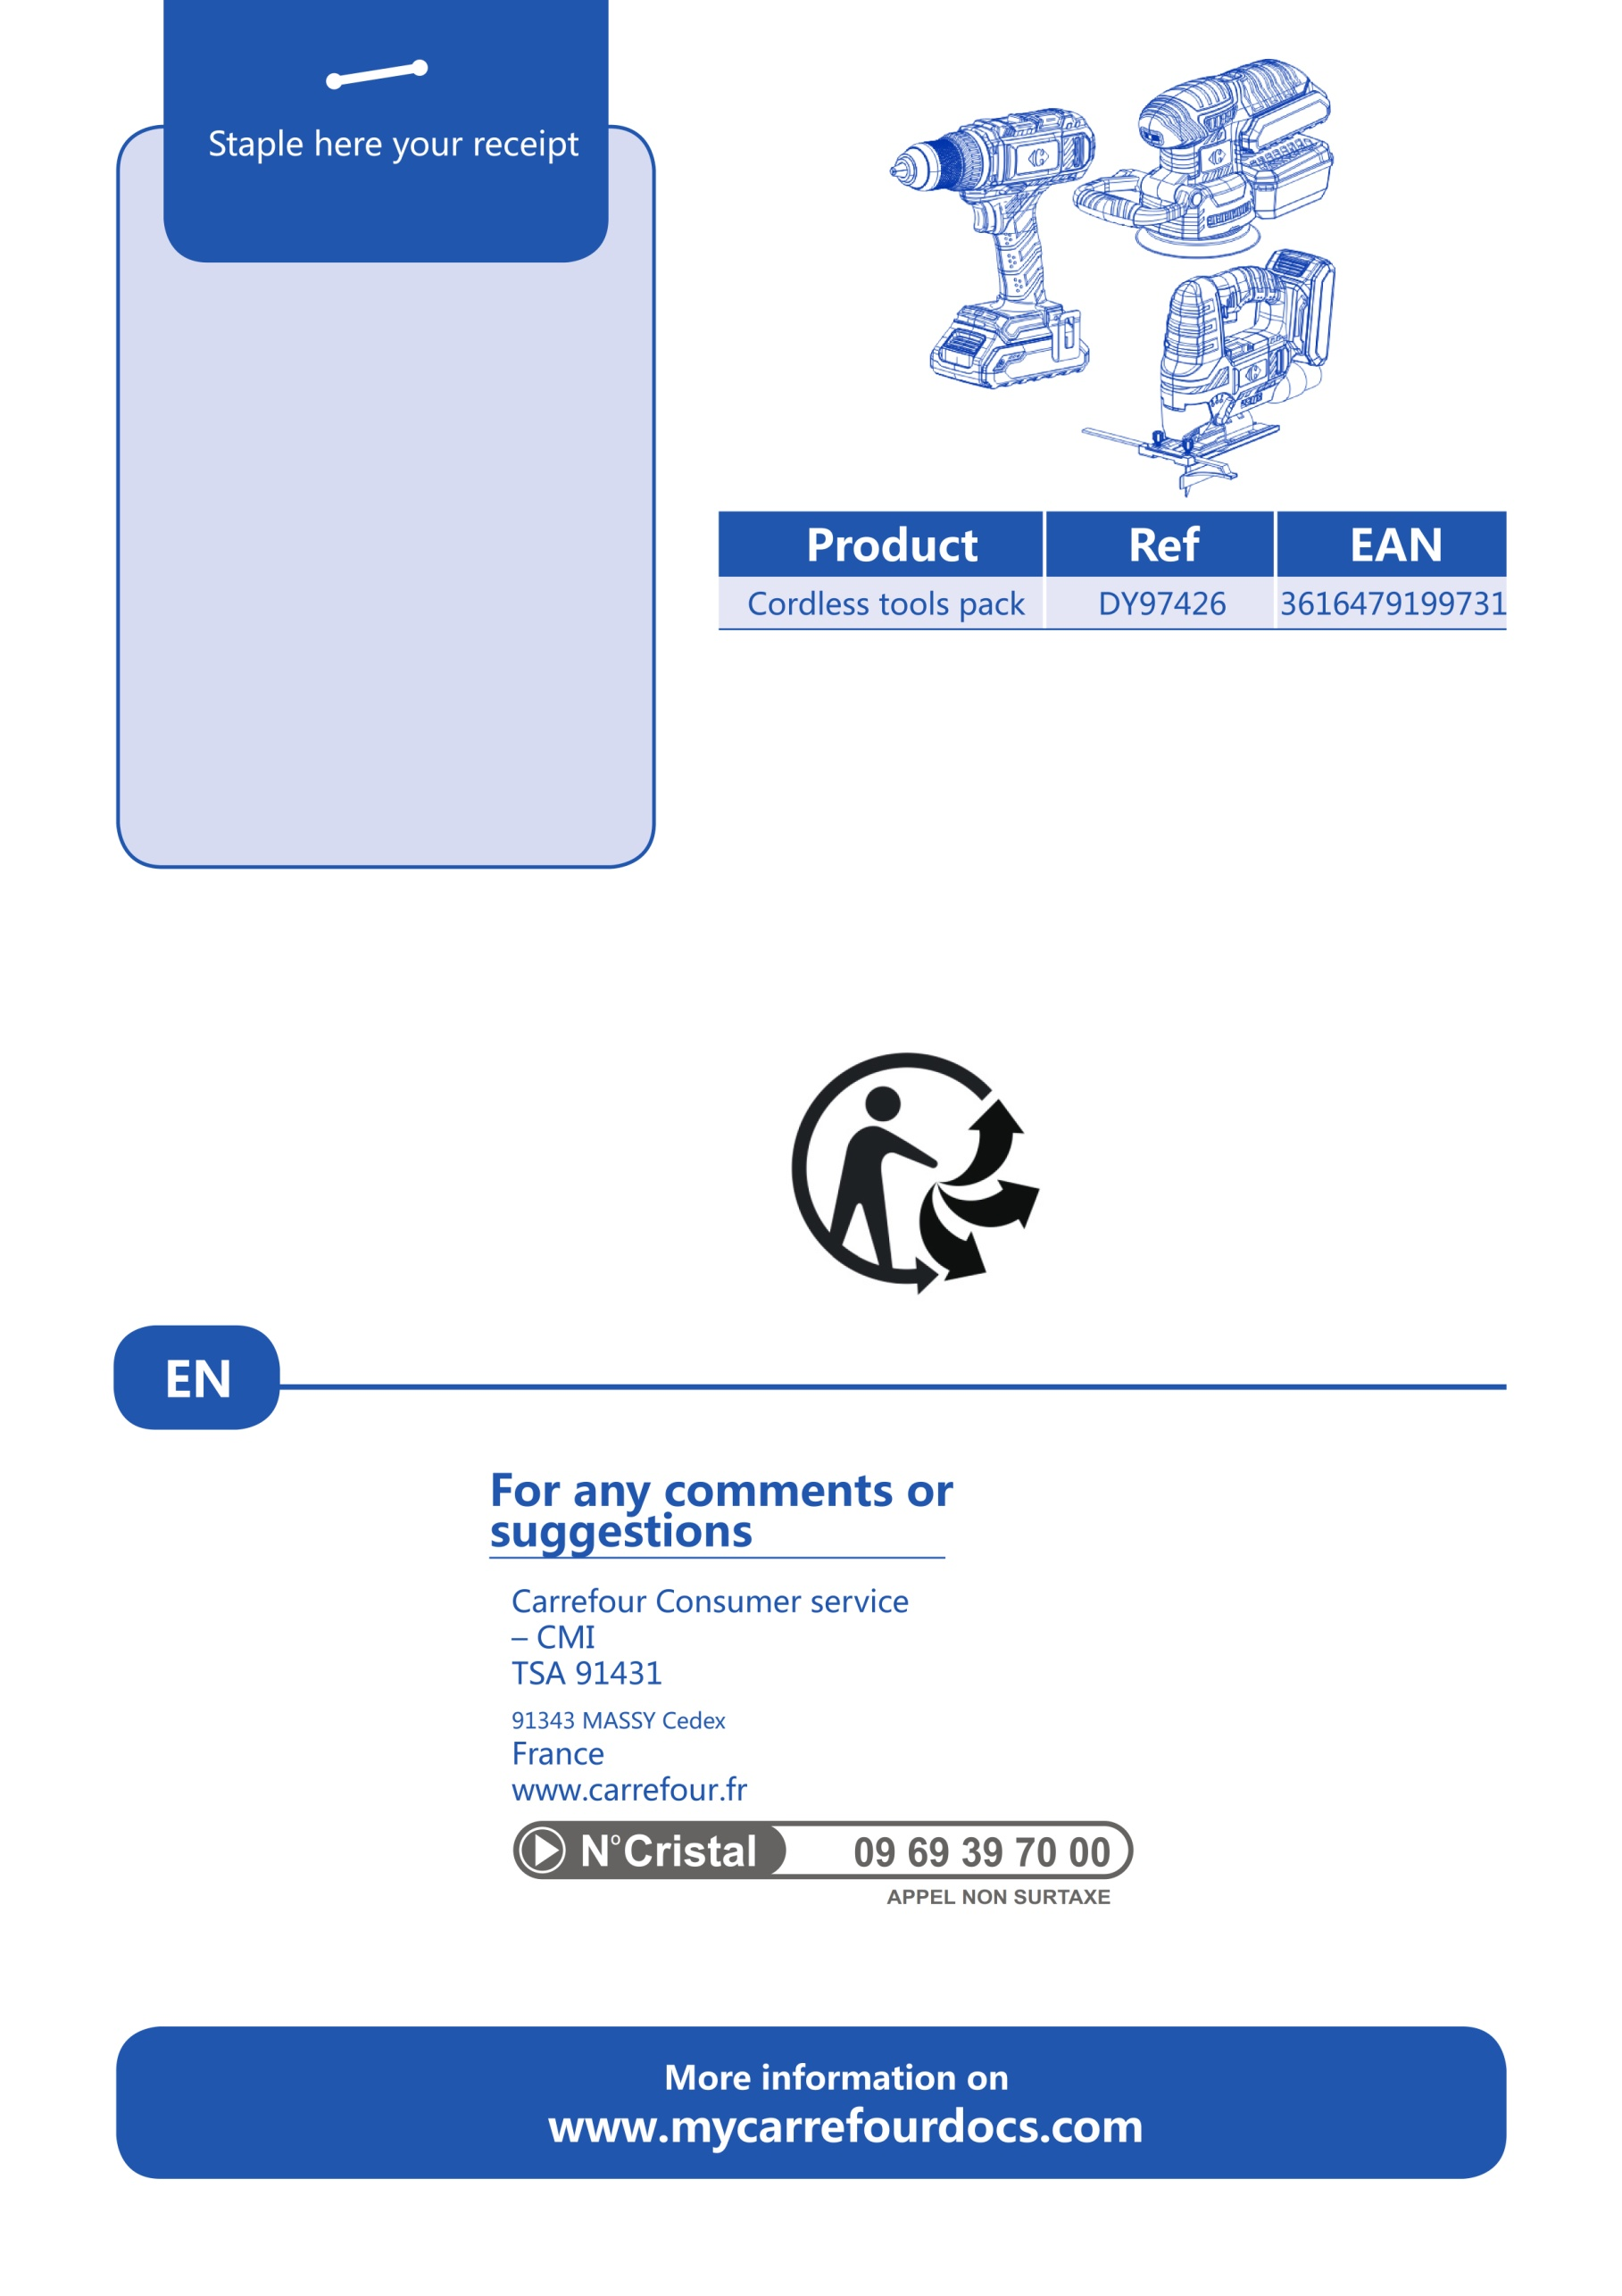

**(DY94273)**

.