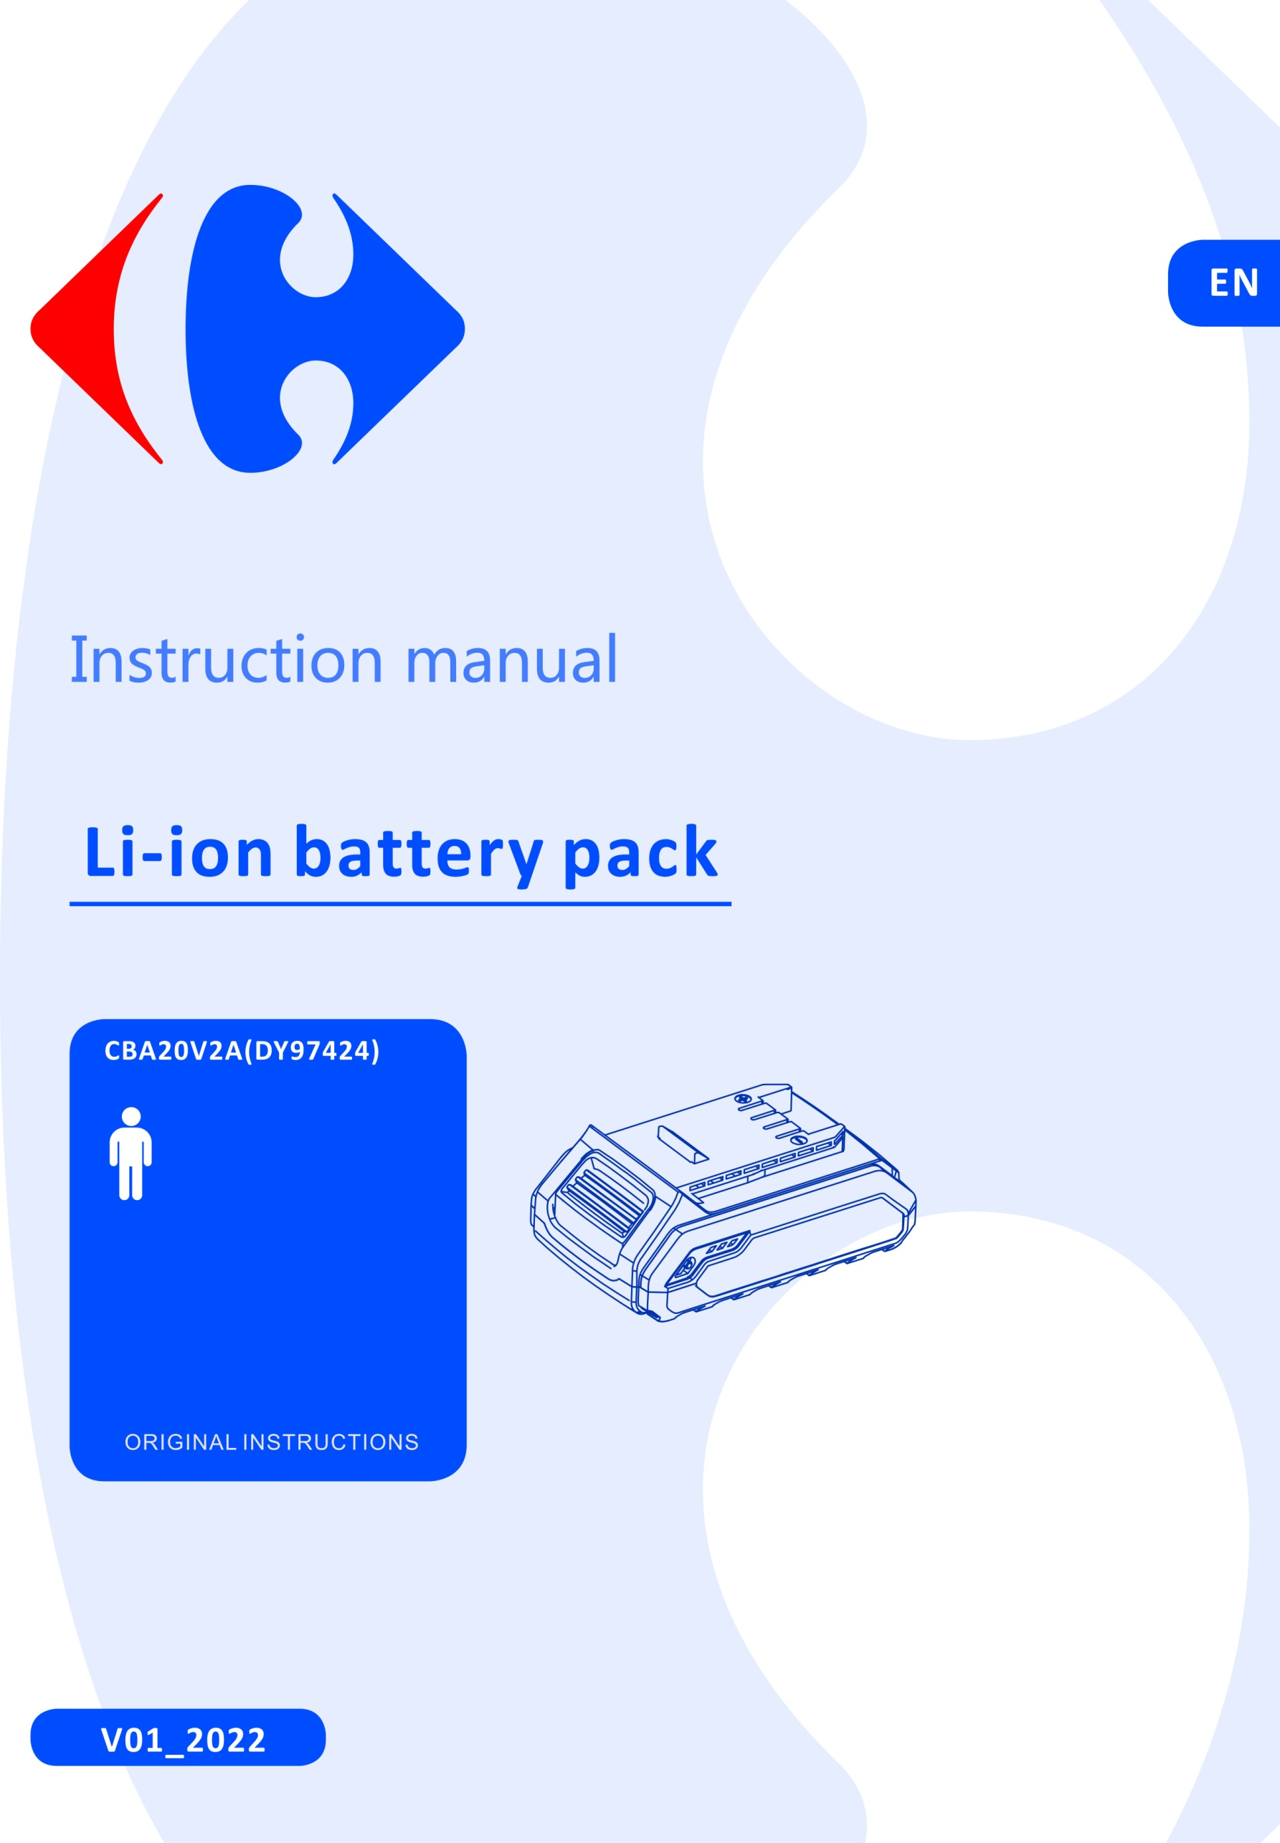



Congratulation on your purchase.
The quality team at CARREFOUR cares for its products to meet conformity and performances.
Paying close attention to your satisfaction, our experts work all day on the improvement of our products.


For a better use of your new device, we recommend you to read carefully this Instruction Manual and keep it for record.
Keep it carefully for future reference.
Please also find information about the scraping of the product in this Instruction Manual.



Before installing or using the product, please read carefully the safety measures after the
summary.
Pictograms used

 | Warning symbols with information on damage and injury prevention.
 | Read the operation instructions carefully.
 | Read and understand all instructions before operating the product. Follow all warnings and safety instructions.
 | Electrical products must not be disposed of with the domestic waste.
 | Protect the rechargeable battery from sunlight and heat (max.50ºC) .
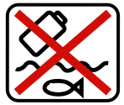 | Protect the rechargeable battery from water and moisture.
 | Protect the rechargeable battery from fire.
CONTENTS
SAFETY INSTRUCTIONS 3
TECHNICAL DATA 4
USE.. 4
MAINTENANCE & STORAGE 5
DISPOSAL 5
CARREFOUR 20V RANGE 5

SAFETY INSTRUCTIONS
- The battery pack is only used on Carrefour serial cordless power tools.
- Recharge only with the charger specified by the manufacturer. A charger that is suitable for one type of battery pack may create a risk of fire when used with another battery pack.
- The battery is not used in any other equipment/appliances or for purposes not mentioned in the manual. Incorrect use can result in a deterioration of battery performance and damage to the equipment /appliances. In certain cases, incorrect use causes abnormal current flow, electrolyte leakage, overheating of a cell or battery, bursting or fire.
- Charging temperature is between 4ºC to 40ºC
- Discharging temperature is from -15ºC to 60ºC
- Storage temperature is between 0ºC to 50ºC at a moderate humidity in a non-corrosive atmosphere. Direct sunlight should be avoided.
- Remove the battery from the device before store.
- Recharge the batteries indoors only because the battery charger is designed for indoor use only. Risk of electric shock.
- Do not subject the battery to strong sunlight over long periods and do not leave it on a heater. Heat damages the battery and this is risk of explosion.
- Allow a hot battery to cool before charging.
- Do not open up the battery and avoid mechanical damage to the battery. Risk of short circuit and fumes may be emitted that irritate the respiratory tract. Ensure fresh air and seek medical assistance in the event of discomfort.
- Do not use non-rechargeable battery.
- Electrolyte leaking from the cells can cause damage to the skin, clothes or any other items exposed to it. If the electrolyte contacts the skin or clothes, wash thoroughly with clean water. If the electrolyte enters into the eyes, do not rub the eyes but flush them immediately with coplous amount of clean water such as tap water, and immediately consult a doctor.
- Do not disassembled or modified the battery, can cause short-circuiting between cells or between the cell and its wiring, and disables the battery’s safety protection system. These can lead to electrolyte leakage, overheating or a cell or battery, bursting and fire.
- Avoid casual or inadvertent shorting of a battery with metallic objects such as : wire, tools, neckless or hairpins, which can cause short-circuiting, which cause excess current flow, electrolyte leakage, heating of cells or batteries, bursting and fire.
- Keep battery away from a fire or heated. The insulation materials will melt and the gas release vent and protection system will be damaged, causing electrolyte leakage, bursting and possibly fire.
- Not allow the battery to contact with water or gets wet, it may short-circuit, overheat, rust or lose its functions.
- Do not expose the battery to mechanical shock, for example, by dropping, throwing or crushing, causing electrolyte leakage, cell and battery heating, bursting and fire.
- Avoid direct connection to electric source such as a car lighter socket, or car battery, may cause excess current to flow at high voltage and can cause electrolyte leakage, overheating of a cell or battery, bursting and fire.
Techncial data
Battery pack | CBA20V2A
Type | Li-ion
Rated voltage | 20V d.c.
Capacity | 2.0Ah (40Wh)

USE
Charging the battery pack (Fig. A)
- The battery can be damaged in case of improper charging.
- Remove the charger's mains plug before inserting or removing the battery.
- This battery can be charged by Carrefour charger CCH20V
- Note: The battery is partially charged upon delivery to avoid damage to the battery caused by a deep discharge. Prior to initial start-up and when the battery is low, the battery should be charged. To do so, please proceed as follows:
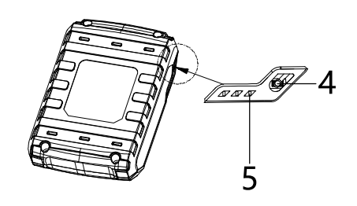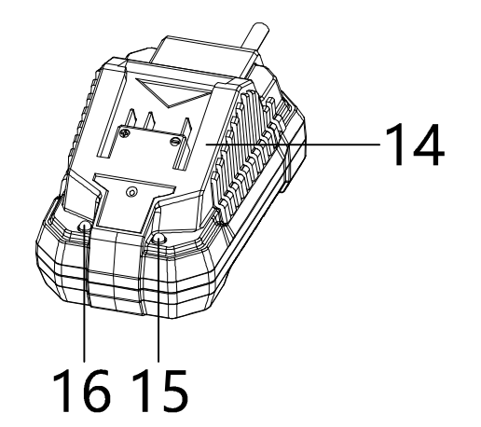
6
5
Fig. A
4 3
2
1
- Slide the battery pack (1) onto the charger (2) upside down till it locks in place.
- Insert the mains plug of the charger into a properly fused mains socket(230-240V~). The RED charge control LED (3) is illuminated; and charging requires approx. 120min.
- Wait until the RED charge control LED (3) goes out and green charge control LED (4) is illuminated, the battery is fully charged.
- Hold onto the mains plug while pulling the power cable of the charger out of the mains socket. The battery pack (1) and the charger (2) may have become warm during charging, allow the battery to cool down to room temperature.
- Take the battery (1) out of the charger (2) by pulling the battery pack (1) out of the charger (2).
Checking the battery charging level
The battery comes with an integrated battery level indication.
The battery status is displayed as follows by the three LEDs of the battery level indication (LED) (5).
LED color | Meaning
Green-Orange-Red | Maximum charge/power
Orange-Red | Medium charge / power
Red | Weak charge – Recharge the battery
Press on the battery charge level button (6) on the battery pack (1). You can read the battery status from the battery level indication (LED) (5).

MAINTENANCE & STORAGE
MAINTENANCE
The battery has been designed to provide maximum trouble-free life. However, like all batteries, they will
eventually wear out. DO NOT disassemble battery pack and attempt to replace the batteries. Handling of
these batteries, especially when wearing rings and jewelry, could result in serious burns.
To obtain the longest possible battery life, remove the battery pack from the charger once it is fully charged and ready for use.
STORAGE
Store the battery pack where the temperature is below 27°C.
Store battery packs in a «charged» condition (minimum of 30%-50% charged).
To charge the battery pack after a six months storage period, it is recommended to discharge the battery about 0%-20% (by running it in a tool) and charge afterwards to maximize the battery lifetime.

DISPOSAL

To help the environment, please dispose of the product properly when it has reached the end of its useful life and not in the household waste. Information on collection points and their opening hours can be obtained from your local authority
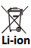
Environmental damage through incorrect disposal of the batteries / rechargeable batteries.
Remove the battery pack from the product before disposal. Batteries /rechargeable batteries may not be disposed of with the usual domestic waste. They may contain toxic heavy metals and are subject to hazardous waste treatment rules and regulations. Please dispose of batteries according to the relevant local requirements

Carrefour 20V range
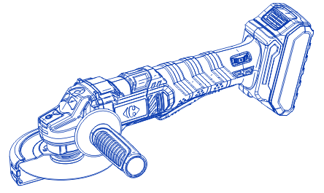 | 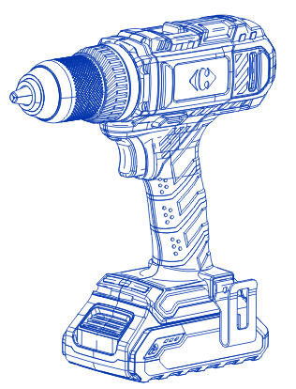 | 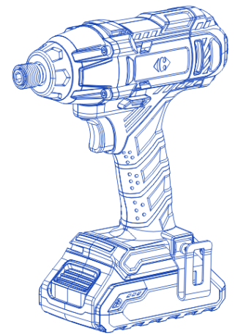
Cordless Angle Grinder | Cordless Drill | Cordless Impact Screwdriver
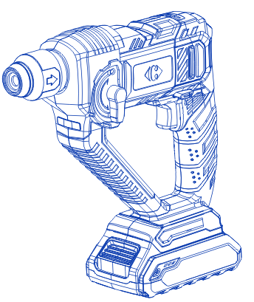 | 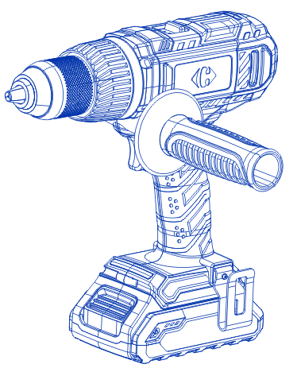 | 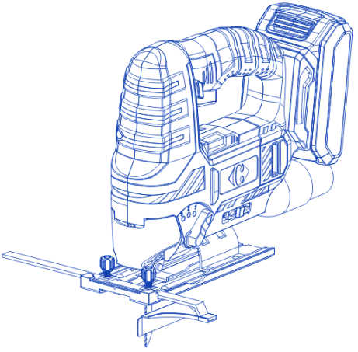
Cordless Rotary Hammer | Cordless Impact Drill | Cordless Jig Saw
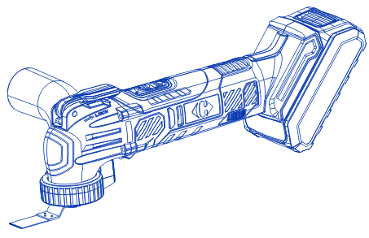 | 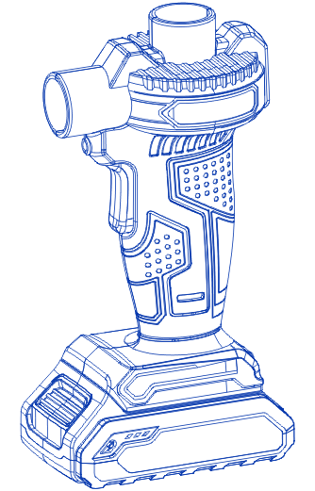 | 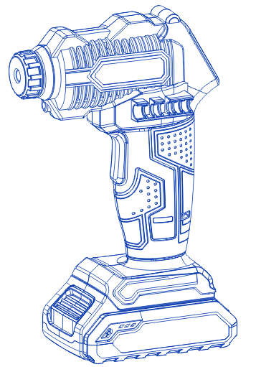
Cordless Multi- Function Tool | Cordless Air pump | Cordless compressor
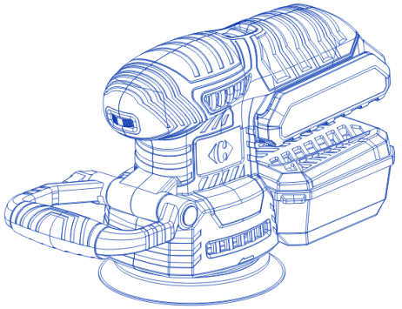 | 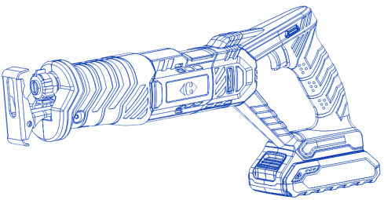 | 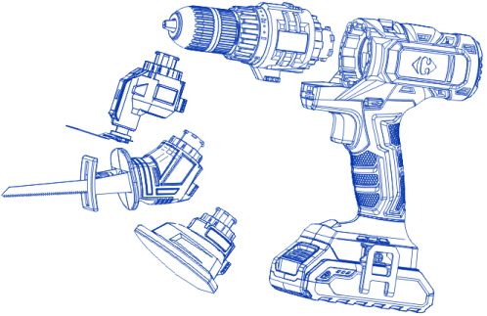
Cordless Obital Sander | Cordless Reciprocating Saw | Cordless multifunction drill
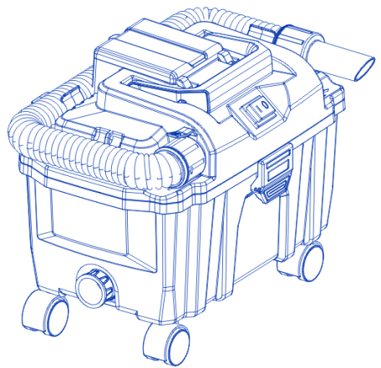 | 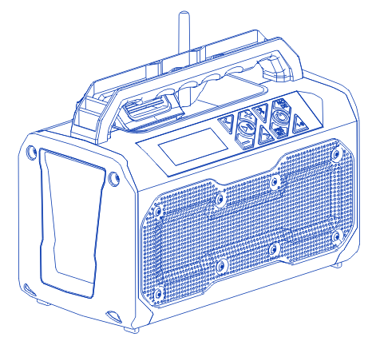 | More  coming soon…
Cordless Wet and dry vacuum | CCBS20V(DY97428)

