USER MANUAL Gas Shredder
Benutzerhandbuch Gasschneider

IMPORTANT
It is vital that you retain and thoroughly read and understand these safety and operating instructions. Incorrect use will make this machine inoperable.
WICHTIG
Es ist sehr wichtig, dass Sie dieses Benutzerhandbuch aufheben, aufmerksam lesen und die darin
enthaltenen Sicherheits- und Gebrauchshinweise verstehen. Unsachgemäßer Gebrauch kann dieses
MODEL NO/MODELLNUMMER.6& 6*

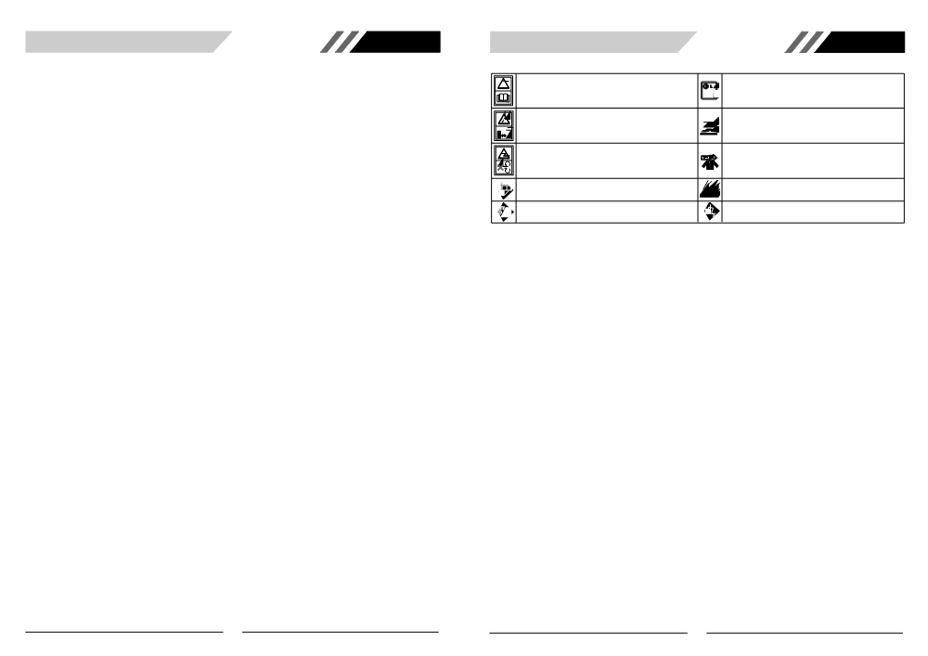

TABLE OF CONTENTS GB GENERAL SAFETY RULES GB

GENERAL SAFETY RULES . . . . .2 Meaning of symbols marked on the product

• Operation
• Maintenance and storage
SPECIFICATIONS .3

Read the user manual before using the machine

Acoustic power level LWA accordance with directive
110 2000/14/EC+2005/88/EC

GENERAL INFORMATION . . .
ASSEMBLY INSTRUCTIONS . . .
• Hopper installation
• Move the shredder
BEFORE STARTING ENGINE . . .
• Oil
• Fuel
OPERATING INSTRUCTIONS . . .
• Before starting engine
• To start engine
. . .4
. .5 Keep bystanders away

Danger-Rotating blades. Keep hands
.6 openings while machine is running.

Were eye and ear protection
.7
Wear gloves to protect your hands
Do not touch a hot silencer or cylinder. You may get
burned. These parts get extremely hot from operation.
When turned off they remain hot for a short time.

and feet out of Petrol engines emit carbon monoxide. DO NOT run in
enclosed area

Petrol is flammable. Allow engine to cool for at least 2
minutes before refueling

Wear safety boots to protect your feet

• Warm engine start
• To stop engine
• Top hopper-front cut
• Top hopper-back chute
WARNING! When using gas tools, basic safety precautions, including the following, should always be followed to
reduce the risk of serious personal injury and/or damage to the unit.
Read all these instructions before operating this product and save these instructions.

• Material push stick
MAINTENANCE INSTRUCTIONS . . . .8
• Blade maintenance
• Change oil
• Air cleaner maintenance
• Spark Plug
• Combustion deposits
• Muffler
• Transporting and storage
TROUBLE SHOOTING THE ENGINE . . . .11
EU DECLARATION OF CONFORMITY . . . . . .12

1
1. Become familiar with the owner's manual before
attempting to operate this equipment.
2. Do not allow children to operate this equipment;
3. Do not operate this equipment in the vicinity of
bystanders;
4. Do not run engine powered machines in an enclosed
area since the exhaust from an engine contains car-
bon monoxide, which is colourless, odourless, and
tasteless; carbon monoxide can be extremely dan-
gerous in enclosed areas;
5. Wear ear protection and safety glasses at all times
while operating the machine;
6. Avoid wearing clothing that is loose fitting or that has
hanging cords or ties;
7. Only operate the machine in open space (e.g. not
close to a wall or other fixed object) and on a firm,
level surface;
8. Do not operate the machine on a paved or gravel sur-
face where ejected material could cause injury;
9. Before starting the machine, check that all screws,
nuts, bolts, and other fasteners are properly secured
and that guards and screens are in place. Replace
damaged or unreadable labels;
10. Use extra care in handling fuels. They are flammable
and the vapours are explosive. The following points
should be observed:
- use only an approved container;
- Never remove the fuel cap or add fuel with the
power source running. Allow engine and exhaust
components to cool before refuelling;
- do not smoke;
- never refuel the machine indoors;
- store the machine or fuel container inside where
there is an open flame, such as a water heater;
- fuel is spilled, do not attempt to start the power
source, but move the machine away from the area of
spillage before starting;
- always replace and securely tighten the fuel cap
after refuelling;
- if the fuel tank is drained, this should be done out-
doors.
11. Shut-off the power unit before attaching or removing
the bag.
• OPERATION
1. Before starting the machine, look into the feeding
chamber to make certain that it is empty;
2. Keep your face and body away from the feed intake
opening;
3. Do not allow hands or any other part of the body or
clothing inside the feeding chamber, discharge chute,
or near any moving part;
4. Keep proper balance and footing at all times. Do not
overreach. Never stand at a higher level than the
base of the machine when feeding material into it;
5. Always stand clear of the discharge zone when oper-
ating this machine;
6. When feeding material into the machine be extreme-
ly careful that pieces of metal, rocks, bottles, cans or
other foreign objects are not included;
7. If the cutting mechanism strikes any foreign objects
or if the machine should start making any unusual
noise or vibration, shut off the power source and
allow the machine to stop. Disconnect the spark plug
wire from the spark plug (electric unit disconnect from
supply) and take the following steps:
- inspect for damage;
- check for and tighten any loose parts ;
- have any damaged parts replaced or repaired with
parts having equivalent specifications.
2

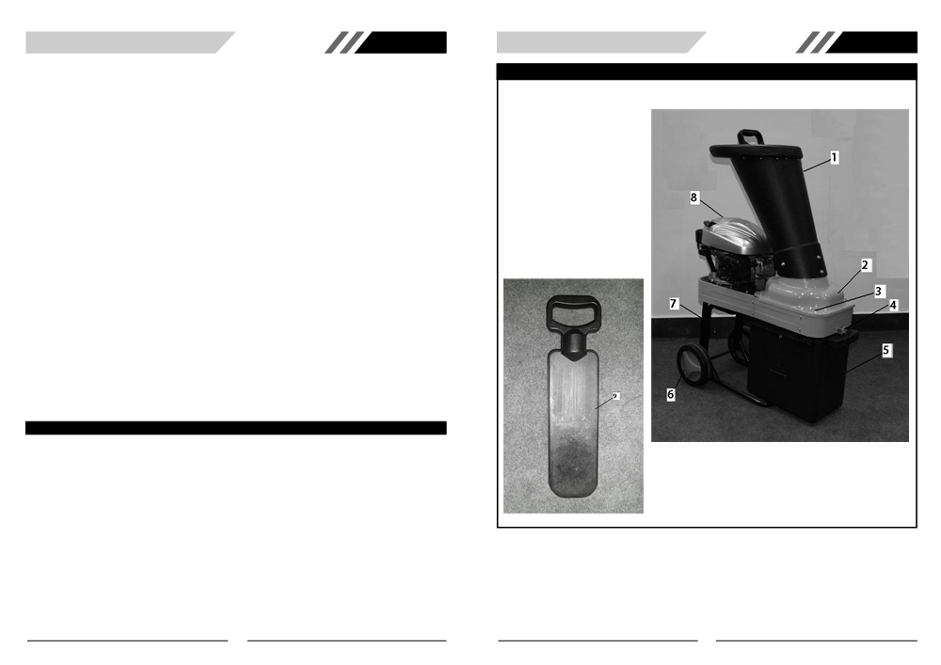

GB GB

8. Do not allow processed material to build up in the dis- • MAINTENANCE AND STORAGE GENERAL IDENTIFICATION
charge zone; this may prevent proper discharge and 1. When the machine is stopped for servicing, inspec-
can result in kickback of material through the feed tion, or storage, or to change an accessory, shut off
intake opening; the power source, disconnect the spark plug wire
9. If the machine becomes clogged, shut-off the power from the spark plug(electric unit disconnect from sup-
source and disconnect the spark plug wire (electric ply), make sure that all moving parts have come to a
unit disconnect from supply) before clearing debris. complete stop and, where a key is fitted remove the
Keep the power source clear of debris and other key. Allow the machine to cool before making any
accumulations to prevent damage to the power inspections, adjustments, etc.
source or possible fire. Remember that operating the 2. Store the machine where fuel vapour will not reach an
starting mechanism on engine powered machines will open flame or spark. For extended storage periods,
still cause the cutting means to move; run the unit dry of fuel. Always allow the machine to
10. Keep all guards and deflectors in place and in good cool before storing;
working condition; 3. When servicing the cutting means be aware that,
11. Do not tamper with the power source governor set- even though the power source will not start due to the
tings; the governor controls the safe maximum oper- interlock feature of the guard, the cutting means can
ating speed and protects the power source and all still be moved by a manual starting mechanism.
moving parts from damage caused by over-speed.
Seek authorised service if a problem exists;11)
12. Do not transport this machine while the power source
is running;
13. Shut off the power source and disconnect the spark
plug lead (electric unit disconnect from supply) when-
ever you leave the work area;
14. Do not tilt the machine while the power source is run-
ning.

SPECIFICATIONS

Engine type . . .
Engine displacement
Hose Power
Cooling system . . .
Ignition system . . .
Max. Cutting diameter
No load speed
Wheel size
Blade type . . .
Hopper size
Dry Weight
Sound pressure level
Sound power level
Guarantee sound power level . . .
Fuel Consumption
.4-stroke, overhead valve single cylinder
. .173 cm³
. . .3.2 kW
.Forced air
.TCI
.2” (50mm)
.3000 min⁻¹
.8” (203mm)
. .H-type
. . .ø 7.2” (183mm)
.36 kg
. .99.6 dB(A)
.108.6 dB(A)
. .110 dB(A)
.341.5 g/kWh

3

1. Hopper 8. Engine
2. Discharge Chute 9. Material Push Stick
3. Hopper Knob
4. Safe Key
5. Dustbin
6. Wheel
7. Leg

4

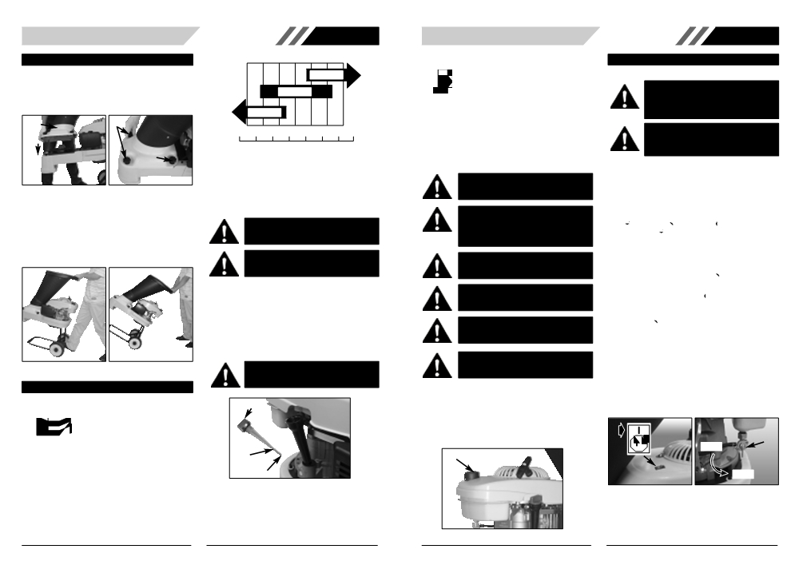

ASSEMBLY INSTRUCTIONS
• HOPPER INSTALLATION
1. Carefully lift up the Hopper (A). (Fig. 1A)
2. Place and align the hopper on top of the blade.
3. Locate the safety knobs (B) and fasten to secure the
hopper with the base unit. (Fig. 1B)

A B

B

Fig. 1A Fig. 1B

• MOVE THE SHREDDER
1. Stand at the back of shredder.
2. Grab the hopper handle, and step on the wheel axle.
(Fig. 2A)
3. Pull down the handle to slant backward the shredder.
(Fig. 2B)
4. Move the shredder.

Fig. 2A Fig. 2B

BEFORE STARTING ENGINE
• OIL
Oil Information
Type of Oil to Use

• Use a high quality detergent oil classified "For service
SF, SG, SH, SJ" or higher.
• SAE 30 is recommended for general use. Other vis-
cosities shown in the chart may be used when the
average temperature in your area is within the indi-
cated range. (Fig. 3)
• Do not use special additives.

GB

SAE
30

10W-30

10

TEMP -20 0 20 40 60 80 100˚F

-30 -20 -100 0 10 20 30 40˚C
STARTNG TEMPERATURE RANGE
Fig. 3

Oil Capacity
The engine holds approximately 0.5 litres.
Check oil level
WARNING: Running engine with insufficient
oil will cause serious engine damage.

WARNING: When checking oil stop engine
and place it on a level, surface.

1. Remove dipstick (A) and wipe clean with cloth. (Fig. 4)
2. Replace dipstick back without lock it in. Pull the dip-
stick out and check the oil level.
3. Oil level should be at upper limit (B) on dipstick.
4. If the oil level is near or below the lower limit (C) mark
on the dipstick, add oil slowly and recheck until oil
level reaches upper limit of dipstick. Do not overfill.
5. Replace and tighten dipstick.

WARNING: Using dirty oil or two-stroke
engine oil will shorten engine useful life.

B

C
Fig. 4

• FUEL
Fuel Information
Type of Fuel to Use

• This engine is certified to operate on unleaded petrol
with a minimum of 77 octane. Fresh fuel prevents
gum from forming in the fuel system. Purchase fuel in
quantity that can be used within 30 days.
• Do NOT mix oil with petrol.
• Keep dust, water and foreign matter away from fuel
tank.
• Do NOT use gasoline which contains Methanol.

WARNING: Gas is extremely flammable; it
will explode if exposed to a source of ignition.

WARNING: Turn engine OFF and let engine
cool before removing gas tank cap. Always
add fuel at well-ventilated place. Keep gaso-
line from sparks, open flames, heat and other
ignition sources.

WARNING: Don’t overfill fuel. The fuel level
should be always below the lowest position of
the fuel tank neck.

WARNING: Check fuel lines, tank, cap and
fittings frequently for cracks or leaks. Replace
if necessary.

WARNING: Prevent skin from frequent con-
tact with gasoline.

WARNING: Keep children and the frail at a
safe distance during refuelling.

Adding Fuel
1. Remove fuel cap (A). (Fig. 5)
2. Fill tank to the lowest position of the fuel tank neck.
Do not over fill.
3. Wipe any gasoline that may have spilled.
4. Reinstall the fuel cap.
Fuel tank capacity: 0.90 liters
A

Fig. 5

GB

OPERATION INSTRUCTIONS
• BEFORE STARTING ENGINE
WARNING: Damage to your eyes, hands,
and ears could result from using this machine
without proper protective gear. Always wear
safety glasses, hearing protection, and
leather gloves when operating this machine.

WARNING: Loose hair and clothing could
get caught in machinery and cause serious
personal injury. Keep loose clothing and long
hair away from moving machinery.

Make sure to check the engine oil and fuel tank before starting the engine.
• TO START ENGINE
1. Move ON/OFF switch to “ON (I)”position. (Fig. 6A)
2. Turn the fuel valve (A) to the ON position. (Fig. 6B)
3. Your unit is designed with a 3 position choke: CHOKE
“ ”, PARTIAL “ ”, and RUN “ ”. Move choke lever
to CHOKE “ ” position. (Fig. 6C)
4. Pull starter rope out a short way until resistance is felt
(approximately 100mm). A smooth rapid pull is
required for a strong spark. Pull starter rope briskly 4
times. (Fig. 6D)
5. Move choke lever to PARTIAL “ ” position. (Fig. 6E)
6. Pull the starter rope until the engine start up.
7. Move choke level to RUN “ ” position right after the
engine started up. (Fig. 6F)
8. If the engine does not start up, move choke level to
PARTIAL “ ” position, then repeat step 6.
9. If engine fails to start, repeat steps 1 through 8.
NOTE: If engine fails to start after repeated attempts, refer to Troubleshooting section.
NOTE: Always pull starter rope straight out. Pulling starter
at an angle will cause rope to rub against the eyelet. This
friction will cause the rope to fray and wear more quickly.
Always hold starter handle when rope retracts. Never
allow rope to snap back from extended position.This could
cause rope to snag or fray and also damage the starter
assembly.

OFF A

ON

Fig. 6A Fig. 6B
5
6

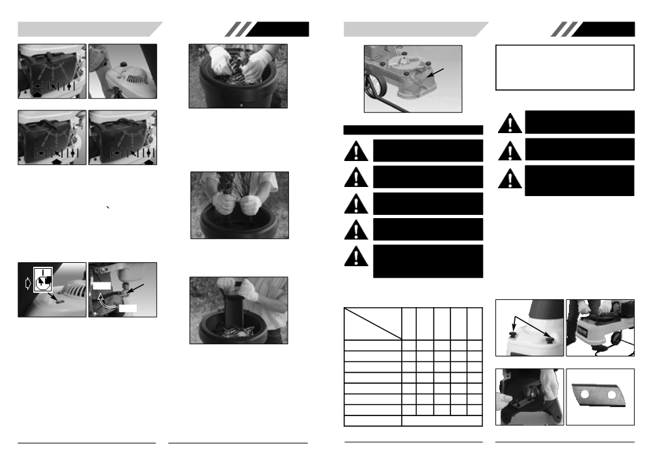

Fig. 6C Fig. 6D

Fig. 6E Fig. 6F

• WARM ENGINE START
1. Move ignition switch to the “RUN (I)” position.
2. Turn the fuel valve to the ON position.
3. Move choke lever on PARTIAL “ ” position, and start
the engine.
4. If the engine still can not start, follow the step as “To
start engine” section in this user manual.
• TO STOP ENGINE
1. Move ignition switch to the “STOP” position. (Fig. 7A)
2. Turn the fuel valve (A) to the OFF position. (Fig. 7B)

A

GB

Fig. 8

• TOP HOPPER-BACK CHUTE
The smaller back chute of the top Hopper accepts medi-
um to larger size garden clippings.
Shredding and mulching is achieved through the same action as the front chute. If a finer type mulch is required, re-feed the mulch through again until the desired result is obtained. (Fig. 9).

Fig. 9
• MATERIAL PUSH STICK
User supplied push stick to push remaining material into hopper opening. DO NOT USE HANDS. (Fig. 10)

Fan

Fig. 11
MAINTENANCE

WARNING: Priors to any maintenance, to
stop engine and switch it off first.

WARNING: Disconnect spark plug wire from
the spark plug to prevent unintentional
engine starting.

WARNING: Unintentional sparking can result
in fire.

WARNING: Unintentional start-up can result
in entanglement, traumatic amputation, or
laceration.

CAUTION: Use only genuine replacement
engine parts. None compliant parts may
damage the engine, and may result in injury.
In addition, use of other parts may void your
warranty rights.

GB

★ Drain engine oil and change it after first 5-8hours of operation and
every 50 hours or three months after that. It is also a highly rec-
ommendation to change oil every 25 hours under heavy load or in
high temperature.
★★ Clean air cleaner more frequently under dusty conditions or when
airborne debris is present. Replace of air cleaner element if it is
very dirty.

• BLADE MAINTENANCE
WARNING: Before removing Top Hopper
knob, ensure the machine is switched off,
and the machine is completely stopped.

WARNING: Take extreme care not to come
in contact with cutting blades.

WARNING: If ejection chute becomes
clogged or cutting blades become jammed,
under no circumstances should you place
your hands in ejection chute to try to clear
obstruction, as this will lead to serious injury.
1. Switch the machine off, and make sure the machine
is completely stopped.
2. Wear gloves when attempting any maintenance to
the cutting blades.
3. Loose four safety knobs as shown on (Fig. 12A),
carefully lift up the hopper.
4. Steps on the hopper support with the foot, takes a
tool to be fixed the blade of plate. (Fig. 12B)
5. Dismantles bit anchor screw 2pcs with the suitable
tool.
6. Closes the hopper, the tighten the screws.
NOTE: The blade is double edged. Should you have to

OFF

ON
Regular maintenance will improve the performance and
extend the life of the engine. Please follow the instructions and schedules indicated below:

Perform task at hourly or 25 50 100
calendar interval, Hours Hours Hours 100-
chang the blade, rotate the blade 180 degree for sharper
edge. (Fig. 12D)

A

Fig. 7A Fig. 7B

• TOP HOPPER-FRONT CUT
The large sloping front chute of the Top Hopper is designed to accept leaves and small garden clippings. Shredding and mulching is achieved by natural suction of the debris through the blade chamber.
Do not overfeed and do not feed wet, soggy material into the shredder as this may clog the blade chamber and the discharge chute. (Fig. 8)

Fig. 10
• REMOVE SAW DUST FROM BUTTOM FAN
Normaly, the fan should rotates slowely whenthe engine is running. It should be stuck by the saw dust if the fan stop rotating. Please use a tool to stir around the fan to remove the saw dust. (Fig. 11)
whichever Each
comes Use or or or 300
first Every Every Every Hours
Task Season Season Season

Check Oil Level •

Change Oil • ★

Clean Air Cleaner • ★★

Check Flywheel Brake Pad •

Check-clean Spark Plug •

Check-adjust idle speed •

Clean Combustion Chamber •

Check Fuel Line Every 2 years (Replace if necessary)

Fig. 12A Fig. 12B

Fig. 12C Fig. 12D
7
8

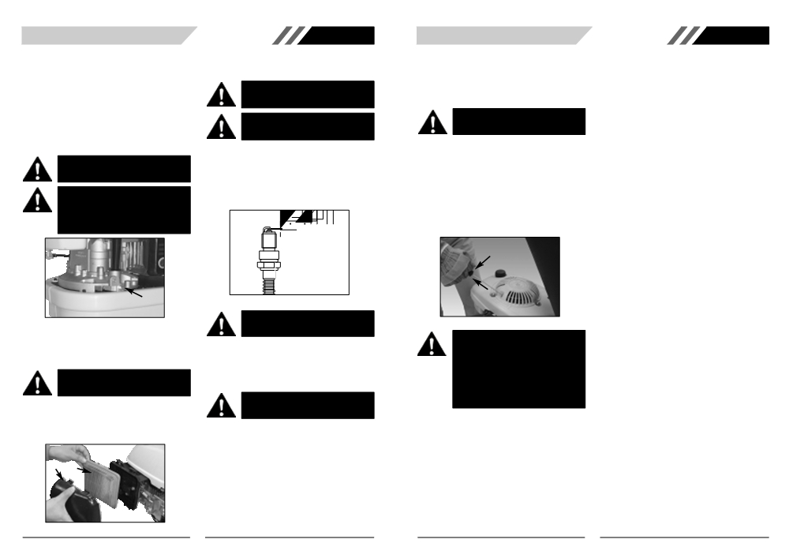

• CHANGE OIL
1. Let engine runs out of fuel, and wait until engine
stopped and cooled slightly.
2. Disconnect spark plug wire and keep away from
spark plug.
3. When engine is still warm, remove oil drain plug (A).
Drain oil into a proper container. (Fig. 13)
4. Clean the oil drain plug before restoring it back.
5. Place engine level. Remove dipstick. Add new recom-
mended oil about 0.3L slowly to upper limit on dip-
stick, Don’t overfill.
6. Replace dipstick.
WARNING: Prevent skin contact with used
engine oil. Wash your skin with soap and
water after oil change.

CAUTION: Used oil is a hazardous waste
product. It is suggested to bring used oil to
your local recycling center with properly
sealed container a sealed container to your
local recycling center. Do not discard with
household waste.

A

Fig. 13
• AIR CLEANER MAINTENANCE
A dirty air filter will increase air intake restriction. Periodical maintenance for air filter will help to improve engine performance and reduce emissions.
WARNING: Never clean air filter with gaso-
line or an easy ignited solvent it may cause
explosion.

1. Remove the air cleaner cover (A), and carefully
remove the filter element (B). (Fig. 14)
2. Clean all parts.
3. Blow off dirt from filter element with pressure air.
4. Reinstall the filter element and air cleaner cover.

A B

Fig. 14
9

GB

• SPARK PLUG
Recommended Spark plug: F6RTC.
Stop the engine and allow it to cool
WARNING: DO NOT use an incorrectly rated
plug. It is essential to keep the spark plug in
good condition - clean and properly adjusted.

WARNING: To keep engine at top perform-
ance spark plug gap should be within speci-
fied and carbon built up free.

1. Removing spark plug with a spark plug wrench.
2. Inspect the spark plug visually. If spark plug is worn,
dirty or has cracks, replace with the recommended
type and heat range.
3. The correct air gap is 0.70 to 0.80 mm. (Fig. 15)
4. Tighten the spark plug.
5. After spark plug is tight; torque to 25-30N·m.

Fig. 15

WARNING: An incorrectly tightened spark
plug may result in poor engine performance
and permanent engine damage.
• COMBUSTION DEPOSITS
We recommend that you should remove combustion deposits from the cylinder, cylinder head, top of piston, and around valves after every 100-300 hours usage.
• MUFFLER
WARNING: If engine just running down, do
not touch muffler. Allow it to cool before oper-
ation.

• TRANSPORTING AND STORAGE
When storing engine for more than 30 days:
1. Store in a dry and clean area.
2. Run engine until fuel tank is empty and engine stops
or add gasoline preservative and running engine after
adding for several minutes to circulate preservative.
WARNING: Gasoline is flammable. Fuel or
fuel vapors may explode. Keep sparks and
open flames from the working area.

3. Change engine lubrication oil.
4. Clean the exterior surfaces of the engine.
5. Remove spark plug; pour one teaspoon of fresh
engine oil into cylinder. Re-install spark plug without
the spark plug wire attached. Pull starter rope slowly
several times to distribute the oil in the engine.
6. Slowly pull start handle (A) until the resistance is
reached, then stop pulling. At that point, valves are
closed, that will prevent dust and rust from entering
cylinder. (Fig. 16)
7. Cover engine well to prevent dust.

A

Fig. 16
WARNING: When you service the engine,
inspect the blade, or clean the underside of
the housing; make sure to always tip the
engine with the spark plug up.Transporting or
tipping the engine with the spark plug down
will cause:
1. Engine smoking
2. Hard starting
3. Spark plug fouling
4. Oil or petrol saturation of the air filter

GB

10

